DEMOBLAZE

Module Name: Homepage, Categories, Product Details, About Us & Contact
Test Case ID: TC01-TC10
Tester Name: Chouhan Himansu Raj singh

Test Scenarios :
TC01 – Verify homepage loading
Scenario ID: TC01
Scenario: Verify homepage loading
Test Steps:
> Step 1: Open Google Chrome
> Step 2: Enter https://www.demoblaze.com/ in the address bar
> Step 3: Wait for the homepage to load

Screenshot:
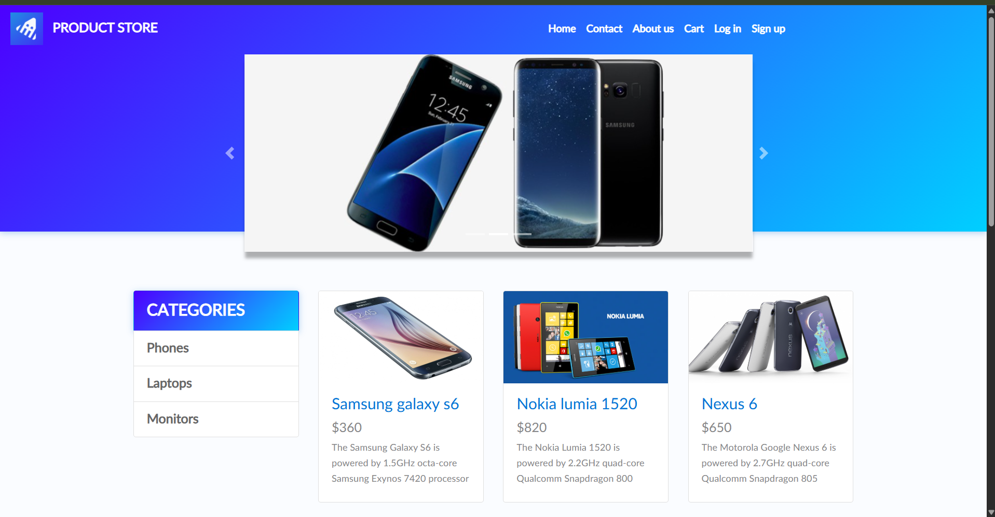

TC02 – Verify Home button
Scenario ID: TC02
Scenario: Verify Home button
Test Steps:
> Step 1: Open the website
> Step 2: Navigate to another page or open a product
> Step 3: Click Home

Screenshot:
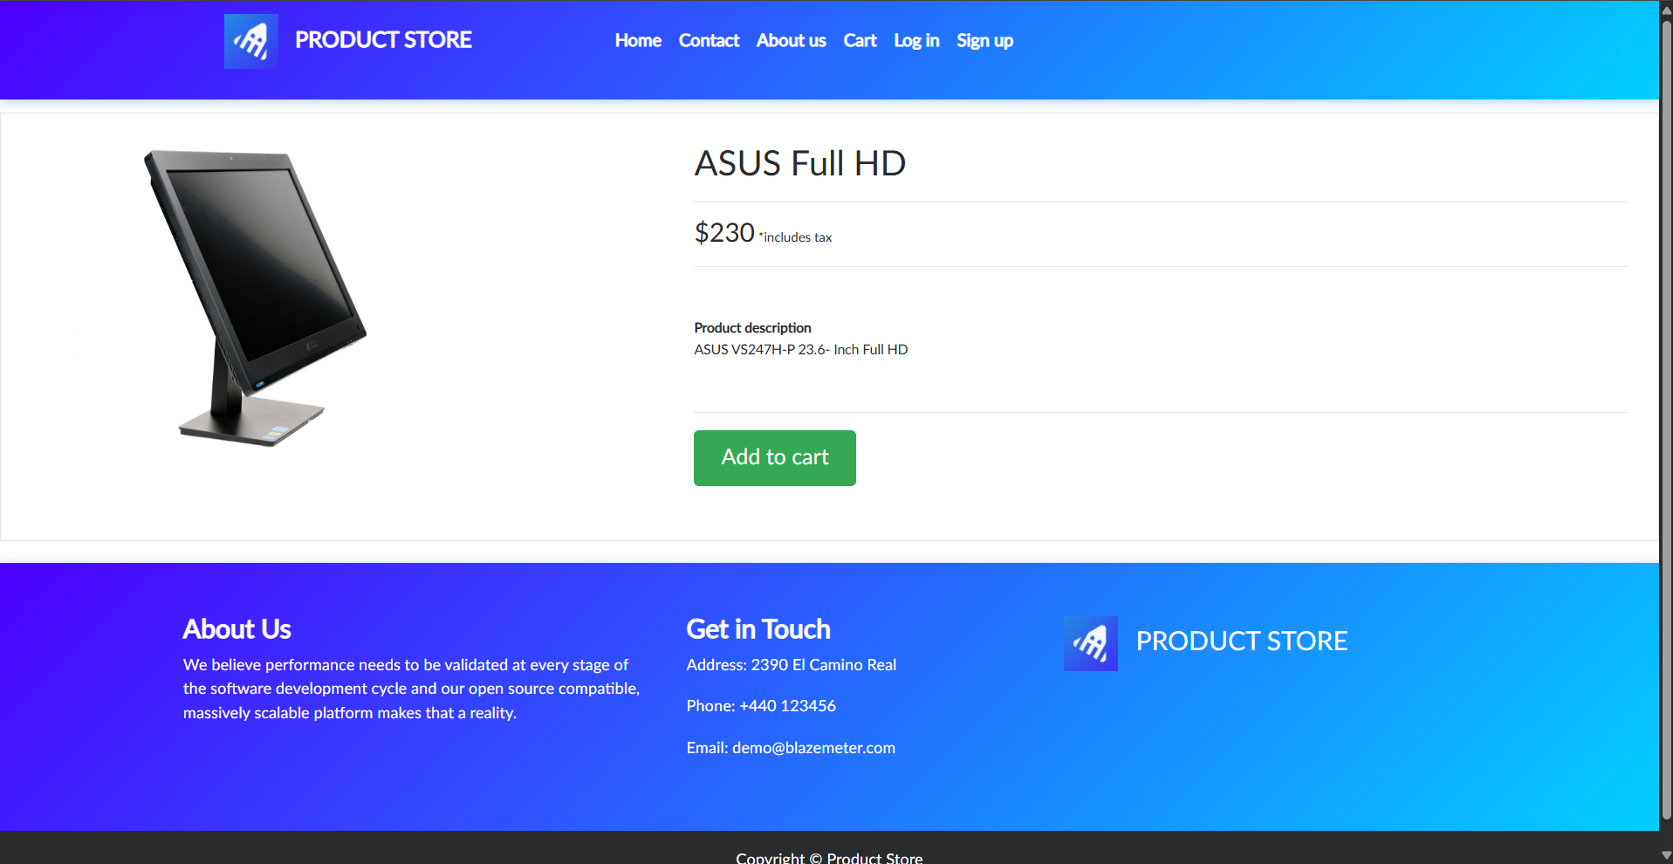

TC03 – Verify Phones category
Scenario ID: TC03
Scenario: Verify Phones category
Test Steps:
> Step 1: Open the homepage
> Step 2: Click Phones in the category list
> Step 3: Observe the products displayed

Screenshot:
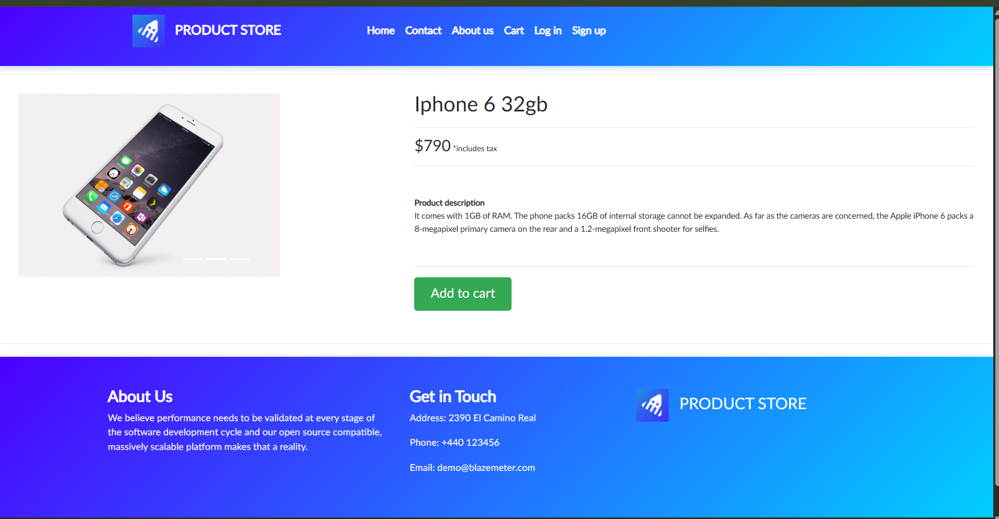

TC04 – Verify Laptops category
Scenario ID: TC04
Scenario: Verify Laptops category
Test Steps:
> Step 1: Open the homepage
> Step 2: Click Laptops in the category list
> Step 3: Observe the products displayed

Screenshot:
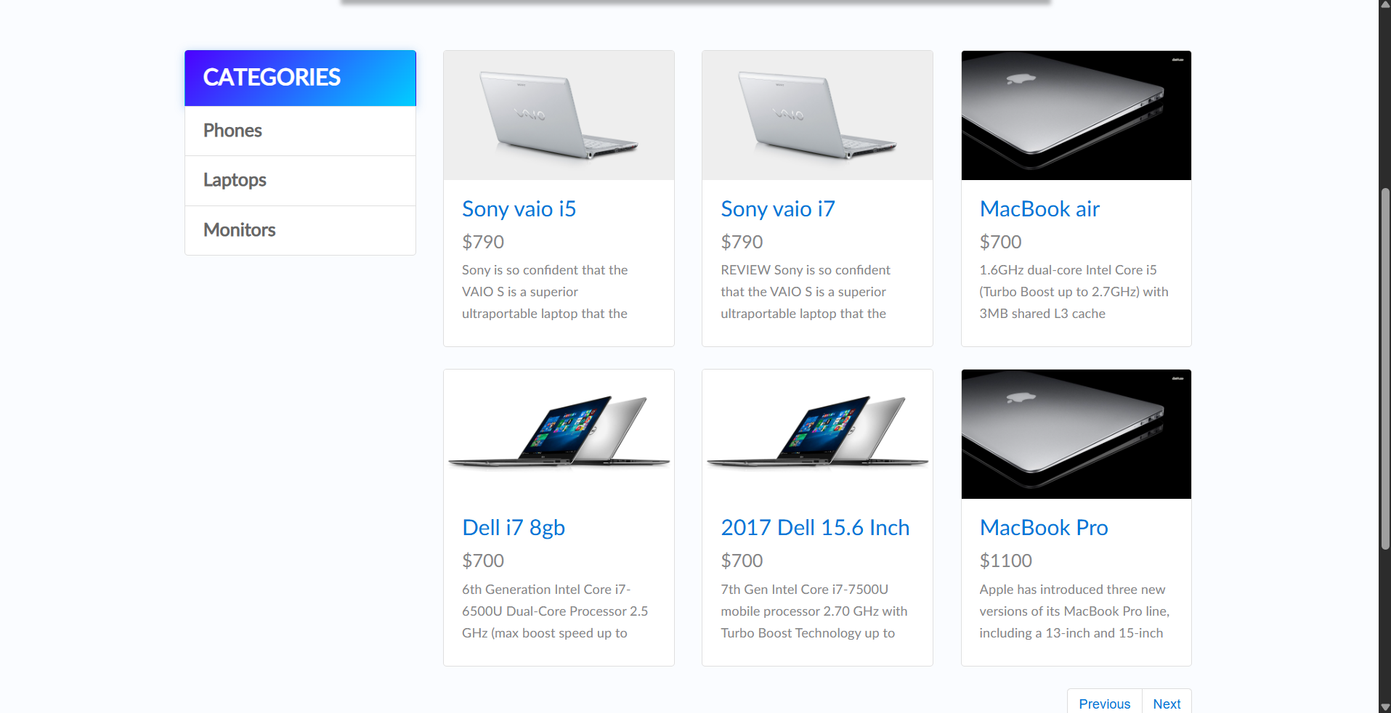

TC05 – Verify Monitors category
Scenario ID: TC05
Scenario: Verify Monitors category
Test Steps:
> Step 1: Open the homepage
> Step 2: Click Monitors in the category list
> Step 3: Observe the products displayed

Screenshot:
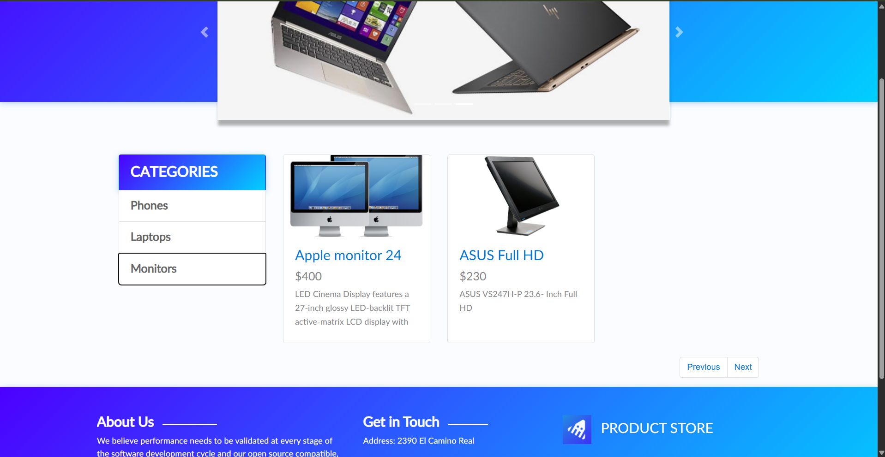

TC06 – Verify product details page
Scenario ID: TC06
Scenario: Verify product details page
Test Steps:
> Step 1: Open any available product from a category
> Step 2: Check the product details page
> Step 3: Verify name, price and description

Screenshot:
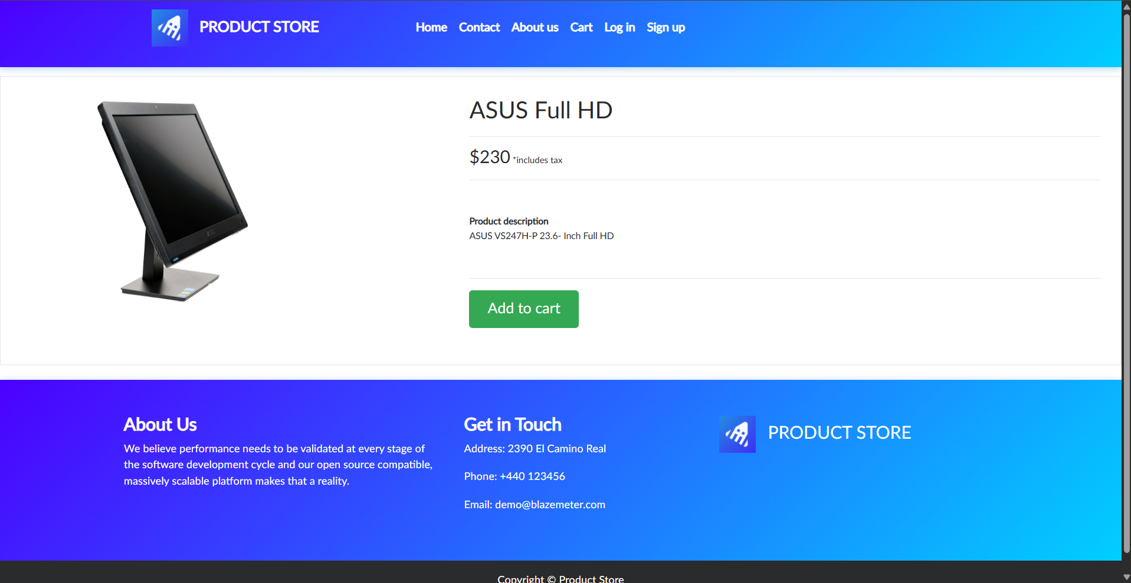

TC07 – Verify About Us popup
Scenario ID: TC07
Scenario: Verify About Us popup
Test Steps:
> Step 1: Open the homepage
> Step 2: Click About us in the top navigation
> Step 3: Check the popup content

Screenshot:
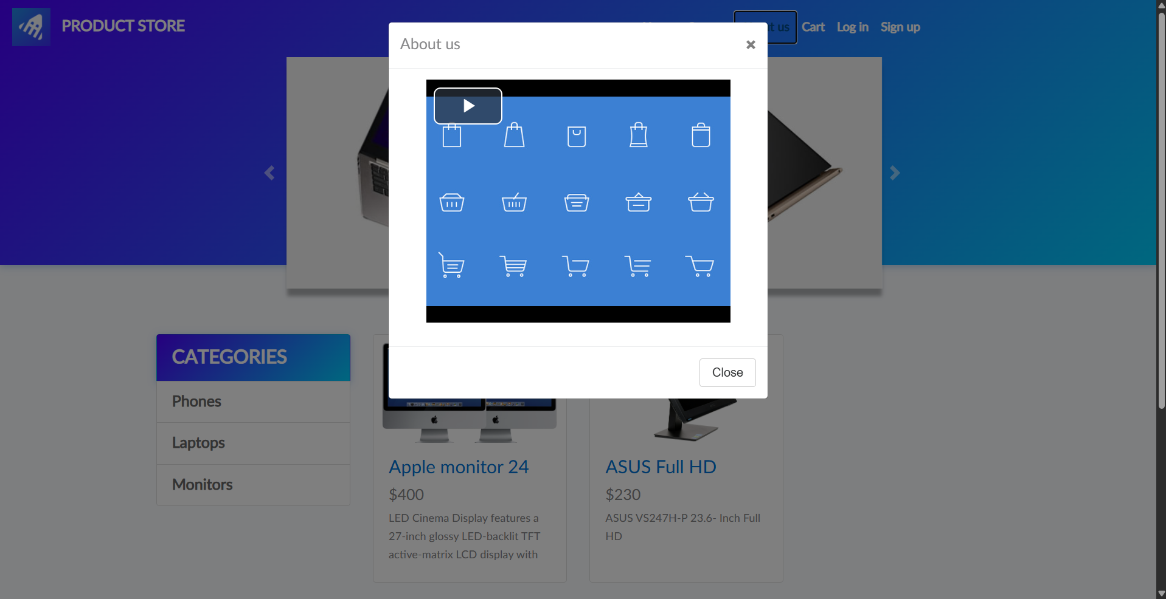

TC08 – Verify About Us close button
Scenario ID: TC08
Scenario: Verify About Us close button
Test Steps:
> Step 1: Open the About Us popup
> Step 2: Click its close (X) button or Close button

Screenshot:
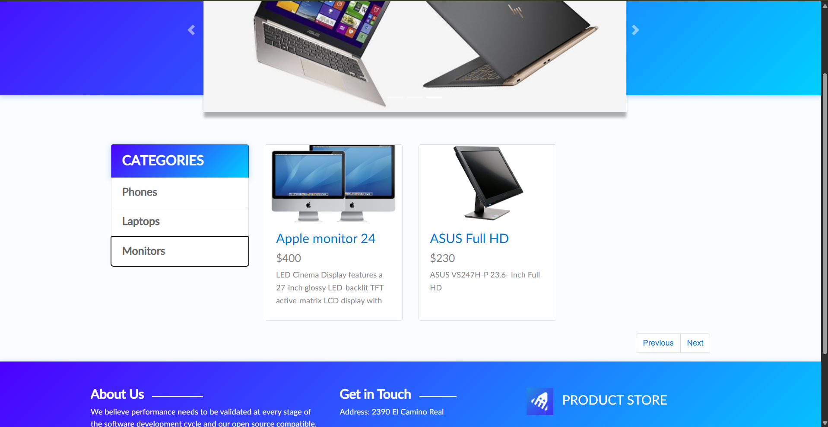

TC09 – Verify Contact form fields
Scenario ID: TC09
Scenario: Verify Contact form fields
Test Steps:
> Step 1: Open the homepage
> Step 2: Click Contact
> Step 3: Check the form fields
Screenshot: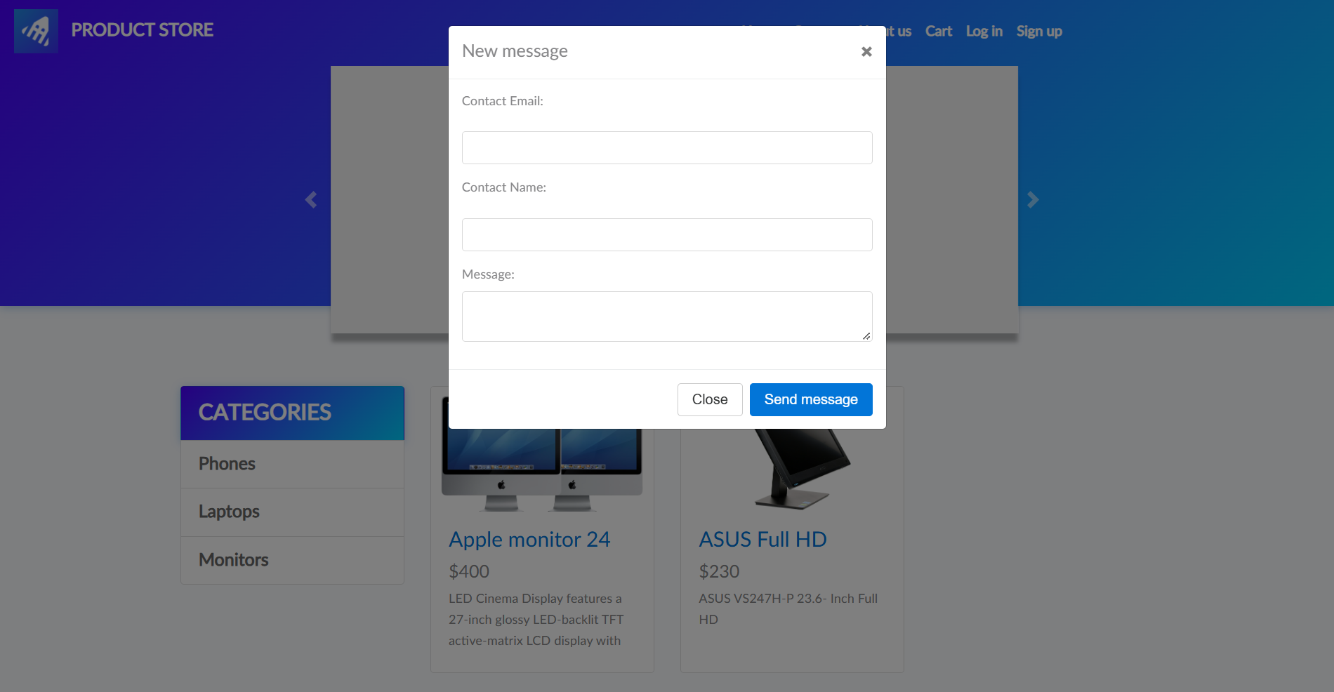
TC10 – Verify Contact form close button
Scenario ID: TC10
Scenario: Verify Contact form close button
Test Steps:
> Step 1: Open the Contact popup
> Step 2: Click its close (X) button or Close button
Screenshot:

