Manual Test Execution

Module Name: Amazon E-Commerce Website - Shopping Workflow Test Case
Test Case ID: TC001 - TC012
Tester Name: Chouhan Himansu Raj singh

Test Scenarios
- Scenario ID: 1a
Scenario: Open Amazon website (TC001)
Test Steps:
1. Open web browser
2. Navigate to www.amazon.in
3. Wait for page to load
Screenshots:
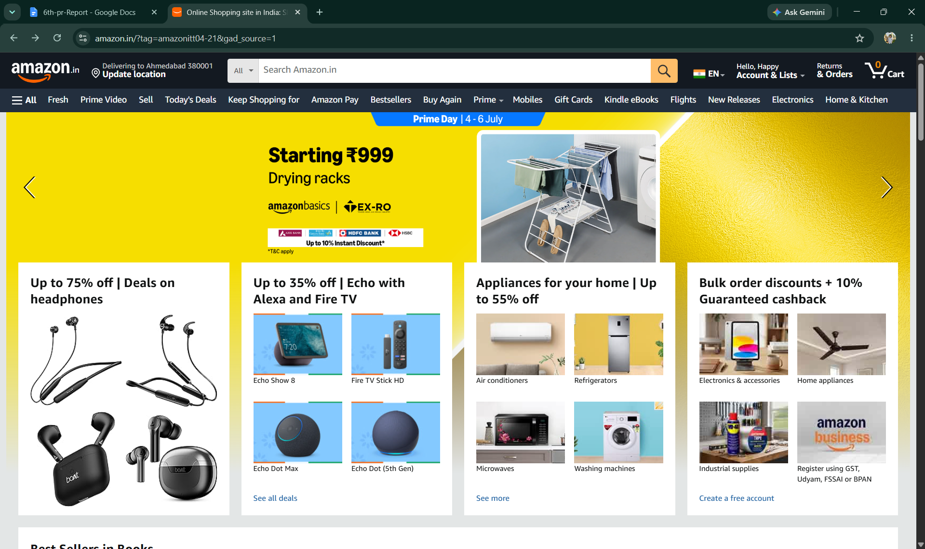
- Scenario ID: 1b
Scenario: Search for a product (TC002)
Test Steps:
1. Open Amazon homepage
2. Click search bar
3. Enter product name
4. Click search icon
Screenshots:
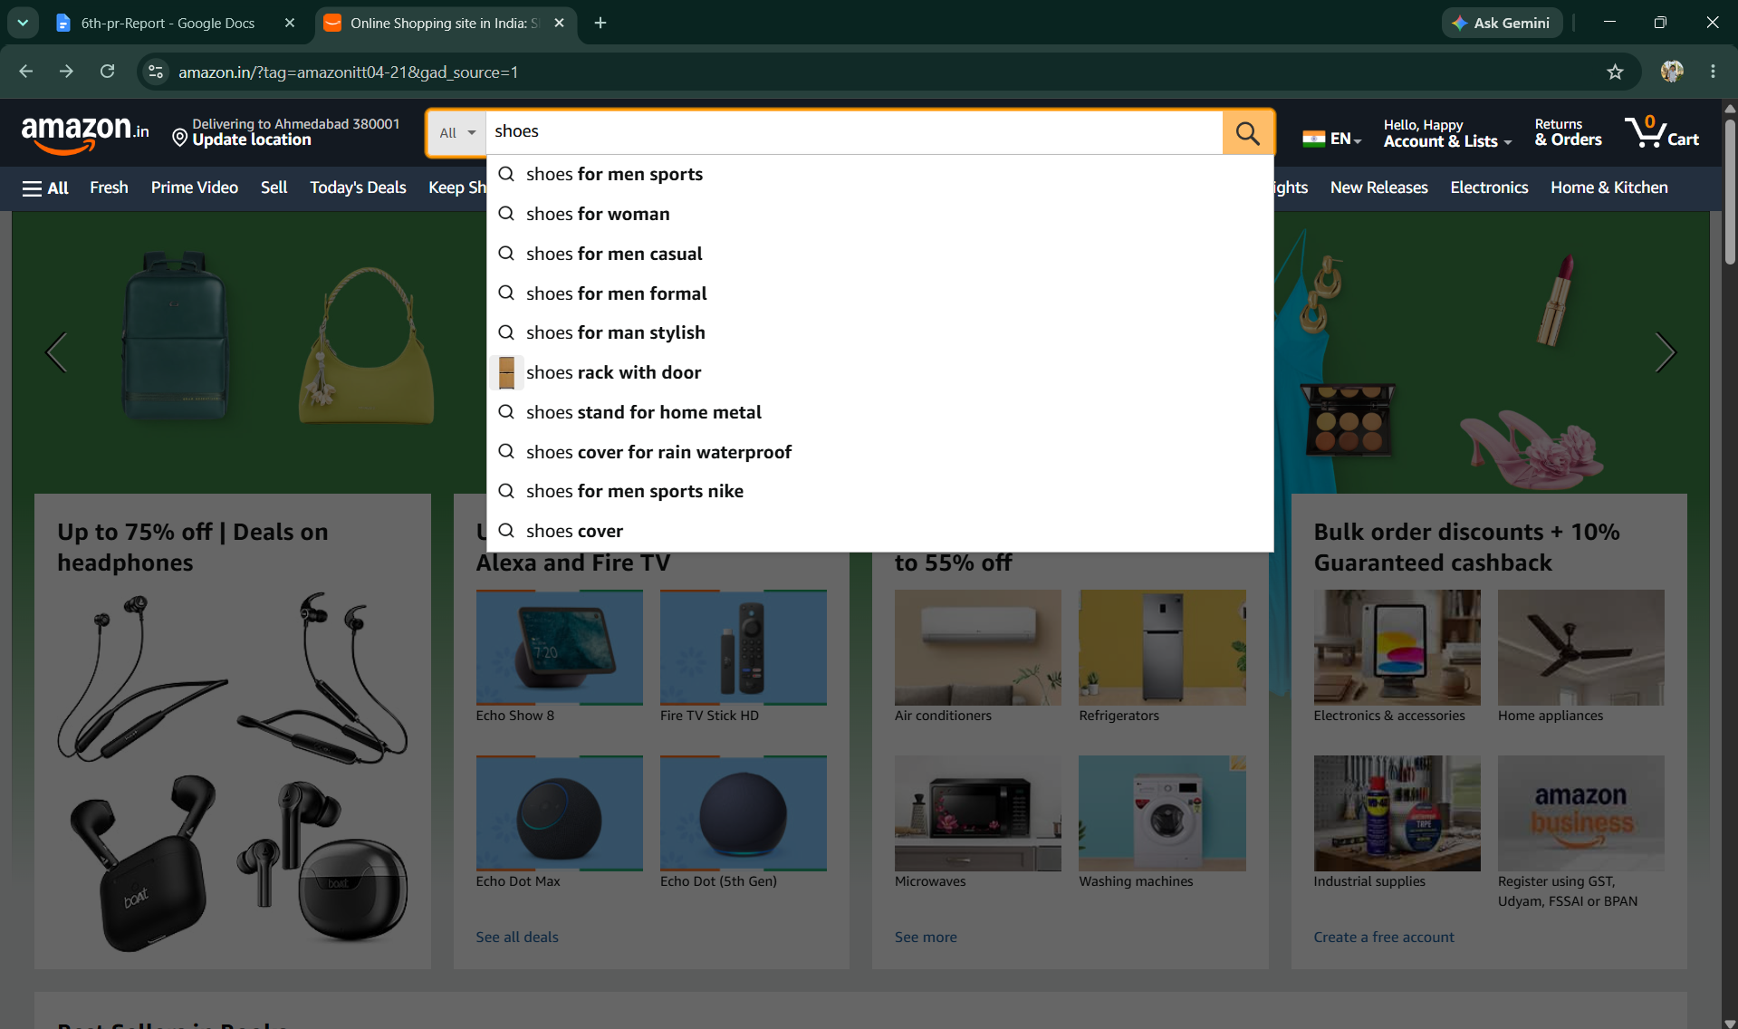

- Scenario ID: 1c
Scenario: Open Product Details page (TC003)
Test Steps:
1. From search results page
2. Click on a product title or image
Screenshots: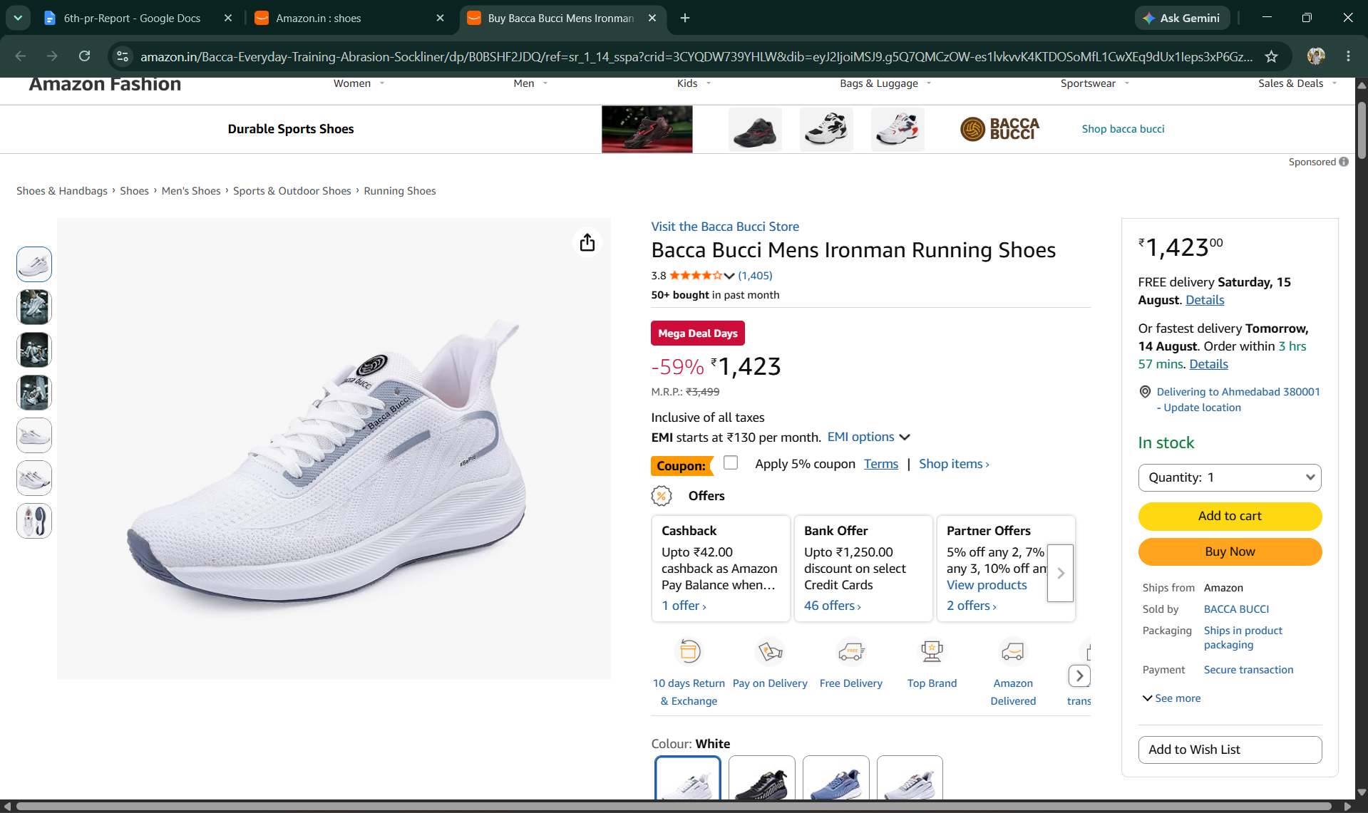

- Scenario ID: 1d
Scenario: Add product to Cart (TC004)
Test Steps:
1. On Product Details page
2. Select quantity
3. Click 'Add to Cart' button
Screenshots:
- Scenario ID: 1e
Scenario: Open Cart page (TC005)
Test Steps:
1. Click Cart icon
2. Cart page opens
Screenshots:
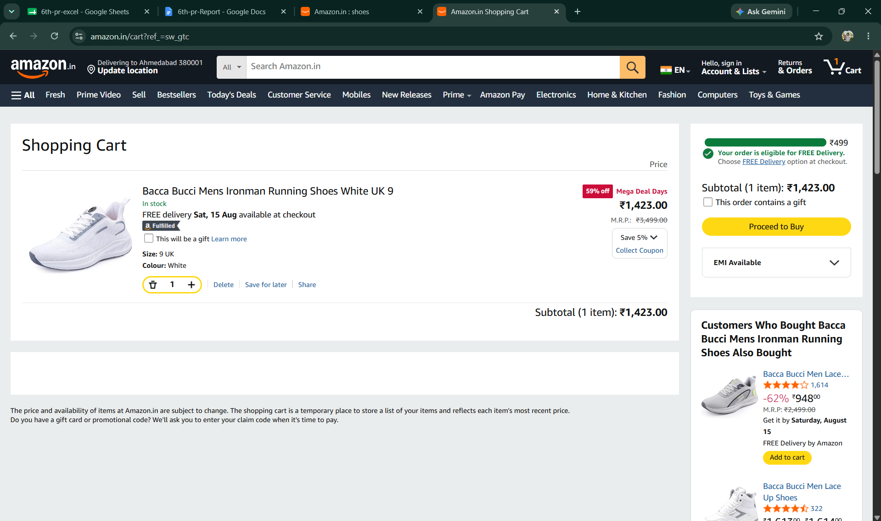
- Scenario ID: 1f
Scenario: Update product quantity in Cart (TC006)
Test Steps:
1. On Cart page
2. Change quantity value/dropdown
3. Click Update
Screenshots:
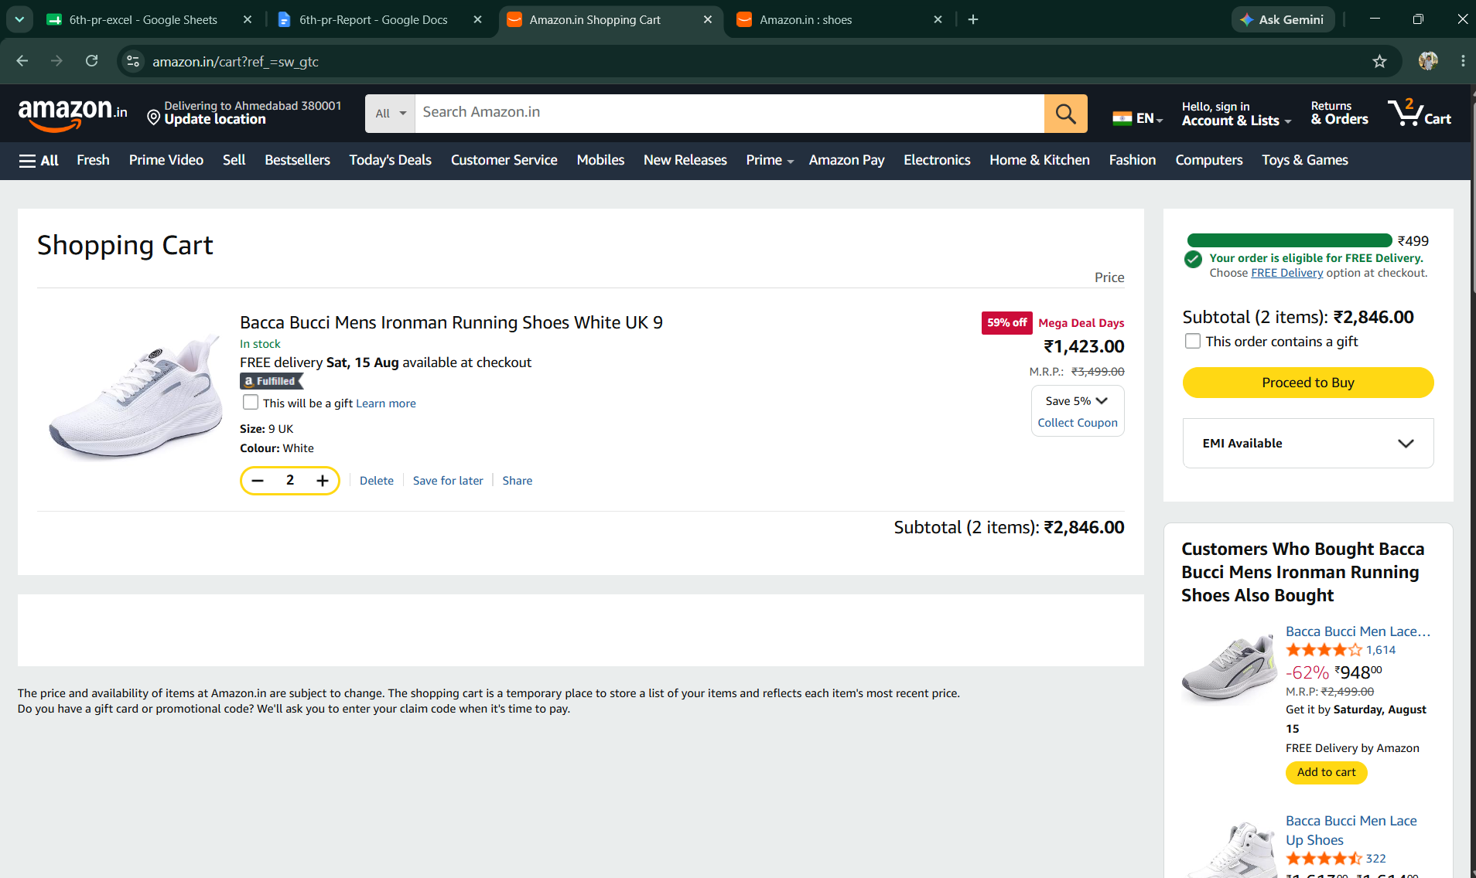
- Scenario ID: 1g
Scenario: Remove product from Cart (TC007)
Test Steps:
1. On Cart page
2. Click Delete/Remove for a product
Screenshots: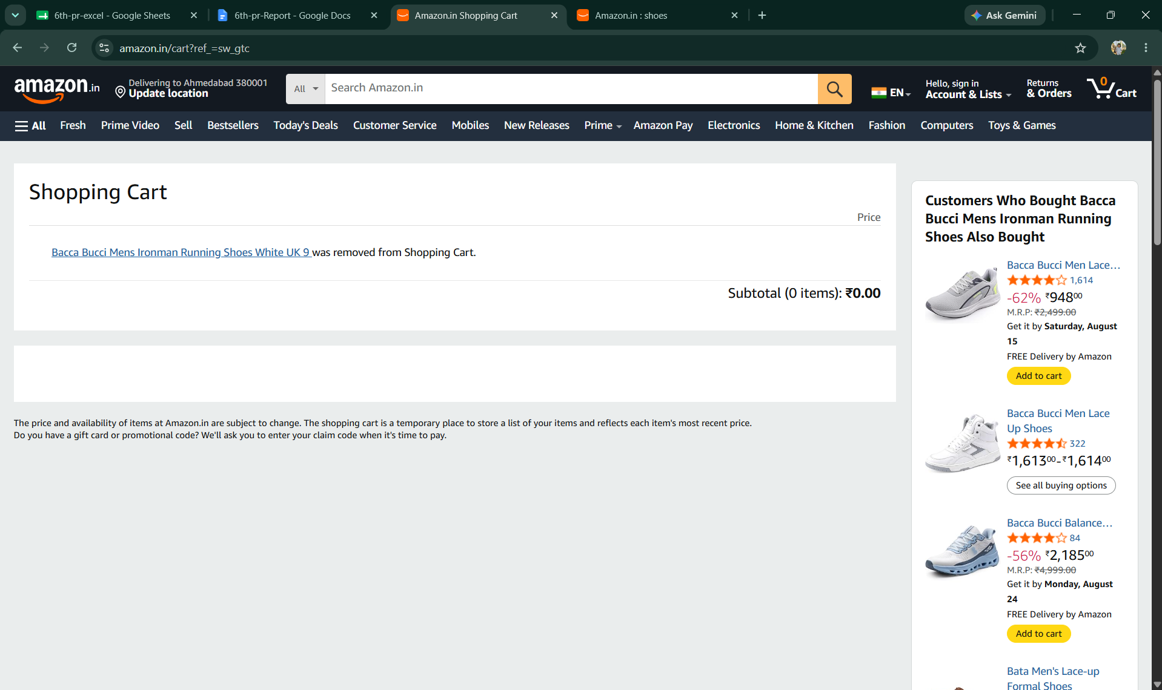

- Scenario ID: 1h
Scenario: Place Order from Cart (TC008)
Test Steps:
1. On Cart page
2. Click 'Place Order' / 'Proceed to Buy'
Screenshots:
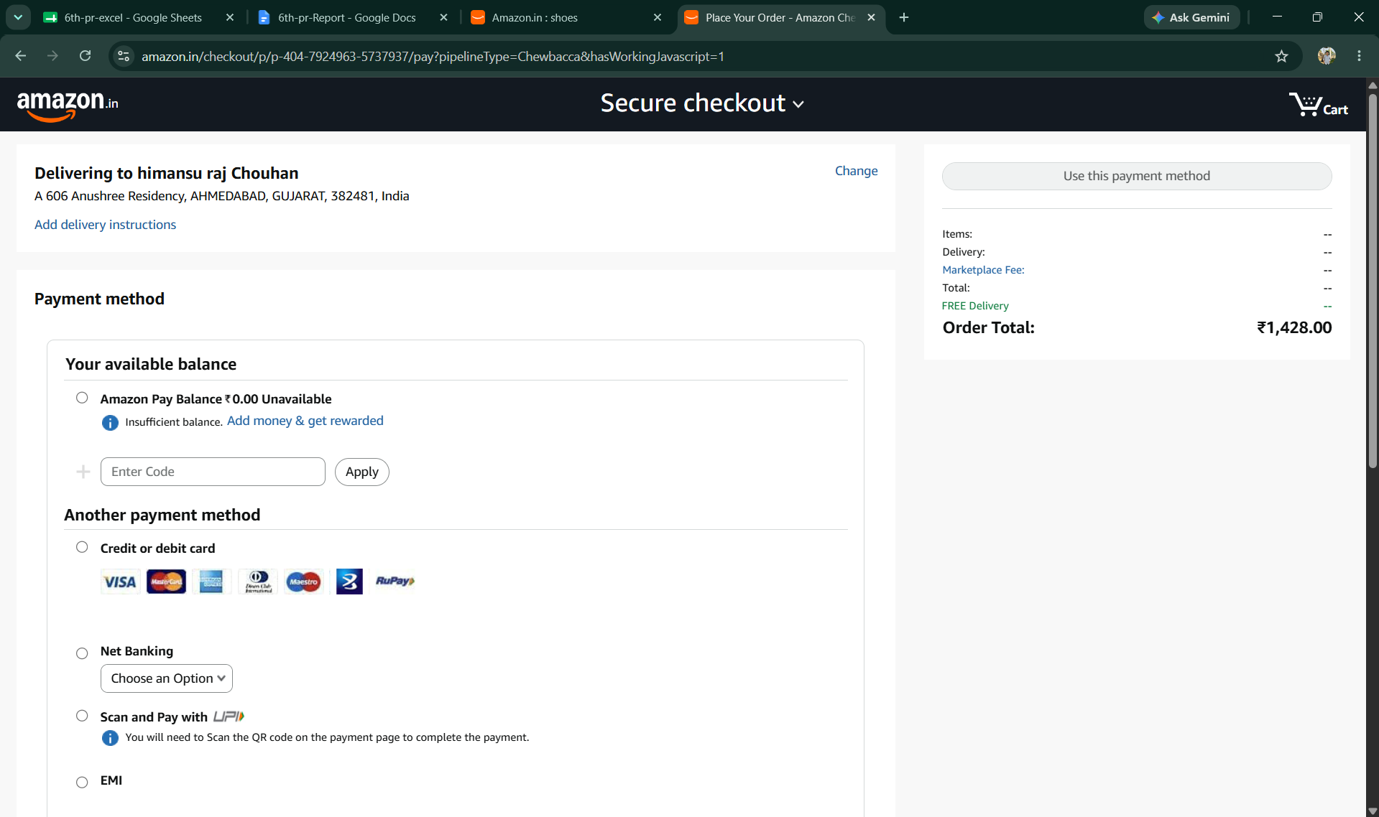
- Scenario ID: 1i
Scenario: Enter Customer Details (TC009)
Test Steps:
1. On Checkout page
2. Enter Name, Address, Phone Number
3. Click Continue/Save
Screenshots: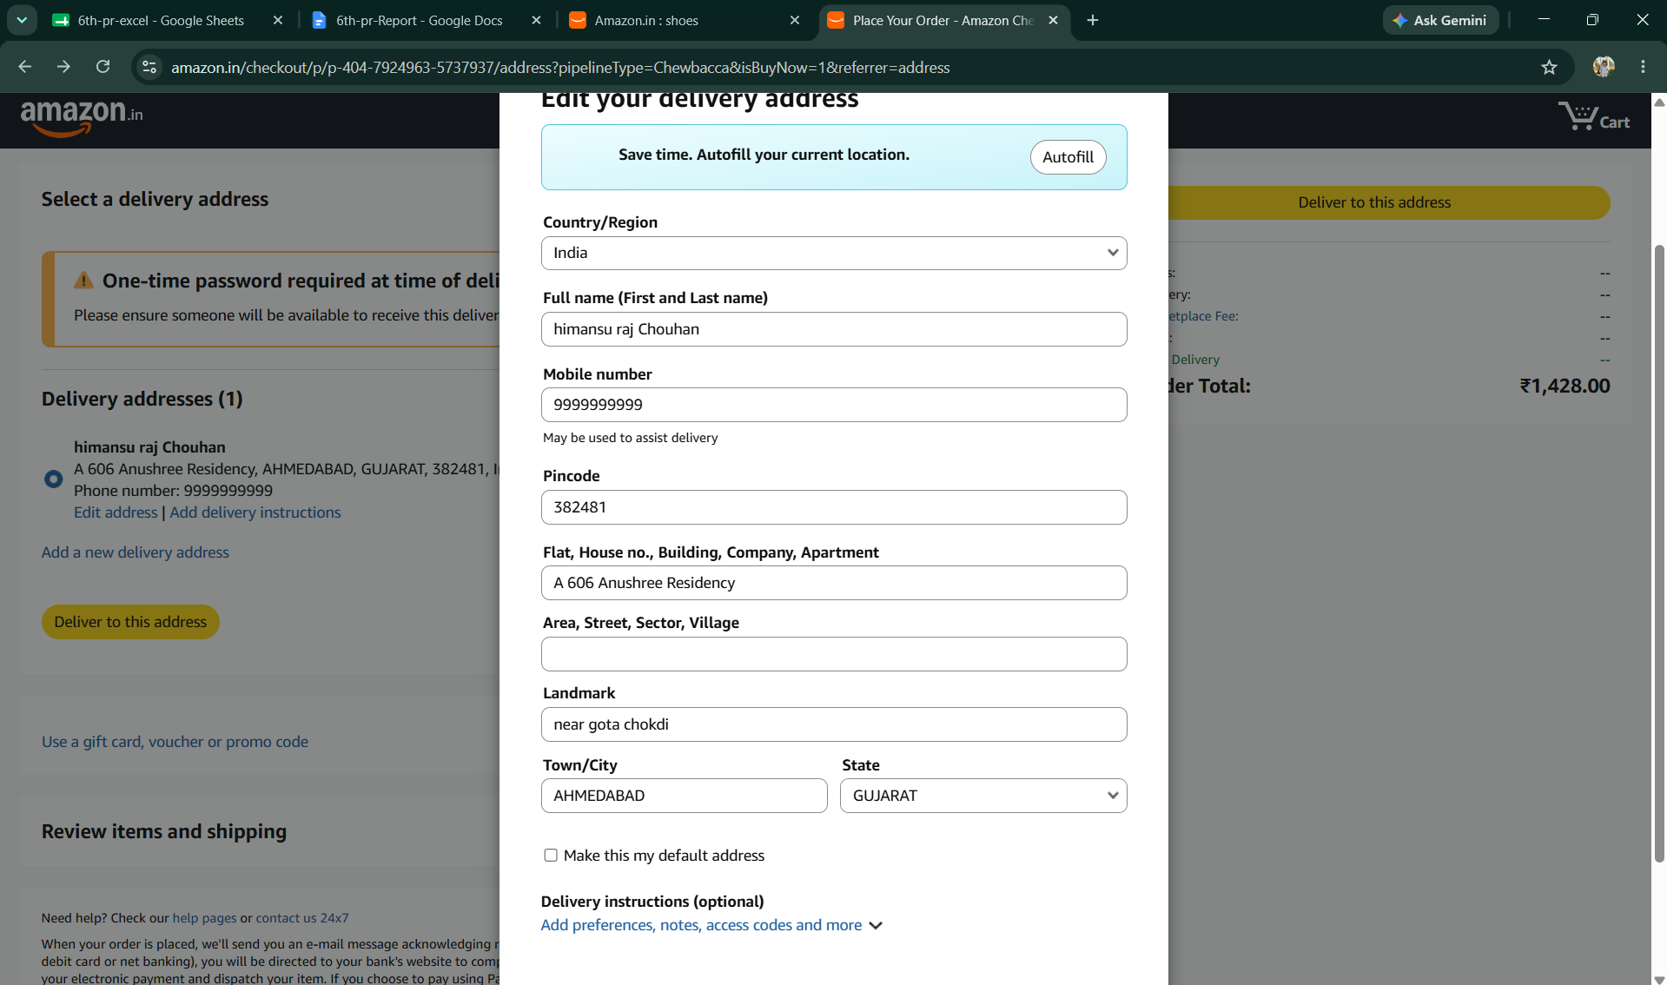

- Scenario ID: 1j
Scenario: Submit order with blank Customer Details (TC010)
Test Steps:
1. On Checkout page
2. Leave Name/Address fields blank
3. Click Continue/Submit
Screenshots: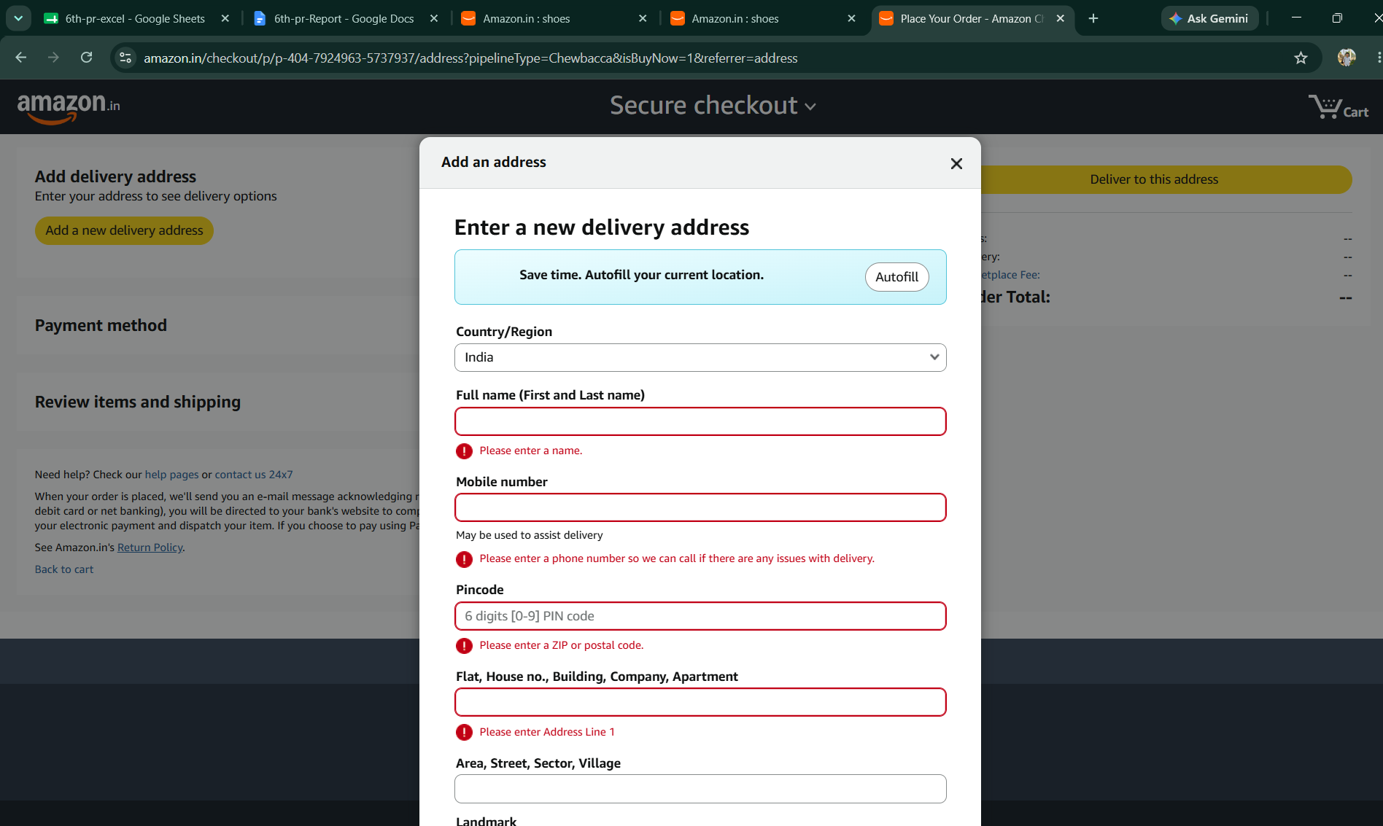

- Scenario ID: 1k
Scenario: Submit Order with valid details (TC011)
Test Steps:
1. Enter valid Customer Details
2. Select payment method
3. Click 'Submit Order'
Screenshots:
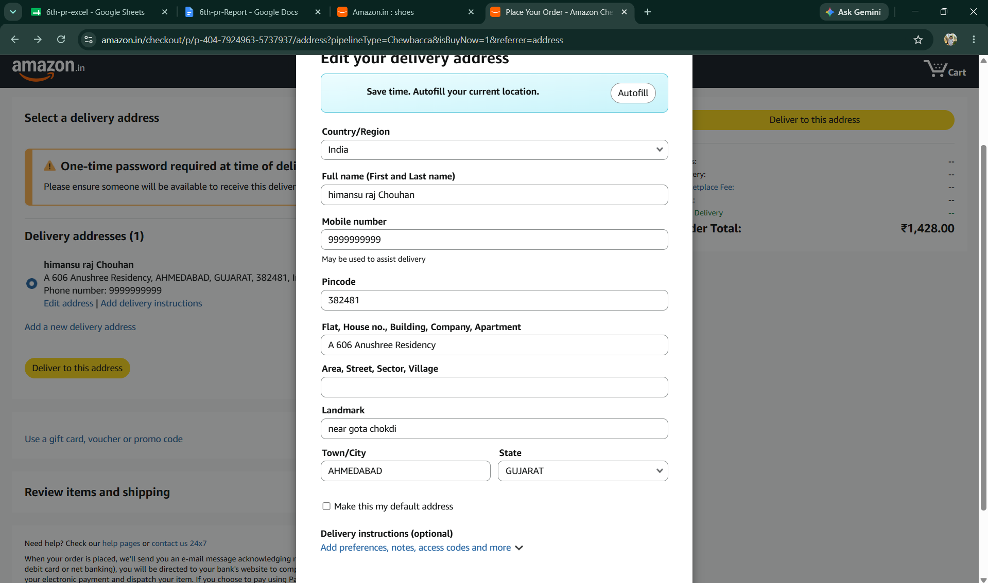
- Scenario ID: 1l
Scenario: Checkout with an empty Cart (TC012)
Test Steps:
1. Ensure Cart is empty
2. Click 'Place Order' / 'Proceed to Buy'
Screenshots: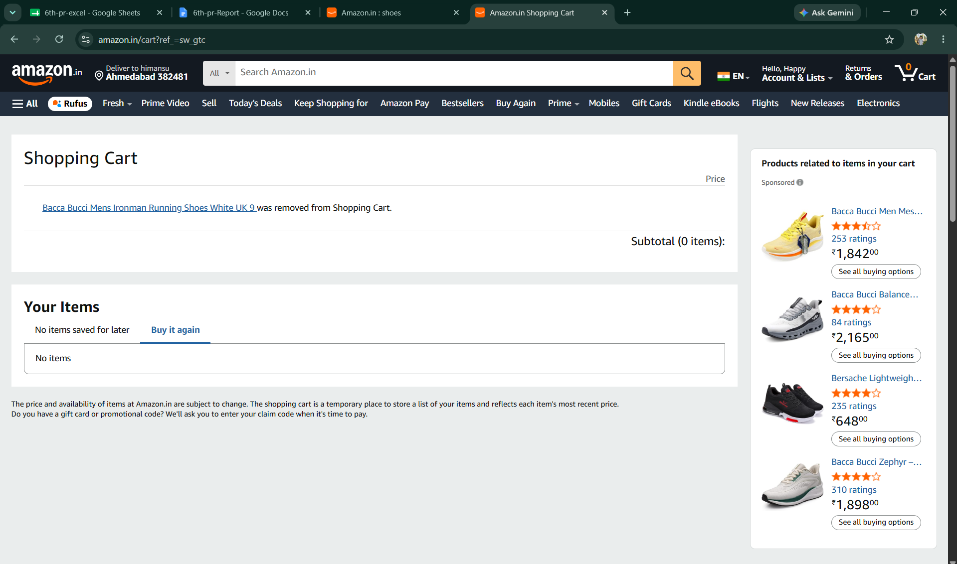

Summary of Test Results
Total Test Cases | 12
Passed | 12
Failed | 0
Not Executed | 0
Pass Rate (%) | 100%
Conclusion and Recommendations
Conclusion
All 12 test scenarios covering the Amazon Shopping Workflow (product search, product details, add to cart, cart management, checkout, and order submission) have been executed with a 100% pass rate. The actual results matched the expected results across valid, invalid, and boundary conditions (blank customer details, an empty cart), indicating that the shopping workflow is functioning correctly and reliably for the tested scenarios.
Test Coverage Analysis
• Homepage load and navigation - PASSED
• Product search functionality - PASSED
• Product details page navigation - PASSED
• Add to Cart functionality - PASSED
• Cart display and summary - PASSED
• Cart quantity update - PASSED
• Cart item removal - PASSED
• Checkout navigation - PASSED
• Customer details entry and validation - PASSED
• Blank field validation at checkout - PASSED
• Order submission with valid details - PASSED
• Empty cart checkout handling - PASSED
Recommendations
• The Shopping Workflow (search through order submission) is ready for further regression testing ahead of deployment.
• Consider adding automated regression tests for the core cart and checkout flows to catch regressions earlier.
• Add explicit test coverage for payment gateway failures and partial/interrupted checkouts.
• Verify cart persistence behavior across sessions and browser refreshes.
• Test concurrent cart updates (e.g., stock changes while an item sits in the cart).
• Add boundary tests for maximum quantity per item and maximum items per order.
• Perform cross-browser and mobile-responsive testing of the checkout flow.
• Conduct performance/load testing on search and checkout under high traffic.
• Validate order confirmation emails/notifications as part of the workflow.
• Schedule periodic re-execution of this test suite as part of ongoing regression testing.
Bug Reports
Summary: No bugs identified during the execution of the 12 test scenarios. All tests passed with expected results matching actual results.

