BVA & Equivalence partitioning

Module Name: E-Commerce Website - Quantity Field Validation (Add to Cart / Checkout Module)
Test Case ID: TC001-TC010
Tester Name: Chouhan Himansu Raj singh

Test Scenarios:

- Scenario ID: 1a
Scenario: Quantity below valid range - Invalid Partition
Test Steps:
1. Open the E-Commerce Website
2. Navigate to a Product Page and select a product
3. Enter Quantity value in the Quantity field
4. Click "Add to Cart" button
Screenshots: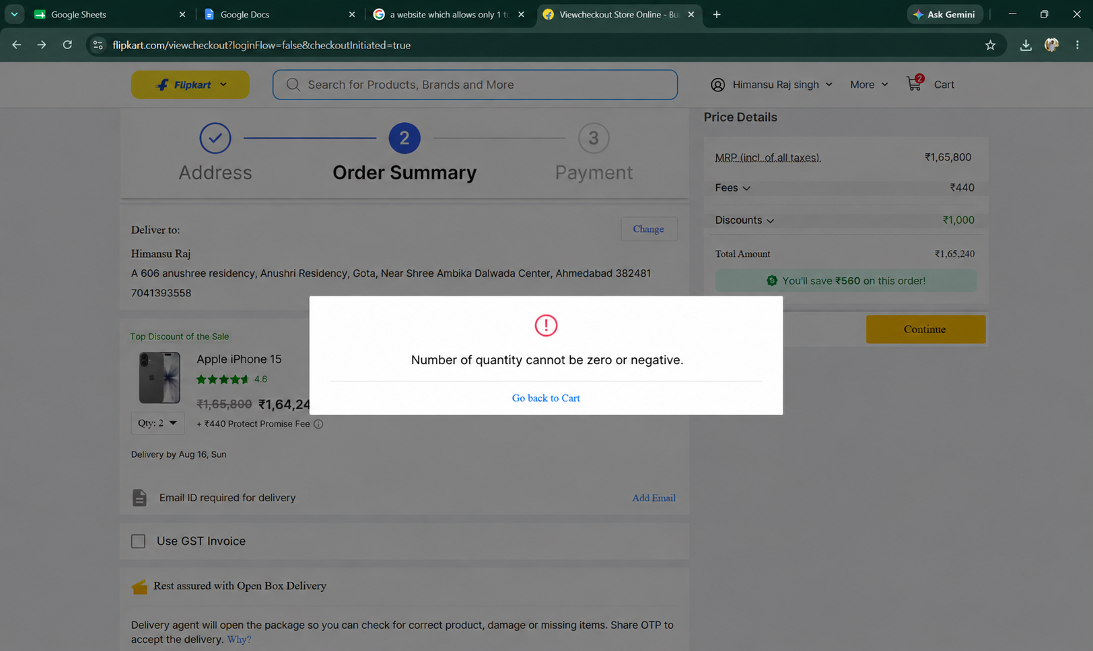

- Scenario ID: 1b
Scenario: Quantity within valid range - Valid Partition
Test Steps:
1. Open the E-Commerce Website
2. Navigate to a Product Page and select a product
3. Enter Quantity value in the Quantity field
4. Click "Add to Cart" button
Screenshots: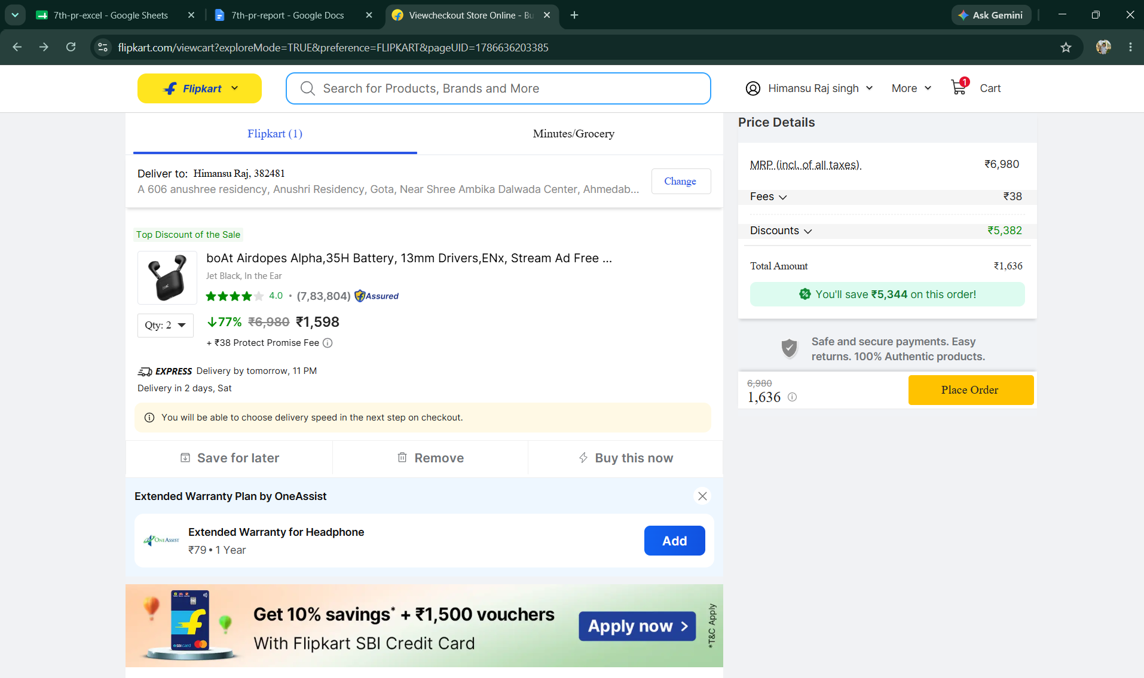

- Scenario ID: 1c
Scenario: Quantity above valid range - Invalid Partition
Test Steps:
1. Open the E-Commerce Website
2. Navigate to a Product Page and select a product
3. Enter Quantity value in the Quantity field
4. Click "Add to Cart" button
Screenshots: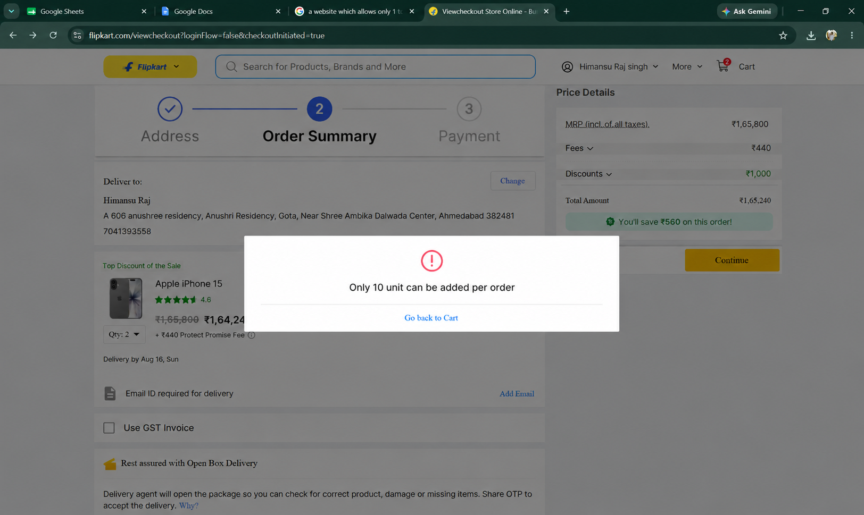

- Scenario ID: 1d
Scenario: Blank / empty Quantity field - Invalid Partition
Test Steps:
1. Open the E-Commerce Website
2. Navigate to a Product Page and select a product
3. Enter Quantity value in the Quantity field
4. Click "Add to Cart" button
Screenshots: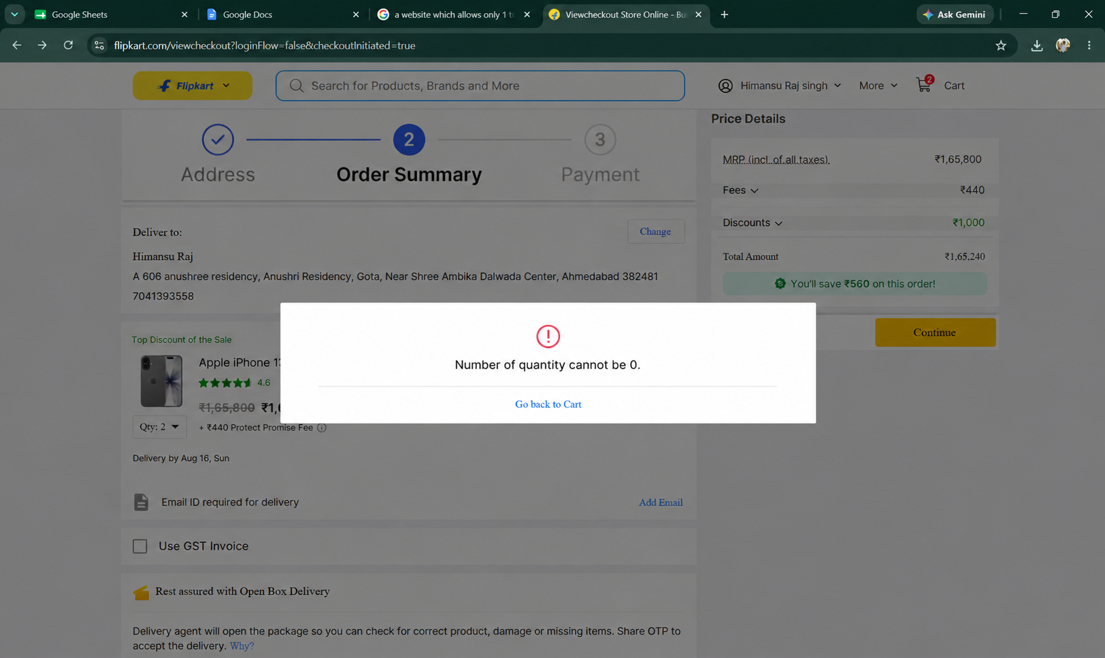

- Scenario ID: 1e
Scenario: Non-numeric Quantity input - Invalid Partition
Test Steps:
1. Open the E-Commerce Website
2. Navigate to a Product Page and select a product
3. Enter Quantity value in the Quantity field
4. Click "Add to Cart" button
Screenshots: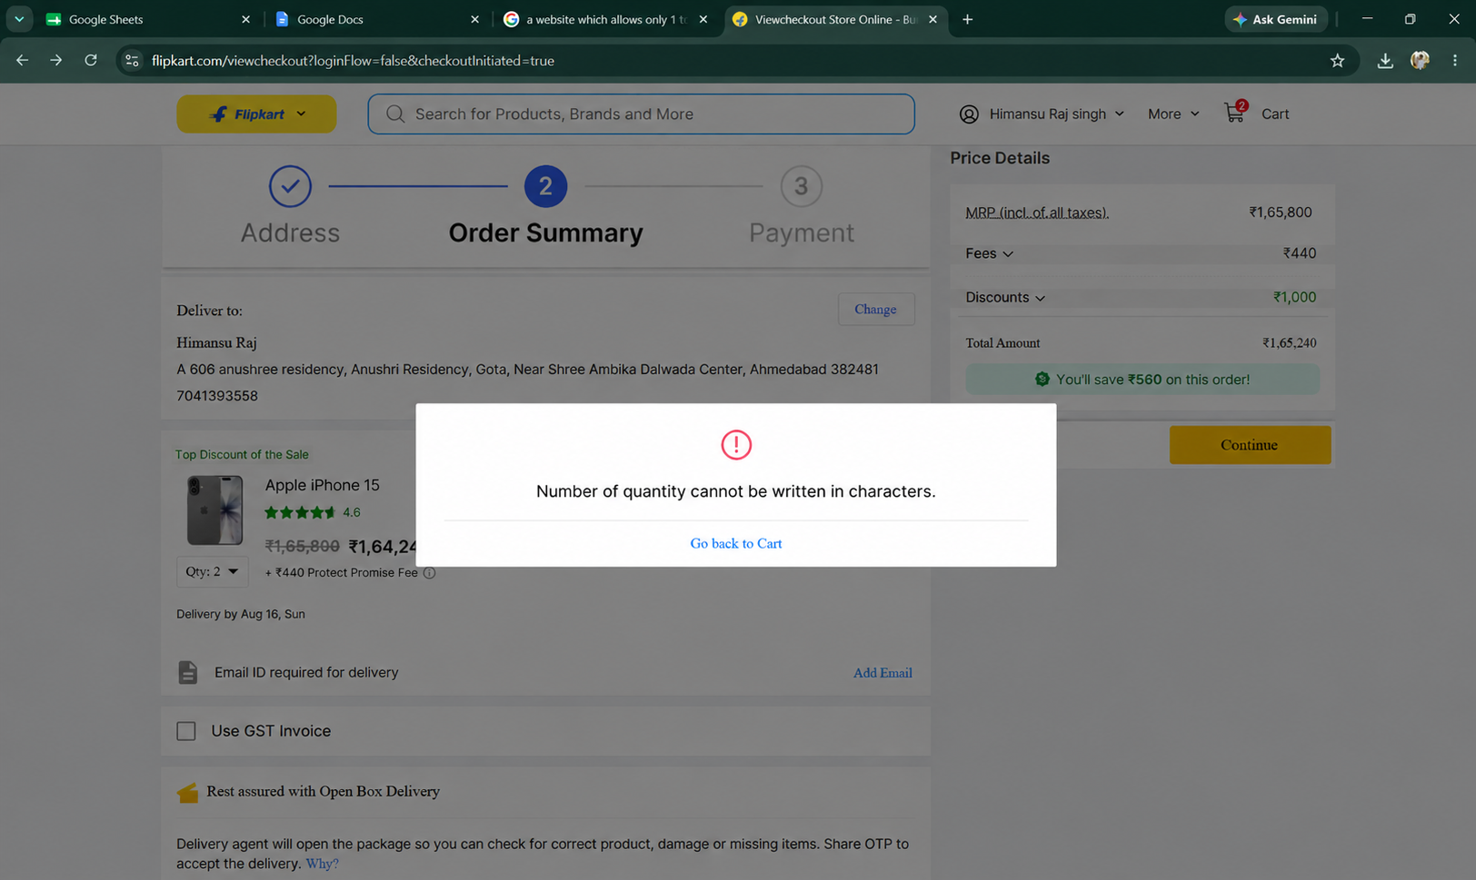

- Scenario ID: 1f
Scenario: Boundary Value Analysis: Minimum - 1, Below lower boundary
Test Steps:
1. Open the E-Commerce Website
2. Navigate to a Product Page and select a product
3. Enter Quantity value in the Quantity field
4. Click "Add to Cart" button
Screenshots:

- Scenario ID: 1g
Scenario: Boundary Value Analysis: Minimum boundary
Test Steps:
1. Open the E-Commerce Website
2. Navigate to a Product Page and select a product
3. Enter Quantity value in the Quantity field
4. Click "Add to Cart" button
Screenshots: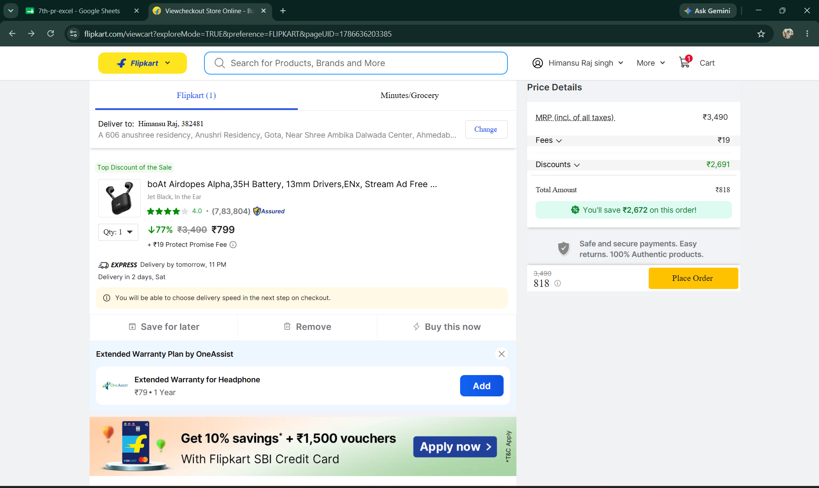

- Scenario ID:1h
Scenario: Boundary Value Analysis: Nominal value
Test Steps:
1. Open the E-Commerce Website
2. Navigate to a Product Page and select a product
3. Enter Quantity value in the Quantity field
4. Click "Add to Cart" button
Screenshots: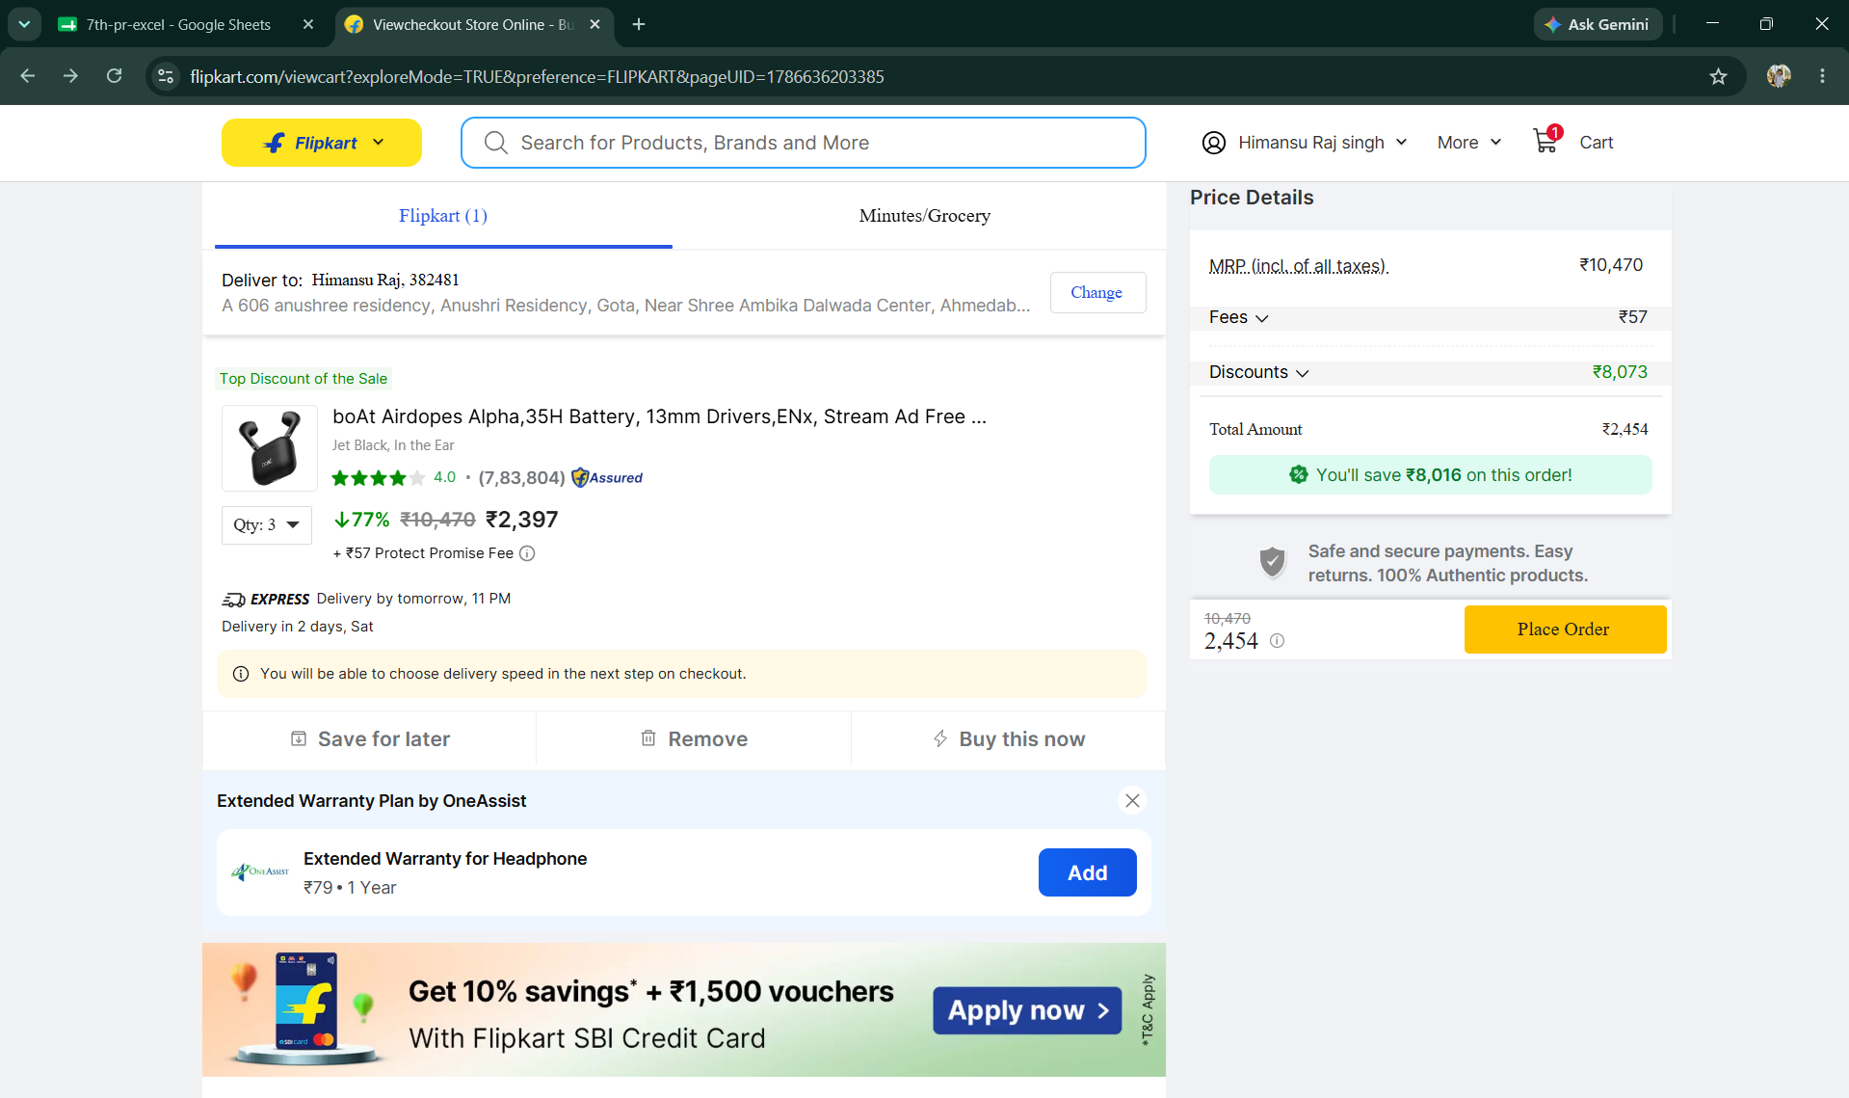

- Scenario ID: 1i
Scenario: Boundary Value Analysis: Maximum boundary
Test Steps:
1. Open the E-Commerce Website
2. Navigate to a Product Page and select a product
3. Enter Quantity value in the Quantity field
4. Click "Add to Cart" button
Screenshots: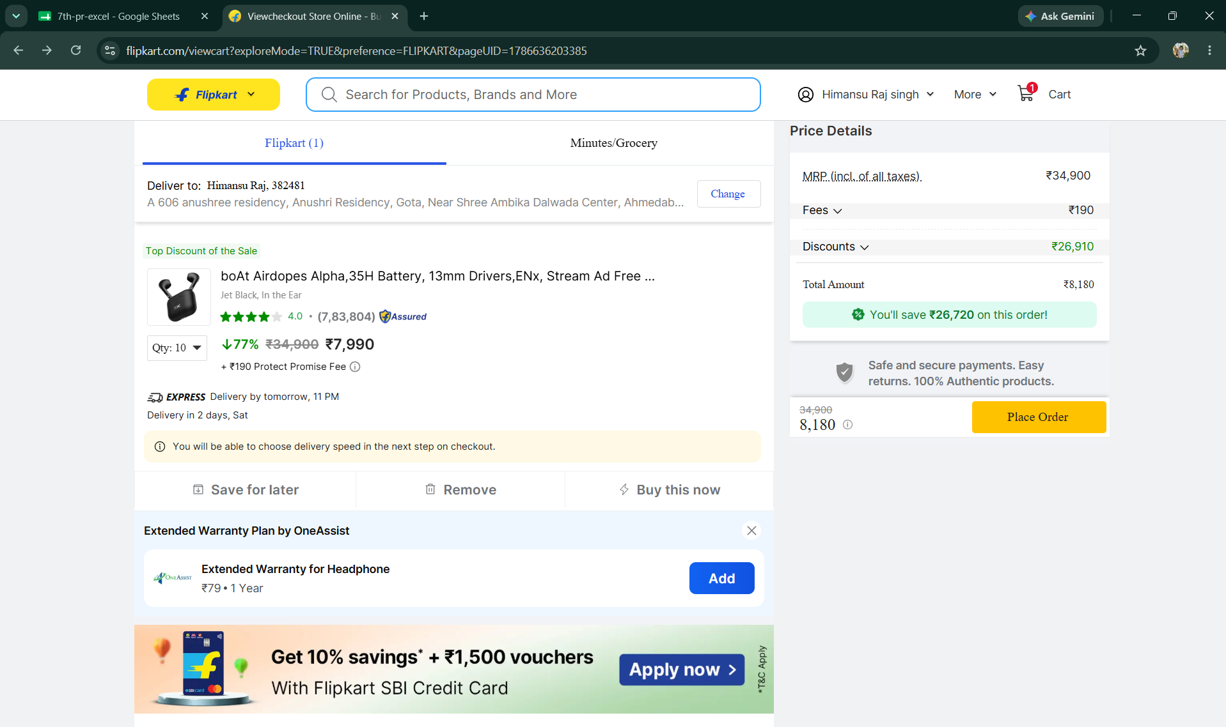

- Scenario ID: 1j
Scenario: Boundary Value Analysis: Maximum + 1, Above upper boundary - Defect Found
Test Steps:
1. Open the E-Commerce Website
2. Navigate to a Product Page and select a product
3. Enter Quantity value in the Quantity field
4. Click "Add to Cart" button
Screenshots:

Summary of Test Results
Total Test Cases | 10
Passed | 9
Failed | 1
Not Executed | 0
Pass Rate (%) | 90%

Conclusion and Recommendations
Conclusion
Nine of the ten test scenarios covering the Quantity field of the E-Commerce Add to Cart / Checkout module (Equivalence Partitioning and Boundary Value Analysis) passed, giving a 90% pass rate. The actual results matched the expected results for the invalid-below-range, valid-range, blank, and non-numeric partitions, and for the minimum, nominal, and maximum boundary values. One boundary test (Maximum + 1, Quantity = 11) failed: the field accepted a quantity above the allowed maximum of 10, indicating a validation defect (BUG-101) in the upper-boundary check.
Test Coverage Analysis
• Quantity below valid range (-5) rejected - PASSED
• Quantity within valid range (5) accepted - PASSED
• Quantity above valid range (15) rejected - PASSED
• Blank quantity field rejected - PASSED
• Non-numeric quantity input rejected - PASSED
• Minimum - 1 boundary (0) rejected - PASSED
• Minimum boundary (1) accepted - PASSED
• Nominal value (5) accepted - PASSED
• Maximum boundary (10) accepted - PASSED
• Maximum + 1 boundary (11) rejected - FAILED (Defect BUG-101)
Recommendations
• Fix the upper-boundary validation (BUG-101) so quantities greater than 10 are rejected with a clear message, then retest BVA05.
• Add automated regression tests covering the Quantity field's valid and invalid partitions and boundary values.
• Extend boundary testing to cover per-item stock limits, not just the fixed 1-10 rule.
• Verify server-side validation matches client-side validation for the Quantity field.
• Test Quantity validation behavior when stock available is lower than the requested valid quantity.
• Re-run the full Equivalence Partitioning and Boundary Value Analysis suite after the fix is deployed.

Bug Reports
Summary: One defect identified during execution of the 10 test scenarios - BUG-101: the Quantity field on the Add to Cart / Checkout module accepts values greater than 10 (Maximum + 1 boundary test, Quantity = 11), instead of rejecting the value with a validation message. Status: Open. All other 9 scenarios passed with expected results matching actual results.

