Bugzilla & TestLink – E-Commerce Test Case & Defect Management

Module Name: Flipkart Website - Quantity Field Validation (Add to Cart / Checkout Module)
Test Case ID: TC001-TC010
Tester Name: Chouhan Himansu Raj singh

Test Scenarios:

● Scenario ID: 1a
Scenario: Quantity below valid range (Invalid Partition)
Test Steps:
1. Open the Flipkart Website
2. Navigate to a Product Page and select a product
3. Enter Quantity value in the Quantity field
4. Click "Add to Cart" button
Screenshots: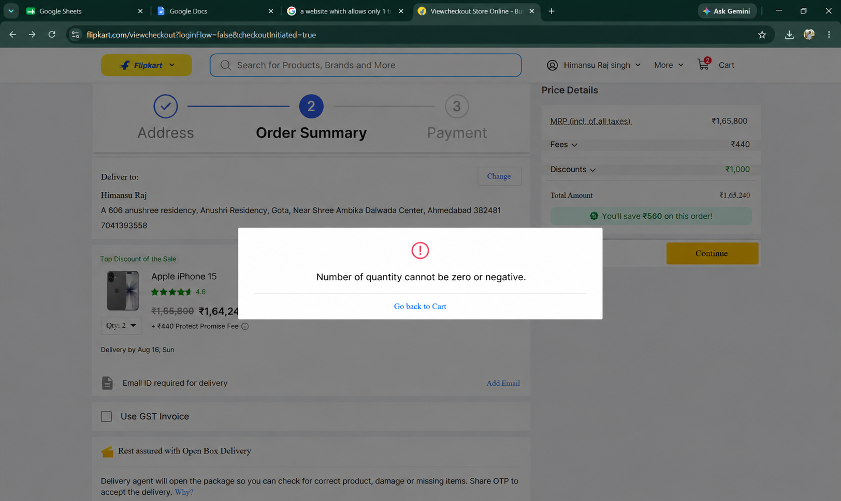
● Scenario ID: 1b
Scenario: Quantity within valid range (Valid Partition)
Test Steps:
1. Open the Flipkart Website
2. Navigate to a Product Page and select a product
3. Enter Quantity value in the Quantity field
4. Click "Add to Cart" button
Screenshots: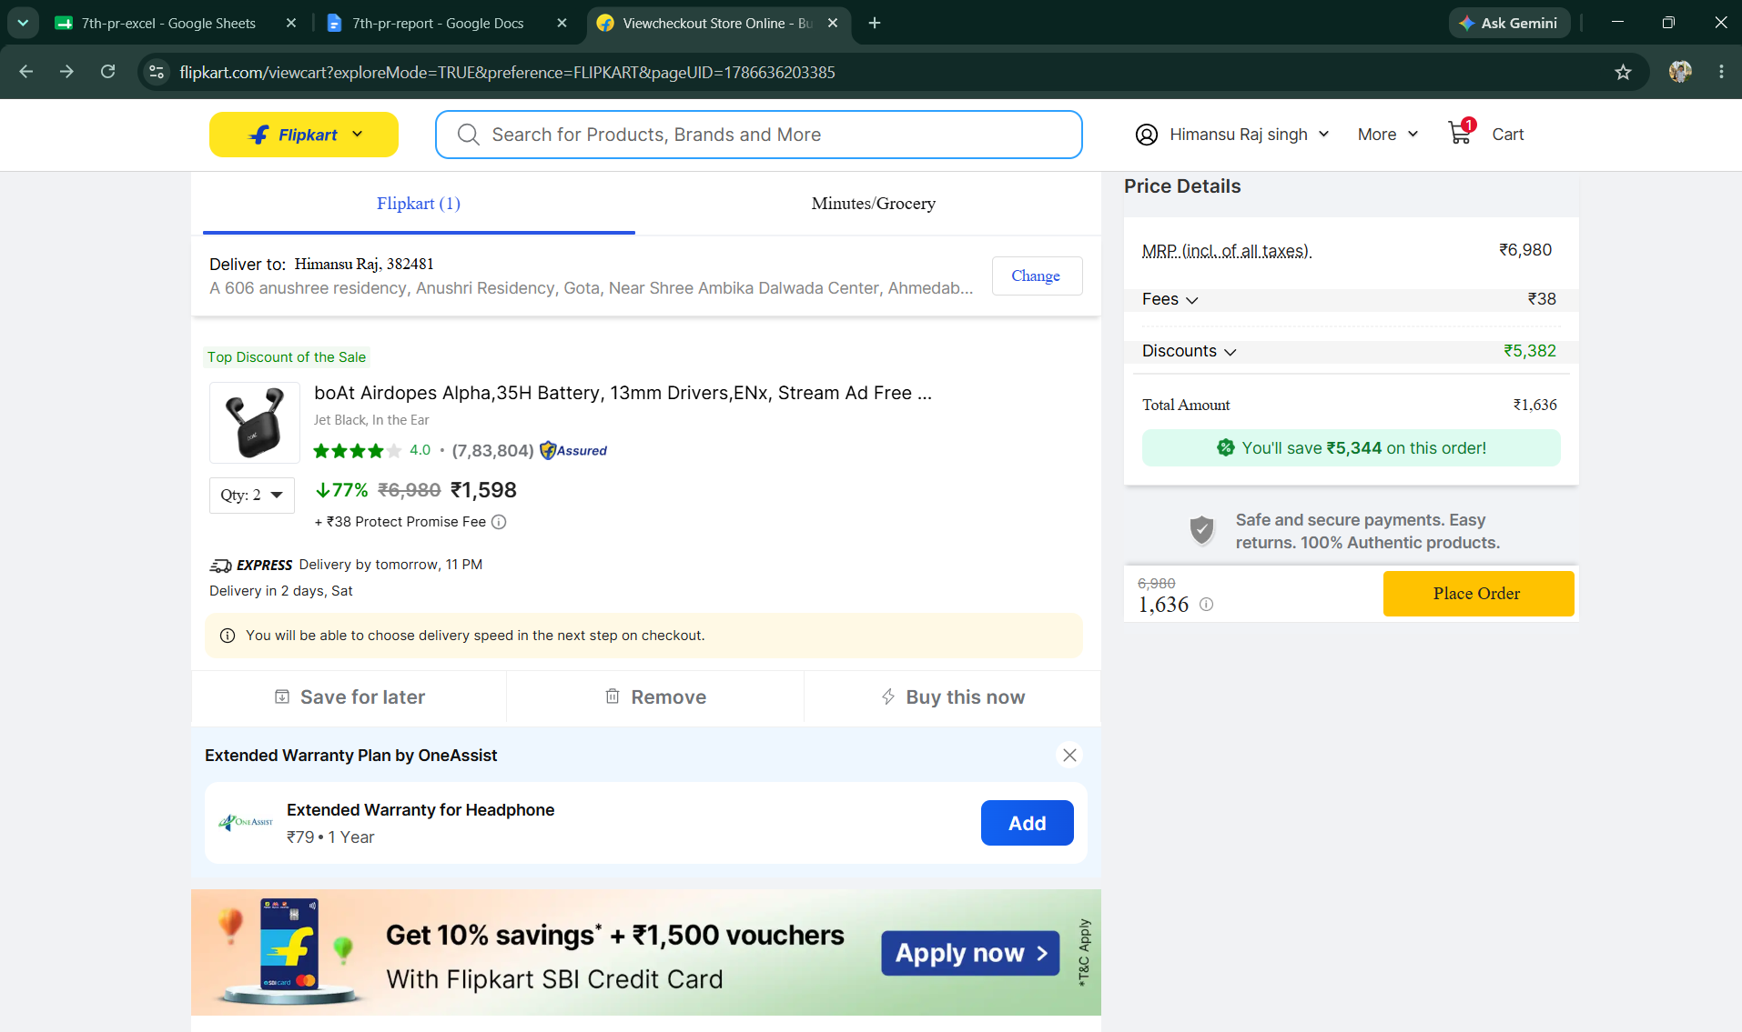

● Scenario ID: 1c
Scenario: Quantity above valid range (Invalid Partition)
Test Steps:
1. Open the Flipkart Website
2. Navigate to a Product Page and select a product
3. Enter Quantity value in the Quantity field
4. Click "Add to Cart" button
Screenshots: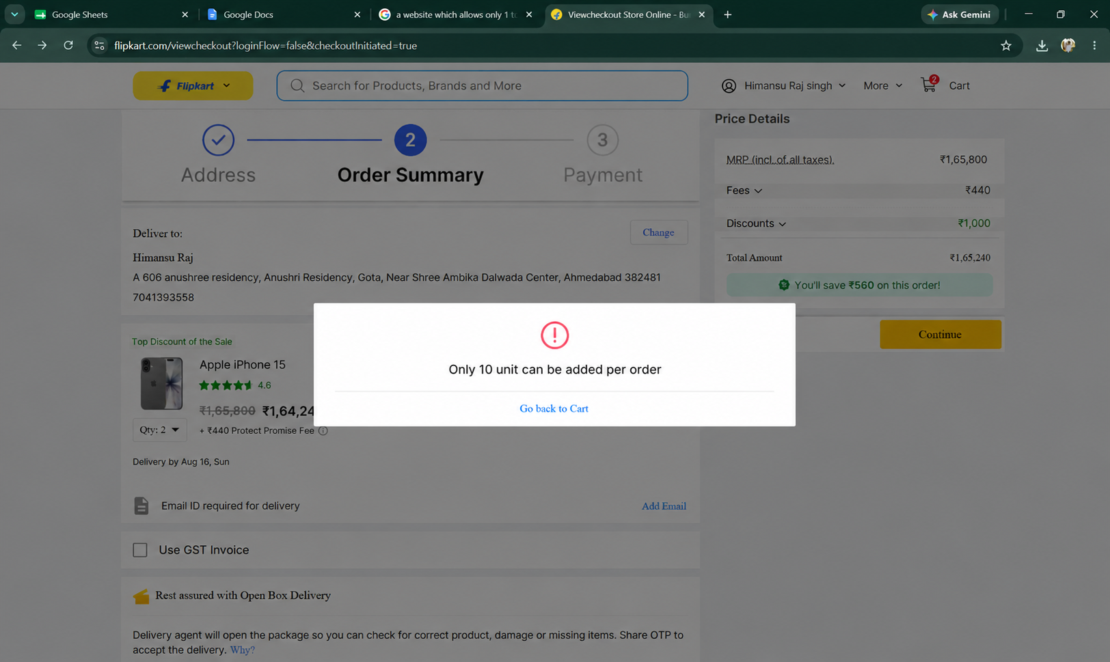

● Scenario ID: 1d
Scenario: Blank / empty Quantity field (Invalid Partition)
Test Steps:
1. Open the Flipkart Website
2. Navigate to a Product Page and select a product
3. Enter Quantity value in the Quantity field
4. Click "Add to Cart" button
Screenshots: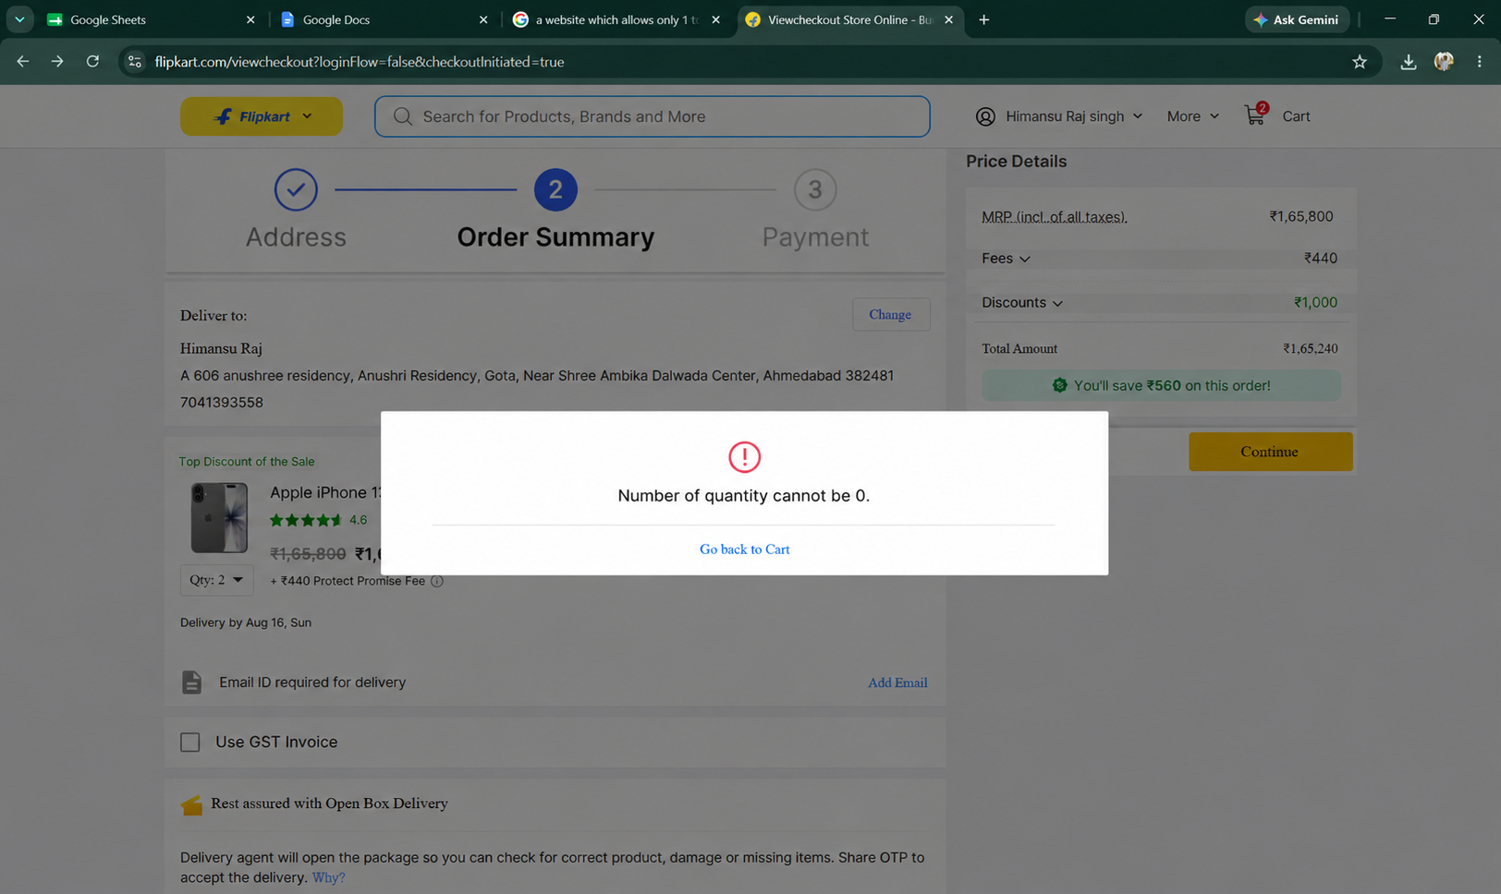

● Scenario ID: 1e
Scenario: Non-numeric Quantity input (Invalid Partition)
Test Steps:
1. Open the Flipkart Website
2. Navigate to a Product Page and select a product
3. Enter Quantity value in the Quantity field
4. Click "Add to Cart" button
Screenshots: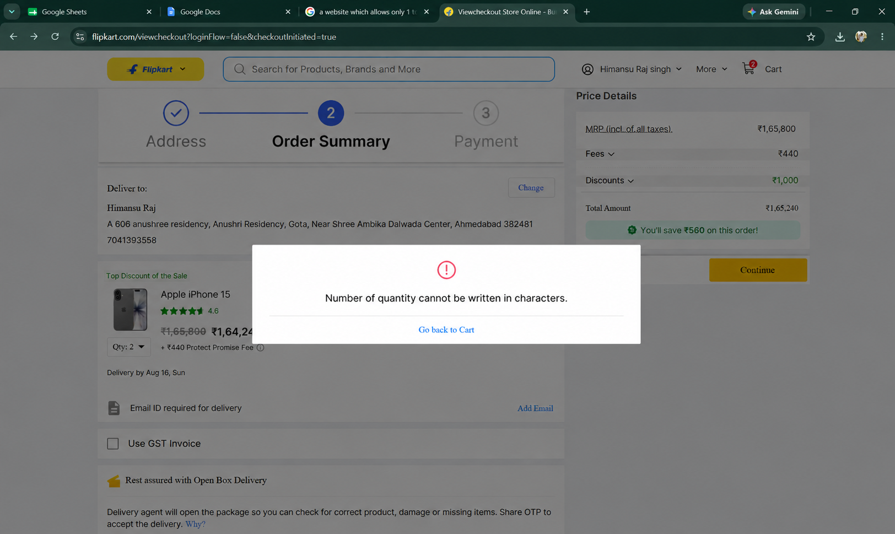

● Scenario ID: 1f
Scenario: Boundary Value Analysis: Minimum - 1 (Below lower boundary)
Test Steps:
1. Open the Flipkart Website
2. Navigate to a Product Page and select a product
3. Enter Quantity value in the Quantity field
4. Click "Add to Cart" button
Screenshots:

● Scenario ID: 1g
Scenario: Boundary Value Analysis: Minimum boundary
Test Steps:
1. Open the Flipkart Website
2. Navigate to a Product Page and select a product
3. Enter Quantity value in the Quantity field
4. Click "Add to Cart" button
Screenshots: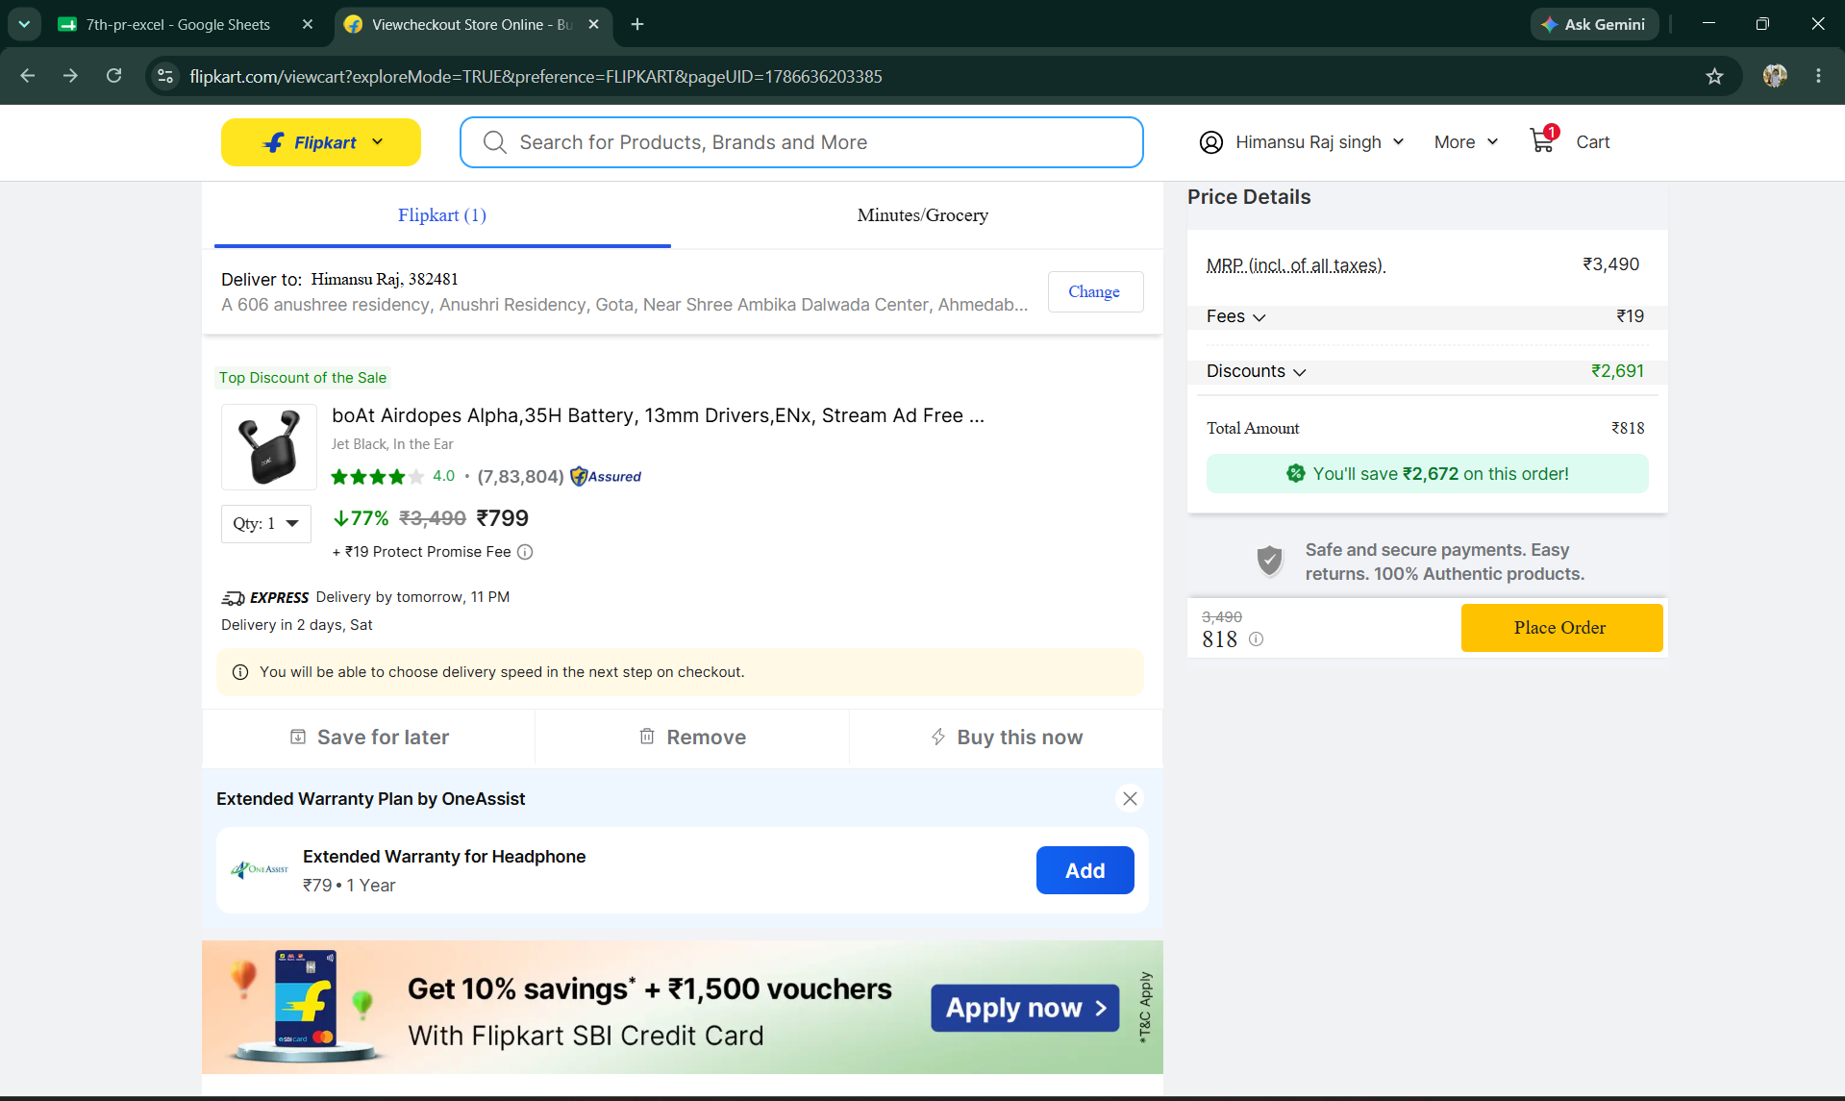

● Scenario ID: 1h
Scenario: Boundary Value Analysis: Nominal value
Test Steps:
1. Open the Flipkart Website
2. Navigate to a Product Page and select a product
3. Enter Quantity value in the Quantity field
4. Click "Add to Cart" button
Screenshots: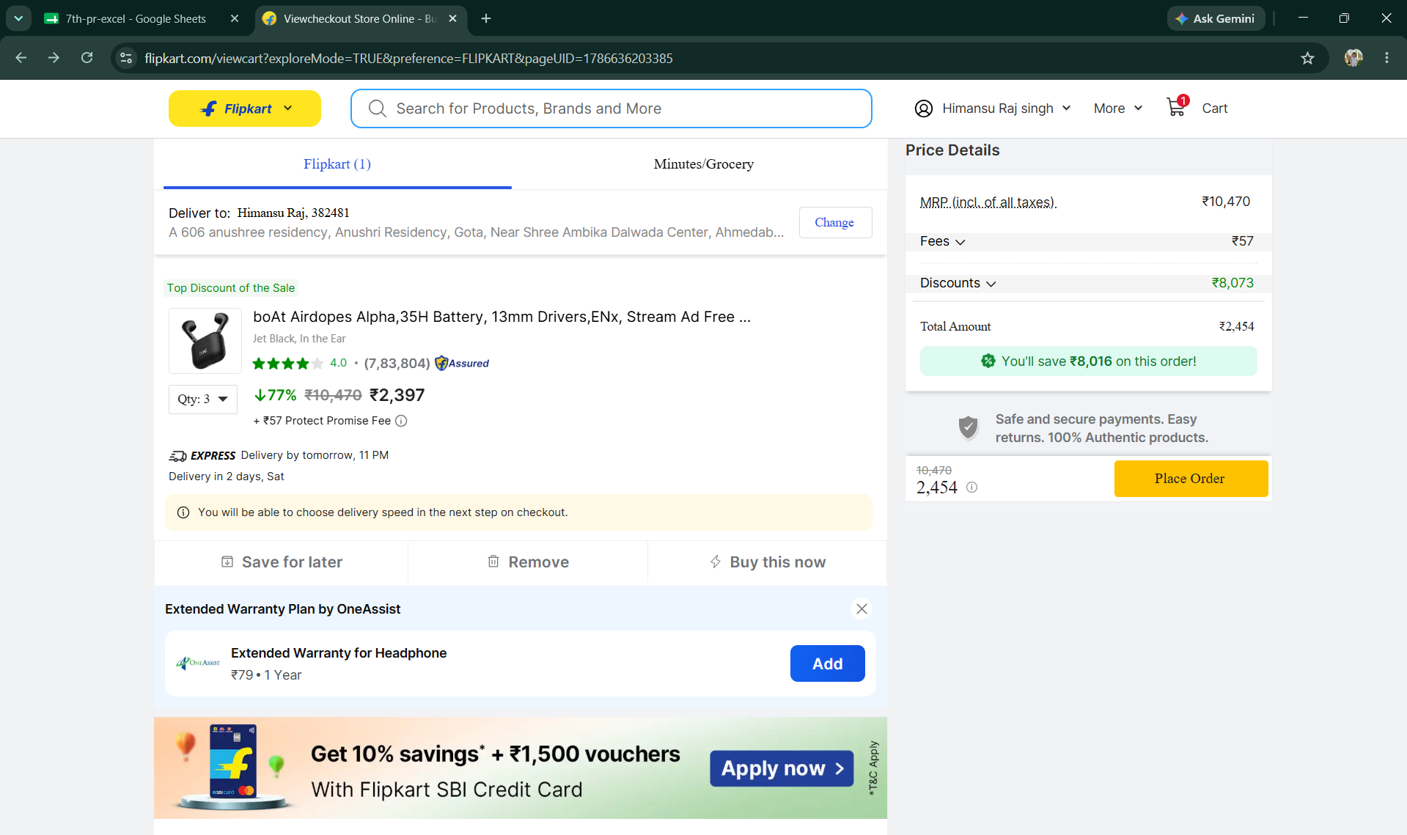

● Scenario ID: 1i
Scenario: Boundary Value Analysis: Maximum boundary
Test Steps:
1. Open the Flipkart Website
2. Navigate to a Product Page and select a product
3. Enter Quantity value in the Quantity field
4. Click "Add to Cart" button
Screenshots: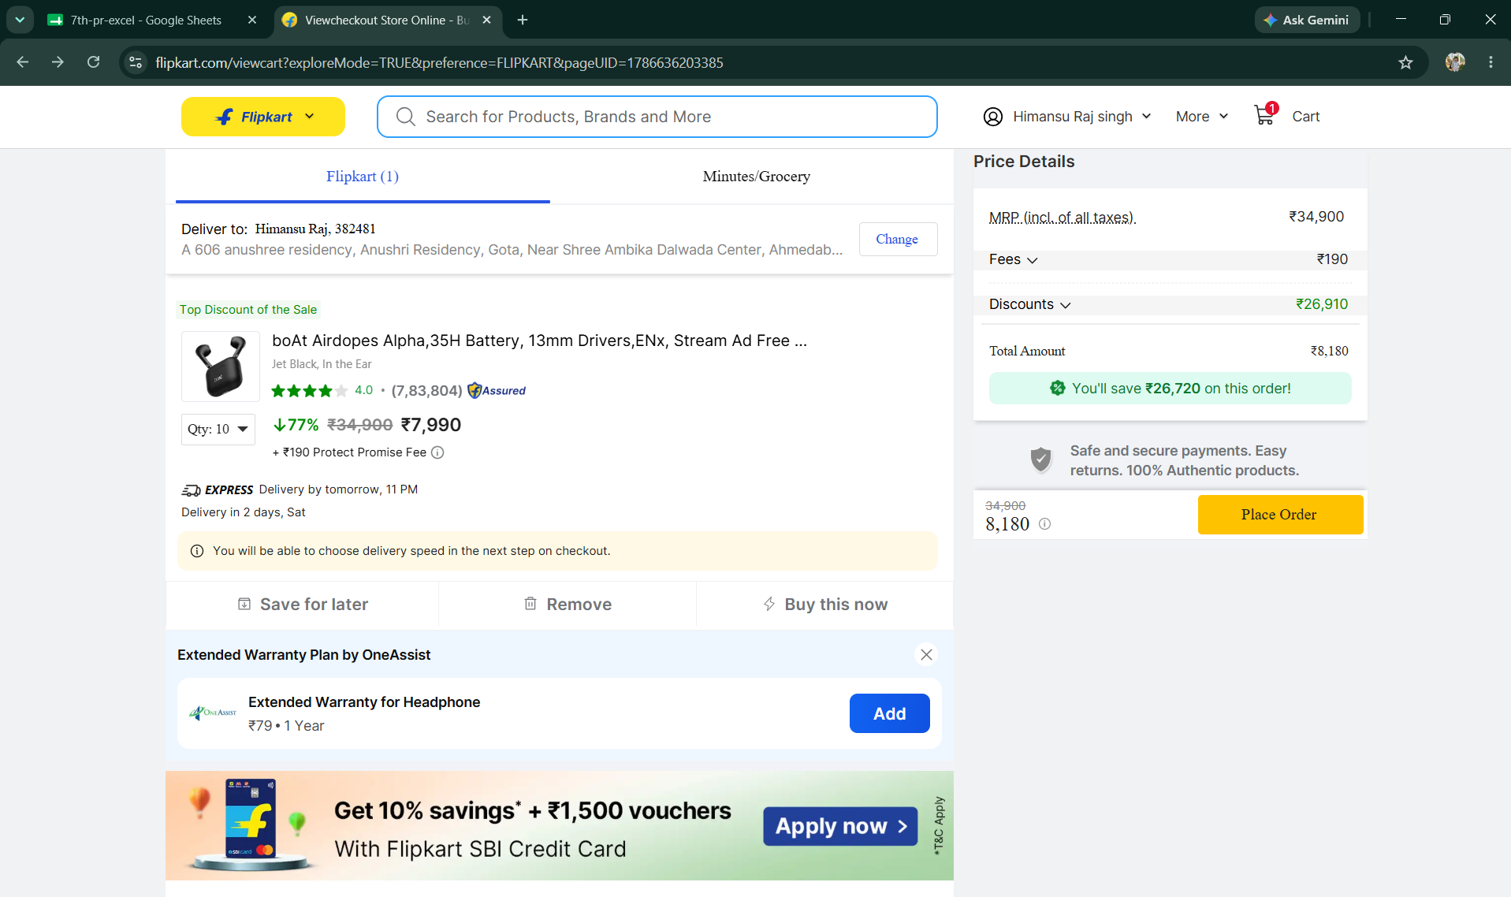

● Scenario ID: 1j
Scenario: Boundary Value Analysis: Maximum + 1 (Above upper boundary) - Defect Found
Test Steps:
1. Open the Flipkart Website
2. Navigate to a Product Page and select a product
3. Enter Quantity value in the Quantity field
4. Click "Add to Cart" button
Screenshots:

Defect ID: BUG-101
Defect: Quantity above the maximum allowed value of 10 is accepted.
Failed input: Quantity = 11
Expected: Quantity greater than 10 should be rejected.
Actual: Quantity 11 was accepted and the item was added with quantity 11.
Status: Open

Summary of Test Results
Total Test Cases | 10
Passed | 9
Failed | 1
Not Executed | 0
Pass Rate (%) | 90%

Conclusion and Recommendations
Conclusion
Nine of the ten test scenarios covering the Quantity field of the Flipkart Add to Cart / Checkout module (Equivalence Partitioning and Boundary Value Analysis) passed, giving a 90% pass rate. One Maximum + 1 boundary test failed for Quantity = 11, where the field accepted a quantity above the allowed maximum of 10. This failure indicates a validation defect, BUG-101, in the upper-boundary check.

Test Coverage Analysis
• Quantity below valid range (-1) rejected - PASSED
• Quantity within valid range (2) accepted - PASSED
• Quantity above valid range (15) rejected - PASSED
• Blank quantity field rejected - PASSED
• Non-numeric quantity input rejected - PASSED
• Minimum - 1 boundary (0) rejected - PASSED
• Minimum boundary (1) accepted - PASSED
• Nominal value (5) accepted - PASSED
• Maximum boundary (10) accepted - PASSED
• Maximum + 1 boundary (11) rejected - FAILED (Defect BUG-101)

Recommendations
• Fix the upper-boundary validation (BUG-101) so quantities greater than 10 are rejected with a clear message, then retest TC010.
• Add automated regression tests covering the Quantity field's valid and invalid partitions and boundary values.
• Ensure server-side validation matches client-side validation for the Quantity field.
• Extend boundary testing to cover per-item stock limits, not just the fixed 1-10 rule.
• Test Quantity validation behavior when stock available is lower than the requested valid quantity.
• Re-run the complete Equivalence Partitioning and Boundary Value Analysis suite after the fix is deployed.

Bug Reports
Summary: One defect identified during execution of the 10 test scenarios.
BUG-101: The Quantity field accepts a value greater than 10 when Quantity = 11 instead of rejecting it.
Status: Open

