DEMO WEB SHOP

Module Name: Product Search, Categories, Product Details & Cart
Test Case ID: TC001-TC010
Tester Name: Chouhan Himansu Raj singh

Test Scenarios :
TC001 – Search for an available product
Scenario ID: TC001
Scenario: Search for an available product
Test Steps:
> Step 1: Open the Demo Web Shop home page
> Step 2: Enter “computer” in the search box
> Step 3: Click Search

Screenshot:
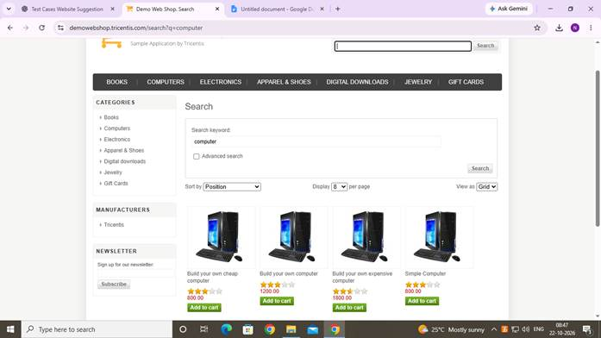

TC002 – Search for an unavailable product
Scenario ID: TC002
Scenario: Search for an unavailable product
Test Steps:
> Step 1: Open the home page
> Step 2: Enter a product name that is not available
> Step 3: Click Search

Screenshot:
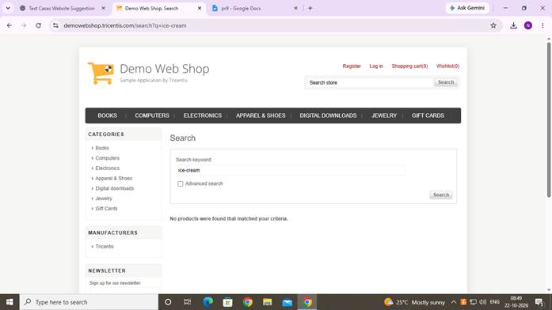

TC003 – Browse a product category
Scenario ID: TC003
Scenario: Browse a product category
Test Steps:
> Step 1: Open the home page
> Step 2: Select the Books category

Screenshot:
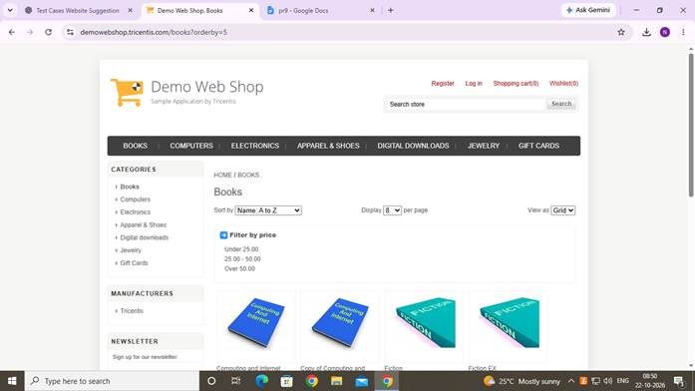

TC004 – Open product details
Scenario ID: TC004
Scenario: Open product details
Test Steps:
> Step 1: Search for a product or open a category
> Step 2: Select a product title

Screenshot:
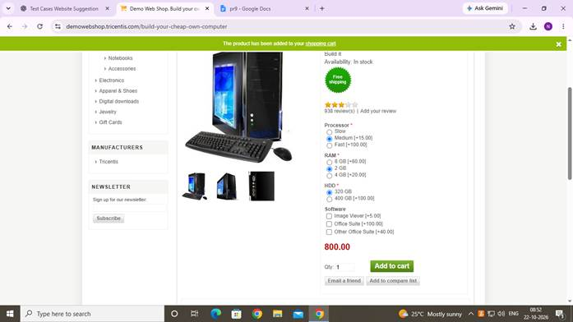

TC005 – Verify product price
Scenario ID: TC005
Scenario: Verify product price
Test Steps:
> Step 1: Open a product details page
> Step 2: Check the displayed price

Screenshot:
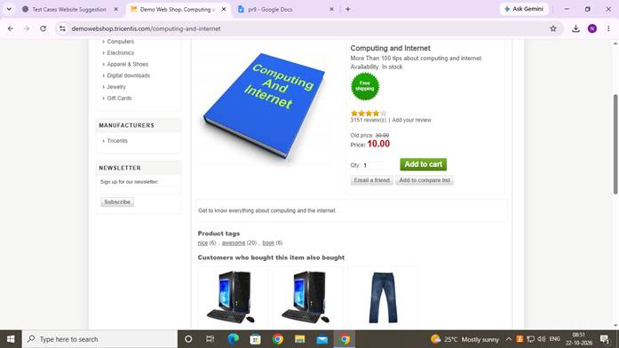

TC006 – Verify quantity field
Scenario ID: TC006
Scenario: Verify quantity field
Test Steps:
> Step 1: Open a product details page
> Step 2: Locate the quantity field

Screenshot:
Figure: Demo Web Shop evidence for TC006

TC007 – Add product to cart
Scenario ID: TC007
Scenario: Add product to cart
Test Steps:
> Step 1: Open a product details page
> Step 2: Click Add to cart

Screenshot:
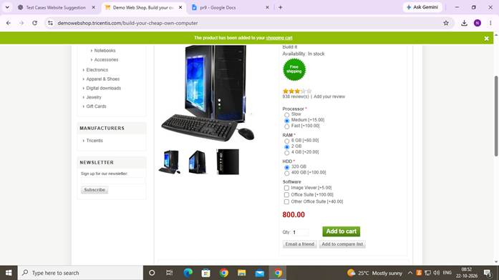

TC008 – View shopping cart
Scenario ID: TC008
Scenario: View shopping cart
Test Steps:
> Step 1: Open the shopping cart page
> Step 2: Check the listed product

Screenshot:
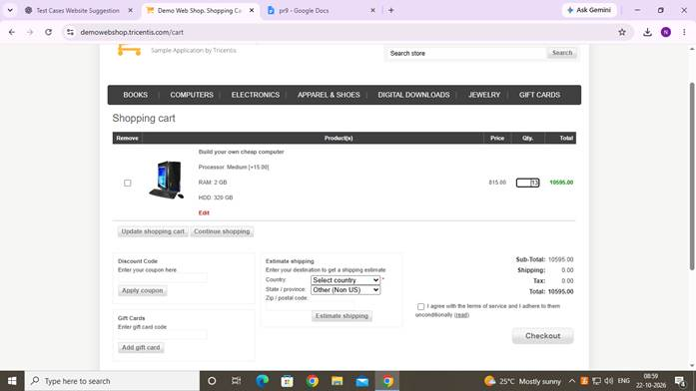

TC009 – Update cart quantity
Scenario ID: TC009
Scenario: Update cart quantity
Test Steps:
> Step 1: Open the shopping cart
> Step 2: Change the quantity and update the cart

Screenshot:

TC010 – Remove product from cart
Scenario ID: TC010
Scenario: Remove product from cart
Test Steps:
> Step 1: Open the shopping cart
> Step 2: Select Remove for a product
> Step 3: Update the cart if prompted

Screenshot:
