

Foundations of Programming

Lab Assignment No. : 02
Name: Sanidhya Choukse
Div:2
Batch2
Prn no:1262251582

PROBLEM STATEMENT:
Write a menu driven program in C to implement the basic arithmetic operations such as Addition, Subtraction, Multiplication, and Division.

OBJECTIVES:
• To understand the concept of menu driven programming in C.
• To apply conditional statements and switch–case control structures.
• To perform basic arithmetic operations using user-defined input.
• To enhance logical thinking and problem-solving skills.

THEORY:
if–else ladder statements syntax and sample program
switch–case or if–else ladder statement syntax and sample progrM
Basic arithmetic operations include Addition, Subtraction, Multiplication, and Division. Division by zero should be avoided.

ALGORITHM:
Step 1: Start
Step 2: Declare variables
num1, num2, choice, result as integers.
Step 3: Display menu to the user:
1 → Addition
2 → Subtraction
3 → Multiplication
4 → Division
Step 4: Read user’s choice.
Step 5: Ask the user to enter two numbers.
Read num1 and num2.
Step 6: Use a switch case (or if-else) to perform operation:
- If choice = 1
result = num1 + num2
- If choice = 2
result = num1 − num2
- If choice = 3
result = num1 × num2
- If choice = 4
result = num1 / num2
Step 7: Display the result.
Step 8: If user wants another operation, go back to Step 3.
Step 9: Stop / End.

Type Program
#include <stdio.h>

int main()
{
int num1, num2, choice;
float result;

// Menu
printf("1. Addition\n");
printf("2. Subtraction\n");
printf("3. Multiplication\n");
printf("4. Division\n");

// Choice input
printf("Enter your choice: ");
scanf("%d", &choice);

// Number input
printf("Enter two numbers: ");
scanf("%d %d", &num1, &num2);

// Switch case
switch(choice)
{
case 1:
result = num1 + num2;
printf("Result = %.2f", result);
break;

case 2:
result = num1 - num2;
printf("Result = %.2f", result);
break;

case 3:
result = num1 * num2;
printf("Result = %.2f", result);
break;

case 4:
result = (float)num1 / num2;
printf("Result = %.2f", result);
break;

default:
printf("Invalid choice");
}

return 0;
}

PLATFORM:
Linux

INPUT:
Choice of operation and two numbers

OUTPUT:
Displays the result of the selected arithmetic operation

SAMPLE INPUT:
num1= 10,num2=5

SAMPLE OUTPUT:
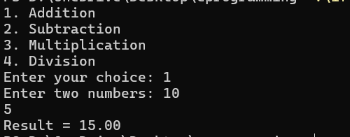
Addition = 15

CONCLUSION:
Thus, the menu driven program in C successfully performs basic arithmetic operations using switch–case statements.

