;l

Foundations of Programming

Assignment No. : 4
Name: Purab Rupesh Agarwal
Div: 2
Batch:2
Prn no:1262252503

- PROBLEM STATEMENT: Write a C Program to calculate the salary of an employee given his basic pay (taken as input from the user). Calculate gross salary of employee. Let HRA be 10 % of basic pay and TA be 5% of basic pay. Let employees pay professional tax as 2% of total salary. Calculate net salary payable after deductions.

OBJECTIVE:

- To understand the importance of flowchart for any programming model.
- To learn simple flowchart symbols and arrows to define relationships.
- To understand and develop visual representations of flow of data.

THEORY:
- Define Algorithm.
An algorithm is a finite set of step-by-step instructions used to solve a problem or perform a task.
Step 1: Start
Step 2: Read the basic pay of the employee
Step 3: Calculate HRA as 10% of basic pay
Step 4: Calculate TA as 5% of basic pay
Step 5: Calculate gross salary by adding basic pay, HRA, and TA
Step 6: Calculate professional tax as 2% of the gross salary
Step 7: Calculate net salary by subtracting professional tax from gross salary
Step 8: Display gross salary and net salary
Step 9: Stop

- What are the different characteristics of an algorithm.
• Input – Takes zero or more inputs
• Output – Produces at least one output
• Definiteness – Steps are clear and unambiguous
• Finiteness – Ends after a finite number of steps
• Effectiveness – Steps are simple and executable
• Generality – Works for all valid inputs

PLATFORM: Linux

INPUT:
#include <stdio.h>

void main() {

float basic_salary, hra, ta, gross_salary, tax, net_salary;

printf("enter basic_salary =");
scanf("%f", &basic_salary);

hra = basic_salary * 0.10; // 10% HRA
ta = basic_salary * 0.05; // 5% TA

gross_salary = basic_salary + hra + ta;

tax = gross_salary * 0.02; // 2% professional tax

net_salary = gross_salary - tax;

printf("net salary =%.0f", net_salary);
}
OUTPUT:
enter basic_salary =10000
net salary =11270
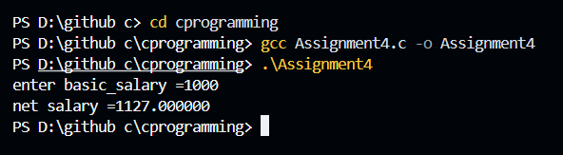
CONCLUSION: Thus, we have learned to write algorithms and to draw its representation in terms of flowchart.

