Github
Link: https://github.com/choumeow/Calculator
mysql: calculator2.sql inside the folder

Demo

1 Register & Login
When open the server, user will be automatically navigated to Login page. User can click on the “Don’t have an account? Register here” to navigate to Registration page.
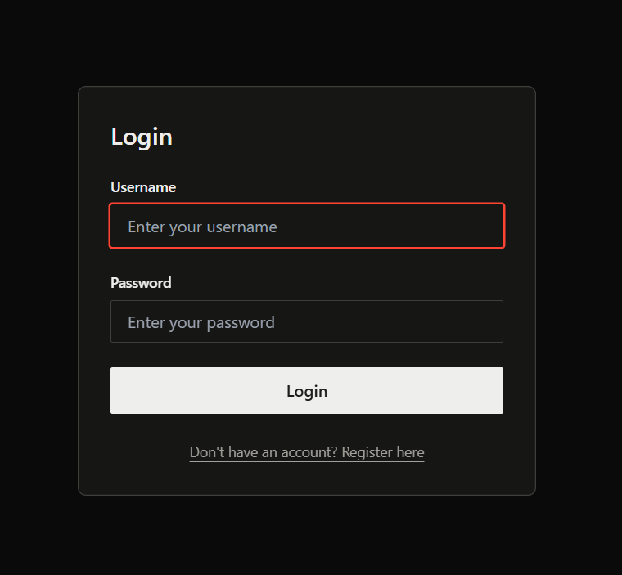
This is the Registration page that will only require for:
- username (unique)
- password (minimum 8 characters)
- confirm password (must match with the password)
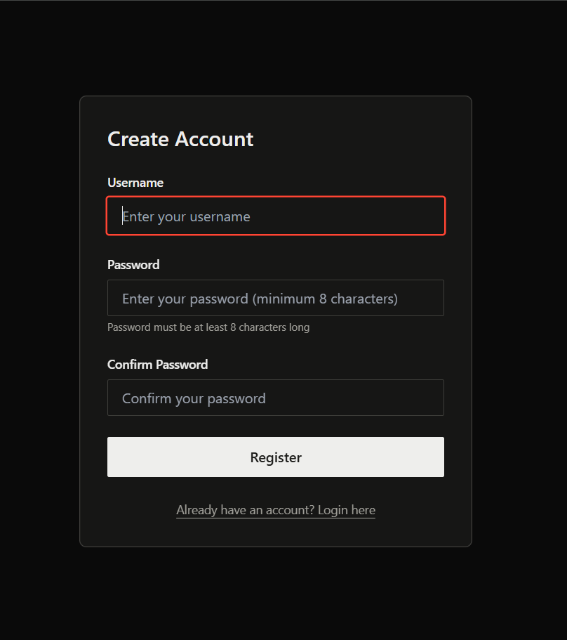

Error Message when:
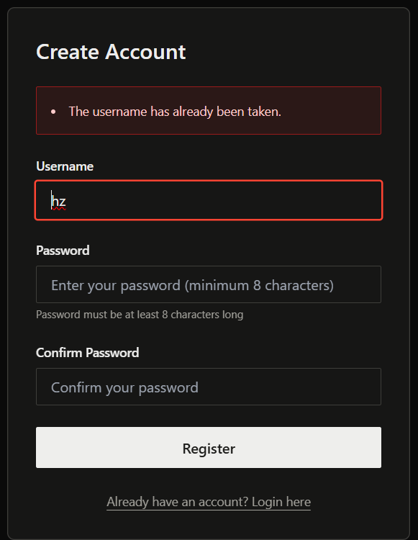 | 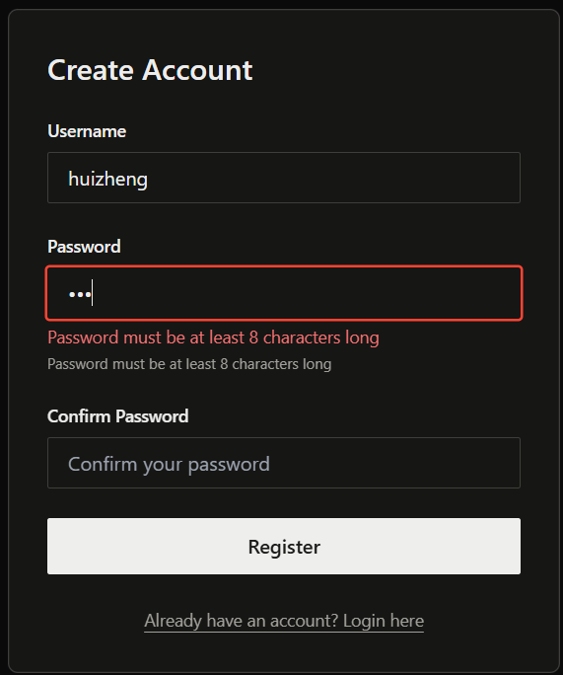 | 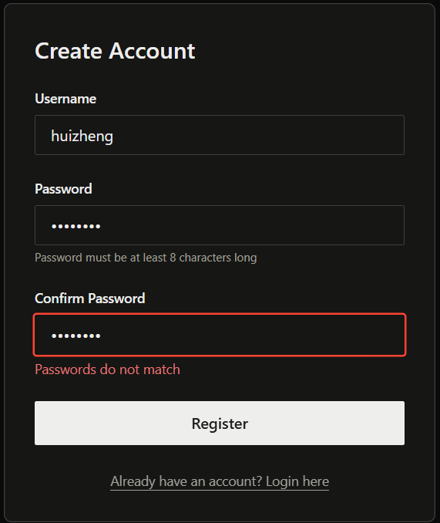
Username entered is already be used | Password does not match 8 characters | Confirm Password does not match with password

If user key in the data match the condition, then a successful will be displayed and the user will be navigated to Login page.
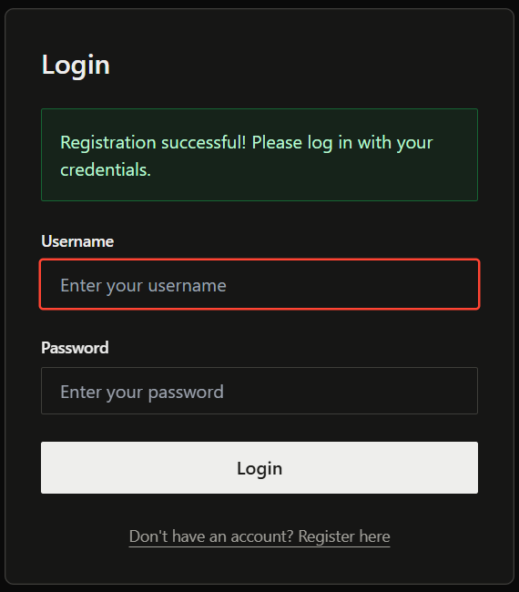
If user key in incorrect username or password, an error message will be displayed.
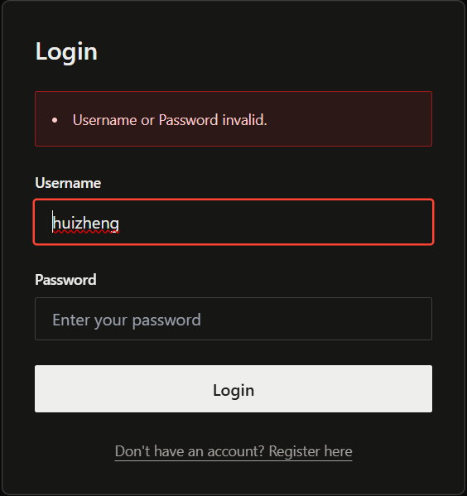

2 Calculator
Once user login successfully, a success message will be displayed, and in the top right corner will appear “Welcome, <username>!” message.
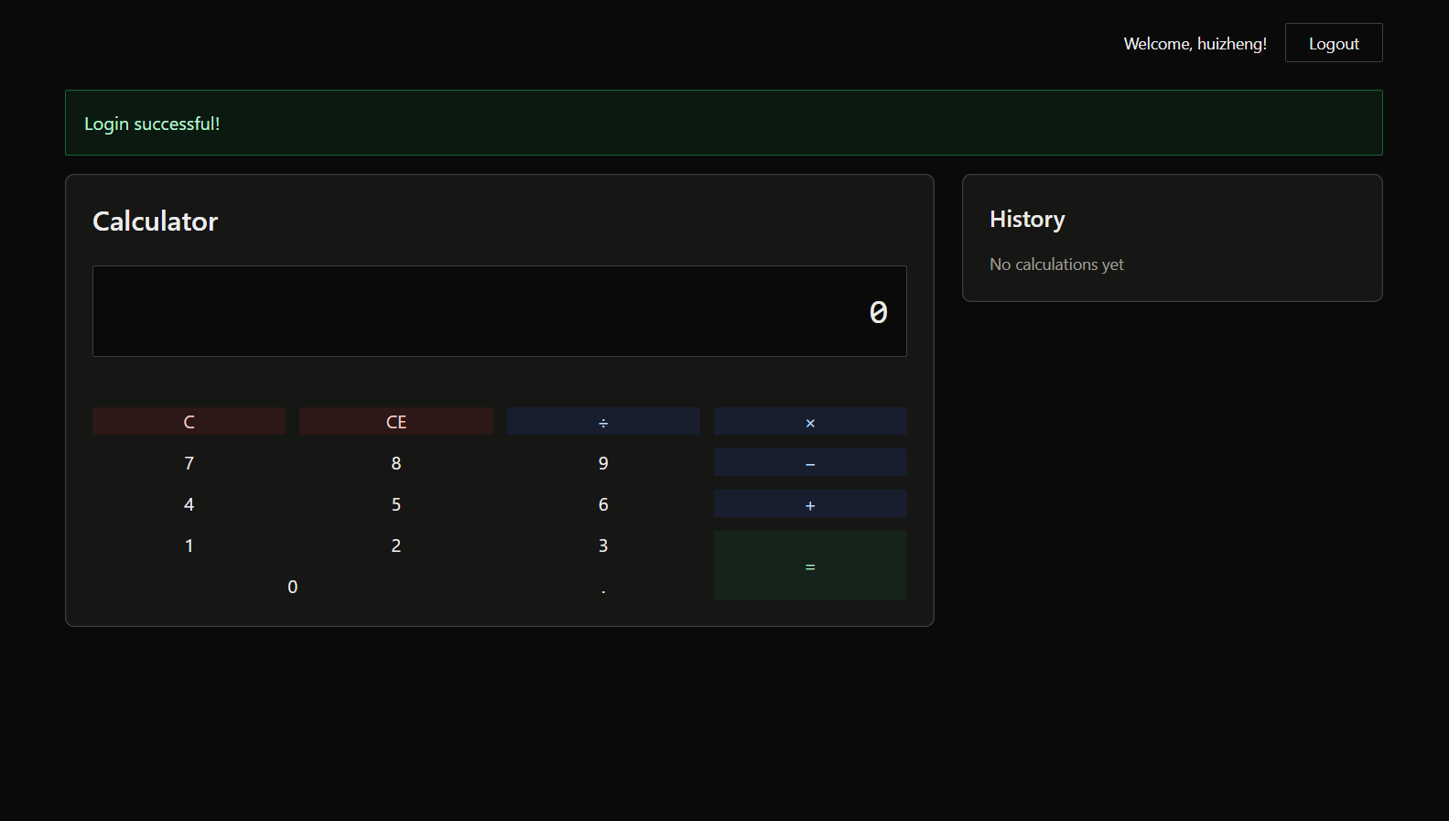
User can key in the expression by clicking the button on screen or using keyboard.
The expression entered will be displayed below the value current key in.
(Not yet press “=”)
The expression which already click “=” will be displayed in the history column.
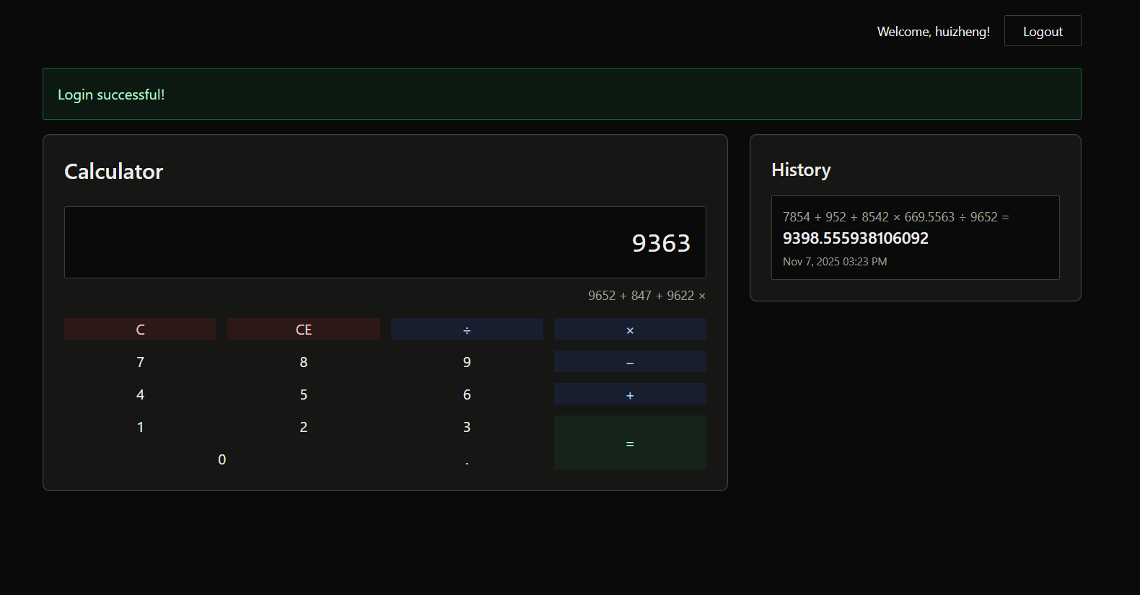

User can click on any record in the history column to continue the calculation.
“C” button: to backspace one character of the current input.
“CE” button: to clear the current input.
Some examples here:
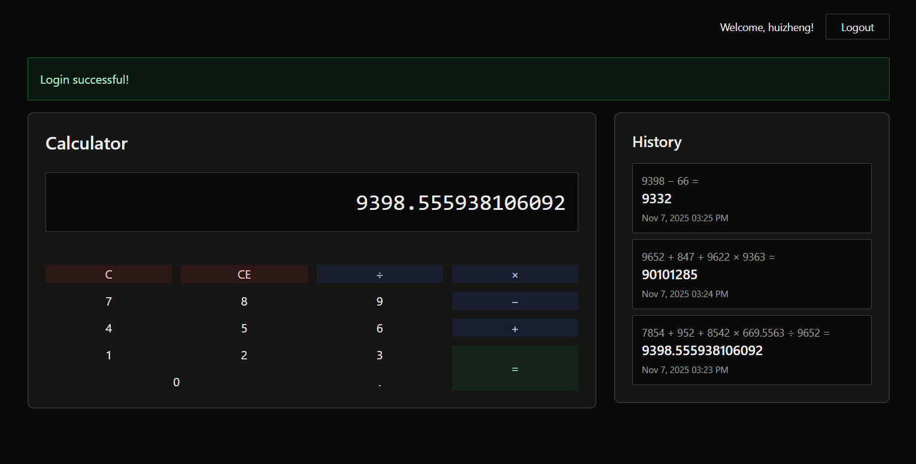 | 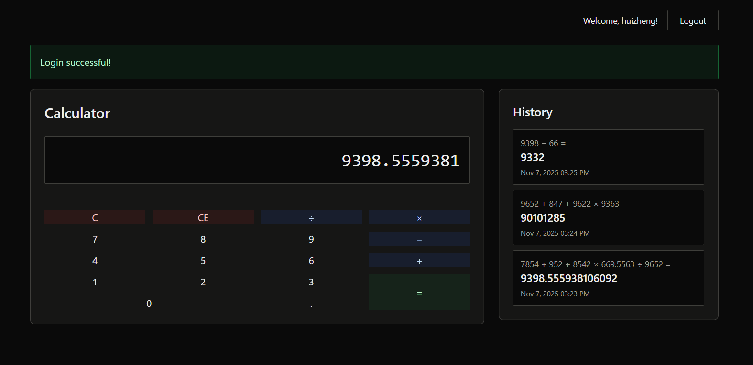
Users click on the previous record in the history column. It will display the result of the calculation as current input. | Users click “C” button to backspace the current input.
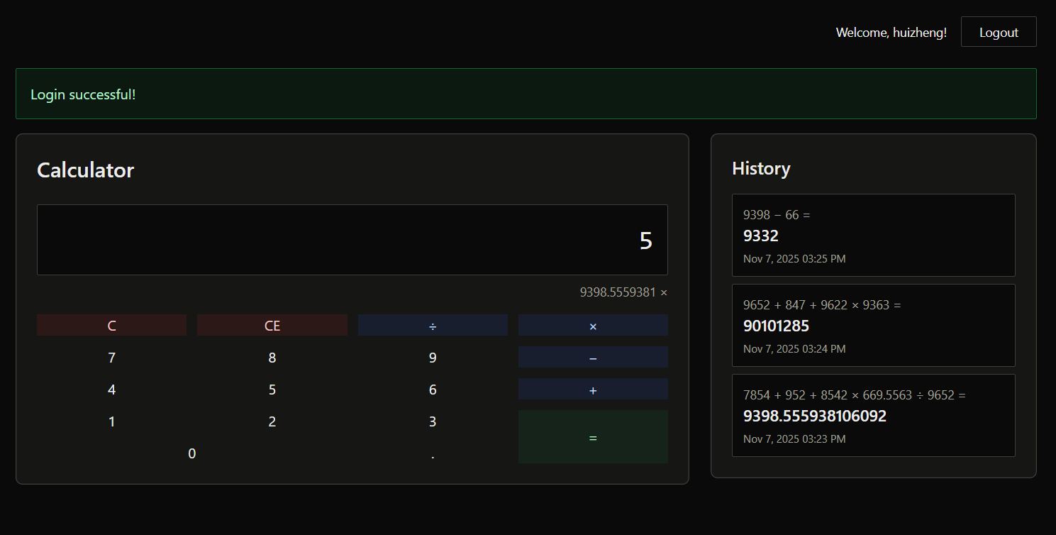 | 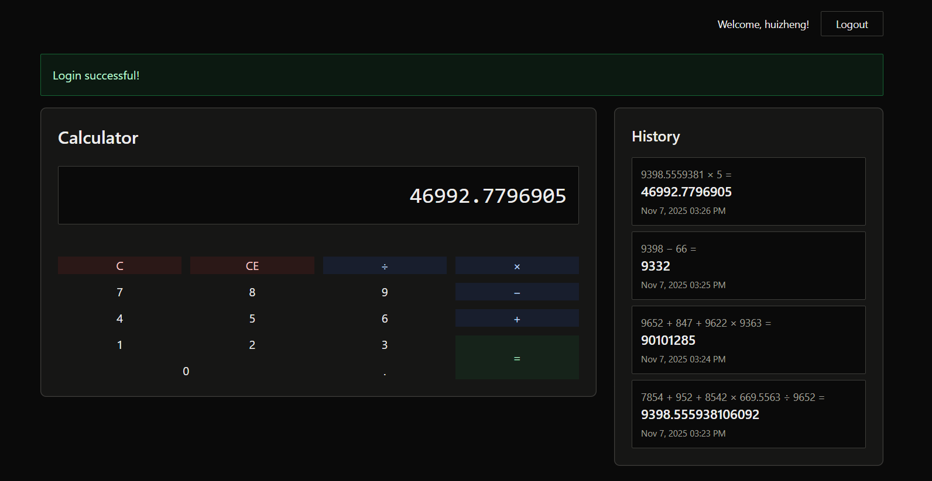
Users continue the calculation (multiple by 5) | After user click on the “=” button, it will create a new record in history.

3 History Column
History Column is set to order by descending, where is the latest on top and the oldest in bottom. Besides, to avoid the website page will be increasingly longer due to the increasing of history record, the history column is set in 5 records per page, if more than 5, history column allow user to scroll down to view for the older calculation history.
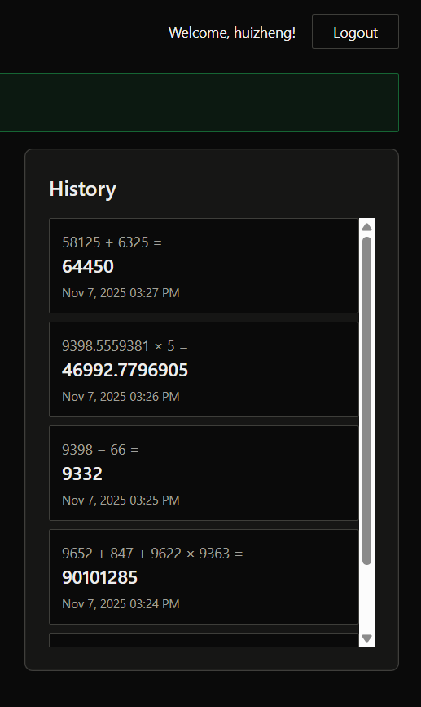 | 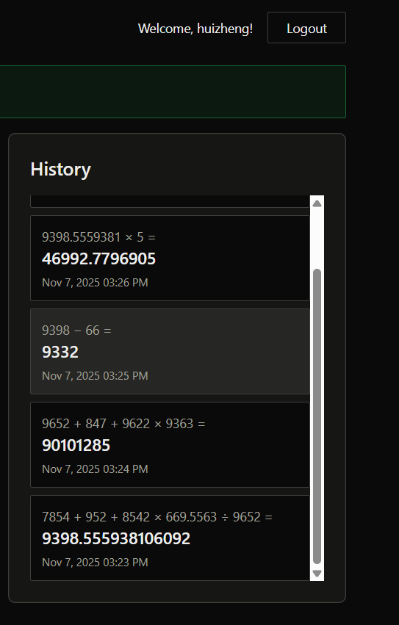
The latest on top | Scroll down for older calculation record

4 Invalid Calculation
When user entered an invalid calculation (like anything divided by 0):
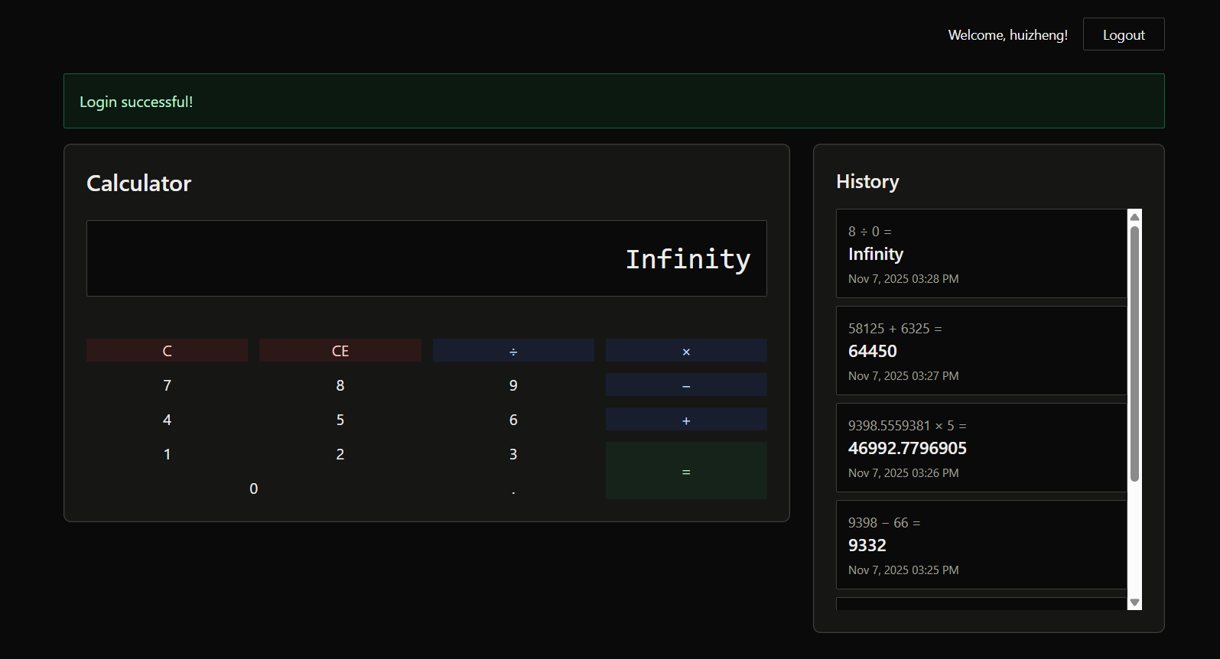

5 Database
The database I used in this project is mysql (access via phpMyAdmin).
users Table:
Calculation Table:
(the records different with the demo due to I have been delete the “huizheng” and recreate for it.)
