HW8 (noise & noise removal)

姓名：周秉儒 學號：r07922166

Gaussian Noise :

amplitude = 10 amplitude = 30



SNR = 13.5768SNR =2.1747

Salt and pepper Noise:

Prob = 0.05 Prob = 0.1



SNR = 0.9265SNR = -2.1203

Noise removal:

Gaussian Noise(amplitude = 10)with box filter:

Box size = 3 Box size = 5



SNR = 17.2744 SNR = 14.1416

Gaussian Noise(amplitude = 30)with box filter:

Box size = 3 Box size = 5



SNR = 10.0000 SNR = 10.6193

Salt and pepper Noise(prob = 0.05) with box filter:

Box size = 3 Box size = 5



SNR = 9.7034 SNR = 10.9541

Salt and pepper Noise(prob = 0.1) with box filter:

Box size = 3 Box size = 5



SNR = 6.5994 SNR = 8.4714

Gaussian Noise(amplitude = 10) with median filter:

Kernel size = 3 kernel size = 5



SNR = 17.6730 SNR = 15.9937

Gaussian Noise(amplitude = 30) with median filter:

Kernel size = 3 kernel size = 5



SNR = 10.7814 SNR = 12.4752

Salt and pepper (prob = 0.05) with median filter:

Kernel size = 3 kernel size = 5



SNR = 19.1076 SNR = 16.3385

Salt and pepper (prob = 0.10) with median filter:

Kernel size = 3 kernel size = 5



SNR = 14.8156 SNR = 15.6722

Gaussian Noise(amplitude = 10) with Opening then Closing:



SNR = 12.6268

Gaussian Noise(amplitude = 30) with Opening then Closing:



SNR = 7.0180

Salt and pepper Noise(prob=0.05)with Opening then Closing:

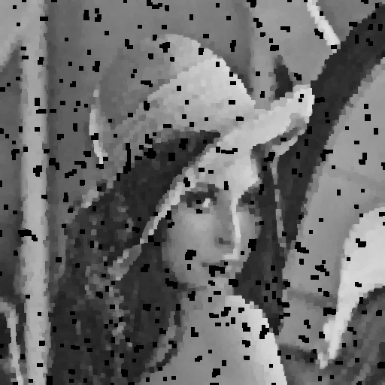

SNR = 3.4896

Salt and pepper Noise(prob=0.10)with Opening then Closing:

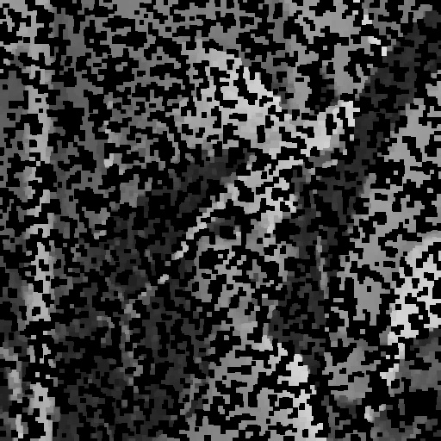

SNR = -2.7947

Gaussian Noise(amplitude=10) with Closing then Openning:



SNR = 12.9651

Gaussian Noise(amplitude=30) with Closing then Openning:

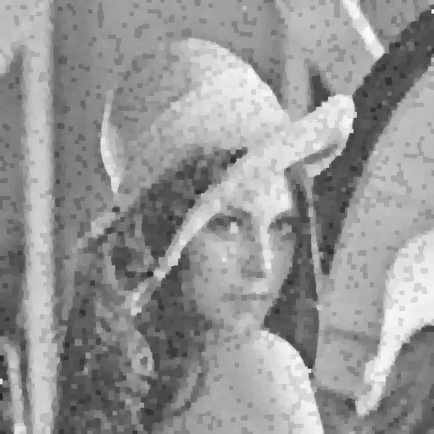

SNR = 6.6112

Salt and pepper Noise(prob=0.05)with Closing then Openning:



SNR = 2.7350

Salt and pepper Noise(prob=0.10)with Closing then Openning:

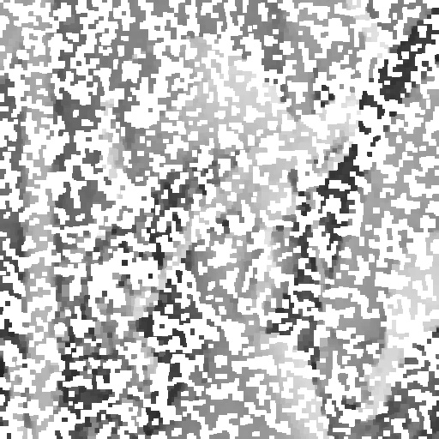

SNR = -3.2382

各個filter之SNR比較

程式碼：

Signal noise ratio:

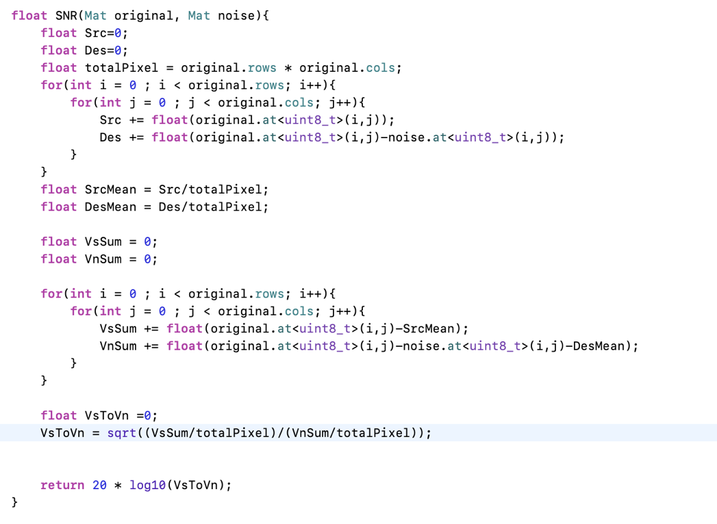

Gaussian Noise:

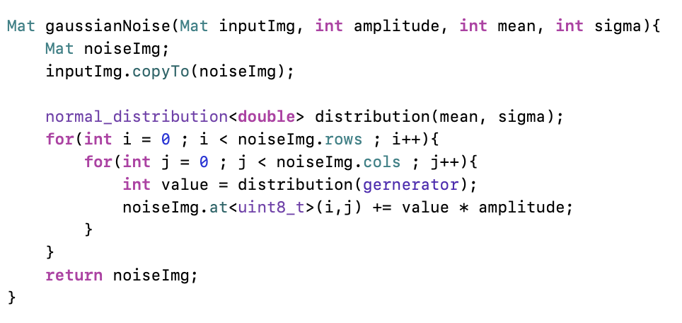

Salt and pepper Noise:

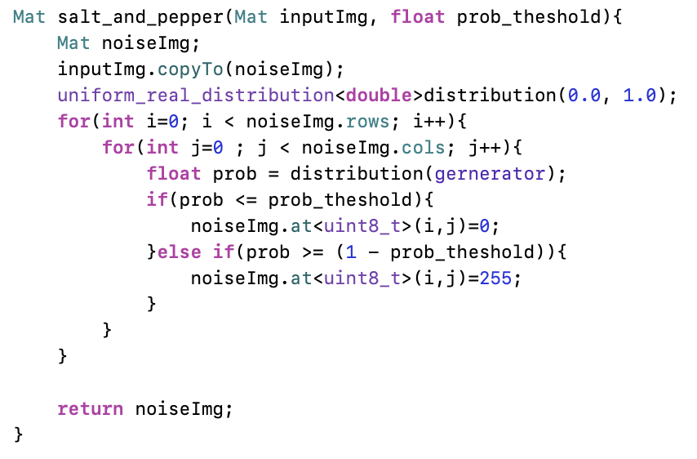

Box filter:

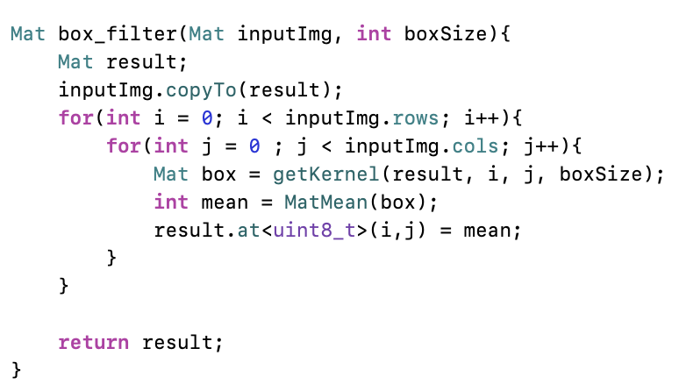

Median filter :

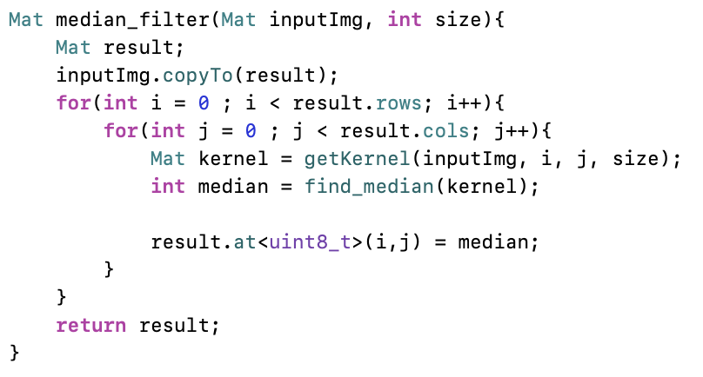

Opening and closeing 程式碼與以前的功課程式碼一樣～