Be inspired.

Programming Languages and Verification Seminar



**­**

Decidable Subclasses of Multi-Mode Systems (Schedulability, Reachability, and Related Problems)

Ashutosh Trivedi  
Indian Institute of Technology Bombay

KOBL 235

Friday, April 17, 2015

1:00 p.m. to 2:00 p.m.

Hybrid automata are a natural and expressive formalism to model systems that exhibit both discrete and continuous behavior. However, the applications of hybrid automata in analyzing cyber-physical systems have been rather limited due to undecidability of simple verification problems such as reachability. This drawback of hybrid automata has fueled the investigation of the so-called compositional methodology to design complex system by sequentially composing well-understood lower-level components. This methodology has, for example, been used in the context of the motion planning problem for mobile robots, where the task is to move a robot along a pre-specified trajectory with arbitrary precision by sequentially composing a set of well-studied simple motion primitives, such as “move left”, “move right” and “go straight”. In this talk, we summarize some of our recent results related to efficient solution of motion planning problem for systems whose motion primitives are given as constant-rate vectors with uncertainties.

**References**

[1] R. Alur, A. Trivedi, and D. Wojtczak. Optimal Scheduling for Constant-Rate Multi-Mode System. Proceedings of the 15th ACM international conference on Hybrid Systems: Computation and Control, HSCC 2012.

[2] R. Alur, V. Forejt, S. Moarref, and A. Trivedi. Safe Schedulability of Bounded-Rate Multi-Mode Systems. Proceedings of the 16th international conference on Hybrid Systems: Computation and Control, HSCC 2013.

[3] S. N. Krishna, U. Mathur, and A. Trivedi. Weak Singular Hybrid Automata. Proceedings of 12th International Conference on Formal Modeling and Analysis of Timed Systems, FORMATS 2014.

[4] D. Bhave, S. Jha, S. N. Krishna, S. Schewe, and A. Trivedi. Bounded-Rate multi-mode systems based motion-planning. Proceedings of the 18th international conference on Hybrid

Systems: Computation and Control, HSCC 2015.

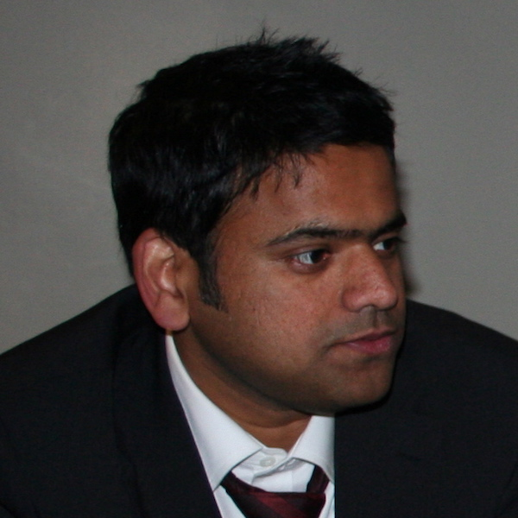

**Ashutosh Trivedi** is an assistant professor at the Indian Institute of Technology Bombay.

**Hosted** by Sriram Sankaranarayanan



*­*

**