**CS302-Design and analysis of Algorithm Spring 2020**

**Assignment 3**

**Due Date: 8th-May-2020 (11:55 pm) (Friday)**

**Assignment Submission**

**Question 1 Part a,b,c,d,e (Brute Force):**

**Member: 1**

**Roll No: ___18F-0269**

**Section: ___4A**

**Name: ___MUHAMMAD AWAIS ZAHID**

**Member: 2**

**Roll No: ___18F-346**

**Section: ___4A**

**Name: ____USAMA SADIQ**

**Member:**

**Roll No: ___18F-0235**

**Section: ___4A**

**Name: ____MUHAMMAD ZEESHAN**

**Question: 1 (Brute Force )**

Create a word search program. Where user can search a specific word or sequence of words from the given list of files (Attached). It should work as following (GUI Application)

**Functionalities**

1. Program must find the position of search word or sequence of words from given files and return name of file, row number and column number.
2. Match whole word only [**Unchecked**]
   1. Program should return Pakistan, adampak, abnopakis, and pak against ‘pak’ searched word because ‘pak’ is present in all of them. The length of return word and search word may differ.
3. Match whole word only [**Checked**]
   1. Program should return only pak against ‘pak’ searched word. The length of return word and search word should be same.
4. Match case [**Unchecked**]
   1. Program should return Bilal, bilaL, bIlaL against ‘bilal’. The upper and lower case should not be checked
5. Match case [**Checked**]
   1. Program should only return bilal against bilal and BilaL against BilaL. The upper and lower case should be checked against each character.

**Implement this by Brute Force.**

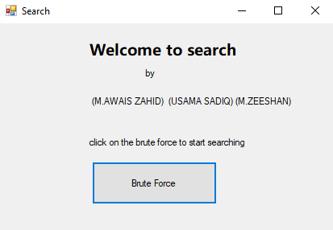

**Enter the word here to search.**

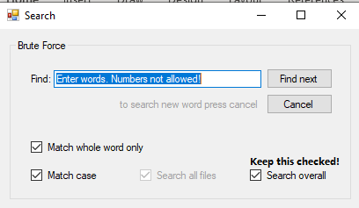

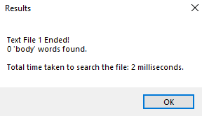

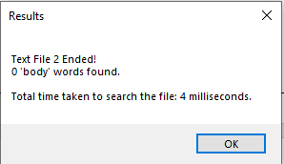

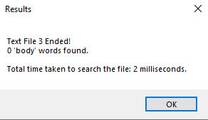

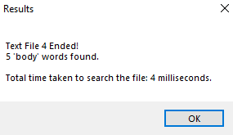

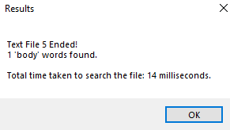

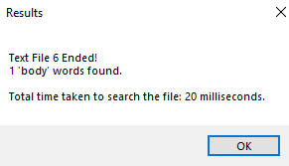

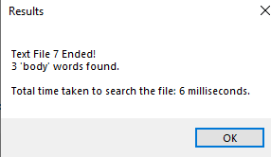

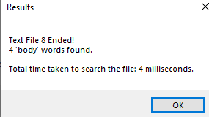

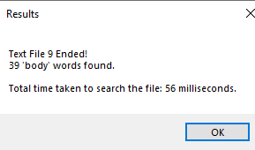

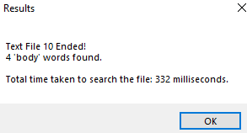

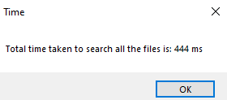

**Time Taken, Brute Force: _444ms__**