ECB Text Sentiment Analysis

# Executive summary

We performed text sentiment analysis on the ECB press conference speeches. By using four different sentiment dictionaries, we constructed four different sentiment score indicators. The scoring is done based on unigrams (single word), with adjustment for negation words through bigrams. The sentiment indicator is then built up from the summation of the scores and its change measured across time.

# Methodology

## Preprocess: Tokenising words and attaching sentiment

Using text scraped from ECB press conference transcript, we tokenise the transcripts into individual words. We start by analysing single words, also referred to as unigrams.

### List of top words and their associated sentiments

After obtaining the count of the words, we now need to find their associated sentiments. We use four dictionaries to measure sentiment, however these dictionaries are not optimised for central bank or macroeconomic analysis and is sub optimal.

|  |  |
| --- | --- |
| Dictionary | Description |
| AFINN | Scale of -5 (very negative) to +5 (very positive) |
| Loughran | For financial applications, various types of sentiments |
| NRC | Crowd sourced emotion-based |
| Bing | Labels as positive or negative |

From an extract of the top words with associated sentiments, we see that the sentiments associated with each dictionary is quite varied.

## # A tibble: 6 x 6  
## # Groups: word, n [6]  
## word n afinn bing loughran nrc  
## <chr> <int> <int> <chr> <chr> <chr>  
## 1 growth 4483 2 <NA> <NA> positive  
## 2 monetary 3760 NA <NA> <NA> anticipation|positive  
## 3 inflation 3396 NA <NA> <NA> fear|negative  
## 4 stability 2930 NA positive positive <NA>  
## 5 council 2738 NA <NA> <NA> anticipation|positive|trust  
## 6 policy 2676 NA <NA> <NA> trust

## Calculating a sentiment score

We then calculate a sentiment score by adding to the score when a positive word appears and subtracting when a negative word appears. In the case of the AFINN dictionary, we multiply the word count n by the sentiment score before summing them together. Here we observe that each indicator is fairly diferent, suggesting that the dictionary has significant impact on your final results.

Using zero as a baseline, we observe that most of the dictionaries tend to give a positive overall sentiment to the minutes, but Loughran views the speeches negatively in most cases

### High scoring words from the dictionary

To account for the differences, we extracted the top contributors to scores both negative and positive across the dictionaries, and see that they are indeed picking out quite different words

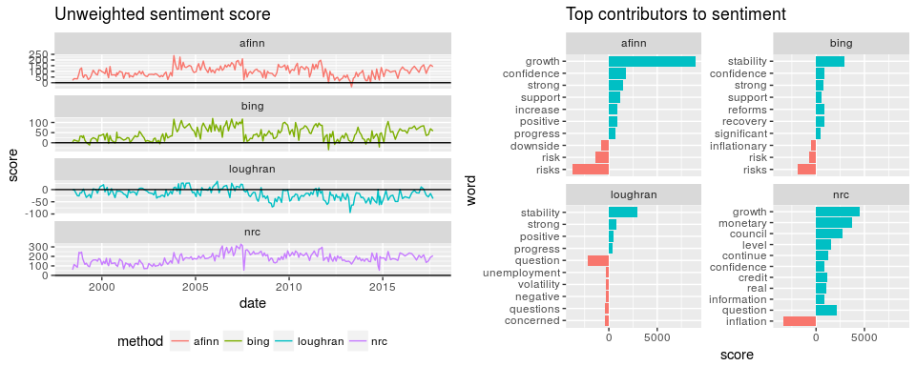

### Calculate weighted scores

As words like growth or inflation may be used very often in any ECB speech, we may want to place more weight on words that occur less often. To adjust for this, we use "term frequency - inverse document frequency" (tf-idt) as a weight. tf-idf measures how unique a particular word is in the other documents. If it is relatively unique, it is given a higher weight, while if it appears frequently in every single document, it would be given a smaller weight. Using the tf-idf as weights, we calculated a weighted score

## Adjusting for bigrams

### Removing negation words

Unigram analysis may not be sufficient, as there are words which are used with opposite intentions, such as "negative growth" or "no money". Hence we extend the analysis to bigrams, which are essentially words paired together with their adjacent words.

To adjust the negated words, we have to first remove its original impact, then add the new impact, which is equivalent to adding twice its new established impact

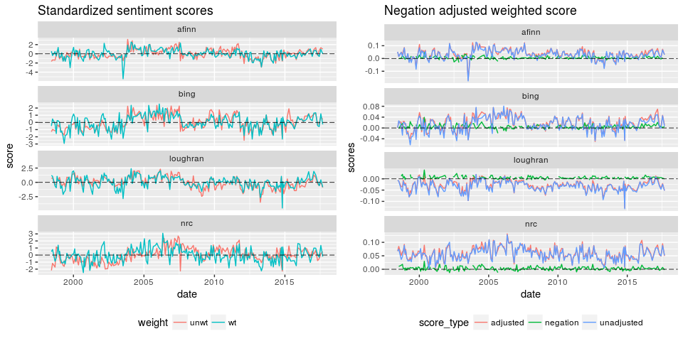

## Predictive ability of sentiment

To test our sentiment indicator, we compared the indicators against 1 day performance of euribor and bond futures.

Performance of the sentiment indicators as market indicators is terrible. If we look at the correlation between each of the indicators and the performance of the assets, the correlation is less than 10%

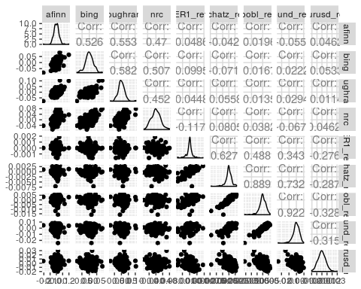

# Limitations of study

There are several limitations in this exploratory study of text sentiment analysis.

1. The first, and biggest issue is the dictionaries used. As macroeconomics and central bank speech can have very different terminologies from what is ordinarily used, or against more generalized financial terms. As there are no readily available dictionaries for macroeconomic analysis at the moment, having one could improve performance significantly.
2. Market movements are a result of market expectations vs central bank stance, hence instead of levels of positivity in the speech, it may be more useful to compare relative levels of positivity between news and market commentary leading up to the meeting, and the eventual tone of the meeting itself. However, much more data will need to be collected to discern market sentiment.

# Conclusion

The current text analytics presented above provides little value as a market indicator, as it faces significant limitations. However, if the limitations can be improved upon in future, there is still potential for the indicator to help glean information from news sources or central bank speeches.