Metro Ticket Generating System in ServiceNow
Phase 4: Data Migration, Testing & Security
Item | Details
Project | Metro Ticket Generating System in ServiceNow
Phase | Phase 4: Data Migration, Testing & Security
Platform | ServiceNow
Prepared by | Bharath Chowdary Tammineedi
Status | In Progress

1. Phase Overview
This phase migrates data securely, performs rigorous testing, and ensures that system access and data protection mechanisms are in place. It covers three areas: Access Control, QA Testing, and Data Integrity.

2. Access Control

2.1 Role-Based ACLs
Role-based Access Control Rules (ACLs) protect the data of the system. Users can book a ticket through the catalog item, but they cannot access the database table directly.
When a custom table is created, four ACLs are created automatically by the system. For the Metro Station's Details table (u_metro_station_s_details), only these default ACLs are used:
Operation | Type | Decision Type | Active
read | record | Allow If | true
create | record | Allow If | true
write | record | Allow If | true
delete | record | Allow If | true
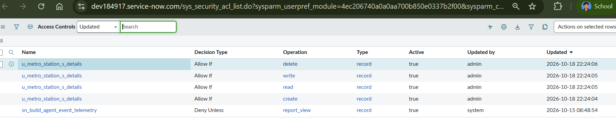
Figure 1: Default Access Controls (ACLs) of the Metro Station's Details table

2.2 Access Control Rules
Access Control Rules (ACLs) are configured to restrict read and write access to sensitive fields depending on the role.
Note: These ACLs are configured by the system itself after the creation of the tables. No additional ACLs were configured for restriction purposes.

3. QA Testing
Catalog testing was carried out for form behavior, QR generation, and visibility of fields on the Book A Metro Ticket catalog item, using the Service Portal.
Test Area | What Was Checked
Form behavior | The booking form accepts Starting From, Going To, Type of Journey, and No of Passengers, and the fare fields are filled in by the Fare auto-calculation client script.
QR generation | On Checkout, the QR Generation client script opens the Metro QR Widget and shows the QR code ticket.
Visibility | The Enter payment mode field is shown when Mode of Payment is set to Others, through the Catalog UI Policy.
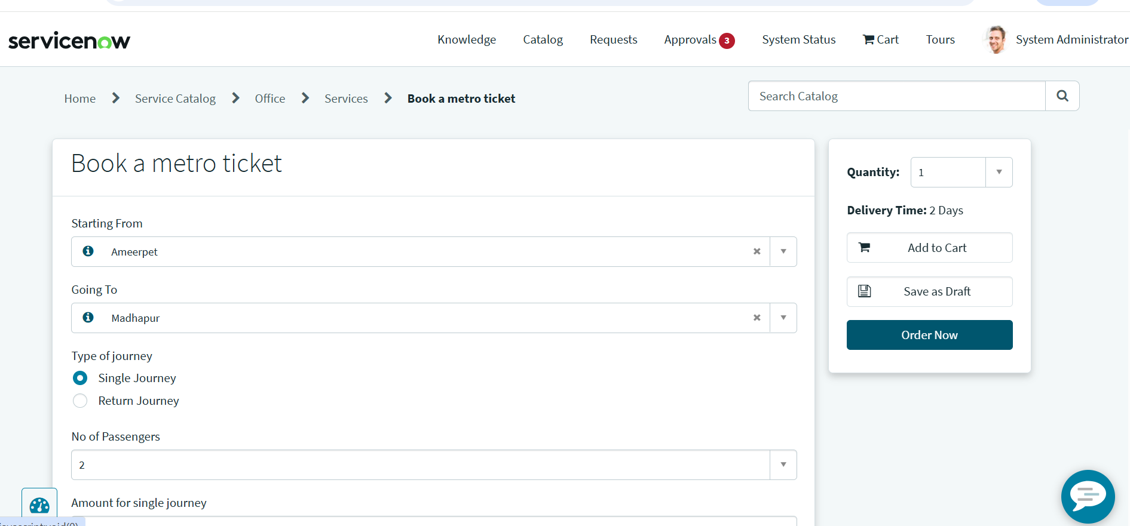
Figure 2: Booking form tested through the Service Portal (stations, type of journey, number of passengers)
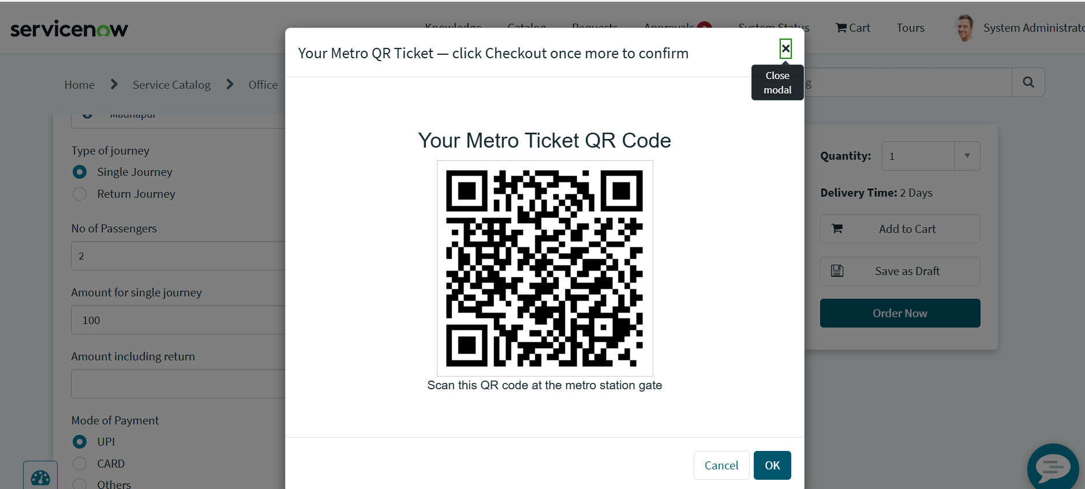
Figure 3: QR code ticket shown in the Metro QR Widget on Checkout

4. Data Integrity
The following measures keep the data entered through the booking form complete and consistent:
Measure | Description
Field validations | Non-empty source and destination, fare match, and approved travel date.
Mandatory fields | Enforced on the client and server side to prevent incomplete submissions.
Auto-populate logic | Default values (for example, single or return journey) are set using catalog client scripts and UI policies.
Fields mapping | The Process Automation Engine is used to automatically map the fields and populate the values given by the user or client.

5. Summary
Phase 4 secured the data with the default role-based ACLs created by the system for the custom table, tested the catalog item for form behavior, QR generation, and field visibility, and kept the booking data consistent through validations, mandatory fields, auto-populated defaults, and field mapping.

