# Team Members

* Akash Jajoo: 61326882
* Niraj Chowdhary: 15013123

# What is working?

* Initially we create routing table for (numNodes-20) nodes.
* However, if numNodes is less than 20 we insert all nodes together in the network.
* Finally, we insert last 20 nodes dynamically in the network if numNodes is greater than 20.
* We update the routing table after the new nodes are inserted.
* Then we process the numRequests inputted by the user for each node in network.

# How to run the code

* Extract Tapestry folder in your local machine
* Go to the folder via CMD
* Run the following command: **mix run project3.exs arg1 arg2**
  + arg1: number of nodes in the network
  + arg2: number of requests per node

# Working Screenshot

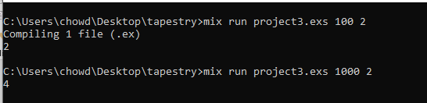

# Maximum input handled

* The code handles maximum input of 10,000 nodes and 3 requests.