21sw74

Lab 13 task

GUI:

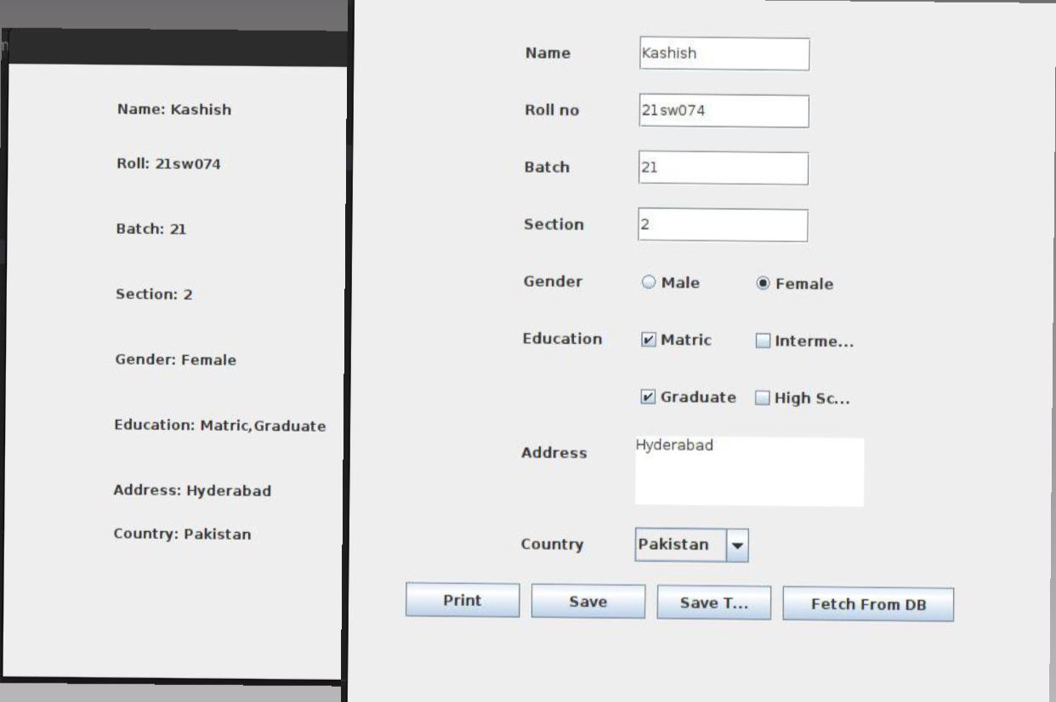

Programs:

File number 1:

import java.sql.*;

public class Database {

Database(String name, String roll, String batch, String section, String Gender, String Qualification, String Address, String Country){

try{

Class.forName("com.mysql.cj.jdbc.Driver");

Connection con=DriverManager.getConnection(

"jdbc:mysql://localhost:3306/Aashish","root","");

String query = "INSERT INTO value VALUES(?,?,?,?,?,?,?,?)";

PreparedStatement myStmt = con.prepareStatement(query);

myStmt.setString(1, name);

myStmt.setString(2, roll);

myStmt.setString(3, batch);

myStmt.setString(4, section);

myStmt.setString(5, Gender);

myStmt.setString(6, Qualification);

myStmt.setString(7, Address);

myStmt.setString(8, Country);

int res = myStmt.executeUpdate();

System.out.println("Records updated");

con.close();

}catch(Exception e){ System.out.println(e);}

}

}

File number 2:

/*

* Click nbfs://nbhost/SystemFileSystem/Templates/Licenses/license-default.txt to change this license

* Click nbfs://nbhost/SystemFileSystem/Templates/Classes/Main.java to edit this template

*/

package lab13;

import java.awt.Color;

import java.awt.Font;

import java.awt.event.ActionEvent;

import java.awt.event.ActionListener;

import java.io.FileNotFoundException;

import java.io.FileReader;

import java.io.FileWriter;

import java.io.IOException;

import javax.swing.BorderFactory;

import javax.swing.ButtonGroup;

import javax.swing.JButton;

import javax.swing.JCheckBox;

import javax.swing.JComboBox;

import javax.swing.JFrame;

import javax.swing.JLabel;

import javax.swing.JOptionPane;

import javax.swing.JRadioButton;

import javax.swing.JTextArea;

import javax.swing.JTextField;

import javax.swing.border.Border;

import javax.swing.border.EtchedBorder;

import org.json.simple.JSONObject;

import org.json.simple.parser.JSONParser;

import org.json.simple.parser.ParseException;

public class Lab13 {

public static void main(String[] args) throws FileNotFoundException, IOException{

Border emptyBorder = BorderFactory.createEmptyBorder();

Border loweredBorderEtched = new EtchedBorder(EtchedBorder.LOWERED);

String[] CountryList = {"Pakistan","UK","India","US","Russia","Ukraine"};

final JFrame frame= new JFrame();

frame.setLayout(null);

frame.setBounds(300, 100,900, 600);

frame.getContentPane().setBackground(Color.green);

frame.setResizable(false);

frame.setDefaultCloseOperation(JFrame.EXIT_ON_CLOSE);

frame.setTitle("Student Registrations");

//name

JLabel Name = new JLabel("Student Name");

Name.setFont((new Font("Open Sans", Font.PLAIN, 18)));

Name.setBounds(100, 50, 200, 20);

final JTextField Namef = new JTextField();

Namef.setBounds(400, 45, 150, 25);

Namef.setFont((new Font("Open Sans", Font.PLAIN, 18)));

final JLabel RegNo = new JLabel("Registration no");

RegNo.setFont((new Font("Open Sans", Font.PLAIN, 18)));

RegNo.setBounds(100, 100, 400, 25);

final JTextField Regf = new JTextField();

Regf.setBounds(400, 95, 150, 25);

Regf.setFont((new Font("Open Sans", Font.PLAIN, 18)));

final JLabel Gender = new JLabel("Gender");

Gender.setFont((new Font("Open Sans", Font.PLAIN, 18)));

Gender.setBounds(100, 150, 100, 20);

final JRadioButton r1=new JRadioButton("male");

final JRadioButton r2=new JRadioButton("female");

final JRadioButton r3=new JRadioButton("Unspecified");

r1.setBackground(Color.green);

r2.setBackground(Color.green);

r3.setBackground(Color.green);

r1.setFont((new Font("Open Sans", Font.PLAIN, 14)));

r2.setFont((new Font("Open Sans", Font.PLAIN, 14)));

r3.setFont((new Font("Open Sans", Font.PLAIN, 14)));

ButtonGroup bg=new ButtonGroup();

bg.add(r1);bg.add(r2);bg.add(r3);

r1.setBounds(400,145,100,30);

r2.setBounds(500,145,100,30);

r3.setBounds(600, 145, 400, 30);

JLabel Batch = new JLabel("Batch");

Batch.setFont((new Font("Open Sans", Font.PLAIN, 18)));

Batch.setBounds(100, 250, 100, 20);

final JTextField Batchf = new JTextField();

Batchf.setBounds(400, 245, 150, 25);

Batchf.setFont((new Font("Open Sans", Font.PLAIN, 18)));

JLabel Section = new JLabel("Section");

Section.setFont((new Font("Open Sans", Font.PLAIN, 18)));

Section.setBounds(100, 200, 100, 20);

final JTextField Sectionf = new JTextField();

Sectionf.setBounds(400, 195, 150, 25);

Sectionf.setFont((new Font("Open Sans", Font.PLAIN, 18)));

//qualification

final JLabel Qualitfication = new JLabel("Qualitfication");

Qualitfication.setFont((new Font("Open Sans", Font.PLAIN, 18)));

Qualitfication.setBounds(100, 300, 150, 20);

final JCheckBox checkBox1 = new JCheckBox("Matric");

checkBox1.setBounds(400,295, 70,20);

checkBox1.setBackground(Color.green);

final JCheckBox checkBox2 = new JCheckBox("College");

checkBox2.setBounds(470,295, 80,20);

checkBox2.setBackground(Color.green);

final JCheckBox checkBox3 = new JCheckBox("Undergraduate");

checkBox3.setBounds(550,295, 130,20);

checkBox3.setBackground(Color.green);

final JCheckBox checkBox4 = new JCheckBox("graduate");

checkBox4.setBounds(670,295, 100,20);

checkBox4.setBackground(Color.green);

checkBox1.setFont((new Font("Open Sans", Font.PLAIN, 14)));

checkBox2.setFont((new Font("Open Sans", Font.PLAIN, 14)));

checkBox3.setFont((new Font("Open Sans", Font.PLAIN, 14)));

checkBox4.setFont((new Font("Open Sans", Font.PLAIN, 14)));

//Country

JLabel Country = new JLabel("Country");

Country.setFont((new Font("Open Sans", Font.PLAIN, 18)));

Country.setBounds(100, 350, 100, 20);

final JComboBox Countries = new JComboBox(CountryList);

Countries.setBounds(400, 345, 150, 25);

Countries.setSelectedIndex(2);

Countries.setFont((new Font("Open Sans", Font.PLAIN, 14)));

//address

JLabel Address = new JLabel("Address");

Address.setFont((new Font("Open Sans", Font.PLAIN, 18)));

Address.setBounds(100, 400, 100, 20);

final JTextArea Addressf= new JTextArea();

Addressf.setBounds(400, 395, 300, 75);

Addressf.setFont((new Font("Open Sans", Font.PLAIN, 18)));

Addressf.setBorder(loweredBorderEtched);

JButton exit = new JButton("Exit");

exit.setBounds(100,500,100,20);

exit.setFont((new Font("Open Sans", Font.PLAIN, 18)));

JButton Print = new JButton("Display");

Print.setBounds(250, 500, 100, 20);

Print.setFont((new Font("Open Sans", Font.PLAIN, 18)));

JButton Create = new JButton("Save");

Create.setFont((new Font("Open Sans", Font.PLAIN, 18)));

Create.setBounds(400, 500, 100, 20);

JButton Insert = new JButton("Insert");

Insert.setFont((new Font("Open Sans", Font.PLAIN, 18)));

Insert.setBounds(550,500,100,20);

frame.add(Insert);

//insert

Insert.addActionListener(new ActionListener() {

@Override

public void actionPerformed(ActionEvent e) {

// TODO Auto-generated method stub

Object obj;

String name,roll,batch,section,Gender,Quali,Address,Country;

try{

obj = new JSONParser().parse(new FileReader("Student.json"));

JSONObject read = (JSONObject) obj;

name=read.get("Name").toString();

roll=read.get("Regno").toString();

Gender=read.get("Gender").toString();

batch=read.get("Batch").toString();

section=read.get("Section").toString();

Quali=read.get("Qualification").toString();

Country=read.get("Country").toString();

Address=read.get("Address").toString();

new Database(name, roll, batch, section, Gender, Quali, Address, Country);

System.out.println("Saved to Database Successfully");

}

catch (IOException | ParseException e1) {

// TODO Auto-generated catch block

e1.printStackTrace();

}

}

}

);

frame.add(Name);

frame.add(Namef);

frame.add(RegNo);

frame.add(Regf);

frame.add(Batch);

frame.add(Batchf);

frame.add(Section);

frame.add(Sectionf);

frame.add(Gender);

frame.add(r1);

frame.add(r2);

frame.add(r3);

frame.add(Qualitfication);

frame.add(checkBox1);

frame.add(checkBox2);

frame.add(checkBox3);

frame.add(checkBox4);

frame.add(Address);

frame.add(Addressf);

frame.add(Country);

frame.add(Countries);

frame.add(exit);

frame.add(Print);

frame.add(Create);

//exit

exit.addActionListener(new ActionListener() {

@Override

public void actionPerformed(ActionEvent e) {

// TODO Auto-generated method stub

System.exit(0);

}

}

);

//create

Create.addActionListener(new ActionListener(){

@Override

public void actionPerformed(ActionEvent e) {

// TODO Auto-generated method stub

String Name=Namef.getText();

String Regno=Regf.getText();

String Batch=Batchf.getText();

String gender;

if(r1.isSelected()) {

gender="Male";

}

else if(r2.isSelected()) {

gender="Female";

}

else{

gender="Prefer not to say";

}

String Section= Sectionf.getText();

String Country=(String) Countries.getSelectedItem();

String Address= Addressf.getText();

String Quali = "";

if(checkBox1.isSelected()) {

Quali+=" Matric";

}

if(checkBox2.isSelected()) {

Quali+=", College";

}if(checkBox3.isSelected()) {

Quali+=" undergraduate";

}if(checkBox4.isSelected()) {

Quali+=" Graduate";

}

JSONObject obj = new JSONObject();

obj.put("Name",Name);

obj.put("Gender",gender);

obj.put("Regno",Regno);

obj.put("Batch",Batch);

obj.put("Section",Section);

obj.put("Qualification",Quali);

obj.put("Country",Country);

obj.put("Address",Address);

try {

FileWriter file = new FileWriter("Student.json");

file.write(obj.toString());

file.close();

} catch (IOException e1) {

// TODO Auto-generated catch block

e1.printStackTrace();

}

}

});

Print.addActionListener(new ActionListener() {

@Override

public void actionPerformed(ActionEvent e) {

// TODO Auto-generated method stub

String Print;

Object obj;

try {

obj = new JSONParser().parse(new FileReader("Student.json"));

JSONObject read = (JSONObject) obj;

Print = "Name = "+read.get("Name")+"\nRegno = "+read.get("Regno")+"\nGender = "+read.get("Gender");

Print+="\nBatch = "+read.get("Batch")+"\nSection = "+read.get("Section")+"\nQualifciation = "+read.get("Qualification");

Print+="\nCountry = "+read.get("Country")+"\nAddress = "+read.get("Address");

JOptionPane.showMessageDialog(frame, Print);

} catch (IOException | ParseException e1) {

// TODO Auto-generated catch block

e1.printStackTrace();

}

}

});

frame.setVisible(true);

}

}