

**American International University- Bangladesh**

**CSC 3215: Web Technologies**

**CO2 and CO4 Evaluation**

**Finished Project Report**

**Fall 2019-2020**

**Project Title: Online Polling System**

**Section: J**

|  |  |
| --- | --- |
| Student Name | Student Id |
| Md. Jamil Chowdhury | **17-34747-2** |
| Islam Din | **17-34936-2** |
| Prokrity, Nusrat Zahan | **17-35105-2** |
|  |  |

**Project Description:**

*The project name is online pooling system. Online voting system is a software platform which is used to secure conduct votes and elections. As a digital platform, they eliminate the need to cast your votes using paper or having to gather in person. In our web site , we have a mail account where they can give messages for any inquiries. Admin will see it and reply to their messages. There is also given a demo video where they can learn more about voting system. There is two types of user : Admin user and voter user.*

***Admin:***

*In admin user ,admin has a secret code. After using this secret code ,he can enter to the admin sign up page. There he can create an account. In Admin page, Admin can add candidates, change his own password and can see the percentages of candidates. There is also a progress bar in admin page.*

***Voter:***

*Another user is a voter user. In our polling system, there is also a sign up page for voters. In that page, they can create their own accounts. After login voter account, voters can change their own password. There is a dashboard in voter account. In dashboard, voter can see total number of candidates,how many votes they will be getting and what is their percentages. In voter account, there also a voting system. In voting system, voters can give their votes on their own will to the suitable candidate . When they will done to give their votes then the voting button will remove automatically and this way they will not be able to get another chance to give another vote or to change their votes.*

**Project Folder Structure:**

*Provide your project folder structure clearly here.:1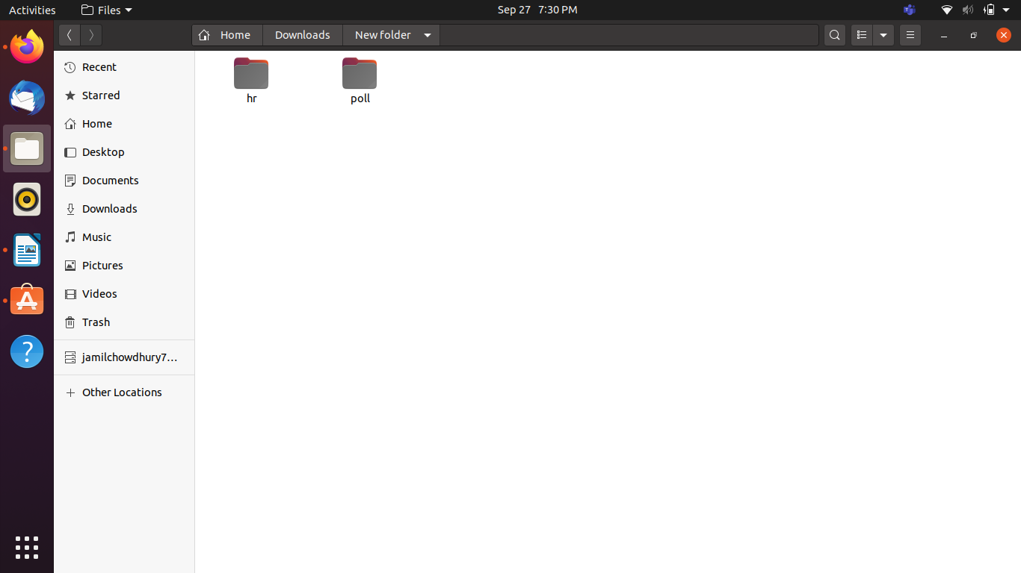*

*2.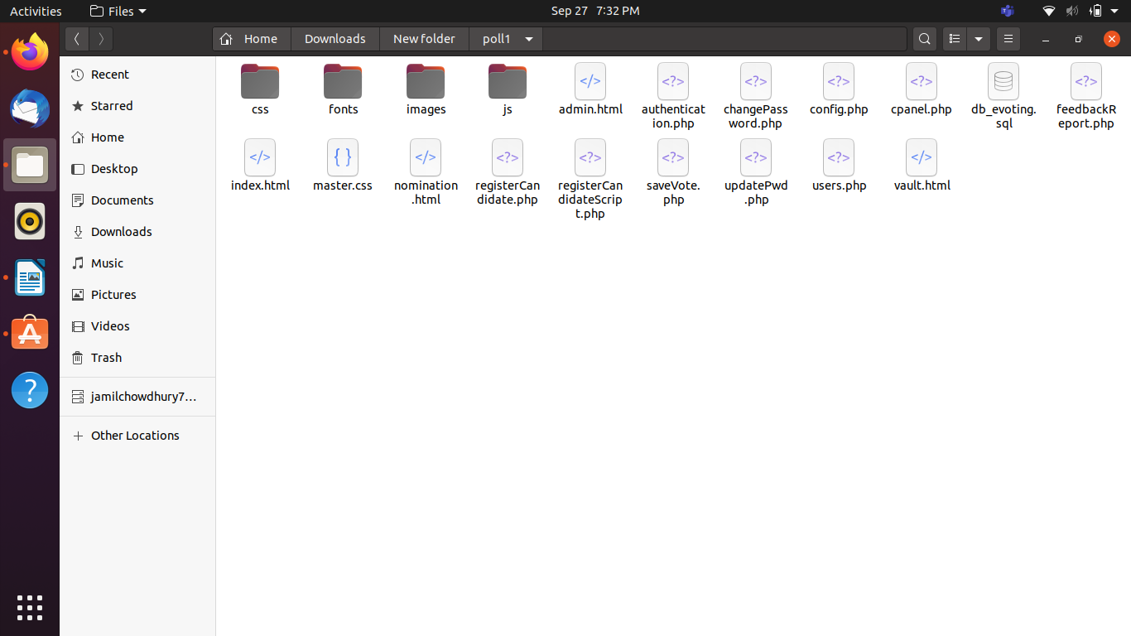*

*3.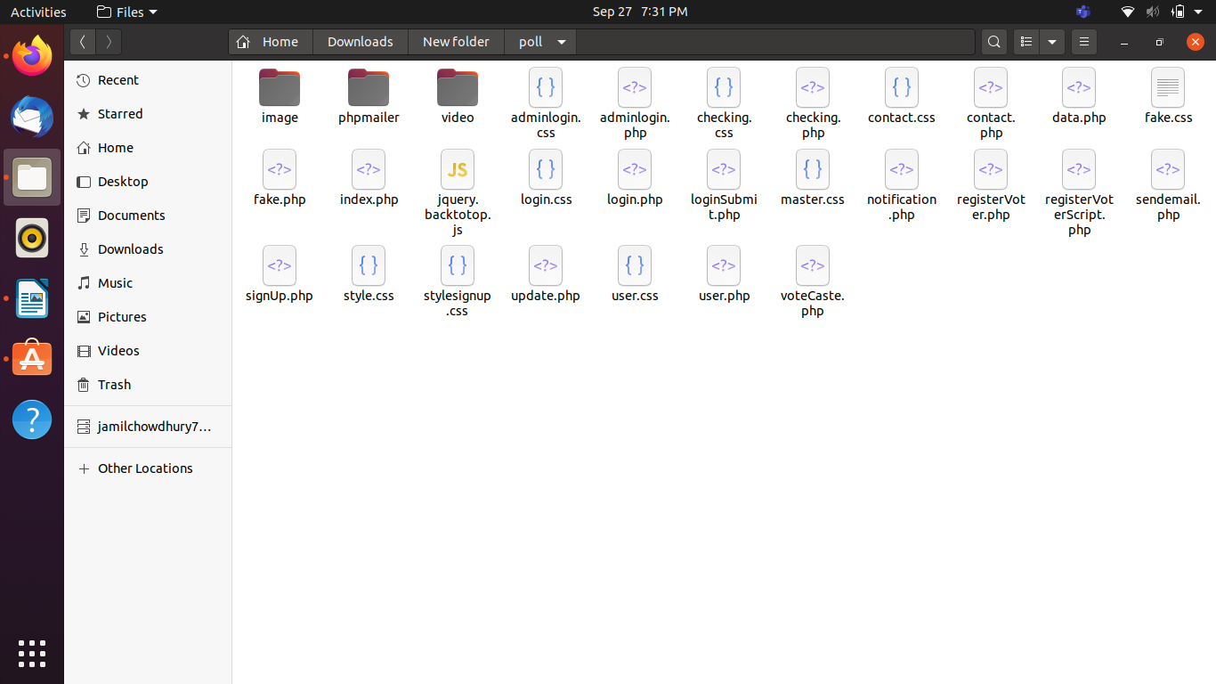*

*4.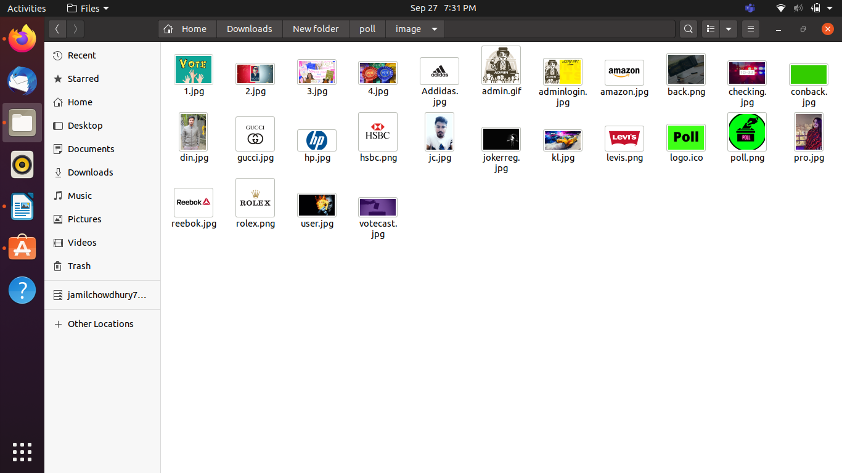*

*5.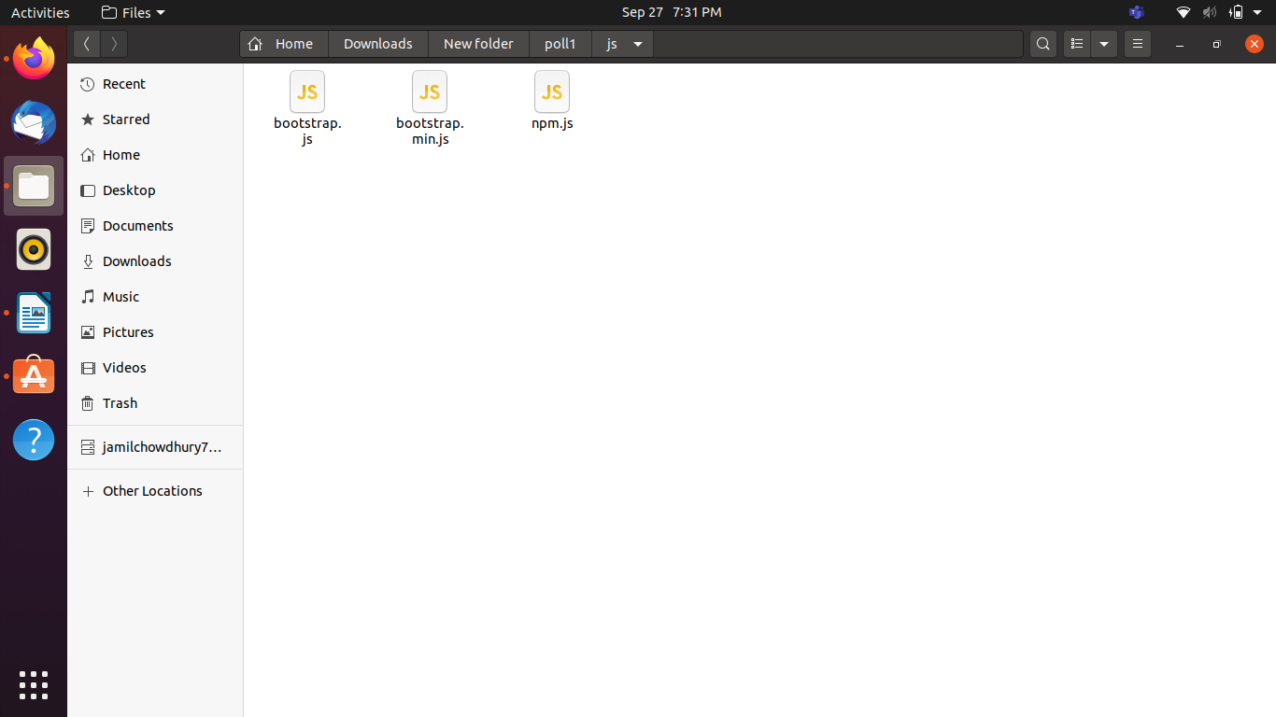*

*6.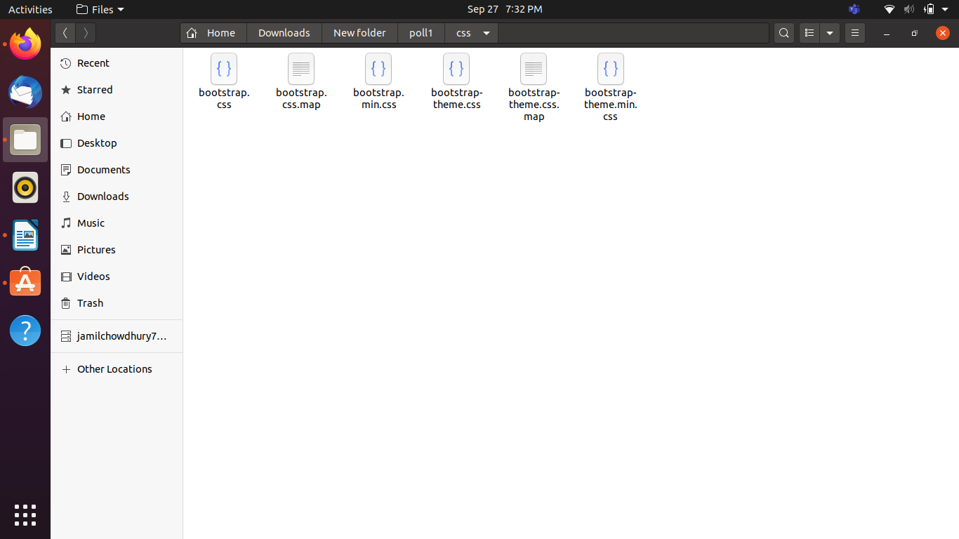*

*7.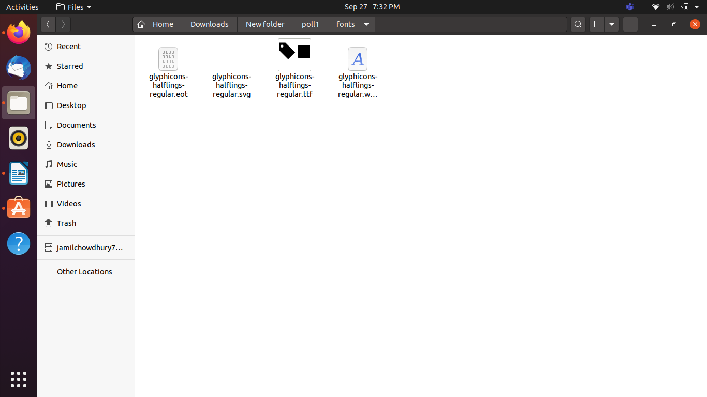*

*8.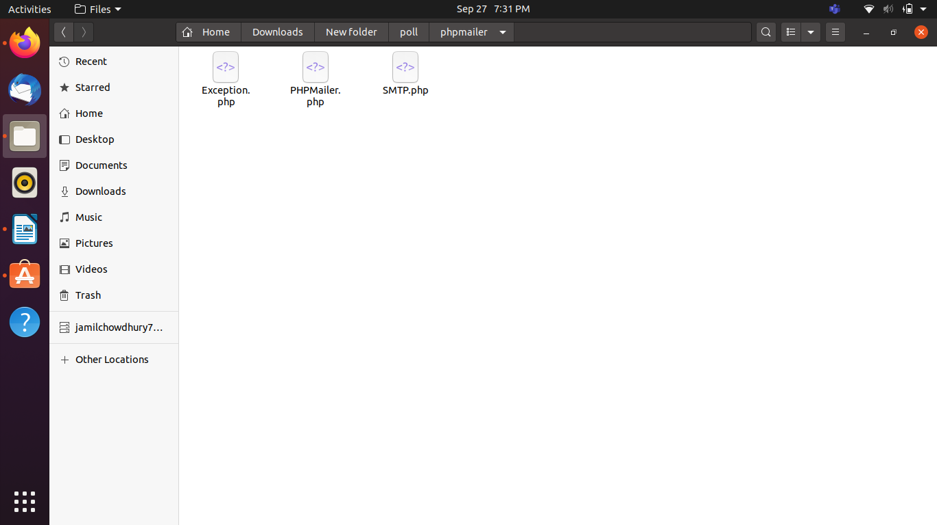*

*9.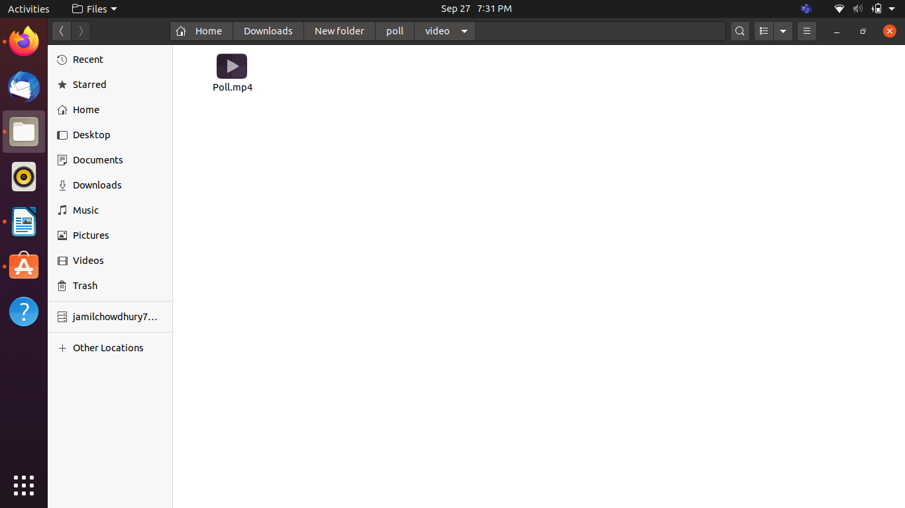*

**Core Modules of the Project:**

***index.php***

*<!DOCTYPE html>*

*<html lang="en" dir="ltr">*

*<head>*

*<meta charset="utf-8">*

*<title>Online Polling System</title>*

*<link rel="icon" href="image/logo.ico">*

*<script src="https://cdnjs.cloudflare.com/ajax/libs/jquery/3.4.1/jquery.min.js" charset="utf-8"></script>*

*<link rel="stylesheet" href="style.css">*

*<script src="https://kit.fontawesome.com/a076d05399.js"></script>*

*<link rel="stylesheet" href="https://cdnjs.cloudflare.com/ajax/libs/font-awesome/5.11.2/css/all.css">*

*<script src="https://code.jquery.com/jquery-3.4.1.js"></script>*

*</head>*

*<body>*

*<div class="header">*

*<a href="http://localhost/poll/"> <img src="image/poll.png" alt="PayRoll Management Logo" width="90" height="80" align="left" ></a>*

*<h2>&nbsp;Online <br>&nbsp;Polling<br>&nbsp;System</h2>*

*</div>*

*<div class="gk">*

*<div class="headbtn">*

*<div class="button"><a href="https://www.facebook.com/VoteOnline" target="_blank">*

*<div class="icon">*

*<i class="fab fa-facebook-f"></i></div>*

*<span>Facebook</span></a>*

*</div>*

*<div class="button"><a href="https://twitter.com/votedotorg?lang=en" target="_blank">*

*<div class="icon">*

*<i class="fab fa-twitter"></i></div>*

*<span>Twitter</span></a>*

*</div>*

*<div class="button"><a href="https://instagram.com/votesystem?igshid=1ud1rwzxrnkon" target="_blank">*

*<div class="icon">*

*<i class="fab fa-instagram"></i></div>*

*<span>Instagram</span></a>*

*</div>*

*<div class="button"><a href="https://github.com/topics/online-voting" target="_blank">*

*<div class="icon">*

*<i class="fab fa-github"></i></div>*

*<span>Github</span></a>*

*</div>*

*<div class="button"><a href="https://www.youtube.com/channel/UC0_tL00Q-h4WWH_qEFAN61A" target="_blank">*

*<div class="icon">*

*<i class="fab fa-youtube"></i></div>*

*<span>YouTube</span></a>*

*</div>*

*</div></div>*

*<nav>*

*<label class="logo">Polling System</label>*

*<ul>*

*<li><a class="active" href="http://localhost/poll/">Home</a></li>*

*<li><a href="#">Features*

*<i class="fas fa-caret-down"></i>*

*</a>*

*<p><ul>*

*<li><a onclick="togglePopup();" href="javascript:void(0);">Demo Video</a></li>*

*<li><a href="/poll3/" >Admin Login</a></li>*

*</ul></p>*

*</li>*

*<li><a href="#">Registration*

*<i class="fas fa-caret-down"></i>*

*</a>*

*<ul>*

*<li><a href="checking.php">Admin</a></li>*

*<li><a href="#">User*

*<i class="fas fa-caret-right"></i>*

*</a>*

*<ul>*

*<li><a href="registerVoter.php">Voter</a></li>*

*</ul></p>*

*</li>*

*</ul>*

*</li>*

*<li><a href="contact.php">Contact</a></li>*

*<li><a href="login.php">Voter Login</a></li>*

*</ul>*

*</nav>*

*<!--image slider start-->*

*<div class="slider">*

*<div class="slides">*

*<!--radio buttons start-->*

*<input type="radio" name="radio-btn" id="radio1">*

*<input type="radio" name="radio-btn" id="radio2">*

*<input type="radio" name="radio-btn" id="radio3">*

*<input type="radio" name="radio-btn" id="radio4">*

*<!--radio buttons end-->*

*<!--slide images start-->*

*<div class="slide first">*

*<img src="image/1.jpg" alt="">*

*</div>*

*<div class="slide">*

*<img src="image/2.jpg" alt="">*

*</div>*

*<div class="slide">*

*<img src="image/3.jpg" alt="">*

*</div>*

*<div class="slide">*

*<img src="image/4.jpg" alt="">*

*</div>*

*<!--slide images end-->*

*<!--automatic navigation start-->*

*<div class="navigation-auto">*

*<div class="auto-btn1"></div>*

*<div class="auto-btn2"></div>*

*<div class="auto-btn3"></div>*

*<div class="auto-btn4"></div>*

*</div>*

*<!--automatic navigation end-->*

*</div>*

*<!--manual navigation start-->*

*<div class="navigation-manual">*

*<label for="radio1" class="manual-btn"></label>*

*<label for="radio2" class="manual-btn"></label>*

*<label for="radio3" class="manual-btn"></label>*

*<label for="radio4" class="manual-btn"></label>*

*</div>*

*<!--manual navigation end-->*

*</div>*

*<!--image slider end-->*

*<div class="feature">*

*<p>Polling features</p>*

*</div>*

*<div class="sub_feature">*

*<div class="sub_feature1">*

*<h3>Immutable and anonymous</h3>*

*<br>*

*<p>Polys is based on blockchain technology, which makes voting 100% secure and immutable. Voter anonymity is guaranteed by transparent crypto algorithms.</p></div>*

*</div>*

*<div class="sub_feature2">*

*<div class="sub_feature1">*

*<h3>Easy to organize,*

*easy to vote</h3>*

*<br>*

*<p>With Polys, creating a vote is intuitive, easy and fast. No coding knowledge is required. Voting can be conducted on the go on a smartphone or tablet.</p></div>*

*</div>*

*<div class="sub_feature3">*

*<div class="sub_feature1">*

*<h3>Transparent and auditable</h3>*

*<br>*

*<p>One of the main characteristics of blockchain technology is its transparency. The crypto algorithms that we use on top of it are merely mathematics.</p></div>*

*</div>*

*<br>*

*<br>*

*<br>*

*<button class="button1 video_button" onclick="togglePopup()">Learn more about polling system</button>*

*<br>*

*<br>*

*<br>*

*<br>*

*<br>*

*<br>*

*<div class="video_section">*

*<video width="90%" height="500" align="right" controls autoplay>*

*<source src="video/poll.mp4" type="video/mp4">*

*</video>*

*</div>*

*<label>Helping our clients improve the election process</label>*

*<div class="jc1">*

*<div class="jc2">*

*<p>"The success was overwhelming.We didn't expect to have that many people to participate in the voting. This became possible thanks to the easy-to-use voting system. We saved a huge amount of time and resources."</p>*

*</div>*

*</div>*

*<div class="imgDiv"></div>*

*<div class="jc_label">*

*<b>Md. Jamil Chowdhury</b>*

*<p>Chief Election Commissioner</p>*

*</div>*

*<div class="jc3">*

*<div class="jc2">*

*<p>"We're very pleased that the citizens were so active in the program to support local initiatives – more than 80 thousand people voted. That exceeded all our expectations."</p>*

*</div>*

*</div>*

*<div class="imgDiv1"></div>*

*<div class="jc_label1">*

*<b>Jubair Islam</b>*

*<p>Election Commissioner </p>*

*</div>*

*<div class="jc4">*

*<div class="jc2">*

*<p>"With the use of Polys, we were able to make a smooth transition and will now never go back to paper voting."</p>*

*</div>*

*</div>*

*<div class="imgDiv2"></div>*

*<div class="jc_label2">*

*<b>Nusrat Jahan Prokrity</b>*

*<p>Election Commissioner </p>*

*</div>*

*<div class="sponsor">*

*<h3>Strategic Partners:</h3>*

*<div class="addidas">*

*<a href="https://www.adidas.com/us" target="_blank"><img src="image/addidas.jpg" width="150" height="120"></a>*

*</div>*

*<div class="hp">*

*<a href="https://www8.hp.com/us/en/home.html" target="_blank"> <img src="image/hp.jpg" width="150" height="120"></a>*

*</div>*

*<div class="hsbc">*

*<a href="https://www.hsbc.com" target="_blank"> <img src="image/hsbc.png" width="150" height="120"></a>*

*</div>*

*<div class="gucci">*

*<a href="https://www.gucci.com/us/en/" target="_blank"> <img src="image/gucci.jpg" width="150" height="120"></a>*

*</div>*

*<div class="rolex">*

*<a href="https://www.rolex.com" target="_blank"> <img src="image/rolex.png" width="150" height="120"></a>*

*</div>*

*<div class="levis">*

*<a href="https://www.levi.com/global" target="_blank"> <img src="image/levis.png" width="150" height="120"></a>*

*</div>*

*</div>*

*<div class="bg"></div>*

*<a id="backtotop"><i class="fa fa-chevron-up"></i></a>*

*<script type="text/javascript" src="jquery.backtotop.js"></script>*

*<div class="bar">*

*<!--chart start-->*

*<div class="chart">*

*<ul class="numbers">*

*<li><span>90%</span></li>*

*<li><span>50%</span></li>*

*<li><span>0%</span></li>*

*</ul>*

*<ul class="bars">*

*<li><div class="bar" data-percentage="50"></div><span>2016</span></li>*

*<li><div class="bar" data-percentage="30"></div><span>2017</span></li>*

*<li><div class="bar" data-percentage="60"></div><span>2018</span></li>*

*<li><div class="bar" data-percentage="90"></div><span>2019</span></li>*

*<li><div class="bar" data-percentage="80"></div><span>2020</span></li>*

*</ul>*

*</div>*

*<!--chart end-->*

*</div>*

*<script type="text/javascript">*

*$(function(){*

*$('.bars li .bar').each(function(key, bar){*

*var percentage = $(this).data('percentage');*

*$(this).animate({*

*'height' : percentage + '%'*

*},1000);*

*});*

*});*

*</script>*

*<div class="footer1">*

*<div class="center_footer">*

*<div class="footer_img">*

*<img src="image/poll.png" width="300" height="300">*

*</div>*

*<div class="footer_img_text">*

*<h3> Online Polling System</h3>*

*<p> 48/1, Nikunjo, Khilkhet,Bangladesh</p>*

*</div>*

*</div>*

*<div class="footer_footer">*

*<label><marquee>Created By Jc | ©2020 All Rights Reserved</marquee></label>*

*</div>*

*<div class="content2">*

*<h2>About us</h2>*

*<p>*

*Online voting systems are software platforms used to securely conduct votes and elections.These services help organizations save time, stick to best practices, and meet internal requirements and/or external regulations, such as third-party vote administration needs.</p>*

*</div>*

*<form method="post" action="index.php">*

*<div class="contact_us">*

*<h3>Contact Us:</h3><br>*

*<strong>Email</strong> *<br>*

*<input type="text" name="email" required><br><br>*

*<strong>Message *</strong><br>*

*<textarea id="textarea" name="textarea" rows="3" cols="45" required></textarea><br>*

*<button class="submit_button">submit</button><br>*

*</div>*

*</form>*

*</div>*

*<div class="popup" id="popup-1">*

*<div class="overlay"></div>*

*<div class="content">*

*<div class="close-btn" onclick="togglePopup()">&times;</div>*

*<h1>Demo Video</h1>*

*<p><video width="100%" height="80%" align="right" controls autoplay>*

*<source src="video/poll.mp4" type="video/mp4">*

*</video></p>*

*</div>*

*</div>*

*<script type="text/javascript">*

*function togglePopup(){*

*document.getElementById("popup-1").classList.toggle("active");*

*}*

*</script>*

*<script type="text/javascript">*

*var counter = 1;*

*setInterval(function(){*

*document.getElementById('radio' + counter).checked = true;*

*counter++;*

*if(counter > 4){*

*counter = 1;*

*}*

*}, 5000);*

*</script>*

*</body>*

*</html>*

***user.php***

*<?php*

*session_start();*

*if(!isset($_SESSION['vid']))*

*{*

*header("location: login.php");*

*}*

*?>*

*<!DOCTYPE html>*

*<html lang="en" dir="ltr">*

*<head>*

*<meta charset="utf-8">*

*<meta name="viewport" content="width=device-width, initial-scale=1.0">*

*<title>Welcome to User</title>*

*<link rel="icon" href="image/logo.ico">*

*<link rel="stylesheet" href="user.css">*

*<link rel="stylesheet" href="https://cdnjs.cloudflare.com/ajax/libs/font-awesome/5.12.1/css/all.min.css">*

*<script src="https://cdnjs.cloudflare.com/ajax/libs/jquery/3.5.1/jquery.min.js" charset="utf-8"></script>*

*</head>*

*<body>*

*<?php*

*//$id=$_GET['a'];*

*$id = $_SESSION['vid'];*

*$db = mysqli_connect("localhost","jc","1549100","StudentVote");*

*$sql = "SELECT * FROM users WHERE id=$id";*

*$result = mysqli_query($db,$sql);*

*$row = mysqli_fetch_array($result,MYSQLI_ASSOC);*

*//$amt = $row['amt'];*

*?>*

*<input type="checkbox" id="check">*

*<!--header area start-->*

*<header>*

*<label for="check">*

*<i class="fas fa-bars" id="sidebar_btn"></i>*

*</label>*

*<div class="left_area">*

*<h3>Poll <span>System</span></h3>*

*</div>*

*<div class="right_area">*

*<a href="index.php" class="logout_btn">Logout</a>*

*</div>*

*</header>*

*<!--header area end-->*

*<!--mobile navigation bar start-->*

*<div class="mobile_nav">*

*<div class="nav_bar">*

*<img src="image/user.jpg" class="mobile_profile_image" alt="">*

*<i class="fa fa-bars nav_btn"></i>*

*</div>*

*<div class="mobile_nav_items">*

*<a onclick="pro1();" href="javascript:void(0);"></i><span>Dashboard</span></a>*

*<a onclick="pro2();" href="javascript:void(0);"><i class="fas fa-table"></i><span>Tables</span></a>*

*<a href="contact.php"><i class="fas fa-th"></i><span>Mail</span></a>*

*<a onclick="pro4();" href="javascript:void(0);"><i class="fas fa-info-circle"></i><span>About</span></a>*

*<a onclick="pro5();" href="javascript:void(0);"><i class="fas fa-sliders-h"></i><span>Settings</span></a>*

*</div>*

*</div>*

*<!--mobile navigation bar end-->*

*<!--sidebar start-->*

*<div class="sidebar">*

*<div class="profile_info">*

*<img src="image/user.jpg" class="profile_image" alt="">*

*<h4><span style="text-transform: uppercase;"><?php echo $row['name']; ?></span></h4>*

*</div>*

*<a onclick="pro1();" href="javascript:void(0);"><i class="fas fa-desktop"></i><span>Dashboard</span></a>*

*<a onclick="pro2();" href="javascript:void(0);"><i class="fas fa-vote-yea"></i><span>Vote</span></a>*

*<a href="contact.php"><i class="fas fa-mail-bulk"></i><span>Mail</span></a>*

*<a onclick="pro4();" href="javascript:void(0);"><i class="fas fa-info-circle"></i><span>About</span></a>*

*<a onclick="pro5();" href="javascript:void(0);"><i class="fas fa-sliders-h"></i><span>Settings</span></a>*

*</div>*

*<!--sidebar end-->*

*<div class="content">*

*<div class="card">*

*<div class="but1" id="profile1">*

*<h1 style='text-align:center;'>Online Polling System </h1>*

*<?php*

*$conn = mysqli_connect("localhost", "jc", "1549100", "studentVote") or die(mysqli_error($conn));*

*$query = "Select id, name, email, voteCount FROM candidate";*

*$result = mysqli_query($conn, $query) or die(mysqli_error($conn));*

*$totalRows = mysqli_num_rows($result);*

*echo "<h2 style='text-align:center;'>Voting Result</h2>";*

*echo "<h2 style='text-align:center;'>Total Number of candidates: ".$totalRows."</h5>";*

*//finding total casted vote*

*$sum2=0;*

*while ($row2 = mysqli_fetch_assoc($result)){*

*$sum2 += $row2['voteCount'];*

*}*

*echo "<h2 style='text-align:center;'>Total Number of casted vote till Now: <b>$sum2</b></h5> <br><br>";*

*// set the pointer back to the beginning*

*mysqli_data_seek($result, 0);*

*?>*

*<table class="table table-striped table-bordered table-hover">*

*<tr> <th>ID</th> <th>Name</th> <th>Email</th> <th>Total Votes (casted)</th> <th>Vote Percentage</th></tr>*

*<?php*

*if($totalRows>0){*

*while($row = mysqli_fetch_array($result)){*

*?>*

*<tr>*

*<td><?php echo $row['id'];?> </td>*

*<td><?php echo $row['name'];?> </td>*

*<td><?php echo $row['email'];?> </td>*

*<td><b><?php echo $row['voteCount'];?></b> </td>*

*<td><?php echo round(votePercent($row['voteCount']),2)." %"; ?></td>*

*</tr>*

*<?php*

*}*

*}*

*else{*

*echo "No results. No registered candidate.";*

*}*

*//echo "sum2 = $sum2";*

*function votePercent($castedVote){*

*global $sum2;*

*$percent = $castedVote * 100 /$sum2; // sum2 is total casted vote*

*return $percent;*

*}*

*?>*

*</table>*

*</div>*

*<div class="but2" id="profile2">*

*<?php*

*//$id=$_GET['a'];*

*$id = $_SESSION['vid'];*

*$db = mysqli_connect("localhost","jc","1549100","StudentVote");*

*$sql = "SELECT * FROM users WHERE id=$id";*

*$result = mysqli_query($db,$sql);*

*$row = mysqli_fetch_array($result,MYSQLI_ASSOC);*

*//$amt = $row['amt'];*

*?>*

*<center>*

*<h1>Online Polling System </h1>*

*<h3> Voter's Dashboard </h3>*

*<hr>*

*<p ><b> Hello, <span style="text-transform: uppercase;"><?php echo $row['name']; ?></span></b></p>*

*<p>Voter ID: <?php echo $row['studentId']; ?> </p>*

*<hr>*

*<?php*

*$voted = $row['voted'];*

*if($voted==1){*

*echo "<b>You have already voted.</b>";*

*}else{*

*echo "You have not voted. Please Vote";*

*echo "<h2><a href='javascript:pro3();'>VOTE HERE</a></h2>";*

*}*

*?>*

*<div class="jumbotron">*

*<p>*

*</p>*

*</div>*

*<hr>*

*</div>*

*<div class="but3" id="profile3">*

*<link href="https://fonts.googleapis.com/css?family=Secular+One" rel="stylesheet">*

*<?php*

*$servername = "localhost";*

*$username = "root";*

*$password = "";*

*$dbname = "studentVote";*

*echo "<h1>Student Election System </h1>";*

*echo"<h2>Please vote your candidate.</h2>";*

*echo "<h2>Registed Candidates are:<br></h2>";*

*// Create connection*

*$conn = new mysqli($servername, $username, $password, $dbname);*

*// Check connection*

*if ($conn->connect_error) {*

*die("Connection failed: " . $conn->connect_error);*

*}*

*$sql = "SELECT id, name, email FROM candidate";*

*$result = $conn->query($sql);*

*?>*

*<form action='voteCaste.php' method='POST'>*

*<table class="table">*

*<?php*

*if ($result->num_rows > 0) {*

*// output data of each row*

*while($row = $result->fetch_assoc()) {*

*echo "<tr><label>";*

*echo "<input type=\"radio\" name=\"chosen_candidate\" value=\"".$row['id']."\">";*

*echo " ID: ". $row["id"]. " , Name: ". $row["name"]. " , Email: " . $row["email"] . "<br><hr>";*

*echo "</label></tr>";*

*}*

*} else {*

*echo "0 results";*

*}*

*$conn->close();*

*?>*

*</table>*

*<p><input type="submit" value="Vote Now" class="btn"></p>*

*</form>*

*</div>*

*<div class="but4" id="profile4">*

*<h1>What is an online voting system?</h1>*

*<p><u>A simple definition: </u><br> <br>*

*Online voting systems are software platforms used to securely conduct votes and elections. As a digital platform, they eliminate the need to cast your votes using paper or having to gather in person.*

*They also protect the integrity of your vote by preventing voters from being able to vote multiple times.*

*Many secure voting platform vendors provide supportive vote management consulting services that help organizations design and implement their voting procedures.*

*These services help organizations save time, stick to best practices, and meet internal requirements and/or external regulations, such as third-party vote administration needs.*

*</p>*

*</div>*

*<div class="but5" id="profile5">*

*<?php*

*//$id=$_GET['a'];*

*$id = $_SESSION['vid'];*

*$db = mysqli_connect("localhost","root","","StudentVote");*

*$sql = "SELECT * FROM users WHERE id=$id";*

*$result = mysqli_query($db,$sql);*

*$row = mysqli_fetch_array($result,MYSQLI_ASSOC);*

*//$amt = $row['amt'];*

*?>*

*<h3>Update Your Details</h3>*

*<form action="update.php" method="post">*

*<input type="text" placeholder="Enter your Registered Email:" name="email3" value="<?php echo $row['studentId']; ?>" readonly >*

*<br>*

*<input type="text" placeholder=" NEW Name" name="name2" >*

*<br>*

*<input type="password" placeholder=" NEW Password" name="pass2" value="">*

*<br><br>*

*<input type="submit" name="submitUpd" value="Update">*

*</form>*

*</div>*

*</div>*

*</div>*

*<!-- profile1 script -->*

*<script type="text/javascript">*

*function pro1(){*

*document.getElementById("profile1").style.display = "block";*

*document.getElementById("profile2").style.display = "none";*

*document.getElementById("profile3").style.display = "none";*

*document.getElementById("profile4").style.display = "none";*

*document.getElementById("profile5").style.display = "none";*

*}*

*function pro2(){*

*document.getElementById("profile2").style.display = "block";*

*document.getElementById("profile1").style.display = "none";*

*document.getElementById("profile3").style.display = "none";*

*document.getElementById("profile4").style.display = "none";*

*document.getElementById("profile5").style.display = "none";*

*}*

*function pro3(){*

*document.getElementById("profile3").style.display = "block";*

*document.getElementById("profile2").style.display = "none";*

*document.getElementById("profile1").style.display = "none";*

*document.getElementById("profile4").style.display = "none";*

*document.getElementById("profile5").style.display = "none";*

*}*

*function pro4(){*

*document.getElementById("profile4").style.display = "block";*

*document.getElementById("profile3").style.display = "none";*

*document.getElementById("profile2").style.display = "none";*

*document.getElementById("profile1").style.display = "none";*

*document.getElementById("profile5").style.display = "none";*

*}*

*function pro5(){*

*document.getElementById("profile5").style.display = "block";*

*document.getElementById("profile4").style.display = "none";*

*document.getElementById("profile3").style.display = "none";*

*document.getElementById("profile2").style.display = "none";*

*document.getElementById("profile1").style.display = "none";*

*}*

*</script>*

*<script type="text/javascript">*

*$(document).ready(function(){*

*$('.nav_btn').click(function(){*

*$('.mobile_nav_items').toggleClass('active');*

*});*

*});*

*</script>*

*</body>*

*</html>*

***signUp.php***

*<?php*

*$db = mysqli_connect("localhost", "jc", "1549100", "studentvote");*

*if(isset($_POST['submit'])){*

*session_start();*

*$name = $_POST['fullname'];*

*$email = $_POST['email'];*

*$password = md5($_POST['password']);*

*$gender=$_POST['gender'];*

*$sql = "INSERT INTO signUp(name, email, gender, password) VALUE('$name', '$email', '$gender', '$password')";*

*mysqli_query($db, $sql);*

*$_SESSION['name'] = $name;*

*$_SESSION['email'] = $email;*

*header("location: index.php");*

*}*

*?>*

*<!DOCTYPE html>*

*<html>*

*<head>*

*<title>Sign UP</title>*

*<link rel="icon" href="image/y.ico">*

*<link rel="stylesheet" href="stylesignup.css">*

*<body>*

*<div>*

*<img src="image/admin.gif" alt="hr"width="600" height="700" align="left">*

*</div>*

*<form method="post" action="signUp.php">*

*<div class="text">*

*<h1><u>Sign Up</u></h1><br><br><br>*

*<label>Name: </label>*

*<input type="text" placeholder="Enter your full name" name="fullname" required ><br>*

*<label>Email:</label>*

*<input type="text" placeholder="jc@yahoo.com" name="email" required><br>*

*<label>password:</label>*

*<input type="Password" placeholder=" Enter Password" name="password" required><br>*

*<label>password:</label>*

*<input type="Password" placeholder=" Retype your Password" required><br>*

*<label>Gender:</label><br><br>*

*</div>*

*<div class="Gender">*

*<input type="radio" id="male" name="gender" value="male"> Male <br>*

*<input type="radio" id="female" name="gender" value="female"> Female <br>*

*<input type="radio" id="others" name="gender" value="others"> Others <br>*

*<div class="Gendersub">*

*<input type="submit" name="submit" value="Sign Up" onClick="alert('We are truly grateful to you for choosing us')"></td>*

*</div>*

*</div>*

*</form>*

*</body>*

*</html>*

|  |  |  |  |  |  |
| --- | --- | --- | --- | --- | --- |
| **CO2 and CO4 Evaluation: Project Report Evaluation** | | | | | |
| **Completeness**  **(5)** | **Validation**  **(5)** | **Feature Implementation**  **(5)** | **Concept Understanding**  **(5)** | **Promptness (5)** | **Total (25)** |
|  |  |  |  |  |  |
|  | | | | | |