SIMTAC Scenario Development Worksheet

1. Course and Trainee Information
courseTitle: Emergency Department Respiratory Emergencies Simulation
department: Emergency Medicine
scenarioTitle: Near-Fatal Asthma (Status Asthmaticus) With Impending Respiratory Failure
targetLearnerGroup: ED residents/registrars, ED nurses, respiratory therapists (if applicable), paramedics transitioning to ED
numberOfTrainees: 4-8
numberOfInstructors: 1-2
levelOfExperience: Intermediate to advanced
prerequisiteKnowledge: Adult asthma exacerbation assessment, initial ED stabilization (ABC), bronchodilator delivery, steroid therapy, magnesium use, escalation pathways (NIV/intubation), ventilator principles for severe asthma, closed-loop communication

2. Specific Learning Objectives
- Perform rapid initial assessment and stabilization of severe asthma using an ABC approach with early oxygenation, bronchodilators, and systemic corticosteroids.
- Recognize signs of impending respiratory failure (fatigue, decreased air movement, rising CO2, altered mental status) and escalate care early (senior help/ICU/anesthesia).
- Deliver evidence-based therapies for severe asthma exacerbation, including continuous inhaled bronchodilators, anticholinergic therapy, and IV magnesium sulfate when indicated.
- Demonstrate safe preparation for ventilatory support (NIV trial when appropriate; RSI planning for difficult ventilation/air trapping) with clear role assignment and closed-loop communication.
- Apply asthma-friendly ventilation principles after intubation (low rate, long expiratory time, avoid breath stacking, permissive hypercapnia) and manage complications (hypotension/auto-PEEP).
- Provide a structured ICU handover including clinical trajectory, treatments given, response, and ongoing risks/monitoring needs.

3. Clinical / Environment Setting
Setting required: Adult Emergency Department resuscitation bay
Remarks: SimMan in ED bed with wall oxygen, suction, monitor/defib available. Nebulizer setup and airway cart present.

4. Instructor Information
- Primary instructor (scenario operator)
- Second instructor/assistant (voice of patient or consultant voice; optional)

5. Confederate Information
- ED triage/primary nurse (optional confederate to prompt workflow)
- Respiratory therapist (optional confederate to assist with nebs/NIV/ventilator setup)

6. Trainees Role
- Team leader (ED physician)
- Airway clinician
- Medication/IV clinician
- Primary nurse
- Recorder/runner (optional)

7. Patient Information
name: Jordan Parker
showOnMonitorBeforeStart: true
makeAvailableDuringSimulation: true
identificationNo: ED-ASA-041
race: Not specified
age: 34
gender: Male
weight: 80 kg
height: 178 cm
pastMedicalAndSocialHistory: Asthma since childhood with prior ICU admission (no prior intubations per family). Frequent SABA use; inconsistent inhaled corticosteroid use due to access issues. Seasonal allergies. No known cardiac disease. Non-smoker. Occasional cannabis vaping (last use yesterday).
currentMedications: Salbutamol (albuterol) inhaler PRN (using repeatedly today), budesonide/formoterol (inconsistent).
foodDrugAllergies: No known drug allergies.
primaryCareProvider: None established
presentingComplaintHistory: Severe shortness of breath and wheeze for 8 hours, worsening over last 2 hours. Trigger: viral URI symptoms x 2 days. Used SABA >10 puffs today with minimal relief. Arrives anxious, speaking in short phrases, using accessory muscles.

8. Scenario Information
timeAllocatedForScenario: 20-25 minutes
timeAllocatedForDebrief: 25-30 minutes
scenarioSummary: A 34-year-old male with known asthma presents to the ED in severe respiratory distress after a viral prodrome and heavy SABA use. Despite initial bronchodilators and oxygen, he develops fatigue, rising CO2, and decreased air movement. Learners must recognize impending respiratory failure, escalate therapy, coordinate team roles, and implement safe ventilatory support (NIV trial if appropriate or RSI with asthma-friendly ventilation). Scenario emphasizes avoiding breath stacking/auto-PEEP, managing post-intubation hypotension, and providing a clear ICU handover.
scenarioInformationToTrainees: You are working in an ED resuscitation bay. A 34-year-old with known asthma has arrived in severe respiratory distress. Manage as you would in your department with available staff and resources.
transitionMode: Dynamic progression based on timely interventions and reassessment; instructor may accelerate deterioration if delays occur.

9. Scenario Flow
State | Vital Signs | Physical Exam | Investigations | Expected Actions | Remarks | Instructor Control | Transition
State 1: Arrival - Severe Asthma Exacerbation (Status Asthmaticus) | BP: 148/92  PR: 132  RR: 34  SPO2: 90% on room air  RHYTHM: Sinus tachycardia | Patient upright, anxious, speaking 1-3 word phrases  Accessory muscle use, intercostal retractions  Prolonged expiratory phase, diffuse expiratory wheeze  Heart Sound: Gallop (optional; may omit if distracting)  Lung Sound: Wheezes  Pulses rapid, skin warm/diaphoretic | POC glucose normal (if asked)  ECG: sinus tachycardia (if asked)  Peak flow unavailable/too dyspneic (if asked)  ABG/VBG available on request (initial): pH 7.33, pCO2 48, pO2 62, HCO3 24 (suggest early fatigue/rising CO2) | Assign roles; use closed-loop communication; place patient on monitor and obtain full set of vitals  Administer oxygen to target SpO2 94-98%  Establish IV access; draw labs as per local practice  Start inhaled bronchodilators: continuous nebulized SABA with ipratropium (or back-to-back nebs)  Administer systemic corticosteroid early (e.g., IV methylprednisolone or PO/IV equivalent)  Consider IV magnesium sulfate for severe exacerbation  Frequent reassessment of work of breathing, ability to speak, air entry, SpO2, and mental status | Capability: Spontaneous breathing  Capability: Bilateral chest rise and fall  Capability: Difficulty breathing  Capability: Cough  Capability: Moaning  Capability: IV Access (Right Arm Only)  If learners delay bronchodilators/steroids >3-4 minutes, worsen sooner (move to State 2 with more severe values).  If appropriate treatment initiated promptly, patient shows slight improvement in SpO2 but remains high risk; still progresses due to severe bronchospasm. | Provide patient voice: anxious, can only speak short phrases; endorses frequent inhaler use and URTI symptoms  Cue nurse/confederate to ask: 'Should we start continuous nebs and get magnesium ready?' if team stalls  If asked about history: no anaphylaxis signs; no fever; chest tightness without pleuritic pain  If learners ask about prior episodes: 'ICU once a few years ago; never intubated' | After initial treatments are started and 3-5 minutes elapse OR if there is a delay in escalation, transition to State 2 (worsening/fatigue).
State 2: Deterioration - Fatigue and Rising CO2 Despite Initial Therapy | BP: 156/96  PR: 140  RR: 28 (appears slower due to fatigue)  SPO2: 92% on high-flow oxygen  RHYTHM: Sinus tachycardia | More fatigued; less agitated; still severe distress  Speech: single words or nodding only  Air entry reduced bilaterally; wheeze less prominent  Lung Sound: Wheezes (diminishing) with areas of poor air movement  Diaphoresis; tired appearance  Possible paradoxical breathing if learners assess closely | VBG/ABG if ordered now: pH 7.25, pCO2 62, pO2 70 (on oxygen), HCO3 27  CXR (if ordered): hyperinflation; no focal consolidation; no pneumothorax  Electrolytes (if asked): mild hypokalemia possible after beta-agonists | Recognize impending respiratory failure (fatigue, rising CO2, reduced air movement)  Escalate bronchodilator delivery (ensure continuous nebulization and adequate dosing) and confirm steroids and magnesium given  Consider epinephrine (IM) if life-threatening asthma with poor air movement (per local protocol) or consider ketamine as an adjunct for severe bronchospasm (per local practice)  Prepare for ventilatory support: call for senior help/anesthesia/ICU, prepare airway equipment, assign airway and medication roles  Consider noninvasive ventilation if appropriate and patient cooperative; monitor closely for failure  Optimize positioning, minimize agitation, avoid excessive sedation unless preparing for definitive airway management | Capability: Spontaneous breathing  Capability: Difficulty breathing  If learners appropriately escalate early and prepare, the patient may stabilize briefly before near-fatal decline; if they fail to recognize danger, rapid progression to State 3 with altered mental status.  If learners attempt intubation without preparation for difficult ventilation/air trapping, make BVM ventilation challenging (high resistance), requiring corrective actions (two-person BVM, airway adjuncts, slower ventilation). | If learners ask about compliance: admits not taking controller inhaler regularly  If learners request consultant: ICU says 'Prepare for possible intubation; we can accept once stabilized'  If NIV attempted: initial tolerance is poor unless team coaches; if coached, SpO2 improves modestly but CO2 continues to rise (failure over minutes)  If learners ask about mental status: 'He looks more tired and is less responsive to questions' | Transition to State 3 when learners either (a) miss signs of impending failure for 2-3 minutes, or (b) despite appropriate therapy, ABG shows worsening hypercapnia and patient becomes altered/exhausted.
State 3: Near-Fatal Asthma - Silent Chest, Altered Mental Status | BP: 104/68  PR: 152  RR: 10-14 (shallow, irregular)  SPO2: 86% despite high-flow oxygen  RHYTHM: Sinus tachycardia | Drowsy, poor cooperation; cannot speak  Minimal air movement bilaterally ('silent chest')  Lung Sound: Absent breath sounds  Cooler extremities; diaphoresis persists  Weak peripheral pulses | ABG/VBG now: pH 7.10, pCO2 90, pO2 58 (on oxygen), HCO3 28  ETCO2 if available after assisted ventilation: elevated with prolonged expiratory phase waveform (if team uses capnography post-intubation) | Declare impending respiratory arrest; activate additional resources (airway/ICU/anesthesia) and prepare for immediate airway intervention  Optimize pre-oxygenation as feasible and prepare for difficult ventilation (two-person bag-mask, airway adjuncts)  Perform RSI only when ready for high-resistance ventilation; confirm tube placement clinically and with CO2 detection  After intubation: implement asthma-friendly ventilation strategy (low rate, long expiratory time, avoid breath stacking; permissive hypercapnia as needed)  Continue bronchodilators via inline nebulization (if available), continue steroids; consider adjuncts per local protocol  Monitor for hypotension after positive pressure ventilation; treat with fluids/vasopressors as needed and reduce auto-PEEP by adjusting ventilation | Capability: Bag-mask ventilation  Capability: Intubation  Capability: Suctioning  Capability: Palpation of pulses  If learners ventilate too fast/high tidal volumes, SpO2 and BP worsen (simulate dynamic hyperinflation/auto-PEEP) and ETCO2 rises; prompt them to slow rate and allow full exhalation.  If learners do not proceed to definitive airway/ventilation, patient progresses toward peri-arrest (optional instructor decision). | Make BVM ventilation initially difficult (high resistance); improvement occurs with correct technique: two-person seal, airway adjunct, slower ventilation, adequate expiratory time  If intubated: confirm with rising CO2 and bilateral chest rise; lung sounds remain very quiet initially  If learners request 'manual disconnect' concept due to air trapping: allow improvement in BP/SpO2 after brief disconnect and slower ventilation (teach point)  If learners give adequate sedation/analgesia post-intubation (verbalized), allow improved synchrony; if not, patient 'bucks' (instructor cue) and SpO2/BP worsen until managed | Transition to State 4 after appropriate airway/ventilation strategy is implemented and team corrects breath stacking (or after effective NIV/assisted ventilation with clear improvement).
State 4: Stabilization - Improved Oxygenation and Ventilation After Correct Management | BP: 118/76  PR: 118  RR: 16 (ventilated) or 22 (if not intubated and improving)  SPO2: 95%  RHYTHM: Sinus tachycardia | If intubated: sedated, synchronized with ventilator; chest rise present with slower respiratory pattern  Air movement improving; wheeze may return as airflow improves  Lung Sound: Wheezes (mild/moderate) or improving air entry  Skin color improves; diaphoresis decreases  No external bleeding; no rash/urticaria | Repeat ABG/VBG (after stabilization): pH 7.22, pCO2 70, pO2 90 (improving oxygenation; permissive hypercapnia acceptable early)  Electrolytes: monitor K+/Mg2+ if beta-agonist heavy use | Reassess and document response to interventions and trends  Maintain ongoing bronchodilator therapy and steroids; continue supportive care  Communicate plan and disposition (ICU admission) with clear handover (situation, background, assessment, recommendation)  Anticipate complications (hypotension, barotrauma, dysrhythmias, hypokalemia) and monitor appropriately  Provide family communication if applicable and time allows | If learners demonstrate strong ICU handover and appropriate ongoing management, scenario can end here.  If learners omit ongoing bronchodilators/steroids, allow mild re-worsening to reinforce continuous therapy and reassessment (optional).  Avoid making this a tension pneumothorax case unless learners specifically perform interventions that warrant that complication. | If asked about ventilator strategy, confirm that slower rate and longer expiratory time improved BP/SpO2 and reduced breath stacking  Provide ICU acceptance once stable: 'We’ll take the patient—please send ABG trends and meds given'  If learners ask for a brief disconnect: allow rapid BP improvement to reinforce concept | End scenario when learners have stabilized the patient, articulated ongoing management, and arranged ICU-level care.
State 5: Stabilization - Improved Oxygenation and Ventilation After Correct Management | BP: 118/76  PR: 118  RR: 16 (ventilated) or 22 (if not intubated and improving)  SPO2: 95%  RHYTHM: Sinus tachycardia | If intubated: sedated, synchronized with ventilator; chest rise present with slower respiratory pattern  Air movement improving; wheeze may return as airflow improves  Lung Sound: Wheezes (mild/moderate) or improving air entry  Skin color improves; diaphoresis decreases | Repeat ABG/VBG (after stabilization): pH 7.22, pCO2 70, pO2 90 (improving oxygenation; permissive hypercapnia acceptable early)  Electrolytes: monitor K+/Mg2+ if beta-agonist heavy use | Reassess and document response to interventions and trends  Maintain ongoing bronchodilator therapy and steroids; continue supportive care  Communicate plan and disposition (ICU admission) with clear handover (situation, background, assessment, recommendation)  Anticipate complications (hypotension, barotrauma, dysrhythmias, hypokalemia) and monitor appropriately  Provide family communication if applicable and time allows | If learners demonstrate strong ICU handover and appropriate ongoing management, scenario can end here.  If learners omit ongoing bronchodilators/steroids, allow mild re-worsening to reinforce continuous therapy and reassessment (optional). | If asked about ventilator strategy, confirm that slower rate and longer expiratory time improved BP/SpO2 and reduced breath stacking  Provide ICU acceptance once stable: 'We’ll take the patient—please send ABG trends and meds given'  If learners ask about disposition: ICU bed confirmed; transfer after stabilization checklist complete | End scenario when learners have stabilized the patient, articulated ongoing management, and arranged ICU-level care.

10. Equipment
Category | Item | Quantity | Remarks
Monitoring | Cardiac monitor with pulse oximetry and NIBP | 1 | Continuous monitoring from arrival
Oxygen/Delivery | Non-rebreather mask and nasal cannula | 1 each | Titrate oxygen to target saturation
Respiratory | Nebulizer setup (continuous capable) with bronchodilator medications | 1 | Continuous SABA; add anticholinergic per protocol
Vascular Access | IV cannulation supplies | 1 set | Capability: IV Access (Right Arm Only)
Medications | Systemic corticosteroid (IV/PO option), magnesium sulfate IV, isotonic fluids | As needed | Per local formulary
Airway | Bag-valve-mask with PEEP valve, oral/nasal airways | 1 set | Two-person BVM emphasized
Airway | Intubation equipment (laryngoscope, ETTs, stylet, bougie, syringe, CO2 detector) | 1 set | Capability: Intubation
Airway | Suction setup | 1 | Capability: Suctioning
Diagnostics | ABG/VBG sampling supplies and results delivery (simulated) | As needed | Provide results on request
Airway | Bag-valve-mask with PEEP valve, oral/nasal airways | 1 set | Two-person BVM emphasized
Airway | Intubation equipment (laryngoscope, ETTs, stylet, bougie, syringe, CO2 detector) | 1 set | Capability: Intubation
Airway | Suction setup | 1 | Capability: Suctioning
Diagnostics | ABG/VBG sampling supplies and results delivery (simulated) | As needed | Provide results on request
Diagnostics | Portable CXR request/result (simulated) | 1 | Hyperinflation; no pneumothorax (unless instructor adds complication)

11. Debrief Information
numberOfDebriefers: 1-2
debriefRoomSetup: Quiet room with whiteboard; allow review of timeline and key vitals/ABGs
debriefDescription: Structure (25-30 min):
1) Reactions (2-3 min): allow brief emotional processing after near-arrest deterioration.
2) Description/Timeline (5 min): map key decision points on a whiteboard (arrival interventions, recognition of fatigue/rising CO2, escalation calls, airway decision, post-intubation ventilation changes). Use ABG trend and clinical signs (speech, air entry, mental status) to anchor timing.
3) Analysis (15-18 min) focusing on escalation timing and communication:
- Escalation timing: identify earliest indicators of impending respiratory failure (reduced air movement, slowing RR from fatigue, rising CO2, inability to speak, altered mental status). Discuss when senior help/ICU/anesthesia should have been called and what triggered that decision.
- Task prioritization: early continuous bronchodilators + steroids + magnesium, and parallel processing (IV/labs/ABG/CXR while treating).
- Ventilatory support decision-making: NIV selection/contraindications, recognizing NIV failure, and committing to definitive airway before arrest.
- Post-intubation physiology: dynamic hyperinflation/auto-PEEP, permissive hypercapnia, hypotension management (rate reduction, longer expiratory time, consider brief disconnect, fluids/pressors as appropriate).
- Communication breakdown points: role assignment clarity, closed-loop orders for time-critical therapies (continuous nebs, steroids, magnesium), who owned reassessment/ABG follow-up, and who initiated escalation calls. Highlight missed read-backs, ambiguous orders, competing priorities, and failure to share 'silent chest/CO2 rising' as a team trigger.
- Team behaviors: call-outs, shared mental model, use of check-backs during RSI, and explicit 'stop/slow down' moments when ventilation strategy needed correction.
4) Summary/Take-home (2-3 min): each learner states one escalation trigger they will act on earlier next time and one communication behavior they will deliberately use (e.g., role assignment + closed-loop + time-stamped reassessment).
logisticsRequired: Printed ABG results (or digital), medication timeline sheet, and optional ventilator strategy prompt card

12. Simulator / Standardised Patient / Task Trainer Preparation
- Program baseline severe asthma vitals and sinus tachycardia rhythm
- Set Lung Sound: Wheezes initially; reduce air movement over time; switch to Lung Sound: Absent breath sounds in near-fatal state
- Enable Capability: Spontaneous breathing, Bilateral chest rise and fall, Difficulty breathing, Cough, Moaning
- Prepare transition to assisted ventilation with Capability: Bag-mask ventilation and Capability: Intubation
- Prepare ABG result cards for each state (initial, worsening hypercapnia, near-fatal, post-stabilization)
- Ensure oxygen delivery props, nebulizer props, airway cart, suction are present and functional (as training equipment)
- Prepare an instructor cue card for deterioration triggers (delayed bronchodilators/steroids; failure to recognize fatigue/rising CO2; overly fast ventilation after intubation)
- Set up optional NIV equipment as a prop and ensure confederate/RT can coach mask tolerance and troubleshooting if used

13. Patient Monitor Setup
Layout: 5 waveform
Parameters: Primary Electrocardiogram, SPO2 (Plethysmogram), CO2 – End-tidal Carbon Dioxide, NBP- Non-invasive Blood Pressure, HR- Heart Rate

14. Document Information
author: SIMTAC Scenario Builder AI
designation: Simulation Scenario Generator
department: Emergency Medicine
dateScenarioDeveloped: 2026-03-02
dateScenarioUpdated: 2026-03-02

Appendix A. Generated Simulation Images
A1. Appendix test image: ED equipment
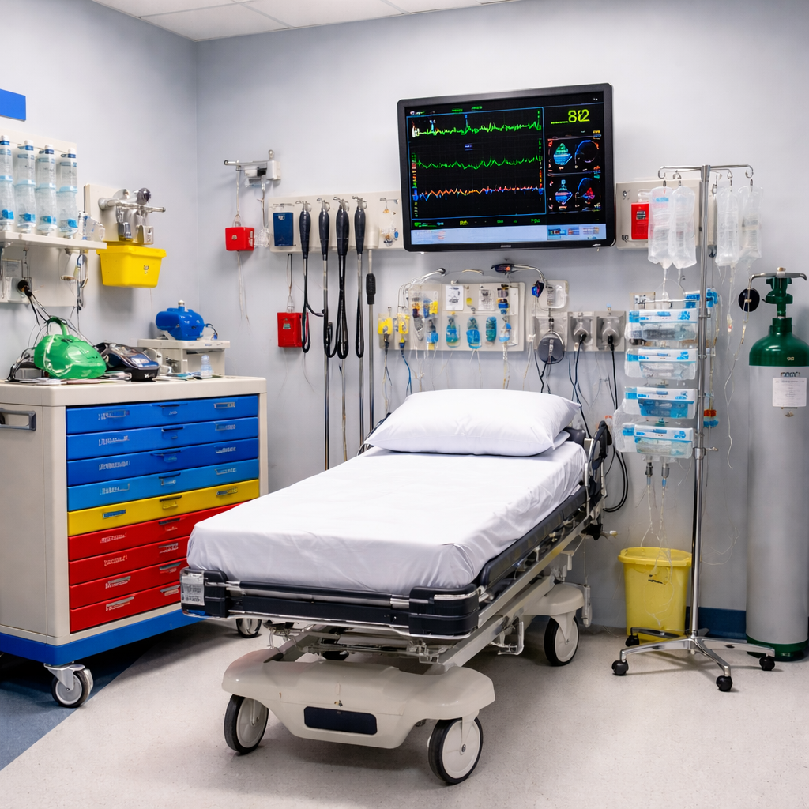
Prompt: Refine with clearer lighting and add labeled monitor waveforms on the screen. Keep no people.

