# **Git使用入门**

# **背景**

# **下载/安装/初次运行**

# **基础**

## **基础概念**

## **Git 有三种状态**

1. 已提交（committed）
2. 已修改（modified）
3. 已暂存（staged）

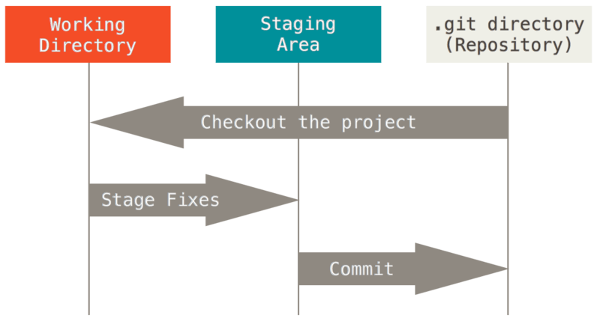  
工作目录、暂存区域以及 Git 仓库.

### **Git 文件的生命周期**

未添加到git库                            未修改                                    被修改                                暂存区  
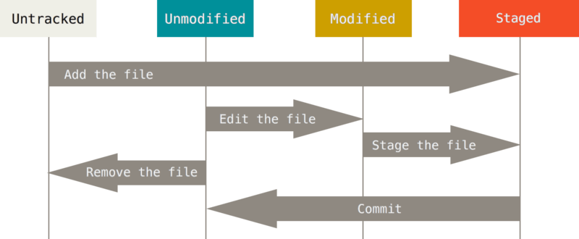

## **基础操作**

### **文件操作**

1. 新增/修改/删除
2. 暂存/取消暂存
3. 提交

### **提交日志**

1. 查看提交日志

### **撤销操作**

#### **修改上次提交**

$ git commit -m 'initial commit'  
$ git add forgotten_file  
$ git commit --amend

#### **WARN:谨慎操作-撤消对文件的修改**

会覆盖本地文件的修改，修改内容无法恢复

Changes not staged for commit:  
 (use "git add <file>..." to update what will be committed)  
 (use "git checkout -- <file>..." to discard changes in working directory)  
 modified: CONTRIBUTING.md  
   
$ git checkout -- CONTRIBUTING.md  
$ git status  
On branch master  
Changes to be committed:  
 (use "git reset HEAD <file>..." to unstage)  
 renamed: README.md -> README

#### **取消暂存(staged)的文件**

$ git add *  
$ git status  
On branch master  
Changes to be committed:  
 (use "git reset HEAD <file>..." to unstage)  
 renamed: README.md -> README  
 modified: CONTRIBUTING.md  
$ git reset HEAD <file>

#### **WARN:谨慎操作-强制恢复文件内容（无论是未跟踪状态或者暂存）**

git reset --hard <file> 使用最新版本内容覆盖本地文件以及暂存区内容，修改内容无法恢复

### **忽略文件**

### **对比**

# **本地开发**

# **远程协作开发**

## **查看远程仓库**

$ git clone https://github.com/schacon/ticgit  
Cloning into 'ticgit'...  
remote: Reusing existing pack: 1857, done.  
remote: Total 1857 (delta 0), reused 0 (delta 0)  
Receiving objects: 100% (1857/1857), 374.35 KiB | 268.00 KiB/s, done.  
Resolving deltas: 100% (772/772), done.  
Checking connectivity... done.  
$ cd ticgit  
$ git remote  
origin

读写远程仓库使用的 Git 保存的简写与其对应的 URL。

$ git remote -v  
originhttps://github.com/schacon/ticgit (fetch)  
originhttps://github.com/schacon/ticgit (push)

## **添加远程仓库**

$ git remote  
origin  
$ git remote add pb https://github.com/paulboone/ticgit  
$ git remote -v  
originhttps://github.com/schacon/ticgit (fetch)  
originhttps://github.com/schacon/ticgit (push)  
pbhttps://github.com/paulboone/ticgit (fetch)  
pbhttps://github.com/paulboone/ticgit (push)

## **从远程仓库中抓取与拉取**

$ git fetch [remote-name]

## **推送到远程仓库**

$ git push origin master

## **查看远程仓库**

$ git remote show origin  
* remote origin  
 Fetch URL: https://github.com/schacon/ticgit  
 Push URL: https://github.com/schacon/ticgit  
 HEAD branch: master  
 Remote branches:  
 master tracked  
 dev-branch tracked  
 Local branch configured for 'git pull':  
 master merges with remote master  
 Local ref configured for 'git push':  
 master pushes to master (up to date)

## **远程仓库的移除与重命名**

$ git remote rename pb paul  
$ git remote  
origin  
paul  
  
$ git remote rm paul  
$ git remote  
origin

## **开发模式**

## **开发流程**

### **pull**

### **本地开发**

### **pull 如果有冲突需要merge**

### **push**

## **Blame**

## **储藏（stash），清理（clean）**

# **数据恢复**

## **引用日志**

## **还原提交**

$ git revert -m 1 HEAD  
[master b1d8379] Revert "Merge branch 'topic'"

# **Git标签**

# **Git分支**

# **GUI客户端**

GitTortoise  
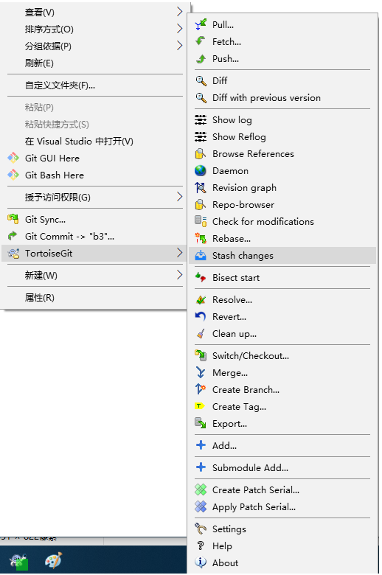

# **SVN 迁移**

## **差异对比**

# **Git 配置**

# **常用命令**

# **常见问题**

# **参考链接**

* [git pro 中文链接](https://git-scm.com/book/zh/v2)