Pooling standardized and unstandardized edges biases a component effect by exactly the untransported edges’ share of the population difference
A simulation study answering catalog problem CMP-11
Ahmad Sofi-Mahmudi
2026-09-23

Abstract
Background. Two-stage component MAIC and STC standardize the individual-data edges to the target and pool them with aggregate edges left in their own populations. Catalog problem CMP-11 asks how large the resulting population mixture is and whether the two-stage route is still the better practical choice.
Methods. Eight trials estimating one component’s effect, a quarter to three quarters with individual data; aggregate trials 0 to 1 SD from the target; effect modification 0 or 0.3; continuous or binary outcome; two-stage pooling with marginal or conditional individual-data edges against transporting every edge to the target; 1000 replicates per cell.
Results. The two-stage bias matched its predicted form, the aggregate edges’ share of the pooled precision times the difference between their own-population and target effects (slope 0.967, 0.997), and was zero whenever modification or separation was zero. At a separation of 0.5 SD it reached -0.106 with coverage 0.265; transporting every edge removed it and had lower RMSE in every such cell (0.038 to 0.089 against 0.047 to 0.113). Pooling conditional rather than marginal individual-data edges added up to 0.033 on the log odds ratio scale.
Conclusion. The two-stage estimate has no single population referent and its bias does not shrink with sample size. Where the aggregate trials’ covariate laws are known well enough to transport them, doing so is better even after paying for the extra variance.

1. The problem
Under linear modification an edge’s effect in population is . MAIC-type standardization (1) moves the individual-data edges to the target; the aggregate edges stay at their own means. The pooled component effect is then biased by , and component STC adds a second term, , from pooling conditional coefficients with marginal aggregate effects on a non-collapsible scale.

2. Design
Registered protocol: protocol.md. Eight trials, 200 per arm; individual-data trials at covariate mean and aggregate trials at , target 0.5; ; outcome on the identity or logit scale. Individual-data edges were fitted with the treatment interaction and standardized to the target by G-computation (marginal) or evaluated at the target mean (conditional). The transported arm shifted every aggregate edge by the effect difference implied by the pooled individual-data interaction, adding the shift’s variance once and ignoring its covariance with the individual-data edges; the aggregate trials’ covariate laws were known exactly, which makes this arm optimistic.

3. Results
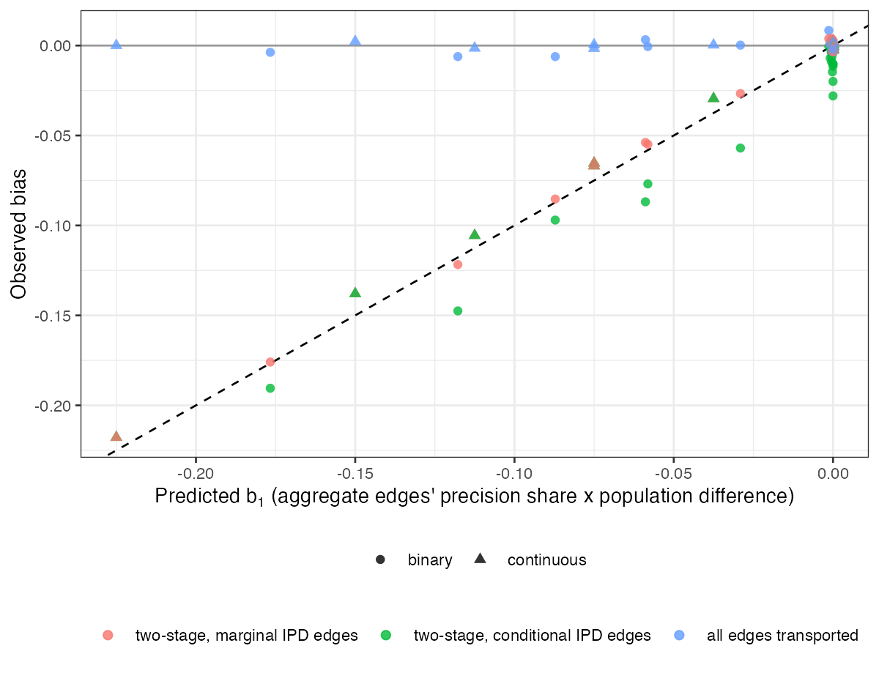
Figure 1: Observed bias against the predicted b_1 in all 36 cells. Dashed: equality.
Table 1: Effect modification 0.3; with no modification every method was unbiased. 1000 replicates per cell; bias MCSE at most 0.005.
scale | IPD share | separation | two-stage marginal: bias (coverage) | two-stage conditional | transported | RMSE two-stage / transported
continuous | 0.25 | 0.0 | 0.001 (0.944) | 0.001 (0.944) | 0.001 (0.944) | 0.040 / 0.040
binary | 0.25 | 0.0 | -0.004 (0.957) | -0.012 (0.954) | -0.004 (0.957) | 0.067 / 0.067
continuous | 0.50 | 0.0 | 0.001 (0.946) | 0.001 (0.946) | 0.001 (0.946) | 0.039 / 0.039
binary | 0.50 | 0.0 | -0.003 (0.939) | -0.020 (0.931) | -0.003 (0.939) | 0.072 / 0.072
continuous | 0.75 | 0.0 | -0.001 (0.946) | -0.001 (0.946) | -0.001 (0.946) | 0.037 / 0.037
binary | 0.75 | 0.0 | -0.002 (0.948) | -0.028 (0.928) | -0.002 (0.948) | 0.070 / 0.070
continuous | 0.25 | 0.5 | -0.106 (0.265) | -0.106 (0.265) | -0.001 (0.940) | 0.113 / 0.050
binary | 0.25 | 0.5 | -0.085 (0.783) | -0.097 (0.743) | -0.006 (0.940) | 0.112 / 0.089
continuous | 0.50 | 0.5 | -0.065 (0.625) | -0.065 (0.625) | -0.002 (0.934) | 0.076 / 0.042
binary | 0.50 | 0.5 | -0.055 (0.878) | -0.077 (0.830) | -0.001 (0.952) | 0.090 / 0.077
continuous | 0.75 | 0.5 | -0.029 (0.888) | -0.029 (0.888) | 0.000 (0.945) | 0.047 / 0.038
binary | 0.75 | 0.5 | -0.027 (0.935) | -0.057 (0.877) | 0.000 (0.944) | 0.078 / 0.075
continuous | 0.25 | 1.0 | -0.218 (0.001) | -0.218 (0.001) | 0.000 (0.906) | 0.222 / 0.074
binary | 0.25 | 1.0 | -0.176 (0.382) | -0.191 (0.332) | -0.004 (0.911) | 0.194 / 0.136
continuous | 0.50 | 1.0 | -0.138 (0.079) | -0.138 (0.079) | 0.002 (0.925) | 0.144 / 0.053
binary | 0.50 | 1.0 | -0.122 (0.665) | -0.147 (0.557) | -0.006 (0.940) | 0.142 / 0.091
continuous | 0.75 | 1.0 | -0.067 (0.639) | -0.067 (0.639) | 0.000 (0.931) | 0.078 / 0.044
binary | 0.75 | 1.0 | -0.054 (0.895) | -0.087 (0.819) | 0.003 (0.936) | 0.094 / 0.085

The refuting sentence failed (Table 1): at 0.5 SD separation the transported arm had the lower RMSE in all six cells, and at 1 SD the two-stage estimates missed the target by more than their own effect when a quarter of the edges had individual data. The bias tracked closely (Figure 1). was zero on the continuous scale, as required, and negative on the log odds ratio scale, growing with the individual-data share because more conditional coefficients entered the pool. The transported arm’s coverage was 0.90 to 0.96, lowest at the largest separation with few individual-data edges, where its variance approximation is weakest.

4. What this does not answer
Eight trials of one component rather than a component network; no one-stage component ML-NMR fit; aggregate covariate laws known exactly; one network size. Peer review has not been done.

References
1. James E. Signorovitch, Eric Q. Wu, Andrew P. Yu, Charles M. Gerrits, Evan Kantor, Yanjun Bao, Shiraz R. Gupta, Parvez M. Mulani. Comparative effectiveness without head-to-head trials: A method for matching-adjusted indirect comparisons applied to psoriasis treatment with adalimumab or etanercept. PharmacoEconomics. 2010;28(10):935–45. doi:10.2165/11538370-000000000-00000

