An aggregate-only treatment’s interaction is identified by assumption, by an ecological gradient or by the prior, and each fails differently
An exact calculation answering catalog problem IDN-06
Ahmad Sofi-Mahmudi
2026-09-23

Abstract
Background. In multilevel network meta-regression a treatment with only aggregate data gets its effect-modifier interaction from a shared-interaction assumption, from the gradient across its trials’ covariate means, or from the prior (1). Catalog problem IDN-06 asks which of these identifies it and what the credible interval then means.
Methods. An exact normal-normal calculation: an individual-data trial of one treatment, one to four aggregate trials of another, discordance between the two interactions of 0 to 0.3, and an ecological term in the aggregate gradient; shared, separate (vague prior) and hierarchical models. Coverage is exact because every posterior mean is linear in normal data.
Results. With one aggregate trial the data carried no information about the treatment’s interaction, yet the shared model’s interval was as narrow as the individual-data trial’s and covered 0.677 and 0.149 at discordance 0.15 and 0.3; the separate model returned its prior. With four aggregate trials the separate model covered nominally until an ecological term of 0.1 entered the gradient, then 0.714. The shared model then covered better only because the ecological bias happened to offset the discordance.
Conclusion. Report where each interaction’s precision comes from. An interval for an aggregate-only treatment’s interaction can come entirely from assumption; one that comes from the gradient inherits ecological bias; neither can be checked from the network alone.

1. The problem
A single aggregate trial reports an effect at one covariate mean and says nothing about how the effect varies with the covariate. Several trials at different means give a between-trial gradient, which is exposed to study-level confounding. The shared restriction imports another treatment’s within-trial interaction, which is right only if the two interactions agree. A Bayesian fit converges in all three cases and reports a proper interval; the source of its precision is not reported.

2. Design
Registered protocol: protocol.md. with ; aggregate trials of treatment at covariate means spread 0.3 or 1 around 0.5, each with variance 0.01, plus , ; . Shared: , combining the within-trial estimate and the gradient. Separate: prior and the gradient. Hierarchical: and the gradient. The direct share is the part of the posterior precision coming from information about itself.

3. Results
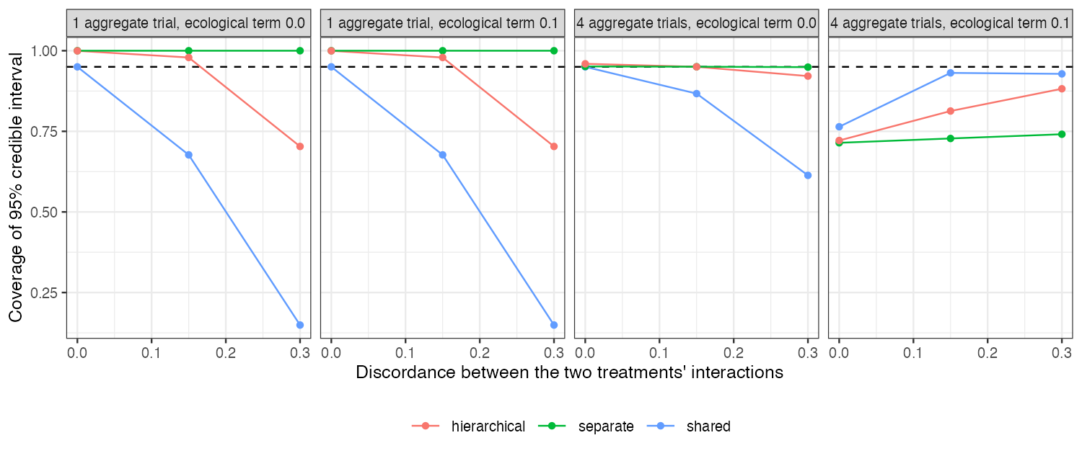
Figure 1: Coverage of the 95% credible interval for the aggregate-only treatment’s interaction (covariate-mean spread 1).
Table 1: Covariate-mean spread 1. Full table in results/decision.md.
trials | discordance | ecological | model | bias | posterior SD | coverage | direct share
1 | 0.00 | 0.0 | shared | 0.000 | 0.100 | 0.950 | 0.000
1 | 0.00 | 0.0 | separate | -0.300 | 0.500 | 1.000 | 0.000
1 | 0.00 | 0.0 | hierarchical | 0.000 | 0.180 | 1.000 | 0.000
4 | 0.00 | 0.0 | shared | 0.000 | 0.056 | 0.950 | 0.690
4 | 0.00 | 0.0 | separate | -0.005 | 0.066 | 0.951 | 0.982
4 | 0.00 | 0.0 | hierarchical | 0.000 | 0.063 | 0.959 | 0.878
1 | 0.15 | 0.0 | shared | -0.150 | 0.100 | 0.677 | 0.000
1 | 0.15 | 0.0 | separate | -0.450 | 0.500 | 1.000 | 0.000
1 | 0.15 | 0.0 | hierarchical | -0.150 | 0.180 | 0.979 | 0.000
4 | 0.15 | 0.0 | shared | -0.047 | 0.056 | 0.867 | 0.690
4 | 0.15 | 0.0 | separate | -0.008 | 0.066 | 0.950 | 0.982
4 | 0.15 | 0.0 | hierarchical | -0.018 | 0.063 | 0.950 | 0.878
1 | 0.30 | 0.0 | shared | -0.300 | 0.100 | 0.149 | 0.000
1 | 0.30 | 0.0 | separate | -0.600 | 0.500 | 1.000 | 0.000
1 | 0.30 | 0.0 | hierarchical | -0.300 | 0.180 | 0.703 | 0.000
4 | 0.30 | 0.0 | shared | -0.093 | 0.056 | 0.613 | 0.690
4 | 0.30 | 0.0 | separate | -0.011 | 0.066 | 0.949 | 0.982
4 | 0.30 | 0.0 | hierarchical | -0.036 | 0.063 | 0.921 | 0.878
1 | 0.00 | 0.1 | shared | 0.000 | 0.100 | 0.950 | 0.000
1 | 0.00 | 0.1 | separate | -0.300 | 0.500 | 1.000 | 0.000
1 | 0.00 | 0.1 | hierarchical | 0.000 | 0.180 | 1.000 | 0.000
4 | 0.00 | 0.1 | shared | 0.069 | 0.056 | 0.764 | 0.690
4 | 0.00 | 0.1 | separate | 0.093 | 0.066 | 0.714 | 0.982
4 | 0.00 | 0.1 | hierarchical | 0.088 | 0.063 | 0.722 | 0.878
1 | 0.15 | 0.1 | shared | -0.150 | 0.100 | 0.677 | 0.000
1 | 0.15 | 0.1 | separate | -0.450 | 0.500 | 1.000 | 0.000
1 | 0.15 | 0.1 | hierarchical | -0.150 | 0.180 | 0.979 | 0.000
4 | 0.15 | 0.1 | shared | 0.022 | 0.056 | 0.931 | 0.690
4 | 0.15 | 0.1 | separate | 0.090 | 0.066 | 0.728 | 0.982
4 | 0.15 | 0.1 | hierarchical | 0.070 | 0.063 | 0.813 | 0.878
1 | 0.30 | 0.1 | shared | -0.300 | 0.100 | 0.149 | 0.000
1 | 0.30 | 0.1 | separate | -0.600 | 0.500 | 1.000 | 0.000
1 | 0.30 | 0.1 | hierarchical | -0.300 | 0.180 | 0.703 | 0.000
4 | 0.30 | 0.1 | shared | -0.024 | 0.056 | 0.928 | 0.690
4 | 0.30 | 0.1 | separate | 0.088 | 0.066 | 0.741 | 0.982
4 | 0.30 | 0.1 | hierarchical | 0.051 | 0.063 | 0.882 | 0.878

The registered primary was confirmed (Figure 1, Table 1): the shared model’s coverage fell to 0.149 at nonzero discordance while the separate model covered 0.942 to 0.955 wherever it had a gradient and no ecological term. The three failures are distinct. Assumption: with one aggregate trial the direct share was zero for every model; the shared interval was narrow and wrong under discordance, and the hierarchical interval covered only as far as its prior spread allowed. Ecology: with a gradient, the separate model’s direct share was near 1 and its bias was the ecological term. Offsetting: the shared model combined both sources and could look right when the two errors cancelled.

4. What this does not answer
Conjugate normal models on contrast-level data rather than multinma fits; one covariate; fixed prior scales; the shared model’s gradient and within-trial information are pooled by precision as a linear model would pool them. Peer review has not been done.

References
1. David M. Phillippo, Sofia Dias, A. E. Ades, Mark Belger, Alan Brnabic, Alexander Schacht, Daniel Saure, Zbigniew Kadziola, Nicky J. Welton. Multilevel network meta-regression for population-adjusted treatment comparisons. Journal of the Royal Statistical Society Series A. 2020;183(3):1189–210. doi:10.1111/rssa.12579

