A partition-sensitivity display for shared effect modifiers is stable exactly when every candidate partition is wrong
A simulation study answering catalog problem IDN-19
Ahmad Sofi-Mahmudi
2026-09-23

Abstract
Background. Multilevel network meta-regression identifies an aggregate-only treatment’s interaction by assuming it shares effect modification with other treatments in its class (1). Nothing governs the partition, and wider classes fit and converge more easily. Catalog problem IDN-19 asks whether the target contrast is sensitive to the partition and whether a sensitivity display over defensible partitions would reveal a wrong one.
Methods. A network with individual data on A versus B, two aggregate trials of A versus C at different covariate means, and one aggregate trial of A versus D; D’s and C’s interactions differing from B’s or not; three partitions that identify the D versus A target contrast; 4000 replicates per cell.
Results. When D’s interaction differed from both B’s and C’s (by 0.3) while theirs agreed, every partition returned the same answer, biased by -0.298: the range over partitions had mean width 0.137, contained the truth in 5% of replicates, and the only available fit test rejected in 5%. The widest partition covered 0.366. When C’s interaction differed from B’s, the partitions disagreed, the range widened to 0.307, and the correct partition was in it.
Conclusion. Partition sensitivity reveals disagreement among the candidate classes, not whether the aggregate-only treatment belongs to any of them. A stable range is not evidence that the partition is right.

1. The problem
An aggregate trial of D at one covariate mean identifies D’s effect at that mean, not its interaction. Transporting D to a target at a different mean needs the interaction, which a shared-modifier class borrows from other treatments. The borrowed value can be tested only against treatments whose own interactions are identified, so the assumption is testable where it is not needed. A display of the target contrast across admissible partitions is the natural safeguard; this study measures when it works.

2. Design
Registered protocol: protocol.md. Effect of treatment against A: with , , , , . Individual data on A versus B (400 patients); aggregate A versus C at covariate means and ; aggregate A versus D at 0; each aggregate effect with variance 0.01. Target covariate mean 1. Partitions {BCD}, {BD}{C} and {B}{CD} were fitted by generalized least squares on the sufficient statistics; only {BCD} has residual degrees of freedom for a fit test.

3. Results
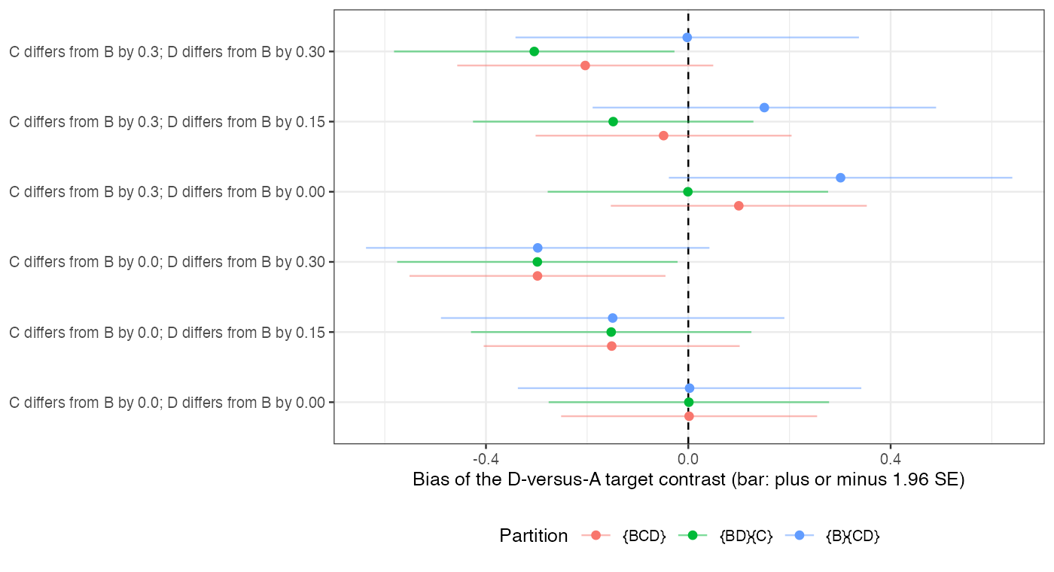
Figure 1: Bias of the D-versus-A target contrast by partition. Bars span 1.96 SE either side of the bias.
Table 1: 4000 replicates per cell.
C differs | D differs | range of estimates contains truth | range of intervals contains truth | range width (estimates) | widest partition coverage | its fit test rejects
0.0 | 0.00 | 36% | 99% | 0.138 | 0.947 | 5%
0.3 | 0.00 | 48% | 98% | 0.307 | 0.884 | 41%
0.0 | 0.15 | 21% | 95% | 0.135 | 0.781 | 5%
0.3 | 0.15 | 69% | 100% | 0.304 | 0.933 | 39%
0.0 | 0.30 | 5% | 70% | 0.137 | 0.366 | 5%
0.3 | 0.30 | 48% | 98% | 0.307 | 0.647 | 41%

The registered primary was confirmed (Figure 1, Table 1). With C like B and D unlike both, the widest partition was biased by -0.298 with coverage 0.366, and its fit test rejected at the nominal rate: the test compares C’s interaction with B’s, the one comparison the data can make, and says nothing about D’s. The other two partitions borrowed D’s interaction from B or from C, which agreed, so they gave the same wrong answer and the sensitivity range was narrow. Only when the candidate classes themselves disagreed (C unlike B) did the range widen, and then it contained the correct partition’s estimate, with {B}{CD} unbiased when D shared C’s interaction and {BD}{C} when it shared B’s.

4. What this does not answer
A small hand-built network with a continuous outcome and linear modification, three admissible partitions, sufficient statistics drawn directly; no overlap factor, larger networks or ML-NMR fits. Peer review has not been done.

References
1. David M. Phillippo, Sofia Dias, A. E. Ades, Mark Belger, Alan Brnabic, Alexander Schacht, Daniel Saure, Zbigniew Kadziola, Nicky J. Welton. Multilevel network meta-regression for population-adjusted treatment comparisons. Journal of the Royal Statistical Society Series A. 2020;183(3):1189–210. doi:10.1111/rssa.12579

