A stability screen for a bridging assumption refutes rarely and cannot confirm
A simulation study answering catalog problem ADJ-09
Ahmad Sofi-Mahmudi
2026-09-23

Abstract
Background. A bridging assumption carries an effect into a gap where no trial exists. Checking the stability of effects across the trials that do exist can refute the bridge but never confirm it. Catalog problem ADJ-09 asks how such a screen performs and whether screening marginal effects creates false alarms through non-collapsibility.
Methods. Four or ten trials whose covariate laws and baseline risks differ, and a gap environment beyond them. The conditional log odds ratio was constant (valid bridge), drifted with an environment feature visibly across the trials and into the gap, or drifted only in the gap. Cochran’s screen abstaining at , on marginal, conditional or standardized log odds ratios: 20 scenarios and 3 controls, 1000 replicates each.
Results. Under a valid bridge with strong prognostic covariates the marginal screen abstained in 0.190 to 0.237 of analyses against 0.113 to 0.124 on the conditional scale; standardizing first removed the excess. Drift visible across the trials that biased the gap estimate by about 0.28 was flagged in only 0.201 to 0.238 of analyses, and drift of twice that size in 0.502 to 0.665. Drift confined to the gap was never flagged above the null rate. Among analyses that passed, coverage in the gap was no better than among all analyses.
Conclusion. Run stability screens on conditional or standardized effects. Treat a pass as uninformative about the gap and a failure as a prompt for sensitivity analysis: with realistic numbers of trials the screen misses most drift it could in principle see.

1. The problem
Invariance across the observed environments is a property of those environments. A bridge can fail in the gap while every observed trial agrees, so a stability screen, like invariant-prediction methods generally (1), can only refute. Whether a failed screen predicts failure in the gap depends on whether the mechanism that varies across trials is the one the bridge relies on. A second problem is a design artifact: on the odds ratio scale the marginal effect varies with the covariate distribution and baseline risk even when the conditional effect is constant, so a screen on marginal effects fires wherever trial populations differ.

2. Design
Registered protocol: protocol.md; ADEMP structure (2). Trial at environment feature , 300 per arm, with , baseline , . Gap at ; estimand the conditional log odds ratio there. Drift: none; linear in at 0.15 or 0.3 per unit; or zero on and rising only beyond. Screen: Cochran’s (3) across trial estimates. The transported estimate is the pooled conditional log odds ratio. Controls: identical trials; a linear risk model with constant risk difference, where the marginal scale is collapsible; large visible drift.

3. Results
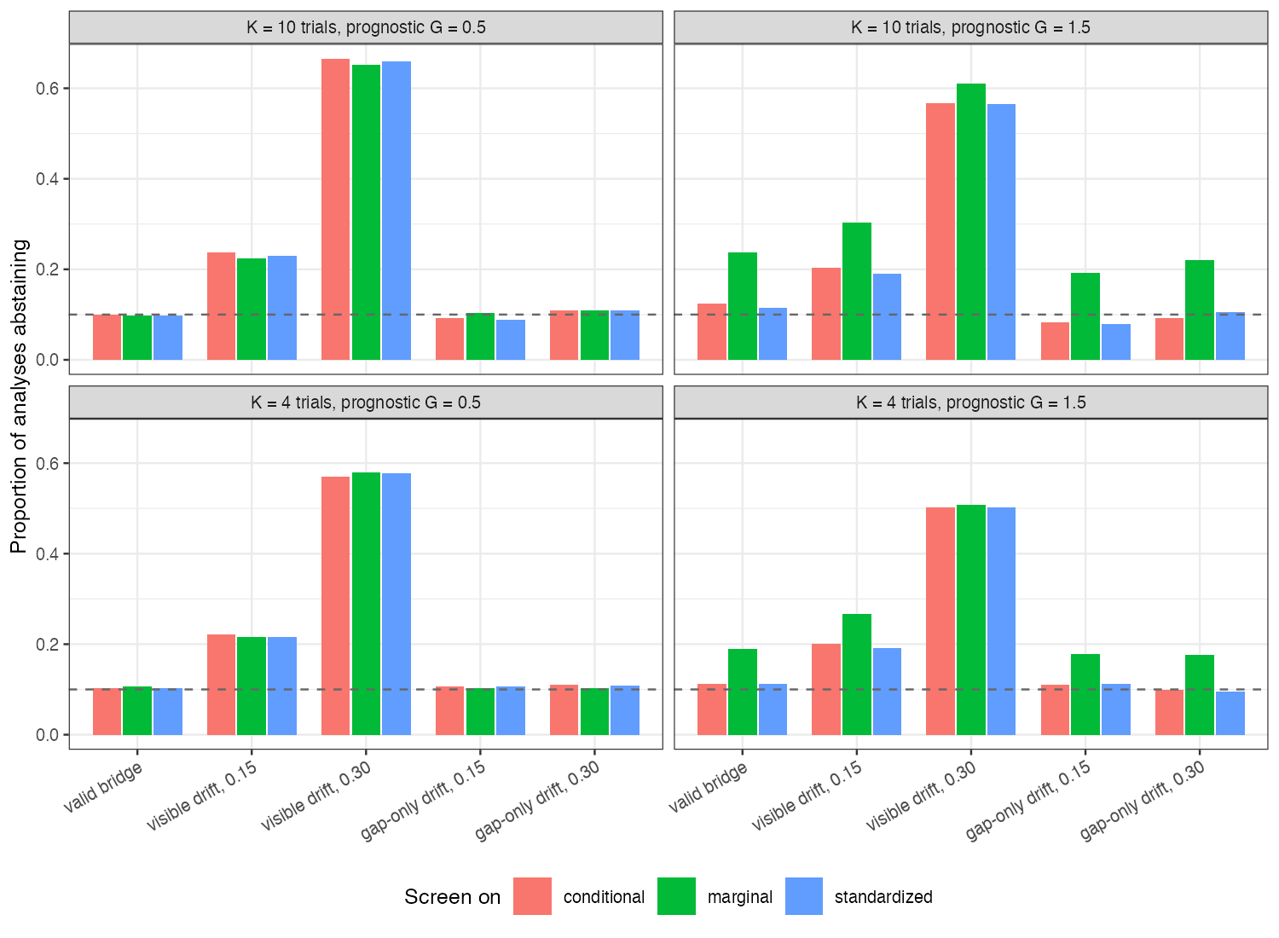
Figure 1: Proportion of analyses abstaining by screen scale and scenario. The dashed line is the nominal 0.10.
The non-collapsibility artifact was confirmed (Figure 1): with the marginal screen’s false abstention exceeded the conditional one’s by 0.077 to 0.113, growing with the number of trials. With the scales agreed. On the collapsible risk-difference scale the marginal screen stayed at 0.117, and with identical trials every screen was near nominal. The conditional screen itself ran slightly above nominal with strong prognosis (up to 0.124).
Sensitivity to visible drift rose with its size and slightly with the number of trials but stayed low: a pooled estimate biased by about 0.28 in the gap was reported without abstention in about four of five analyses. Large drift (0.6 per unit, the positive control) was flagged in 0.995 of analyses. Gap-only drift was indistinguishable from a valid bridge, as it must be, while biasing the gap estimate by up to 0.60.
Screening did not improve the analyses that were reported: coverage among passed analyses differed from coverage among all by at most 0.011.

4. What this does not answer
One event-rate level, no measurement shift between trials, and Cochran’s rather than a sign-stability rule or a formal invariance test. Environments were valid by construction; in practice establishing that trials are exchangeable environments is the hard part. Peer review has not been done.

References
1. Jonas Peters, Peter Bühlmann, Nicolai Meinshausen. Causal inference by using invariant prediction: Identification and confidence intervals. Journal of the Royal Statistical Society Series B. 2016;78(5):947–1012. doi:10.1111/rssb.12167
2. Tim P. Morris, Ian R. White, Michael J. Crowther. Using simulation studies to evaluate statistical methods. Statistics in Medicine. 2019;38(11):2074–102. doi:10.1002/sim.8086
3. William G. Cochran. The combination of estimates from different experiments. Biometrics. 1954;10(1):101–29. doi:10.2307/3001666

