Double robustness does not cover an omitted confounder, and the two errors add
A simulation study answering catalog problem QBA-11
Ahmad Sofi-Mahmudi
2026-09-23

Abstract
Background. Doubly robust (augmented weighting) estimators for unanchored comparisons (1) are consistent if either the weighting or the outcome model is correct. Catalog problem QBA-11 asks what this does and does not protect against, in particular an omitted confounder and a sensitivity grid built on a misspecified model.
Methods. Unanchored transport of a continuous outcome with a quadratic covariate effect, target covariate variances differing from the source’s, and an omitted binary confounder with strength and source-target prevalence difference 0.1 or 0.3, at two overlap levels: 16 scenarios, 2000 replicates each. MAIC, outcome regression and the augmented estimator under every combination of correct and misspecified weighting and outcome models.
Results. With both models correct the augmented estimator’s bias equaled the omitted-variable bias in every scenario and coincided with the correctly specified single-model estimators (largest difference 0.002). At it was unbiased with either model wrong (at most 0.003), where the corresponding single-model estimator was biased by up to 0.202. With both models wrong, the misspecification bias and the omitted-variable bias added (largest interaction 0.008). With exact-balance weights, augmentation by an outcome model built from the balanced terms reproduced MAIC.
Conclusion. Double robustness protects against one wrong nuisance model and nothing else. An omitted confounder biases every consistent estimator equally, and a sensitivity grid built on a misspecified analysis is shifted by the misspecification bias, which moves its tipping point while its width looks right.

1. The problem
Every estimator consistent for the observed-data functional converges to when a confounder with outcome effect and prevalence difference is omitted. Double robustness concerns which nuisance models must be right to reach ; it says nothing about the distance from to . A sensitivity analysis indexes that distance by but starts from the estimate, so any misspecification bias translates the whole region.
With exact-balance (entropy) weights, whenever is linear in the balanced functions, so the augmentation term vanishes and the augmented estimator equals MAIC (2). The probe showed this for two of DESIGN.md’s four augmented arms; augmentation changes the estimate only when the outcome model contains terms the weights do not balance.

2. Design
Registered protocol: protocol.md; ADEMP structure (3). Source: 300 patients of A, ; . Target , , reporting means and SDs; . Omitted with prevalence in the source and 0.3 in the target. Weighting on means only is wrong because the variances differ; on means and second moments it is right. A linear outcome model is wrong; one with is right. Estimand: the target mean of .

3. Results
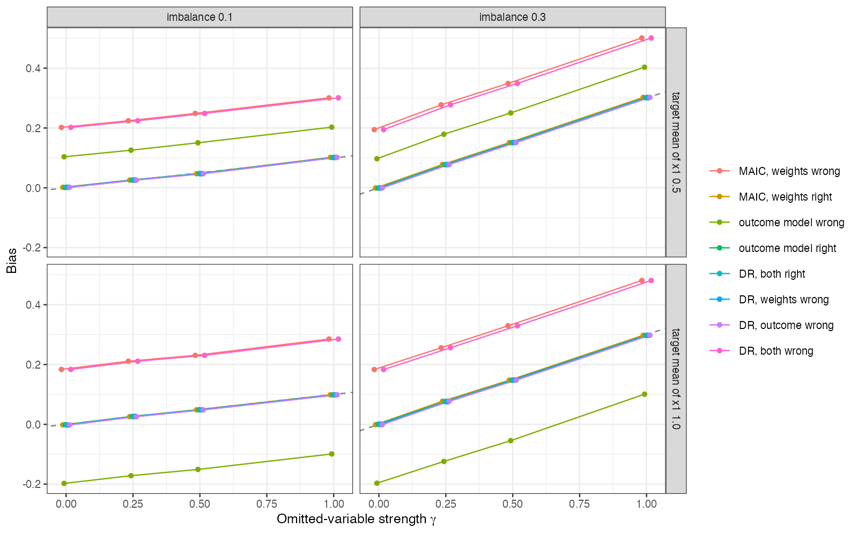
Figure 1: Bias against omitted-variable strength. The dashed line is the omitted-variable bias \gamma\delta. Correct and doubly robust estimators lie on it; misspecified ones run parallel to it.
Figure 1 is the demonstration the catalog asked for. The table at , :
weighting | outcome model | MAIC or outcome regression, | augmented, | augmented,
right | right | -0.000 | -0.000 | 0.302
wrong | right | 0.195 | -0.001 | 0.301
right | wrong | 0.097 | -0.000 | 0.302
wrong | wrong |  | 0.195 | 0.501
The third column is the single-model estimator built on the wrong model in that row (MAIC in the second, outcome regression in the third). The augmented estimator is right whenever one model is, and its bias at is in the first three rows; with both models wrong the two biases add.
The registered sensitivity-region criterion was not met as stated: a misspecified analysis’s region contained the truth at in 0.888 of replicates, just under the 0.90 threshold. The region was defined as the estimate minus the declared bias range, without sampling error, so even a correct analysis included the truth only half the time; the criterion was badly posed. The location error it was meant to expose is clear regardless: the misspecified analysis’s region was displaced by 0.195 at and 0.201 at , a constant shift comparable to the largest declared bias.

4. What this does not answer
Continuous outcome, where the omitted-variable bias is exactly ; on a non-collapsible scale the correct outcome model is only approximately correct after omitting . Parametric nuisance models without cross-fitting; drMAIC’s E-value screen and a formally bias-indexed doubly robust estimator were not run. Peer review has not been done.

References
1. Harlan Campbell, Antonio Remiro-Azócar. Doubly robust augmented weighting estimators for the analysis of externally controlled single-arm trials and unanchored indirect treatment comparisons. Research Synthesis Methods. 2026. doi:10.1017/rsm.2026.10106
2. Qingyuan Zhao, Daniel Percival. Entropy balancing is doubly robust. Journal of Causal Inference. 2017;5(1):20160010. doi:10.1515/jci-2016-0010
3. Tim P. Morris, Ian R. White, Michael J. Crowther. Using simulation studies to evaluate statistical methods. Statistics in Medicine. 2019;38(11):2074–102. doi:10.1002/sim.8086

