Flexible outcome models reduced but did not remove transport bias where the target left the data, and could not see a modification they were not built to see
A simulation study answering catalog problem MOD-02
Ahmad Sofi-Mahmudi
2026-09-23

Abstract
Background. Flexible outcome models are proposed to remove the misspecification bias of parametric simulated treatment comparison (STC). Catalog problem MOD-02 asks whether they do so under adversarial response surfaces, and at what cost to interval validity.
Methods. A binary-outcome trial with one adversarial feature at a time (a threshold prognostic effect, a hinge in the treatment effect, or a covariate-by-covariate modification); targets 0.5, 1 and 1.5 SD from the source; parametric STC, a generalized additive model with smooth treatment modification, and one with linear modification, each standardized by G-computation; 500 replicates per cell.
Results. Under the hinge modification at the farthest target, STC was biased by -0.144 and the smooth-modification GAM by -0.085 (coverage 0.930): a reduction of about 40%, short of the registered halving, with the same RMSE because its variance was larger. Under the covariate-by-covariate modification every method was biased by about -0.175, because additive smooths cannot represent a product. The threshold prognostic term cancelled in all methods.
Conclusion. Flexibility helped only against misspecification in the shape it could represent and only partly where the target lay beyond the data. Transport bias from surfaces outside the model’s span is unchanged by flexibility within it.

1. The problem
Transport integrates the fitted outcome model over the target. Where the target’s covariates fall beyond the source’s, the fitted surface there is an extrapolation, and a flexible model’s extrapolation is set by its smoothing penalty (1) rather than by data. The catalog’s refuting sentence says flexibility trades transparent for opaque misspecification.

2. Design
Registered protocol: protocol.md. Source , 300 per arm; with PROG (A), MOD (B) or (C). Target , . The smooth-modification GAM has baseline smooths and centered treatment-difference smooths in each covariate (mgcv, REML); the structured GAM has smooth prognostic terms and linear modification. Delta-method SEs; the GAM formula was corrected before any result was read (protocol.md, section 4).

3. Results
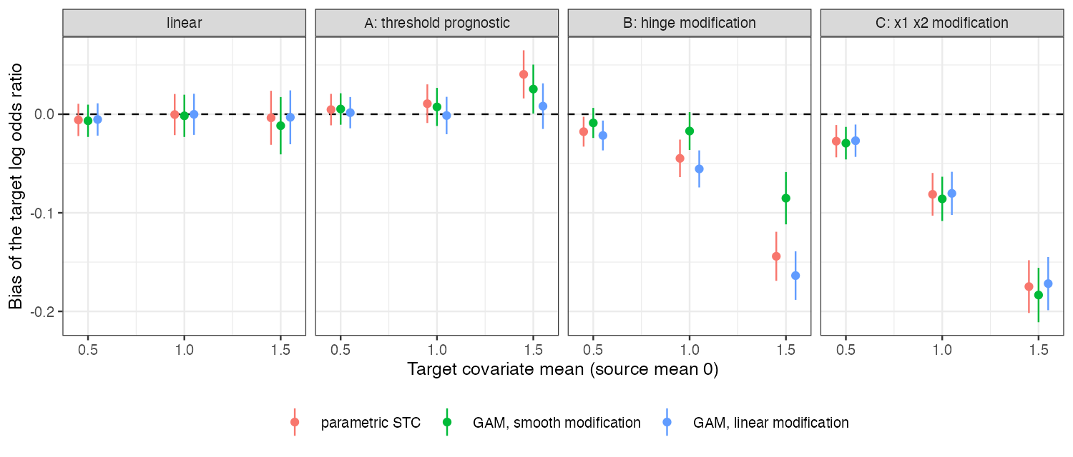
Figure 1: Bias of the target log odds ratio by surface and target distance.
Table 1: 500 replicates per cell; bias MCSE at most 0.015.
surface | target mean | STC: bias (coverage) | GAM, smooth modification | GAM, linear modification
none | 0.5 | -0.006 (0.960) | -0.007 (0.958) | -0.005 (0.960)
A | 0.5 | 0.005 (0.954) | 0.005 (0.950) | 0.002 (0.950)
B | 0.5 | -0.018 (0.950) | -0.009 (0.944) | -0.022 (0.948)
C | 0.5 | -0.027 (0.950) | -0.029 (0.952) | -0.027 (0.956)
none | 1.0 | -0.000 (0.950) | -0.002 (0.940) | -0.000 (0.952)
A | 1.0 | 0.011 (0.950) | 0.007 (0.944) | -0.001 (0.946)
B | 1.0 | -0.045 (0.950) | -0.017 (0.942) | -0.055 (0.946)
C | 1.0 | -0.081 (0.932) | -0.086 (0.922) | -0.080 (0.926)
none | 1.5 | -0.004 (0.940) | -0.012 (0.944) | -0.003 (0.946)
A | 1.5 | 0.040 (0.962) | 0.026 (0.942) | 0.008 (0.956)
B | 1.5 | -0.144 (0.930) | -0.085 (0.930) | -0.164 (0.904)
C | 1.5 | -0.175 (0.904) | -0.183 (0.914) | -0.172 (0.910)

The registered primary found the refuting sentence to hold (Table 1, Figure 1). Bias grew with target distance for every method on surfaces B and C. The smooth-modification GAM tracked the hinge better than STC at every distance but still lost most of its advantage to variance at the farthest target (RMSE 0.314 against 0.318). The structured GAM, which imposes linear modification, was no better than STC on B. Coverage stayed near 0.90 to 0.93 in the biased cells because the intervals were wide (empirical SD about 0.3).

4. What this does not answer
No BART, random forest, doubly robust or ML-NMR arm; logit link, one sample size; model-based intervals only. MOD-10’s question, whether flexibility helps at low and hurts at high unsupported mass, is read off these cells in its note. Peer review has not been done.

References
1. Simon N. Wood. Fast stable restricted maximum likelihood and marginal likelihood estimation of semiparametric generalized linear models. Journal of the Royal Statistical Society Series B. 2011;73(1):3–36. doi:10.1111/j.1467-9868.2010.00749.x

