Modifier discovery across trials: no penalty is both stable and powerful, and study-level heterogeneity creates a false modifier that more trials entrench
A simulation study answering catalog problem ADJ-10
Ahmad Sofi-Mahmudi
2026-09-23

Abstract
Background. Population adjustment needs the effect modifiers, and data-driven discovery from pooled trial data is proposed when they are unknown. Catalog problem ADJ-10 asks whether discovered sets are stable and correct enough to use, and whether study-level factors create modifiers that more data do not remove.
Methods. Three to twelve trials with 2400 patients in total, ten candidate covariates whose means vary across trials, one or three true modifiers, and an unmeasured study-level factor that shifts the treatment effect and, when confounded, tracks one covariate’s trial mean. Lasso on the interactions at the minimum-cross-validation penalty and by the one-standard-error rule, pooled or with trial-specific treatment effects; 300 replicates per cell, each with an independent second dataset for stability.
Results. At the minimum-error penalty the true modifiers were found in almost every analysis, together with 1.65 to 2.83 false modifiers among seven null covariates, and the selected sets agreed across independent datasets with Jaccard similarity 0.37 to 0.57. The one-standard-error rule was stable only when it selected nothing: a single modifier was found in 0.027 to 0.053 of analyses. With study-level confounding, pooled discovery selected the confounded covariate in 0.69 of analyses with 3 trials and 0.93 with 12; trial-specific treatment effects held it to 0.14 to 0.46, the rate for any null covariate.
Conclusion. Discovery is a hypothesis generator. Where effect heterogeneity has a study-level cause, pooled discovery converts it into a false modifier, and more trials at the same total size make that more certain, not less.

1. The problem
A covariate modifies the treatment effect within trials if patients who differ in it respond differently. Across trials, a covariate whose trial mean correlates with the trial’s treatment effect looks like a modifier whatever the reason, the ecological bias that IPD meta-analysis guidance separates by estimating interactions within trials (1). A pooled analysis with one treatment effect uses both sources. When a study-level factor such as a protocol difference moves the treatment effect, every covariate whose trial means happen to follow it becomes a candidate modifier.

2. Design
Registered protocol: protocol.md. trials of patients; covariates with trial means ; , , with an unmeasured . With confounding (), . Lasso (2) penalizes only the ten interactions; the pooled model has one treatment effect, the within-trial model one per trial. Both penalties come from one cross-validated fit. The target effect at covariate means 0.5 and is refitted by least squares with the selected interactions.

3. Results
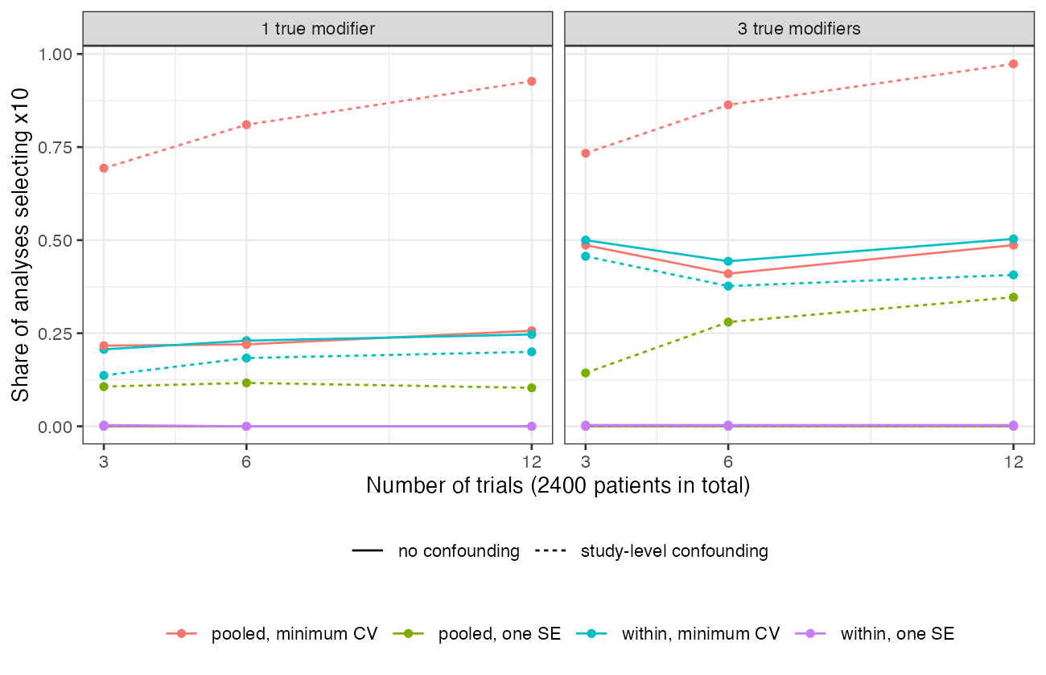
Figure 1: Share of analyses selecting the confounded covariate x_{10}. Dashed: no confounding, where x_{10} is an ordinary null covariate.
Table 1: Ranges over the number of trials (and modifiers where not stated); 300 replicates per cell. Power is the share of true modifiers selected; the false-modifier count excludes x_{10}.
analysis | power | false modifiers (of 7) | stability | target bias
pooled, minimum CV, no confounding | 1.00 to 1.00 | 1.65 to 2.83 | 0.37 to 0.57 | -0.001 to 0.005
pooled, minimum CV, confounding | 0.99 to 1.00 | 3.56 to 3.87 | 0.41 to 0.68 | 0.023 to 0.057
within-trial, minimum CV, confounding | 0.99 to 1.00 | 1.55 to 2.76 | 0.40 to 0.58 | -0.010 to 0.008
one SE rule, one modifier, no confounding | 0.027 to 0.053 | 0.00 to 0.01 | 0.90 to 0.95 | -0.095 to -0.089
one SE rule, three modifiers, no confounding | 0.37 to 0.59 | 0.00 to 0.02 | 0.39 to 0.42 | -0.178 to -0.109

The registered condition for usability, stability of at least 0.8 with at most 0.5 false modifiers in every cell, failed for every method (Table 1). The minimum-error penalty traded stability for power; the one-standard-error rule’s high stability with a single modifier was agreement on the empty set, and its target estimate was biased toward no modification.
Study-level confounding affected pooled discovery in two ways (Figure 1). It selected more often as trials were added at the same total size, because more trials give more trial means with which to fit the study-level pattern. And it raised the false modifiers among the other null covariates from 1.65 to 2.83 to 3.56 to 3.87, because their trial means correlate with by chance. Trial-specific treatment effects absorbed and removed both effects. The pooled minimum-error target estimate was biased by 0.023 to 0.057, the spurious interaction times the target mean.

4. What this does not answer
Lasso only; multi-study causal forests and other flexible learners were not run. Continuous outcome, so event sparsity is absent; linear modification; one overlap level. The within-trial analysis needs the IPD of every trial. Selected sets are evaluated as hypotheses; post-selection inference for the target is DEC-11’s and COV-04’s subject. Peer review has not been done.

References
1. Richard D. Riley, Thomas P. A. Debray, David Fisher, Miriam Hattle, Nadine Marlin, Jeroen Hoogland, François Gueyffier, Jan A. Staessen, Jiguang Wang, Karel G. M. Moons, Johannes B. Reitsma, Joie Ensor. Individual participant data meta-analysis to examine interactions between treatment effect and participant-level covariates: Statistical recommendations for conduct and planning. Statistics in Medicine. 2020;39(15):2115–37. doi:10.1002/sim.8516
2. Robert Tibshirani. Regression shrinkage and selection via the lasso. Journal of the Royal Statistical Society Series B. 1996;58(1):267–88. doi:10.1111/j.2517-6161.1996.tb02080.x

