Shrinkage priors on interactions do not give honest intervals for a transported effect
A simulation study answering catalog problem COV-04
Ahmad Sofi-Mahmudi
2026-09-23

Abstract
Background. Simulated treatment comparison needs the treatment-by-covariate interactions, and with many candidates analysts shrink or select them. Continuous shrinkage does not select, so its posterior interval is often taken to be honest by construction. Catalog problem COV-04 asks whether it is.
Methods. Continuous-outcome STC with eight candidate interactions, one strong modifier or three moderate ones, 100 or 300 patients per arm; 1000 replicates per cell with the whole procedure rerun each time. Five priors on the interactions: flat, empirical-Bayes ridge, hierarchical normal, spike-and-slab averaging and the median-probability model.
Results. Coverage of the transported effect’s 95% interval was 0.794 to 0.948 for empirical-Bayes ridge, 0.868 to 0.959 for the hierarchical normal, 0.908 to 0.974 for spike-and-slab averaging, 0.785 to 0.931 for the median-probability model and 0.939 to 0.955 for the flat prior. Every non-flat prior’s bias was negative, toward no effect modification, reaching 0.191 with three moderate modifiers at 100 per arm.
Conclusion. Shrinkage does not select but it still undercovers: when the interactions the target weights push the effect in one direction, their joint shrinkage biases the transported effect and the narrower interval does not carry that bias. Only the flat prior was honest in every cell.

1. The problem
The transported effect in STC is the conditional effect plus the interactions weighted by the target’s covariate means. Shrinking the interactions toward zero pulls that sum toward the source-population effect. If the interactions share a sign relative to the target shift, the pull accumulates rather than averaging out. A posterior interval is centered on the shrunk sum and is narrower than the flat one, so whether it covers at a fixed truth is an empirical question, not a property of the prior class. The median-probability model (1) conditions on a selected set and is the Bayesian form of DEC-11’s selection problem.

2. Design
Registered protocol: protocol.md; ADEMP as in (2). Eight independent covariates; , , with on one covariate or on three. Target covariate means 0.5; estimand . Main effects flat, residual SD plugged in, conjugate normal posteriors computed exactly. Empirical-Bayes ridge sets the interaction prior SD by maximizing the marginal likelihood; the hierarchical normal integrates it over a half-Cauchy(0, 0.5) prior (3); spike-and-slab averages over all 256 inclusion patterns (slab SD 0.5, inclusion probability 0.5).

3. Results
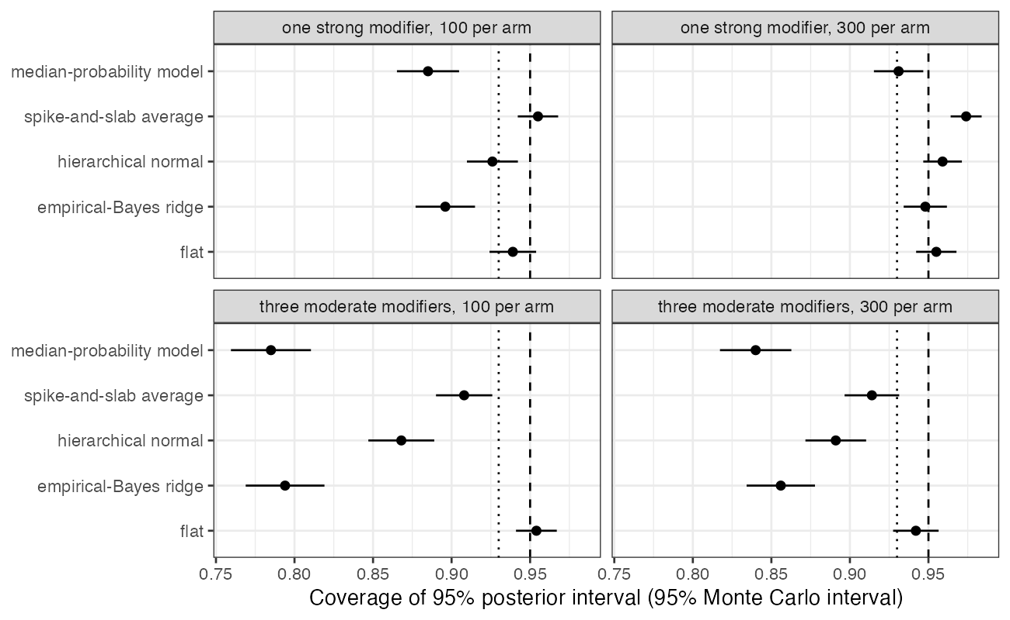
Figure 1: Coverage by prior. Dashed: nominal 0.95; dotted: the registered threshold 0.93.
Table 1: 1000 replicates per cell; coverage MCSE at most 0.013.
n per arm | modifiers | prior | bias | coverage | width
100 | one strong | eb ridge | -0.109 | 0.896 | 0.813
100 | one strong | flat | -0.002 | 0.939 | 1.004
100 | one strong | hier normal | -0.105 | 0.926 | 0.862
100 | one strong | median model | -0.030 | 0.885 | 0.664
100 | one strong | spike slab | -0.036 | 0.955 | 0.829
300 | one strong | eb ridge | -0.045 | 0.948 | 0.523
300 | one strong | flat | 0.003 | 0.955 | 0.562
300 | one strong | hier normal | -0.042 | 0.959 | 0.534
300 | one strong | median model | -0.004 | 0.931 | 0.372
300 | one strong | spike slab | -0.005 | 0.974 | 0.450
100 | three moderate | eb ridge | -0.191 | 0.794 | 0.784
100 | three moderate | flat | -0.007 | 0.954 | 1.003
100 | three moderate | hier normal | -0.181 | 0.868 | 0.869
100 | three moderate | median model | -0.127 | 0.785 | 0.686
100 | three moderate | spike slab | -0.138 | 0.908 | 0.865
300 | three moderate | eb ridge | -0.093 | 0.856 | 0.511
300 | three moderate | flat | -0.004 | 0.942 | 0.563
300 | three moderate | hier normal | -0.088 | 0.891 | 0.542
300 | three moderate | median model | -0.037 | 0.840 | 0.418
300 | three moderate | spike slab | -0.056 | 0.914 | 0.505

The registered failure condition held: both continuous-shrinkage priors covered below 0.93 beyond Monte Carlo error, worst with three moderate modifiers at 100 per arm (empirical-Bayes ridge 0.794, hierarchical normal 0.868). Three moderate modifiers were worse than one strong one because each is individually weak and is shrunk further, while the target sums all three.
Integrating the prior scale instead of plugging in its maximum recovered part of the loss (0.794 to 0.868), which is the uncertainty in the fitted scale that DESIGN.md pointed to. The rest is the bias a zero-centered prior imposes at a fixed nonzero truth, and fully Bayesian averaging does not remove it. Spike-and-slab averaging undercovered less (lowest 0.908) because its slab leaves included interactions nearly unshrunk. Selecting the median-probability model and conditioning on it was the worst prior at 300 per arm and within 0.011 of the empirical-Bayes ridge at 100.
Larger trials reduced every bias, and with one strong modifier at 300 per arm every prior except the median-probability model covered at least 0.948.

4. What this does not answer
Continuous outcome with conjugate normal priors; the regularized horseshoe, heredity constraints and projection-predictive selection were not run. All true interactions were nonnegative and the target shift was the same for every covariate, which is the aligned case; with interactions of mixed sign relative to the shift the shrinkage bias partly cancels and coverage should be closer to nominal. No null scenario without modifiers. Peer review has not been done.

References
1. Maria Maddalena Barbieri, James O. Berger. Optimal predictive model selection. The Annals of Statistics. 2004;32(3):870–97. doi:10.1214/009053604000000238
2. Tim P. Morris, Ian R. White, Michael J. Crowther. Using simulation studies to evaluate statistical methods. Statistics in Medicine. 2019;38(11):2074–102. doi:10.1002/sim.8086
3. Andrew Gelman. Prior distributions for variance parameters in hierarchical models. Bayesian Analysis. 2006;1(3):515–34. doi:10.1214/06-BA117A

