Weighted conformal prediction keeps its marginal guarantee under shift by returning infinite intervals where the source has no data
A simulation study answering catalog problem ADJ-04
Ahmad Sofi-Mahmudi
2026-09-23

Abstract
Background. Weighted split-conformal prediction reweights calibration scores by the target-to-source density ratio and keeps marginal coverage under covariate shift. It has been proposed as the honest interval for flexible standardization in population-adjusted comparisons. Catalog problem ADJ-04 asks whether it solves the support problem.
Methods. A spline outcome model fitted to a source with , curvature where the source is thin, target means 0.5, 1 and 1.5; split and weighted conformal intervals (true and estimated density ratio) at nominal 0.9; 500 replicates per shift.
Results. Over all target patients the weighted intervals covered 0.904 to 0.919. Beyond the source’s largest covariate value they covered 0.704 at a target mean of 0.5 and 0.830 at 1, and at 1.5 they covered 0.991 because 83% of those intervals were infinite. Estimating the density ratio changed none of this.
Conclusion. The guarantee is marginal over the target. In the region the extrapolation concerns, the method either undercovers or reports that it knows nothing. It makes the support problem visible; it does not solve it.

1. The problem
Weighted conformal prediction (1) extends split conformal prediction (2) to covariate shift by weighting each calibration score by the density ratio . The weighted quantile includes a point mass at infinity with weight , so when a target patient’s own weight exceeds of the total the interval is infinite. The effective calibration size is about , which for a normal mean shift is . Coverage is guaranteed on average over the target, not conditionally on where in the target a patient sits. DESIGN.md predicted that the region beyond the source’s support is where it fails.

2. Design
Registered protocol: protocol.md. Source : 300 patients to fit a natural spline with 3 degrees of freedom and 300 to calibrate. Outcome , . Target , 1000 patients per replicate. Scores . The estimated ratio is a logistic regression of 1000 unlabeled target draws against the calibration points. “Beyond the source’s range” means above the largest source . The registered runner reused the outcome function’s name for a file path and failed; the variable was renamed and the run restarted before any result existed.

3. Results
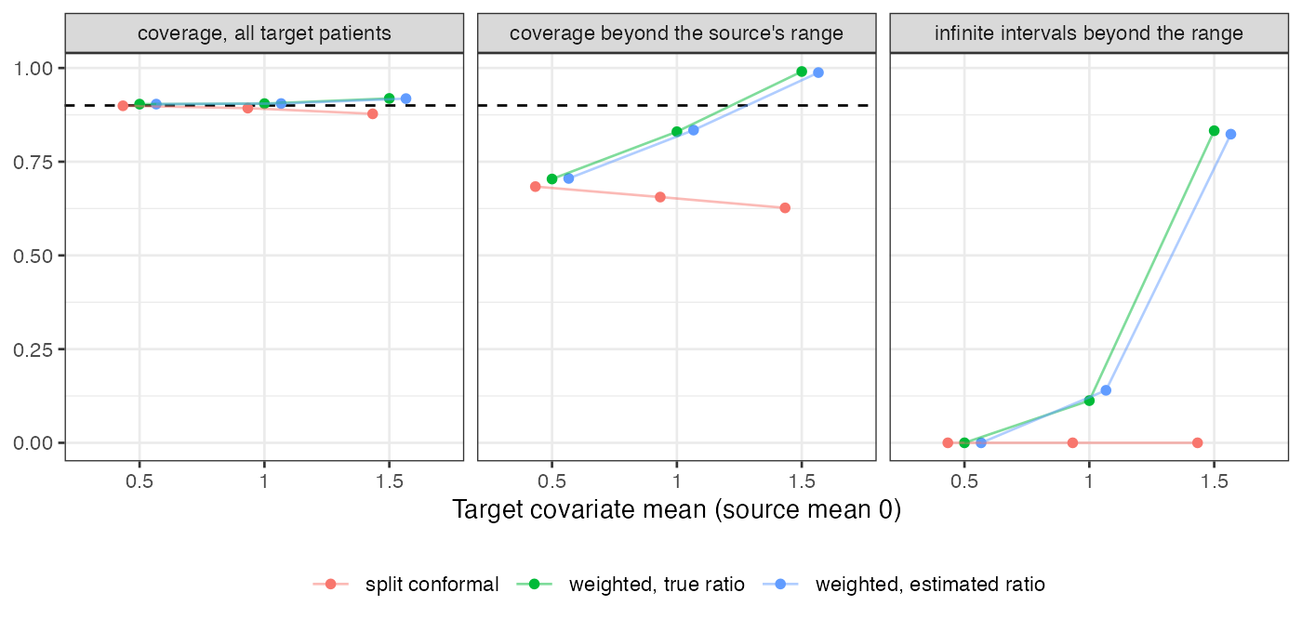
Figure 1: Coverage over all target patients and beyond the source’s range, and the share of infinite intervals there. Dashed: nominal 0.9.
Table 1: 500 replicates per shift; coverage beyond the range is averaged over replicates with at least one such patient.
target mean | interval | coverage | beyond range | infinite beyond range | median finite width | calibration ESS
0.5 | split | 0.899 | 0.684 | 0.000 | 3.34 | 235 | 234
1.0 | split | 0.893 | 0.656 | 0.000 | 3.34 | 119 | 110
1.5 | split | 0.878 | 0.627 | 0.000 | 3.33 | 51 | 32
0.5 | weighted, true ratio | 0.904 | 0.704 | 0.000 | 3.38 | 235 | 234
1.0 | weighted, true ratio | 0.905 | 0.830 | 0.113 | 3.44 | 119 | 110
1.5 | weighted, true ratio | 0.919 | 0.991 | 0.833 | 3.58 | 51 | 32
0.5 | weighted, estimated ratio | 0.904 | 0.705 | 0.000 | 3.38 | 235 | 234
1.0 | weighted, estimated ratio | 0.905 | 0.834 | 0.140 | 3.44 | 119 | 110
1.5 | weighted, estimated ratio | 0.918 | 0.988 | 0.823 | 3.58 | 51 | 32

The registered failure condition held on both counts (Figure 1, Table 1). Over the whole target the weighted intervals were valid, and split conformal fell to 0.878 at the largest shift. Beyond the source’s range, split conformal covered about two thirds of patients at every shift, because its residual quantile comes from the region where the model fits. Weighting raised that coverage in step with the share of infinite intervals: at a target mean of 1, 11% of intervals there were infinite and coverage was still 0.830; at 1.5 almost all were infinite. At 0.5 the tail patients’ weights were too small to trigger the infinite interval and too small to widen the finite one, and coverage there was 0.704, barely above split conformal’s 0.684.
The calibration ESS matched at the two smaller shifts and exceeded it at 1.5 (51 against 32), because the divergence is driven by weights too rare to appear in 300 calibration points.

4. What this does not answer
Prediction intervals for individual outcomes, not intervals for a marginal treatment effect; one covariate; one outcome model; no BART or Gaussian process arm; no support diagnostic evaluated as a classifier. Peer review has not been done.

References
1. Ryan J. Tibshirani, Rina Foygel Barber, Emmanuel J. Candès, Aaditya Ramdas. Conformal prediction under covariate shift. In: Advances in neural information processing systems 32. 2019.
2. Jing Lei, Max G’Sell, Alessandro Rinaldo, Ryan J. Tibshirani, Larry Wasserman. Distribution-free predictive inference for regression. Journal of the American Statistical Association. 2018;113(523):1094–111. doi:10.1080/01621459.2017.1307116

