drMAIC 0.1.0 returns the MAIC estimate as its doubly robust estimate, with an interval six times too narrow
A simulation study answering catalog problem SFW-14
Ahmad Sofi-Mahmudi
2026-09-23

Abstract
Background. drMAIC (1) is a CRAN package offering a doubly robust matching-adjusted indirect comparison with analytic and bootstrap intervals. It has no methods publication or independent evaluation. Catalog problem SFW-14 asks whether it implements what it claims.
Methods. Code inspection, then an unanchored binary-outcome simulation: a 2 by 2 of correct or incorrect weighting and outcome models at two levels of overlap, 600 replicates per cell, against a correctly augmented estimator; the package’s percentile bootstrap in two cells (150 replicates each).
Results. The package’s doubly robust estimate equaled its MAIC estimate in every replicate (largest difference 1.6e-15). With wrong weights and a correct outcome model it therefore kept MAIC’s bias (0.066, MCSE 0.007), which correct augmentation removed (0.004). The analytic standard error was 0.028 to 0.029 against an empirical SD of 0.166 to 0.215, and 95% intervals covered 0.198 to 0.260. The percentile bootstrap covered 0.780 to 0.793.
Conclusion. drMAIC 0.1.0 is not doubly robust and its intervals are invalid. It should not be used in submissions until the four defects below are fixed.

1. The problem
An augmented weighting estimator is consistent if either the weighting model or the outcome model is correct (2). That is a theorem; a simulation can test only whether code implements it. MAIC (3) supplies the weights. The augmentation must average the outcome model’s predictions over the target population and add the weighted mean residual in the individual-data trial.

2. What the code does
Four defects in dr_maic() and bootstrap_ci(), read before the run:
- The outcome-model term is averaged over the wrong population. The code sets theta_stc <- sum(w_norm * m_hat), the weighted mean of predictions over the individual-data patients, then adds dr_correction, the weighted mean residual. The sum is , the MAIC estimate, whatever the outcome model. The weights never meet the target covariate law except through the moments they balance.
- The variance is divided by twice. .dr_variance() returns sum((w_norm * (Y - theta))^2) / n; with normalized weights, sum(...) is already the variance of the weighted mean.
- The scales are mixed. That probability-scale variance, plus the comparator’s probability-scale squared SE, is reported as the SE of a log odds ratio.
- The bootstrap resamples a different analysis. bootstrap_ci() recomputes weights on means only, refits the outcome model with the default formula, and holds the comparator’s estimate fixed, so its interval omits the comparator’s sampling error.
The time-to-event path returns a weighted median survival time labeled as a hazard ratio; it is reported here from the code and not simulated.

3. Design
Registered protocol: protocol.md. Individual data on A (300 patients); the target publishes ’s mean and SD, the proportion with , and B’s response proportion and SE (300 patients). Source , ; target , , . Outcome for A, B adding . Estimand: the target marginal log odds ratio, A versus B. Correct weights balance means and ’s second moment (the true density ratio); wrong weights balance means only. The correct outcome model includes ; the wrong one is linear. The comparator is augmentation done correctly, with the outcome model averaged over the published target law and a 50-resample bootstrap SE.

4. Results
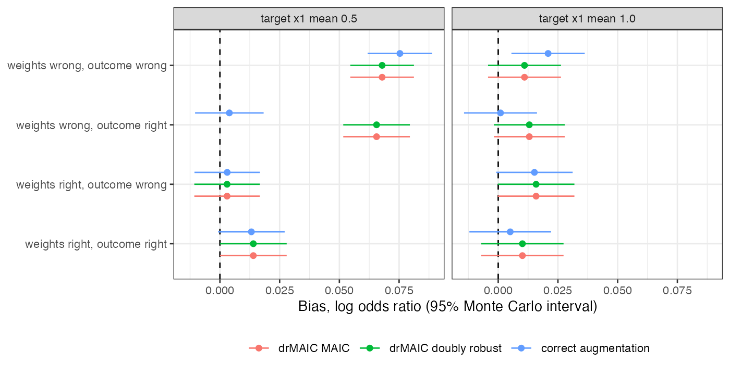
Figure 1: Bias of the package’s two estimates and of correct augmentation. The package’s two estimates coincide in every cell.
Table 1: Per cell, 600 replicates. MCSE of bias 0.007 to 0.009.
weights | outcome model | target mean | drMAIC DR bias | correct augmentation bias | drMAIC SE | empirical SD | drMAIC coverage | augmentation coverage
right | right | 0.5 | 0.014 | 0.013 | 0.029 | 0.175 | 0.248 | 0.958
wrong | right | 0.5 | 0.066 | 0.004 | 0.029 | 0.174 | 0.237 | 0.945
right | wrong | 0.5 | 0.003 | 0.003 | 0.029 | 0.171 | 0.240 | 0.960
wrong | wrong | 0.5 | 0.068 | 0.075 | 0.029 | 0.166 | 0.260 | 0.930
right | right | 1.0 | 0.010 | 0.005 | 0.028 | 0.215 | 0.198 | 0.933
wrong | right | 1.0 | 0.013 | 0.001 | 0.028 | 0.185 | 0.218 | 0.962
right | wrong | 1.0 | 0.016 | 0.015 | 0.028 | 0.200 | 0.252 | 0.945
wrong | wrong | 1.0 | 0.011 | 0.021 | 0.028 | 0.191 | 0.240 | 0.940

All three registered failure conditions held (Figure 1, Table 1). Where MAIC with wrong weights was biased (), the package’s doubly robust estimate carried the same bias and correct augmentation did not. At wrong weights produced little bias for either, so that cell does not discriminate. With both models wrong, correct augmentation was biased, as the theorem allows. The analytic SE was essentially the comparator’s probability-scale SE, about one sixth of the true SD on the log odds ratio scale. Correct augmentation’s intervals covered 0.930 to 0.962.
The percentile bootstrap, 150 replicates per cell with 200 resamples, covered 0.793 and 0.780. The comparator’s sampling variance it omits is 44% of the total variance at , and the resampled weights balance means only.

5. What this does not answer
One package version, binary outcome, one sample size. G-MAIC, the published augmented weighting comparator named in the design, was not run. Continuous outcomes follow the same identity in defect 1 but were not simulated. Peer review has not been done.

References
1. Anupama Singh. drMAIC: Doubly robust matching-adjusted indirect comparison for HTA [Internet]. 2026. Available from: https://CRAN.R-project.org/package=drMAIC
2. Heejung Bang, James M. Robins. Doubly robust estimation in missing data and causal inference models. Biometrics. 2005;61(4):962–73. doi:10.1111/j.1541-0420.2005.00377.x
3. James E. Signorovitch, Eric Q. Wu, Andrew P. Yu, Charles M. Gerrits, Evan Kantor, Yanjun Bao, Shiraz R. Gupta, Parvez M. Mulani. Comparative effectiveness without head-to-head trials: A method for matching-adjusted indirect comparisons applied to psoriasis treatment with adalimumab or etanercept. PharmacoEconomics. 2010;28(10):935–45. doi:10.2165/11538370-000000000-00000

