Interaction coefficients need their own consistency check
A simulation study answering catalog problem COV-10
Ahmad Sofi-Mahmudi
2026-09-23

Abstract
Background. In network meta-regression the treatment-by-covariate interactions satisfy a consistency equation of their own. If direct and indirect paths carry opposing interactions, the pooled coefficient can be near zero while the usual consistency check on treatment effects passes. Catalog problem COV-10 asks how often this happens, what it costs and whether an interaction-consistency check detects it.
Methods. Triangle networks with two, four or eight studies per comparison, covariate spread across studies of 0.3 or 1 SD, path interaction slopes that were consistent, partly opposing or cancelling (modification of 0.3 on every path pooling to zero), and treatment effects consistent or not: 36 scenarios, 2000 replicates each.
Results. The effect-consistency check flagged 0.094 to 0.107 of analyses with inconsistent interactions, its null rate. The pooled interaction for the cancelling configuration averaged 0.000; its spread across analyses was 1.50 to 4.23 times its model SE (0.190 against 0.053 with four studies and wide spread), so a Wald test still selected the covariate in up to 0.882 of analyses. Either way the target effect was biased: by -0.134 to -0.260 with partly opposing and -0.227 to -0.305 with cancelling interactions. An interaction-consistency check detected it in 0.163 to 1.000 of analyses depending on study count and covariate spread.
Conclusion. Cancellation is not a knife-edge: partial opposition attenuates the pooled interaction across a continuum and biases the target effect. Check the consistency of interactions directly; a passed effect-consistency check says nothing about them.

1. The problem
Consistency requires for effects and, separately, for interactions. With equal precision on the three paths a consistency meta-regression estimates C’s interaction as from the path slopes, so slopes of , and give zero although each path is modified. The effect check (1) compares intercepts, not slopes, and cannot see it.

2. Design
Registered protocol: protocol.md; ADEMP structure (2). Study estimates with SE 0.1; covariate means ; effects , , plus a loop shift of 0 or 0.2. Path slopes , : consistent , partly opposing , cancelling . The covariate is kept if the Wald test of both interactions has . Target: C versus A at covariate 1.5 with the AC path’s truth.

3. Results
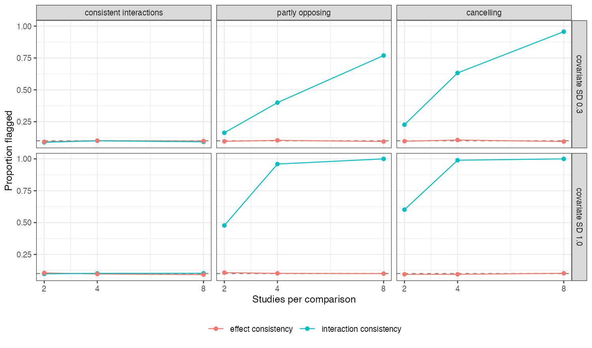
Figure 1: Flag rates of the interaction-consistency and effect-consistency checks by studies per comparison. The dashed line is the nominal 0.10.
The two checks responded to different parameters (Figure 1): the interaction check reached 1.000 with eight studies and wide covariate spread but only 0.227 with two studies and narrow spread, while the effect check fired only when effects themselves were inconsistent.
The masking showed in the value of the pooled coefficient, not in selection: under inconsistency the model-based SE assumes the paths agree, so the estimate scattered well beyond it and the Wald test often rejected. Whether selected or not, the analysis used an attenuated interaction and missed the target by 0.13 to 0.30. With consistent interactions and narrow covariate spread, selection itself cost coverage (as low as 0.318) because the covariate was often dropped.

4. What this does not answer
Stylized triangles with continuous study estimates; the design-by-treatment interaction model and larger networks were not run. Per-path regressions with two studies and narrow covariate spread were unstable, so the AC-path estimates in results/decision.md are not interpretable there. Peer review has not been done.

References
1. Heiner C. Bucher, Gordon H. Guyatt, Lauren E. Griffith, Stephen D. Walter. The results of direct and indirect treatment comparisons in meta-analysis of randomized controlled trials. Journal of Clinical Epidemiology. 1997;50(6):683–91. doi:10.1016/S0895-4356(97)00049-8
2. Tim P. Morris, Ian R. White, Michael J. Crowther. Using simulation studies to evaluate statistical methods. Statistics in Medicine. 2019;38(11):2074–102. doi:10.1002/sim.8086

