Selecting effect modifiers on the analyzed data narrows the STC interval; resampling the whole procedure restores it
A simulation study answering catalog problem DEC-11
Ahmad Sofi-Mahmudi
2026-09-23

Abstract
Background. Effect modifiers for a simulated treatment comparison (STC) are often chosen by testing interactions on the same data, and the interval then treats the chosen model as fixed. Catalog problem DEC-11 asks how much coverage this costs and whether the interval should include the selection step.
Methods. G-computation STC with six candidate modifiers, one or three of them real, 100 to 1000 patients per arm, binary outcome, target covariate means shifted by 0.4 SD: 6 scenarios, 400 replicates each. Rules: all six interactions, the true ones, none, those with , and lasso; the significance rule was also paired with a bootstrap that repeats the selection.
Results. After significance selection the naive interval covered 0.887 to 0.927, its SE 7% to 20% smaller than the estimate’s spread. The whole-procedure bootstrap covered 0.938 to 0.968. Lasso at the one-standard-error penalty kept almost no interactions (at most 0.15 on average) and behaved like dropping them all: coverage 0.333 with three real modifiers at 1000 per arm. Fitting all six interactions covered 0.930 to 0.963.
Conclusion. An interval after data-driven modifier selection must include the selection, by resampling the whole procedure; otherwise fit all candidate interactions. Penalized selection tuned for prediction can remove real modifiers and leave the transported effect biased.

1. The problem
Conditioning on a model chosen from the data makes the naive interval too narrow unless the selection is part of the variance (1). In STC the selected interactions determine how the effect is transported, so both the point estimate and its interval depend on the selection.

2. Design
Registered protocol: protocol.md; ADEMP structure (2). Six independent normal candidates; with the first one or three; target covariate means 0.4. Estimand: target marginal log odds ratio (Monte Carlo over draws). G-computation from a logistic model with all six main effects and the selected interactions; delta-method intervals; whole-procedure bootstrap with 60 resamples. Lasso (3) penalized the interactions only, with the penalty chosen by 5-fold cross-validation (one-standard-error rule).

3. Results
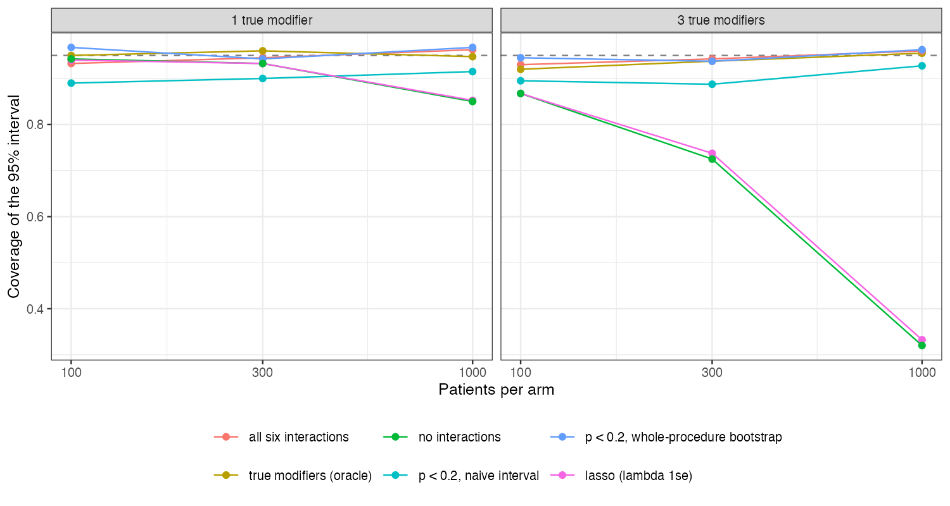
Figure 1: Coverage of the 95% interval by selection rule and sample size.
The significance rule’s shortfall came from variance, not bias (bias at most 0.046): selection sometimes kept a modifier and sometimes not, and the naive SE saw only one of those models (Figure 1). With three modifiers the shortfall was not monotone in sample size, as registered: it was largest at 300 per arm, where selection was most unstable (all true modifiers kept in 0.26 of analyses). Omitting the interactions biased the effect by about 0.2 with three modifiers, and the lasso rule inherited that bias because its cross-validated penalty favored prediction of the outcome, to which the interactions contribute little.

4. What this does not answer
STC only; MAIC-based selection, overlap levels, larger candidate sets and uncertainty in the target summaries were not run; 400 replicates and 60 bootstrap resamples per analysis. Peer review has not been done.

References
1. Richard Berk, Lawrence Brown, Andreas Buja, Kai Zhang, Linda Zhao. Valid post-selection inference. The Annals of Statistics. 2013;41(2):802–37. doi:10.1214/12-AOS1077
2. Tim P. Morris, Ian R. White, Michael J. Crowther. Using simulation studies to evaluate statistical methods. Statistics in Medicine. 2019;38(11):2074–102. doi:10.1002/sim.8086
3. Robert Tibshirani. Regression shrinkage and selection via the lasso. Journal of the Royal Statistical Society Series B. 1996;58(1):267–88. doi:10.1111/j.2517-6161.1996.tb02080.x

