Departures from shared linear effect modification did not reorder population-adjustment methods
A simulation study answering catalog problem DIA-08
Ahmad Sofi-Mahmudi
2026-09-23

Abstract
Background. Simulation studies of population adjustment usually generate shared linear effect modification, which makes the restriction of a linear outcome model true. Catalog problem DIA-08 asks whether departures from that structure reverse the method ranking, so that published rankings reflect the generator.
Methods. Anchored binary-outcome comparison with reported moments held fixed. A’s effect modification was linear, a threshold, a modifier-by-modifier interaction or quadratic, at target covariate means of 0.3, 0.8 and 1.2 SD, plus skewed covariates with linear modification: 16 scenarios, 2000 replicates each. Unadjusted, MAIC on means, MAIC on means and SDs, STC with linear interactions and STC with quadratic and product terms were ranked by RMSE.
Results. The RMSE ordering under linear modification was reproduced under every departure (rank correlation 0.90 to 1.00); the only change was a swap between the two worst methods. STC with linear interactions ranked first in every scenario, although its bias grew to 0.119 under the interaction departure at the poorest overlap, because MAIC’s variance there was far larger (RMSE 0.344 against 0.534). Registered verdict: refuted.
Conclusion. At these magnitudes, departures that break a linear model’s restriction biased it less than weighting’s loss of effective sample size cost the alternatives, so rankings were set by variance and survived. A generator decides a ranking only when the departure’s bias exceeds the precision differences between methods.

1. The problem
A method that imposes a restriction true under the generator gains efficiency for free, so under shared linear modification a linear STC should win on RMSE. A departure from linearity biases it and leaves MAIC’s matching of moments comparatively unaffected, so the ranking might reverse. Whether it does depends on whether the new bias is large relative to the variance differences, which published comparisons (1) do not separate.

2. Design
Registered protocol: protocol.md; ADEMP structure (2). AC trial with individual data, 300 per arm; BC trial in the target, 300 per arm, reporting covariate means and SDs and arm event counts. ; B’s effect ; A’s effect (linear), with the term replaced by (threshold), or plus (interaction) or (quadratic). Estimand: marginal log odds ratio, B versus A, in the target. STC marginalizes over normals with the reported moments.
The registered rule reads a Spearman correlation of at least 0.9 as orderings surviving. With five methods one adjacent swap gives exactly 0.9, which the first run of the analysis stored as 0.8999… and classified as partial; the correlation is now rounded before comparison, which changes the verdict to refuted and nothing else.

3. Results
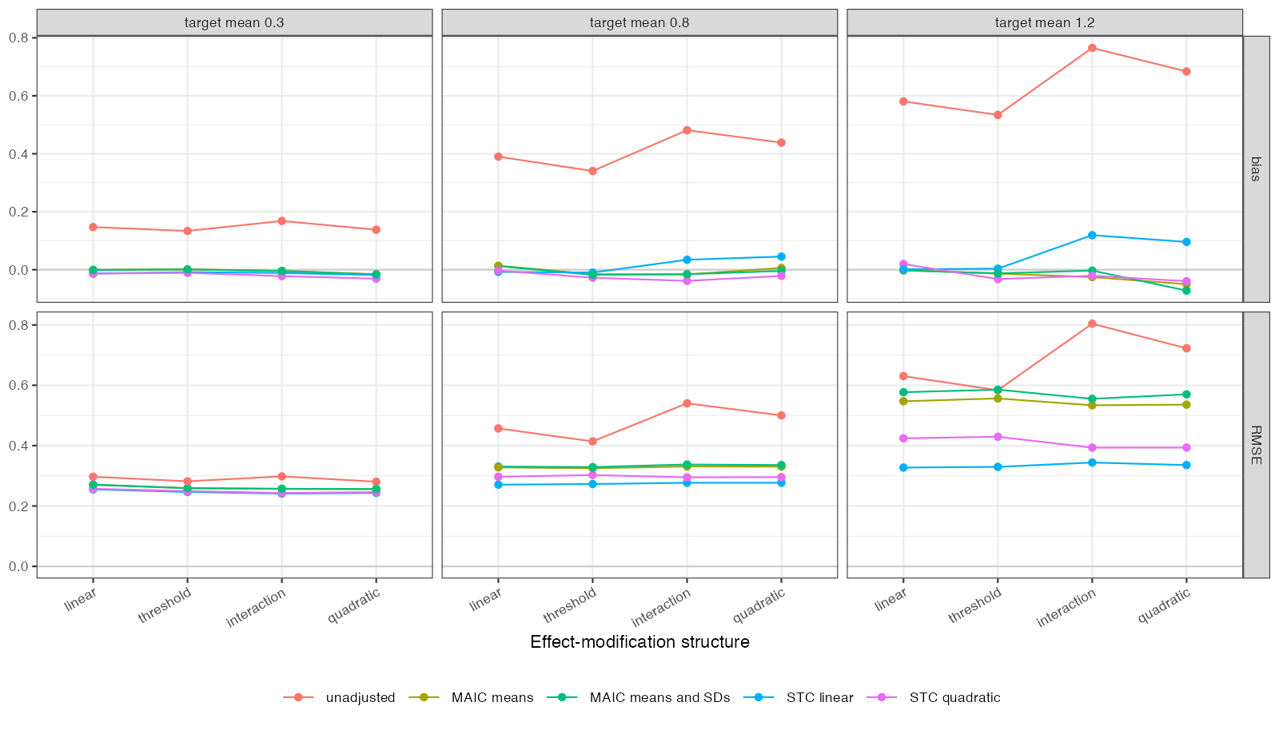
Figure 1: RMSE and bias by method and effect-modification structure at three overlap levels.
RMSE was nearly flat across departures for every method (Figure 1); what changed it was overlap. The departures moved the linear STC’s bias from about zero to 0.119, while its RMSE advantage over MAIC at the poorest overlap exceeded 0.2. The quadratic STC, correctly specified under two of the departures, paid more in variance than it saved in bias. Skewed covariates reordered the second and third methods at the smallest shift, as much as any modification departure did.

4. What this does not answer
Departure magnitudes were moderate (they changed the target effect by 0.1 to 0.3 on the log odds ratio scale); stronger departures or larger trials, where variance matters less, can reverse the ranking. Treatment-specific, subnetwork and within-versus-between departures need a network and were not run; no ML-NMR. Peer review has not been done.

References
1. David M. Phillippo, Sofia Dias, A. E. Ades, Nicky J. Welton. Assessing the performance of population adjustment methods for anchored indirect comparisons: A simulation study. Statistics in Medicine. 2020;39(30):4885–911. doi:10.1002/sim.8759
2. Tim P. Morris, Ian R. White, Michael J. Crowther. Using simulation studies to evaluate statistical methods. Statistics in Medicine. 2019;38(11):2074–102. doi:10.1002/sim.8086

