Bias mechanisms in an unanchored MAIC do not add
A numerical study answering catalog problem DIA-13
Ahmad Sofi-Mahmudi
2026-09-23

Abstract
Background. Quantitative bias analyses for unanchored comparisons usually vary one bias mechanism at a time. Catalog problem DIA-13 asks whether mechanisms acting together produce the sum of their separate biases, and whether a one-at-a-time analysis bounds the joint bias.
Methods. Exact population-level calculation for an unanchored MAIC with a binary outcome, under an omitted confounder (outcome log odds ratio to 1, prevalence 0.3 against 0.5), misclassification of the comparator’s reported outcome (sensitivity down to 0.8) and measurement error in the matched covariate (reliability down to 0.6): 45 combinations.
Results. Where the confounder and misclassification acted together, the interaction was up to 0.163 on the log odds ratio scale; where either was absent it was at most 0.005. The median interaction was 29% of the sum of the separate biases. With both at their largest the joint bias was 0.156 against a sum of 0.314; with the confounder reversed, the joint bias was 0.101 against a sum of -0.051, the opposite sign. The joint bias exceeded the largest single-mechanism bias in 22 of 36 combinations.
Conclusion. One-at-a-time bias analyses neither add up to nor bound the joint bias. Mechanisms that change the outcome rate on which another mechanism acts interact strongly; these should be analyzed jointly, while mechanisms acting on different parts of the estimator can be combined additively.

1. The problem
An unanchored MAIC (1) compares A’s outcome, reweighted to the target, with B’s published outcome. An omitted confounder shifts A’s transported rate; comparator misclassification distorts B’s reported rate by an amount that depends on the true rate; measurement error in a matched covariate under-corrects A’s rate. On the log odds scale each mechanism’s bias depends on the rates the others have moved, so the joint bias is not the sum. Standard bias-analysis practice treats mechanisms separately or combines them by simulation (2) without reporting the interaction.

2. Design
Registered protocol: protocol.md. with B’s effect ; source , ; target , . Misclassification: reported proportion . Measurement error: MAIC on the error-prone covariate moves the latent mean by the reliability times 0.5. Exact 80-point Gauss-Hermite quadrature. Interaction: joint bias minus the three single-mechanism biases.

3. Results
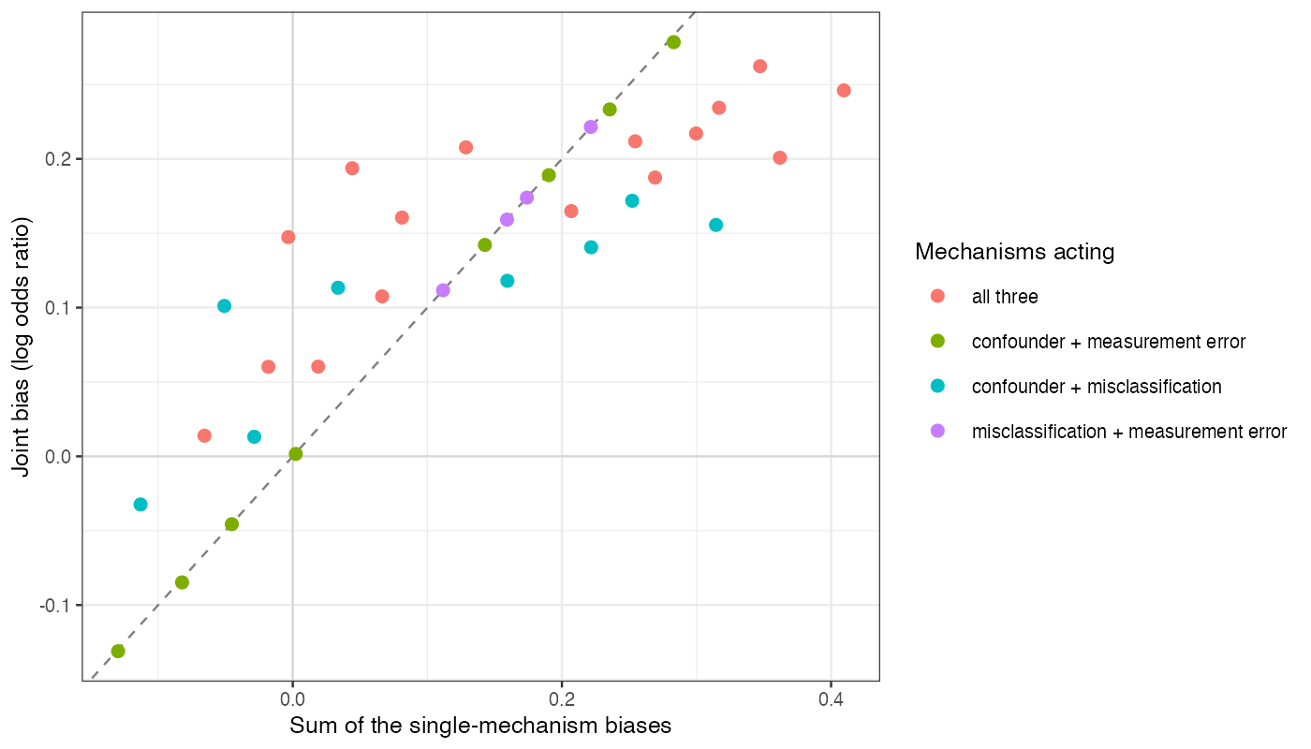
Figure 1: Joint bias against the sum of the single-mechanism biases for combinations of two or three mechanisms. The dashed line is additivity.
Combinations involving measurement error with only one other mechanism lay on the additivity line (Figure 1); every combination of the confounder with misclassification lay off it. Misclassification pulls a reported proportion toward the middle by an amount that depends on the proportion itself, and the confounder changes which proportion B’s arm has, so the two mechanisms compose rather than add. Both additivity and bounding failed; the median relative interaction is inflated where the separate biases cancel, so absolute interactions are the better summary.

4. What this does not answer
Population-level only: no estimation, no bias-analysis procedure, no false reassurance or tipping sets (DIA-14 scores those). Three mechanisms; selection, correlated sensitivity parameters and overlap were not varied. Peer review has not been done.

References
1. James E. Signorovitch, Eric Q. Wu, Andrew P. Yu, Charles M. Gerrits, Evan Kantor, Yanjun Bao, Shiraz R. Gupta, Parvez M. Mulani. Comparative effectiveness without head-to-head trials: A method for matching-adjusted indirect comparisons applied to psoriasis treatment with adalimumab or etanercept. PharmacoEconomics. 2010;28(10):935–45. doi:10.2165/11538370-000000000-00000
2. Matthew P. Fox, Richard F. MacLehose, Timothy L. Lash. Applying quantitative bias analysis to epidemiologic data. 2nd ed. Cham: Springer; 2021. doi:10.1007/978-3-030-82673-4

