Scoring a bias analysis as a classifier: false reassurance lives in the elicited region
A simulation study answering catalog problem DIA-14
Ahmad Sofi-Mahmudi
2026-09-23

Abstract
Background. A quantitative bias analysis (QBA) for an unanchored MAIC declares a decision robust when it holds across an assumed region of bias. Such analyses are usually checked by recovering the truth when the bias is known, which tests the arithmetic but not whether a “robust” verdict can be trusted. Catalog problem DIA-14 asks how often the verdict is wrong.
Methods. Unanchored MAIC with an unmeasured binary confounder whose prevalence differs between populations; 18 scenarios, 2000 replicates each. Elicited bias regions of half-width 0.05, 0.15 or 0.3 missed the true bias with probability 0, 0.1 or 0.3 (symmetric errors or errors toward zero bias), or were centered at zero bias. A deterministic grid (equivalent here to bounds and to the tipping point) and a probabilistic QBA were scored on false reassurance (robust although the true bias reverses the decision) and false fragility.
Results. Whenever the region contained the true bias the grid never reassured falsely, an exact property confirmed in every replicate. With elicitation errors scaled to the region’s width, false reassurance stayed at or below 0.167. With a region centered at zero bias it reached 0.776, 0.370 and 0.092 for half-widths 0.05, 0.15 and 0.3. Probabilistic QBA almost never reassured falsely but called 0.620 to 0.854 of sound decisions fragile, because its verdict absorbs sampling uncertainty. Oracle recovery was nominal in every scenario (coverage 0.951 to 0.961).
Conclusion. A QBA verdict’s reliability is set by where the analyst puts the region, not by the QBA method, and oracle recovery cannot show it. Report the tipping point and the region separately, and justify the region’s center.

1. The problem
Let be the true bias of the MAIC (1) estimate and the decision be “B better” when the bias-adjusted estimate is below 0. The decision at the true bias differs from the unadjusted one (“flip”) when . A grid over a region declares ROBUST when keeps its sign for every in it. If the region contains , ROBUST implies no flip, so false reassurance is exactly zero; overall it is at most the probability that the region excludes . For one scalar bias, the grid, the bounds over the region and a comparison of the tipping point with the region give the same verdict, so the methods DESIGN.md listed collapse to two.

2. Design
Registered protocol: protocol.md; ADEMP structure (2). MAIC of A (300 patients) against B (300) on a measured covariate; unmeasured binary with outcome log odds ratio 0.5 or 1, prevalence 0.3 in the source and 0.3, 0.5 or 0.7 in the target; true B effect , or ; from 0 to 0.37. Region with and , so that it excludes with probability ; errors symmetric or pointed toward zero; or . Probabilistic QBA: uniform on the region plus sampling error, ROBUST when the adjusted estimate keeps its sign with probability at least 0.95.

3. Results
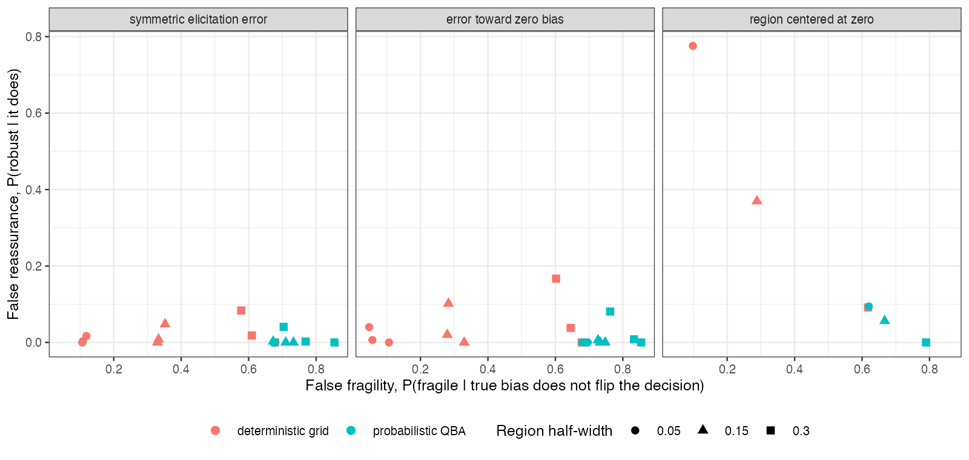
Figure 1: False reassurance against false fragility for the grid and probabilistic QBA, pooled over the 12 scenarios with nonzero bias.
Neither method dominated (Figure 1). The grid traded false fragility for false reassurance through the region’s width. Under symmetric or understated errors a wider region raised false reassurance slightly, because the errors grew with it (for example 0.040 to 0.167 at exclusion 0.3); when the region was anchored at zero, width protected (from 0.776 to 0.092). Most regions that missed the truth still did not produce false reassurance: that needs the region to miss on the far side of the estimate.
Probabilistic QBA’s verdict requires the adjusted estimate to be clear of zero, so it behaves like a significance test and is fragile whenever the estimate is small, whatever the bias. Its own Monte Carlo error, with 1000 draws, changed the verdict in 0.009 to 0.016 of analyses.

4. What this does not answer
One scalar bias parameter, so dependence between bias parameters is not studied; effect modification and overlap were not varied; the elicitation model is assumed, so the study cannot say how often real regions miss. Peer review has not been done.

References
1. James E. Signorovitch, Eric Q. Wu, Andrew P. Yu, Charles M. Gerrits, Evan Kantor, Yanjun Bao, Shiraz R. Gupta, Parvez M. Mulani. Comparative effectiveness without head-to-head trials: A method for matching-adjusted indirect comparisons applied to psoriasis treatment with adalimumab or etanercept. PharmacoEconomics. 2010;28(10):935–45. doi:10.2165/11538370-000000000-00000
2. Tim P. Morris, Ian R. White, Michael J. Crowther. Using simulation studies to evaluate statistical methods. Statistics in Medicine. 2019;38(11):2074–102. doi:10.1002/sim.8086

