Single-arm studies matched to one comparator arm must enter a network with their shared covariance
A simulation study answering catalog problem HET-02
Ahmad Sofi-Mahmudi
2026-09-23

Abstract
Background. When several single-arm studies are each matched to the same comparator arm, their pseudo-contrasts share that arm’s sampling error. Published implementations enter them as independent. Catalog problem HET-02 asks what that does to a network estimate.
Methods. Network of two randomized trials (B versus C with a C arm of 50 or 200, A versus B) and one to eight single-arm studies of A matched to trial 1’s C arm; fixed-effect generalized least squares with the correct block covariance or with the pseudo-contrasts treated as independent (8 scenarios, 4000 replicates each).
Results. Modeling the shared arm gave coverage of 0.945 to 0.955. Treating the pseudo-contrasts as independent shrank the reported SE as studies were added (0.137 to 0.059 with a C arm of 50) while the estimate’s true spread barely changed (0.168 to 0.149); coverage fell to 0.567. The two analyses’ point estimates differed little (mean absolute difference at most 0.020) and rarely in sign.
Conclusion. A comparator arm reused by several matched studies must be counted once. Ignoring the shared covariance leaves the estimate nearly unchanged here but reports a precision that grows with the number of studies, so the interval, and any decision based on significance, is wrong.

1. The problem
With , every pair has , and each also shares it with any other contrast estimated from the same C arm. This is the multi-arm correlation of network meta-analysis (1) arising without a multi-arm trial.

2. Design
Registered protocol: protocol.md; ADEMP structure (2). Continuous outcome, SD 1; single-arm studies of 100; trial 2 with 200 per arm; true A versus C 0.15, B versus C 0.3. The correct covariance puts between every pair of pseudo-contrasts and between each pseudo-contrast and trial 1’s contrast. A first probe had the latter sign wrong; it was corrected before the run.

3. Results
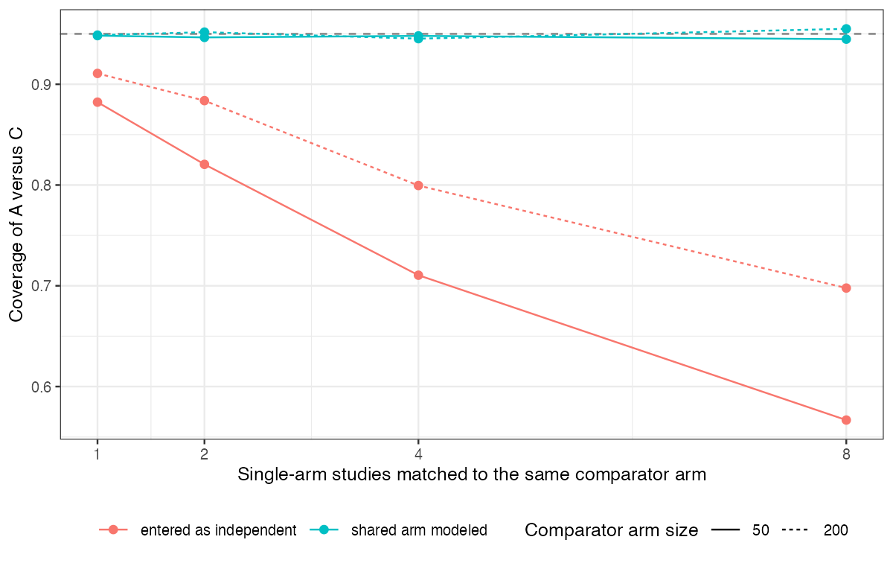
Figure 1: Coverage of the A-versus-C estimate by the number of single-arm studies sharing one comparator arm.
The naive SE fell roughly as because the C arm’s error was treated as averaging out, while it is common to every pseudo-contrast (Figure 1). The damage grew with the number of studies and was worse when the shared arm was small, since then its error is a larger part of each pseudo-contrast’s variance.

4. What this does not answer
Fixed-effect network with continuous outcomes and no weighting step; with heterogeneity or conflicting direct and indirect evidence, reweighting the shared arm can also move the point estimate, which is how a published network reversed its conclusion. The weighting-induced covariance is CMP-12’s subject. Peer review has not been done.

References
1. Alexander J. Franchini, Sofia Dias, A. E. Ades, Jeroen P. Jansen, Nicky J. Welton. Accounting for correlation in network meta-analysis with multi-arm trials. Research Synthesis Methods. 2012;3(2):142–60. doi:10.1002/jrsm.1049
2. Tim P. Morris, Ian R. White, Michael J. Crowther. Using simulation studies to evaluate statistical methods. Statistics in Medicine. 2019;38(11):2074–102. doi:10.1002/sim.8086

