Population-adjusted synthesis with few studies: pool the aggregate trials first, then adjust once
A simulation study answering catalog problem HET-10
Ahmad Sofi-Mahmudi
2026-09-23

Abstract
Background. Random-effects intervals depend on the number of studies, and in population-adjusted synthesis one individual-data trial often supplies the adjusted contrast for several aggregate trials. Catalog problem HET-10 asks how interval coverage behaves at the small study counts typical of these analyses.
Methods. One individual-data trial of A versus C transported by MAIC to the target, and 2 to 12 aggregate trials of B versus C with heterogeneity SD 0, 0.1 or 0.2 (18 scenarios, 2000 replicates each). Per-trial adjusted contrasts meta-analyzed as independent, or a two-step analysis pooling the aggregate trials before subtracting the transported contrast once; DerSimonian-Laird or Hartung-Knapp intervals.
Results. Meta-analyzing the per-trial contrasts as independent lost coverage as trials were added (0.546 to 0.888 with DerSimonian-Laird), because the shared individual-data error does not average out. The two-step analysis with DerSimonian-Laird covered 0.932 to 0.961 from four trials and 0.909 at fewer with heterogeneity; with Hartung-Knapp it was conservative at small counts (up to 1.000).
Conclusion. Count the individual-data trial once: pool the aggregate evidence, then adjust. With fewer than four aggregate trials no interval here was both calibrated and informative, and that should be stated when such an analysis is reported.

1. The problem
When the same transported A-versus-C estimate is subtracted from each of aggregate B-versus-C contrasts, the adjusted contrasts share its error. A random-effects meta-analysis (1) that treats them as independent divides that error’s variance by . Separately, DerSimonian-Laird intervals are too narrow with few studies, and the Hartung-Knapp adjustment (2) is the usual repair.

2. Design
Registered protocol: protocol.md; ADEMP structure (3). Individual data: 300 per arm, , A’s effect ; aggregate trials of 200 per arm in the target ( mean 0.5), B’s effect , . Estimand: B versus A in the target. MAIC weights the individual-data trial to the target mean; sandwich variance.

3. Results
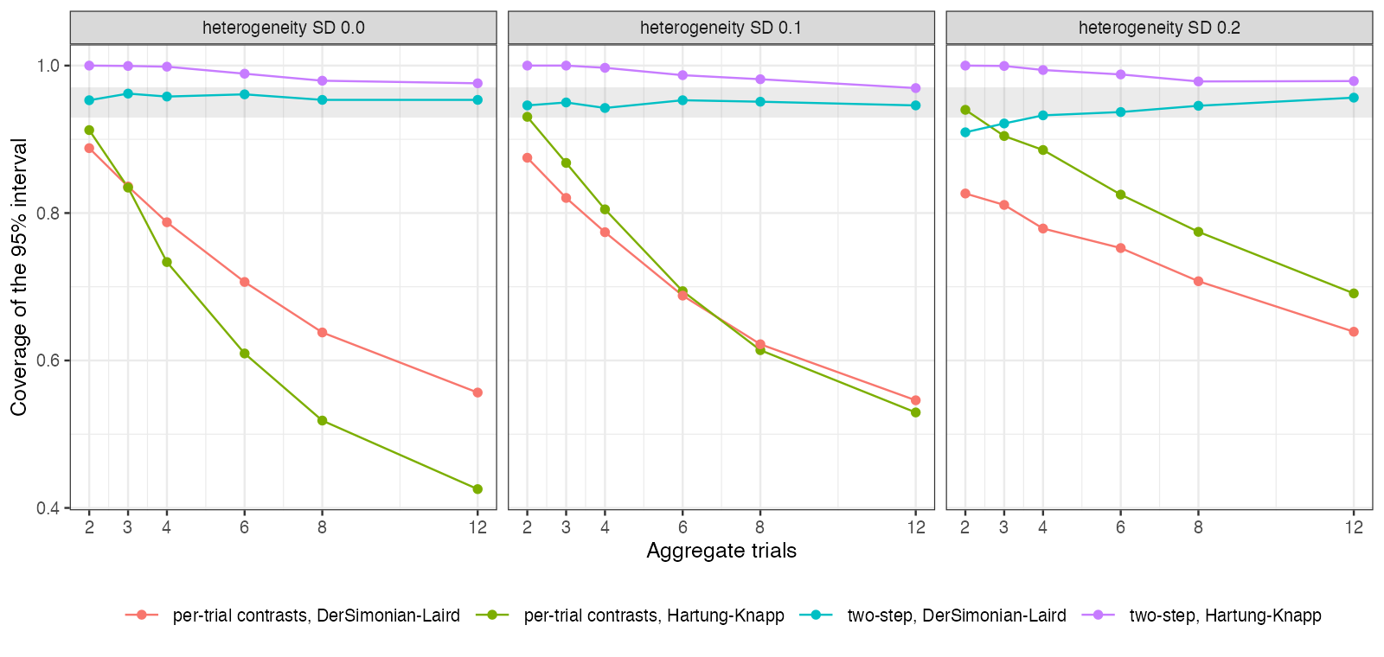
Figure 1: Coverage by method, number of aggregate trials and heterogeneity. The shaded band is 0.93 to 0.97.
Figure 1 separates the two problems. The independence error grows with and was present without heterogeneity; the small- error of DerSimonian-Laird appeared at two or three trials with heterogeneity. Hartung-Knapp with fixed the latter at the price of very wide intervals when was 2 or 3.

4. What this does not answer
A pairwise synthesis with one individual-data trial rather than a network; continuous outcome; no one-stage or Bayesian analysis; one overlap level. Peer review has not been done.

References
1. Rebecca DerSimonian, Nan Laird. Meta-analysis in clinical trials. Controlled Clinical Trials. 1986;7(3):177–88. doi:10.1016/0197-2456(86)90046-2
2. Joachim Hartung, Guido Knapp. On tests of the overall treatment effect in meta-analysis with normally distributed responses. Statistics in Medicine. 2001;20(12):1771–82. doi:10.1002/sim.791
3. Tim P. Morris, Ian R. White, Michael J. Crowther. Using simulation studies to evaluate statistical methods. Statistics in Medicine. 2019;38(11):2074–102. doi:10.1002/sim.8086

