Transitivity screens have blind spots that can be constructed, and their union shares one
A simulation study answering catalog problem IDN-01
Ahmad Sofi-Mahmudi
2026-09-23

Abstract
Background. Transitivity cannot be tested directly; it is screened by comparing reported study characteristics across comparisons, testing loop inconsistency and measuring heterogeneity. Catalog problem IDN-01 asks how well these screens perform together and whether their pattern identifies which assumption failed.
Methods. Triangle networks (A, B, C) with two or five studies per comparison. Five mechanisms of size 0.1, 0.2 or 0.4: none; a measured modifier whose study means differ by comparison; an unmeasured modifier making C look better in every comparison that includes it, which keeps the loop consistent; a loop-breaking shift; and study-level drift. 26 scenarios, 2000 replicates each. Screens at : dissimilarity of the measured modifier, the Bucher loop test and Cochran’s . Target: B versus C in a declared population, by consistency network meta-analysis.
Results. The loop-consistent unmeasured modifier of size 0.4 biased the network estimate by -0.402 (coverage 0.004 or less) while at least one screen fired in 0.279 to 0.281 of analyses, the same as with no violation (0.274 to 0.283). A loop-breaking shift of 0.4 was flagged in 0.766 to 0.975 and drift in 0.948 to 1.000. A measured modifier was flagged every time although meta-regression left the estimate unbiased. Reading the mechanism from which screen fired was right for 0.433 of loop breaks and 0.341 of drift analyses.
Conclusion. Each screen sees one direction of violation, and a violation that shifts a treatment consistently wherever it was tested is invisible to all of them while biasing the result as much as any. Passing every screen does not establish transitivity, a failed screen does not identify the mechanism, and a dissimilarity flag need not mean bias.

1. The problem
A screen is a function of observed data; if the transport restriction implies , then failing refutes , but passing does not confirm it. A violation whose projection onto what responds to is zero is detected at ’s size. Dissimilarity sees reported covariates, the loop test (1) sees violations that break the loop, and heterogeneity (2) sees within-comparison variation. An unreported modifier that makes one treatment look better in every comparison that includes it changes no reported covariate, keeps the loop closed and adds no within-comparison variation.

2. Design
Registered protocol: protocol.md; ADEMP structure (3). Study estimates with SE 0.15; , against A. Measured modifier means 0, 0.5, 1 across AB, AC, BC in the measured-modifier mechanism and 0.5 otherwise. The estimator is a fixed-effect consistency model, with meta-regression on the measured modifier when its study means vary. Mechanisms were read from the flag pattern as: dissimilarity, measured modifier; loop test without dissimilarity, loop break; heterogeneity alone, drift; nothing, no violation.

3. Results
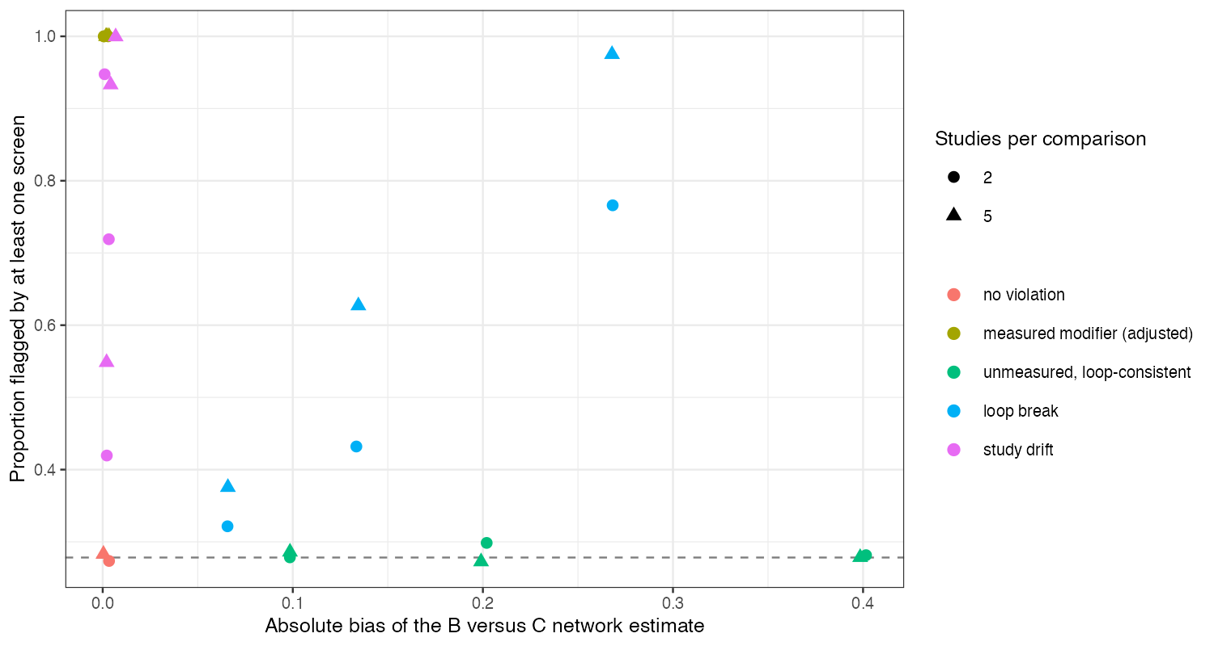
Figure 1: Proportion of analyses flagged by at least one screen against the bias of the network estimate. The dashed line is the rate with no violation.
Figure 1 shows the blind spot: the loop-consistent mechanism sits at the null detection rate at every bias. More studies per comparison raised the power of the loop test and against the mechanisms they can see, and did nothing for this one.
Identification from the flag pattern was poor. Drift also raised the loop test’s rejection rate (to 0.568), so drift and loop breaks were confused, and a loop break was read as no violation in 0.417 of analyses pooled over sizes. The unmeasured mechanism produced the same pattern as no violation in 0.717 of analyses (the decision table in results/decision.md counts this as the pattern being read correctly, which it is only in that sense). The dissimilarity screen’s firing for a measured modifier is a correct signal that adjustment is needed, not evidence of bias after it.

4. What this does not answer
Stylized triangles with continuous study estimates rather than real network geometries; calendar-time drift represented as random study shifts; the published record of network meta-analyses abandoned on transitivity grounds was not scored. Peer review has not been done.

References
1. Heiner C. Bucher, Gordon H. Guyatt, Lauren E. Griffith, Stephen D. Walter. The results of direct and indirect treatment comparisons in meta-analysis of randomized controlled trials. Journal of Clinical Epidemiology. 1997;50(6):683–91. doi:10.1016/S0895-4356(97)00049-8
2. William G. Cochran. The combination of estimates from different experiments. Biometrics. 1954;10(1):101–29. doi:10.2307/3001666
3. Tim P. Morris, Ian R. White, Michael J. Crowther. Using simulation studies to evaluate statistical methods. Statistics in Medicine. 2019;38(11):2074–102. doi:10.1002/sim.8086

