A held-out-trial check can hold its size, but a pass licenses very little
A simulation study answering catalog problem IDN-07
Ahmad Sofi-Mahmudi
2026-09-23

Abstract
Background. Withholding one trial, predicting its contrast from the rest of the evidence and comparing the prediction with what the trial observed is proposed as a falsification check for transport assumptions. Catalog problem IDN-07 asks for a pass or fail rule with known operating characteristics.
Methods. One individual-data trial and five aggregate trials with a continuous outcome and linear effect modification. The withheld trial’s contrast was predicted by G-computation at its reported covariate mean. Violations of 0, 0.15 or 0.3 (the effect itself is about 0.3), between-trial heterogeneity 0 or 0.1, two covariate spreads and a central or peripheral withheld trial: 24 scenarios, 2000 replicates each. Rules: a standardized discrepancy with all variance components; the same without heterogeneity; the prediction aimed at the population implied by the remaining trials; and a sign-disagreement rule.
Results. With the prediction aimed at the withheld trial’s own population the discrepancy had mean zero under the null (at most 0.009), and the full rule held a size of 0.035 to 0.073; the registered limit of 0.07 was exceeded by 0.003 in one scenario. Omitting heterogeneity raised size to 0.104. Aiming the prediction at the remaining trials’ population gave a nonzero null mean (up to 0.603) and size up to 0.962 for a peripheral trial. Power was low everywhere: 0.073 to 0.170 at violation 0.15 and 0.211 to 0.474 at 0.3. The sign-disagreement rule flagged 0.021 to 0.440 of valid analyses depending on how close the effect was to zero.
Conclusion. A held-out-trial check needs an externally fixed target (the withheld trial’s own population) and a variance that includes heterogeneity; with both, its size is controlled. Its power against violations as large as the effect is below one half, so a pass licenses very little and should not be reported as validation.

1. The problem
The discrepancy has mean zero under a valid transport assumption only if both sides refer to the same population. Its variance must include the prediction’s sampling error, the observed contrast’s sampling error and between-trial heterogeneity; the covariance between the two sides is not zero when the prediction uses the withheld trial’s own covariate summaries. A rule that omits a variance component rejects valid analyses; one that aims at the wrong population tests a composite null.

2. Design
Registered protocol: protocol.md; ADEMP structure (1). Individual data: 300 per arm, . Aggregate trials: 200 per arm, with , ; the third (central) or fifth (peripheral) is withheld. , . Heterogeneity is estimated by DerSimonian-Laird (2) from the other four trials’ residuals against their predictions. Rules flag at .

3. Results
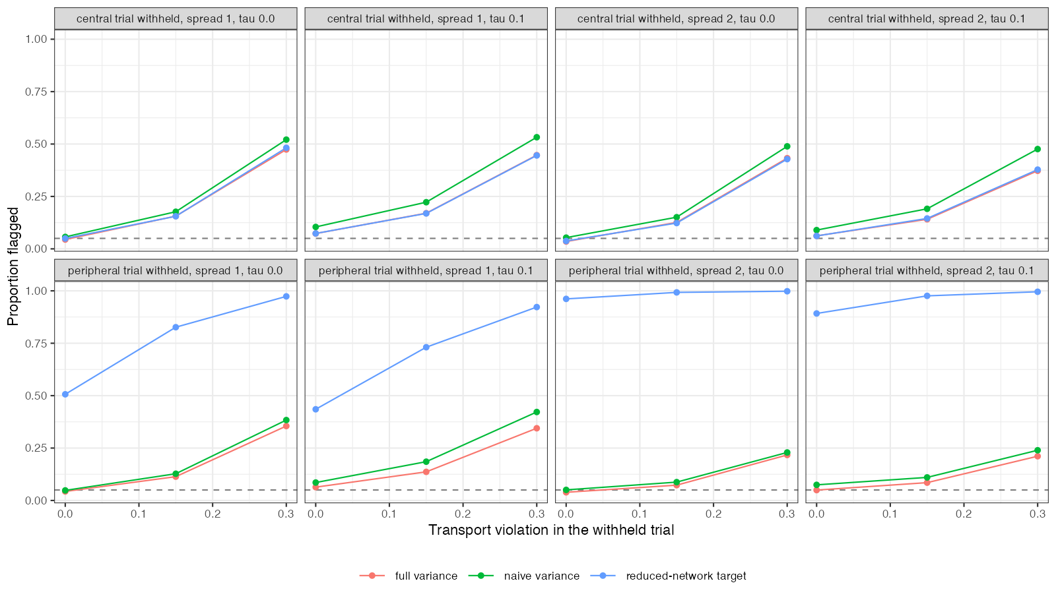
Figure 1: Proportion of analyses flagged by violation size, for each rule and configuration. The dashed line is 0.05.
The external target removed the estimand mismatch entirely, and the full variance kept size near nominal; it was conservative for the peripheral trial at wide spread (0.039), where the prediction’s variance dominated and its covariance with the observed contrast was positive (Figure 1). The one scenario above 0.07 had heterogeneity estimated from only four trials, which DerSimonian-Laird underestimates.
Power rose little with any factor. The detectable violation is set by the sampling error of a single trial’s contrast and of the prediction at its covariate mean, and a network supplies one withheld trial at a time. The sign rule is not calibratable: its flag rate is a property of the effect’s distance from zero, not of the violation.

4. What this does not answer
Continuous outcome and G-computation, so MAIC weight-estimation variance and non-collapsibility are absent; a Bayesian predictive rule and a conditional-moment test were not run; five aggregate trials only. Peer review has not been done.

References
1. Tim P. Morris, Ian R. White, Michael J. Crowther. Using simulation studies to evaluate statistical methods. Statistics in Medicine. 2019;38(11):2074–102. doi:10.1002/sim.8086
2. Rebecca DerSimonian, Nan Laird. Meta-analysis in clinical trials. Controlled Clinical Trials. 1986;7(3):177–88. doi:10.1016/0197-2456(86)90046-2

