Transporting a continuous outcome: the mean is safe under a pooled residual, the responder probability is not
A simulation study answering catalog problem OUT-05
Ahmad Sofi-Mahmudi
2026-09-23

Abstract
Background. Continuous outcomes are transported by G-computation from normal linear models, often with one residual SD. The target mean does not involve the residual, but a responder probability does. Catalog problem OUT-05 asks how large the difference is and whether floor effects on bounded scales make it depend on the target population.
Methods. Source trial of 300 per arm, residual SD equal in both arms or twice as large under treatment, normal or skewed errors, a floor holding 0%, 10% or 25% of the control arm, and a target shifted by 0.3 or 1 SD: 24 scenarios, 1000 replicates each. Estimands: the target mean difference and the difference in the probability of exceeding the target control arm’s median or 90th percentile. Methods: normal model with pooled or arm-specific SD, Tobit with arm-specific scales, and logistic regression of the responder indicator.
Results. Without a floor the pooled-SD model’s mean contrast was unbiased (at most 0.031) while its responder contrasts were biased by up to 0.102 when the SDs differed, with opposite signs at the two thresholds (for example 0.022 and -0.102). Arm-specific SDs removed that bias for normal errors but not with a floor (up to 0.058) or skew. Tobit handled the floor (at most 0.003) but not skew. Logistic regression of the responder indicator was unbiased in every scenario (at most 0.006). The floor biased the linear model’s mean contrast by at most 0.070, more at the larger target shift, but under 2% of the effect.
Conclusion. Report responder probabilities from a model of the responder indicator, or at least with arm-specific dispersion and a model for the floor; a pooled normal residual biases them in a direction set by the threshold, even where the mean is right.

1. The problem
With an identity link and a correct mean model, the target mean contrast contains no residual term. A responder probability contains : a pooled value too small for the treated arm overstates response when the conditional mean is above the threshold and understates it below, so the error does not average out. A floor adds a point mass that a normal model spreads below the boundary; censored regression (1) models it, and how much it matters depends on how close the target sits to the floor.

2. Design
Registered protocol: protocol.md; ADEMP structure (2). Latent with , , ; normal or standardized Gamma(4); . Truths from Monte Carlo draws.

3. Results
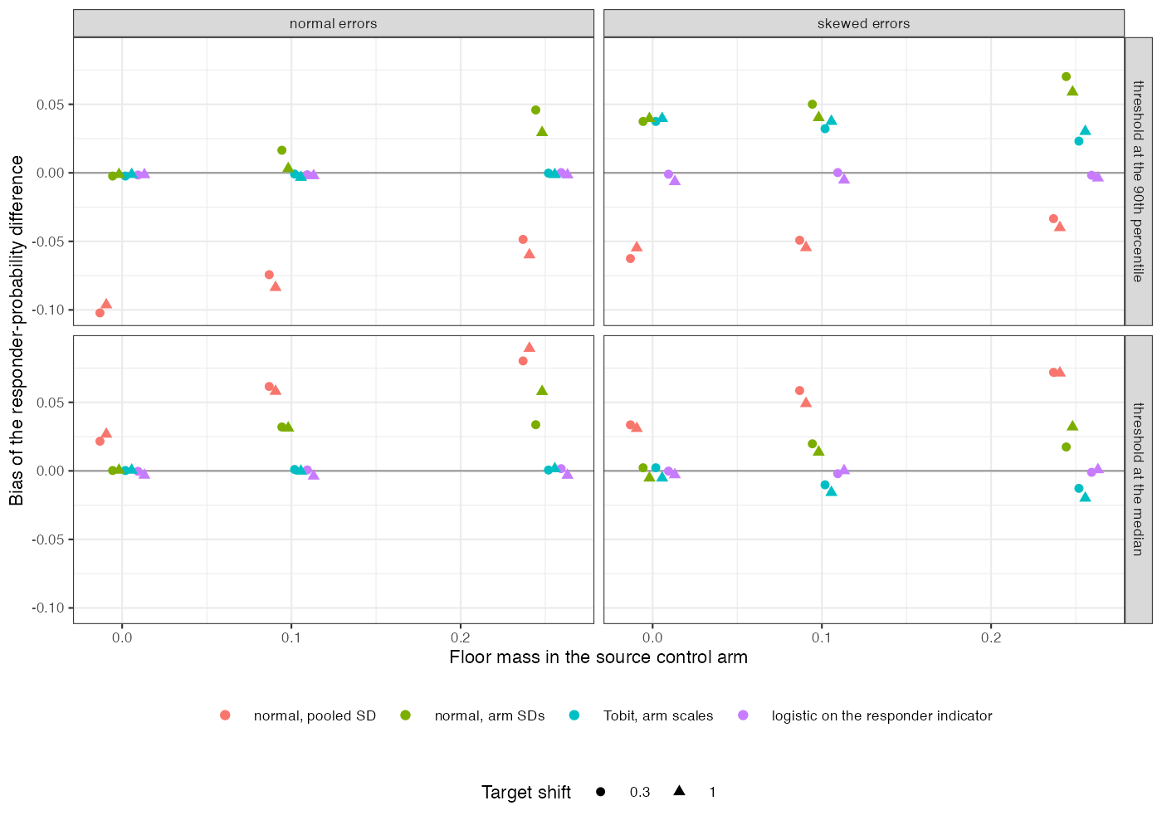
Figure 1: Bias of the responder-probability difference by method, floor mass and error distribution, SD ratio 2.
The dissociation registered as the primary outcome held (Figure 1): the same fitted mean model gave an unbiased mean contrast and biased responder contrasts. The direction reversed between the median and the tail threshold, so averaging over thresholds would hide it. Each parametric repair fixed the feature it models and missed the others; the direct binary model needed no distributional assumption for the outcome and paid in variance (RMSE 0.031 against 0.023 for the correct normal model at the tail).

4. What this does not answer
One source trial with arm-specific dispersion rather than several studies with study-specific dispersion; no ceiling; bias and RMSE only, without intervals; no ML-NMR. Peer review has not been done.

References
1. James Tobin. Estimation of relationships for limited dependent variables. Econometrica. 1958;26(1):24–36. doi:10.2307/1907382
2. Tim P. Morris, Ian R. White, Michael J. Crowther. Using simulation studies to evaluate statistical methods. Statistics in Medicine. 2019;38(11):2074–102. doi:10.1002/sim.8086

