Unsupported target mass matters only where the effect is modified, and weight diagnostics cannot see where that is
A simulation study answering catalog problem OVL-01
Ahmad Sofi-Mahmudi
2026-09-23

Abstract
Background. When part of the target population lies outside the source trial’s covariate support, weighting and outcome-model methods must extrapolate. Catalog problem OVL-01 asks whether support diagnostics (effective sample size, unsupported mass, weight concentration) identify the analyses that fail.
Methods. Anchored transport of a continuous outcome with one covariate truncated in the source, leaving 0%, 14% or 27% of the target unsupported. The unsupported direction was orthogonal, partly or fully aligned with effect modification, which was linear or bent beyond the support boundary: 36 scenarios, 1000 replicates each. MAIC, spline G-computation and G-computation trimmed to the supported region. Covariate laws did not depend on alignment or shape, so every weight diagnostic had the same distribution across them.
Results. Bias appeared only where modification bent in the unsupported direction: at the largest unsupported mass, -0.292 for G-computation and -0.303 for MAIC with full alignment, against 0.023 and -0.006 with orthogonal alignment and under 0.017 with linear modification. Within an overlap level the weight diagnostics discriminated failed analyses at chance (AUROC 0.481 to 0.528). A score weighting unsupported distance by the estimated interaction reached 0.592 for G-computation and 0.657 for MAIC; the registered margin of 0.10 over effective sample size was missed by 0.01, and neither was usable (registered verdict). Trimming gave unbiased estimates of the restricted population’s effect (at most 0.026).
Conclusion. Unsupported mass is harmful only where the effect changes in a way the source cannot show, and no diagnostic built from covariates and weights can tell whether that is so. Report the restricted estimand, or state the extrapolation assumption, rather than reading effective sample size as a safety check.

1. The problem
The transport bias from the unsupported region is . Effective sample size and related diagnostics (1) are functions of covariates and weights and can see only the first factor. The second depends on how the effect behaves where the source has no patients, which a correctly specified model extrapolates and a misspecified one does not.

2. Design
Registered protocol: protocol.md; ADEMP structure (2). Source 300 per arm, with truncated at ; target with known law. , , , alignment , or . MAIC (3) balanced the target means; G-computation used natural splines with 3 degrees of freedom, linear beyond the observed range. Failure: the 95% interval excluded the truth.

3. Results
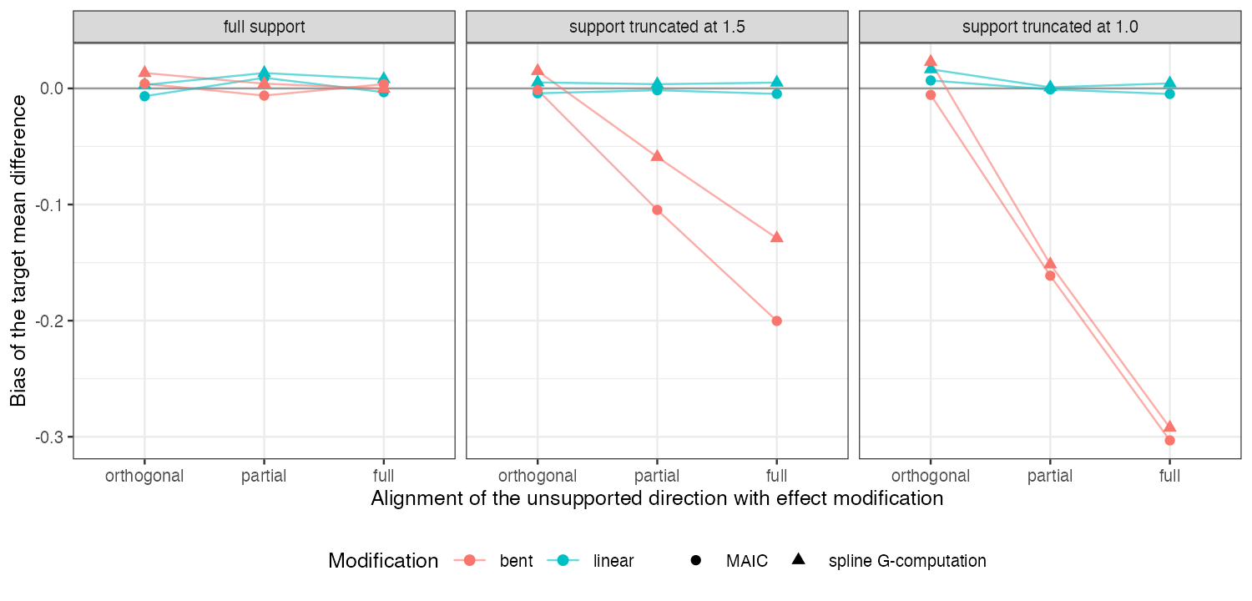
Figure 1: Bias of MAIC and spline G-computation by alignment and modification shape, strength 0.6.
Figure 1 shows the product structure: no bias at full support, none with linear modification at any truncation (the falsifier: a correct model recovers the unsupported region), and bias growing with alignment only when modification bent beyond the support. Effective sample size fell from 0.72 to 0.41 of the sample with truncation in every panel alike, so it tracked the first factor and nothing else. Pooled across overlap levels it did predict large absolute errors (AUROC 0.754), but through variance: lower effective sample size means wider sampling error, not detected extrapolation bias.
The outcome-informed score helped because it multiplies unsupported distance by the estimated interaction, but it cannot distinguish linear from bent modification beyond the support, so it also flagged the linear scenarios where extrapolation was harmless.

4. What this does not answer
Continuous outcome and two covariates; ML-NMR, ML-UMR and NMI were not run; failure was defined by interval non-coverage because no decision context fixes a material threshold. Peer review has not been done.

References
1. David M. Phillippo, A. E. Ades, Sofia Dias, Stephen Palmer, Keith R. Abrams, Nicky J. Welton. Methods for population-adjusted indirect comparisons in health technology appraisal. Medical Decision Making. 2018;38(2):200–11. doi:10.1177/0272989X17725740
2. Tim P. Morris, Ian R. White, Michael J. Crowther. Using simulation studies to evaluate statistical methods. Statistics in Medicine. 2019;38(11):2074–102. doi:10.1002/sim.8086
3. James E. Signorovitch, Eric Q. Wu, Andrew P. Yu, Charles M. Gerrits, Evan Kantor, Yanjun Bao, Shiraz R. Gupta, Parvez M. Mulani. Comparative effectiveness without head-to-head trials: A method for matching-adjusted indirect comparisons applied to psoriasis treatment with adalimumab or etanercept. PharmacoEconomics. 2010;28(10):935–45. doi:10.2165/11538370-000000000-00000

