A misclassified modifier needs correcting in the weights as well as the outcome model
A simulation study answering catalog problem QBA-06
Ahmad Sofi-Mahmudi
2026-09-23

Abstract
Background. A binary effect modifier recorded with error enters population adjustment through the balancing step and through the outcome model. Catalog problem QBA-06 asks whether correcting the outcome model alone is enough.
Methods. Anchored transport of an A-versus-C contrast with a misclassified binary modifier (prevalence 0.3 in the source and 0.5 in the target), four assay scenarios (identical good, identical poor, worse in the source, worse in the target) and two modification strengths: 8 scenarios, 1000 replicates each. MAIC on the recorded covariate, with prevalence correction, and with latent-prevalence weights; STC on the recorded covariate, with only its outcome model corrected, and fully corrected. Assay sensitivity and specificity were known.
Results. MAIC on the recorded covariate was biased even when both studies used the same assay (-0.130 to -0.032), and correcting the target prevalence alone did not help (up to -0.130). Correcting only STC’s outcome model left -0.051 to -0.012. Full correction of STC and MAIC with latent-prevalence weights were unbiased (at most 0.006 and 0.006).
Conclusion. Balancing a misclassified covariate does not balance the true one, whatever the assays, because reweighting recorded categories leaves each category’s true composition at the source’s. Both paths need correcting: the outcome model and the population it is averaged over, or for MAIC, weights chosen on the latent prevalence.

1. The problem
With recorded , MAIC (1) reweights the and categories to match the target’s reported prevalence. The weighted source’s true prevalence is then , which depends on the source’s prevalence through Bayes’ rule and does not equal the target’s. DESIGN.md said identical assays make balance on imply balance on ; they do not. An outcome model on is attenuated (2), and correcting it still averages over the wrong population if the target’s reported prevalence is used as the true one.

2. Design
Registered protocol: protocol.md; ADEMP structure (3). Source trial 400 per arm; , ; the target reports the prevalence of from 800 patients. Latent-prevalence MAIC chooses the weight share of with equal to the target’s corrected prevalence. The corrected STC is a latent-class logistic likelihood with the known source assay.

3. Results
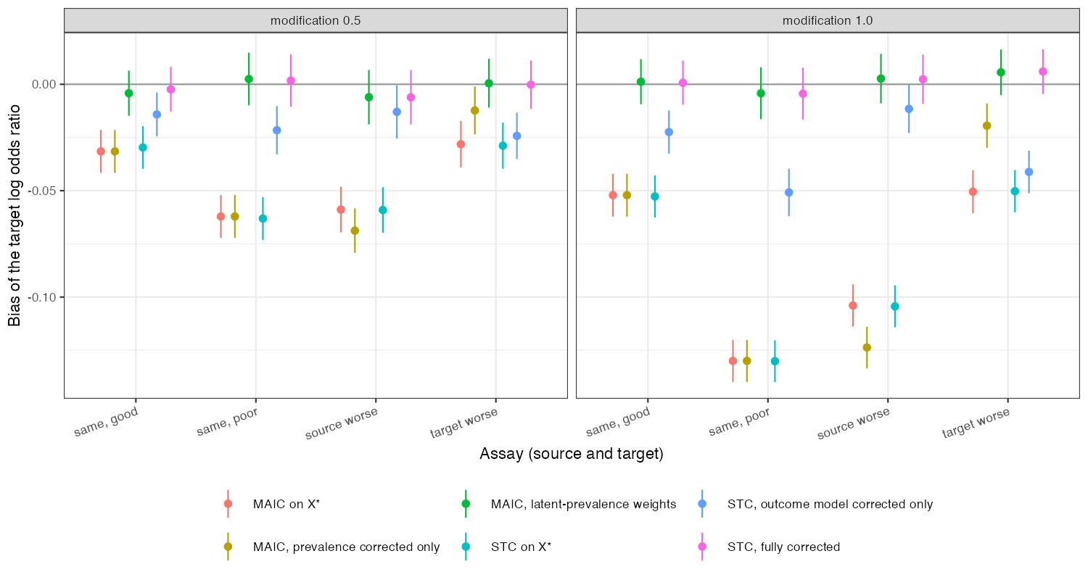
Figure 1: Bias by method and assay scenario with 95% Monte Carlo intervals.
The naive MAIC and STC behaved identically (Figure 1): with one binary covariate both average the same category-specific effects. Their bias grew with modification strength and with a poorer source assay. Each partial correction fixed one path and left the other.

4. What this does not answer
Known assay parameters, so validation-substudy and prior uncertainty were not propagated; a single binary covariate; no interval assessment. Peer review has not been done.

References
1. James E. Signorovitch, Eric Q. Wu, Andrew P. Yu, Charles M. Gerrits, Evan Kantor, Yanjun Bao, Shiraz R. Gupta, Parvez M. Mulani. Comparative effectiveness without head-to-head trials: A method for matching-adjusted indirect comparisons applied to psoriasis treatment with adalimumab or etanercept. PharmacoEconomics. 2010;28(10):935–45. doi:10.2165/11538370-000000000-00000
2. Raymond J. Carroll, David Ruppert, Leonard A. Stefanski, Ciprian M. Crainiceanu. Measurement error in nonlinear models: A modern perspective. 2nd ed. Boca Raton: Chapman; Hall/CRC; 2006. doi:10.1201/9781420010138
3. Tim P. Morris, Ian R. White, Michael J. Crowther. Using simulation studies to evaluate statistical methods. Statistics in Medicine. 2019;38(11):2074–102. doi:10.1002/sim.8086

