The strongest measured covariate does not bound the bias from what was not measured
A simulation study answering catalog problem QBA-26
Ahmad Sofi-Mahmudi
2026-09-23

Abstract
Background. A common argument in bias analysis is that no measured covariate, when dropped, moves the estimate as much as the assumed unmeasured bias, so the unmeasured bias is implausible. Catalog problem QBA-26 asks whether such a single-covariate benchmark bounds omitted structure that is a sum of several variables.
Methods. Unanchored binary-outcome MAIC with four measured covariates and one, three or six omitted covariates, correlated at 0, 0.3 or 0.6, each 0.5, 1 or 2 times as strong as the strongest measured covariate: 21 scenarios, 1000 replicates each. The benchmark was the largest change in the estimate from dropping one measured covariate, used plain or scaled by , by a correlation-adjusted factor with the true correlation, or by .
Results. With three or six omitted variables each no stronger than the strongest measured one, the plain benchmark covered the true residual bias in 0.00 to 0.07 of analyses; the bias was 1.43 to 5.67 times the median benchmark. Scaling by covered 0.00 to 0.76. Scaling by covered at least 0.99 when each omitted variable was half as strong as the strongest measured one, and about 0.6 when as strong. The benchmark itself shrank as the omitted structure grew (from 0.163 to 0.067), because on the odds ratio scale unexplained outcome variation attenuates every covariate’s marginal effect.
Conclusion. A maximum over single measured covariates bounds a sum over omitted ones only when one variable is omitted and it is weaker. Any benchmark argument must state an assumption about how many omitted variables there are and how strong, and scaling for shifts in the same direction needs a factor near , not .

1. The problem
With omitted structure , the transport bias of MAIC (1) grows with the sum of the omitted variables’ contributions, while a leave-one-covariate-out benchmark measures one measured variable at a time. Formal benchmarking (2) expresses unmeasured strength as a multiple of a measured covariate’s, which is an explicit assumption; the informal argument omits it. DESIGN.md proposed a multiplier , the standard deviation of a sum. When the omitted variables are all shifted in the same direction between populations their biases add, so the multiplier should be nearer .

2. Design
Registered protocol: protocol.md; ADEMP structure (3). Individual data on 400 patients of A; target covariate means 0.3 SD higher. Measured coefficients 0.6, 0.4, 0.3, 0.2; omitted coefficients each; one latent factor gives the omitted variables pairwise correlation . . Estimand: A’s marginal log odds in the target. The true residual bias is MAIC’s limit minus the truth, from draws. The scaled rules were given the true , which favors them.

3. Results
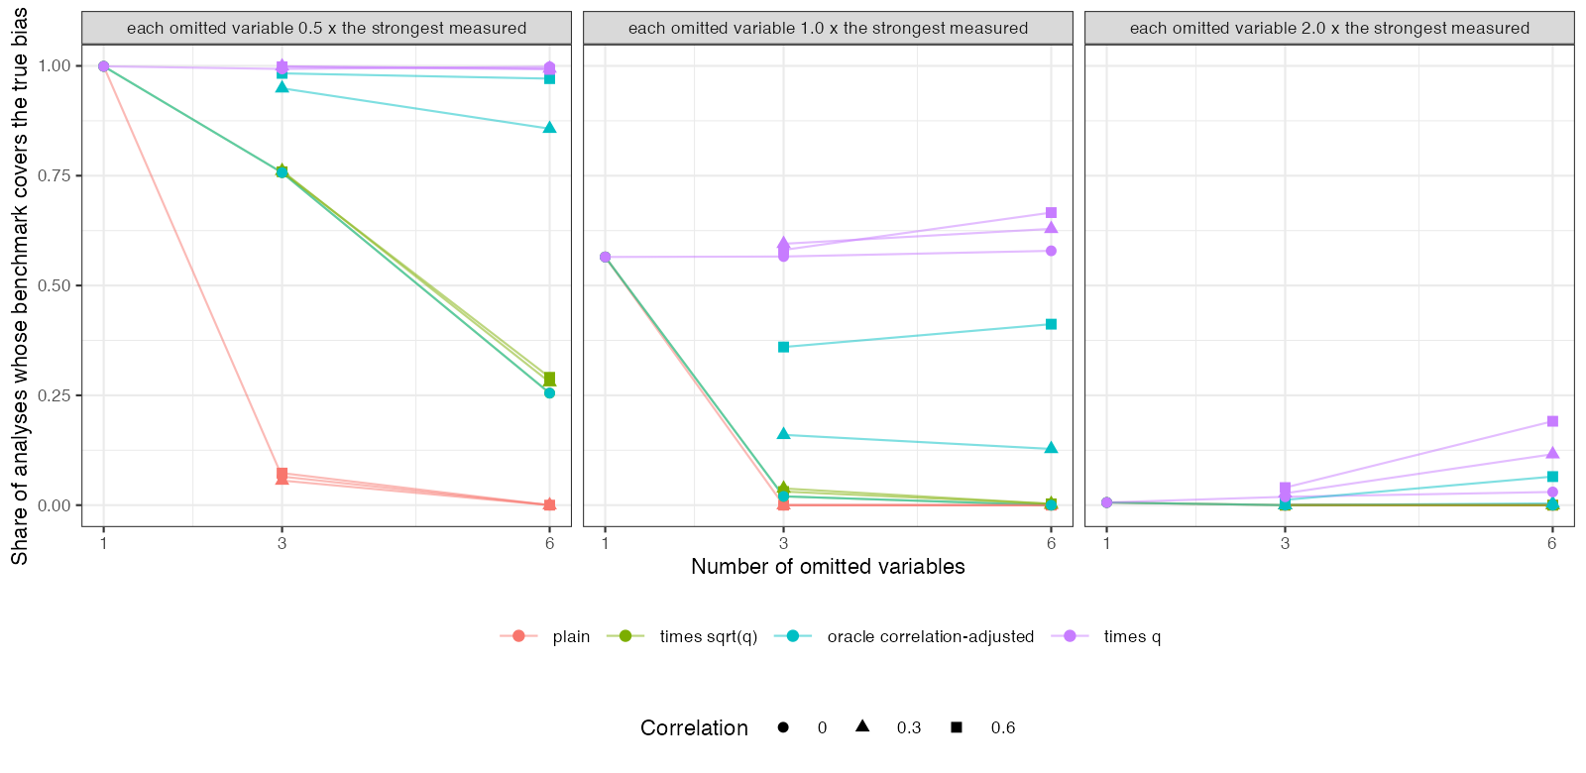
Figure 1: Share of analyses whose benchmark covers the true residual bias, by rule, number of omitted variables and their strength.
With one omitted variable half as strong as the strongest measured one, every rule covered (Figure 1); with one as strong, about half did, because the benchmark and the bias were equal on average. With more omitted variables coverage by the plain and rules collapsed. The correlation-adjusted factor helped only where correlation was high, and only with the true correlation, which an analyst does not have. The multiplier worked when its premise held (each omitted variable weaker than the strongest measured one) and failed when it did not.

4. What this does not answer
Omitted variables shifted in the same direction; with random directions their biases partly cancel and becomes the relevant scale. Continuous latent-factor correlation; one overlap level; the negative-control route was not run. Peer review has not been done.

References
1. James E. Signorovitch, Eric Q. Wu, Andrew P. Yu, Charles M. Gerrits, Evan Kantor, Yanjun Bao, Shiraz R. Gupta, Parvez M. Mulani. Comparative effectiveness without head-to-head trials: A method for matching-adjusted indirect comparisons applied to psoriasis treatment with adalimumab or etanercept. PharmacoEconomics. 2010;28(10):935–45. doi:10.2165/11538370-000000000-00000
2. Carlos Cinelli, Chad Hazlett. Making sense of sensitivity: Extending omitted variable bias. Journal of the Royal Statistical Society Series B. 2020;82(1):39–67. doi:10.1111/rssb.12348
3. Tim P. Morris, Ian R. White, Michael J. Crowther. Using simulation studies to evaluate statistical methods. Statistics in Medicine. 2019;38(11):2074–102. doi:10.1002/sim.8086

