Choosing among population-adjustment methods on the same data: the interval survives, the estimate does not
A re-scoring study answering catalog problem MIS-04
Ahmad Sofi-Mahmudi
2026-09-23

Abstract
Background. Analysts often fit several population-adjustment methods and report one, with that method’s interval. Catalog problem MIS-04 asks whether the selection matters and what averaging over the candidates would change.
Methods. Re-scoring of 32,000 stored replicates from DIA-08 (anchored binary-outcome comparison, 16 scenarios), each with estimates and SEs from MAIC on means, MAIC on means and SDs, linear STC and quadratic STC. Rules: a prespecified method; the method with the smallest SE; the method with the most favorable estimate; and an equal-weight average with between-model variance added.
Results. Choosing the most precise method reproduced the prespecified linear STC in most replicates and covered 0.938 to 0.956. Choosing the most favorable estimate biased it by up to -0.259 on the log odds ratio scale while coverage stayed at 0.927 or more, because the favored method was often a wide-interval MAIC. Averaging with between-model variance over-covered (up to 0.991), since the candidates share the same data. The registered rule counts that difference, so the refuting sentence fails as registered.
Conclusion. Among outcome and weighting models the candidates are close and a conditional interval loses little coverage, but selecting by result moves the estimate materially while its interval looks fine. Prespecify the method. Averaging needs weights that account for the candidates’ shared data; adding between-model variance to the mean within-model variance is too conservative.

1. The problem
Model selection is part of inference (1), and a conditional interval ignores it. For population adjustment the candidates are estimates from the same individual data, so they are strongly correlated: how much selection costs depends on how far apart they are and on which rule chooses.

2. Design
Registered protocol: protocol.md, committed before any scoring (DIA-08’s RMSE rankings were already known). The four candidates’ estimates and SEs per replicate came from DIA-08’s run: threshold, interaction, quadratic and linear modification at target covariate means 0.3, 0.8 and 1.2, skewed covariates, and no modification.

3. Results
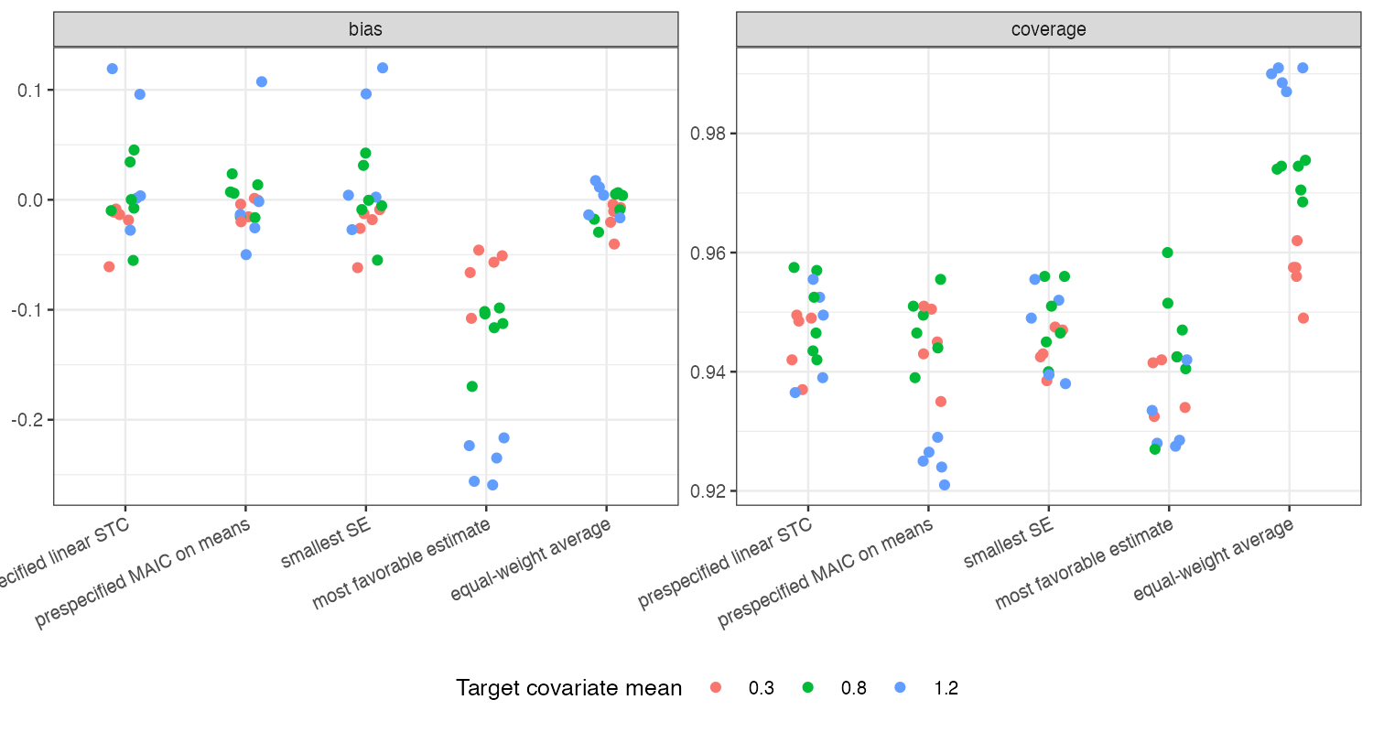
Figure 1: Bias and coverage by selection rule across the 16 scenarios.
Figure 1 shows the asymmetry. The result-selected estimate was shifted in the favored direction in every scenario, most at poor overlap where the candidates differed most, but its interval, often from the least precise candidate, still covered. A reader would see a nominal interval around a biased estimate. The averaged interval was the widest of all rules.

4. What this does not answer
Selection over outcome and weighting models only; treatment partitions and bridges, where candidates can be observationally equivalent and no data-based weight exists, were not studied. Equal weights rather than stacking. Peer review has not been done.

References
1. S. T. Buckland, K. P. Burnham, N. H. Augustin. Model selection: An integral part of inference. Biometrics. 1997;53(2):603–18. doi:10.2307/2533961

