outstandR’s G-computation estimate moved by about 0.05 on the log odds ratio across defensible target reconstructions
A simulation study answering catalog problem SFW-12
Ahmad Sofi-Mahmudi
2026-09-23

Abstract
Background. outstandR (1) standardizes an individual-data trial’s outcome model over a pseudo-population simulated from the aggregate trial’s published means and SDs, by default with normal margins and a Gaussian copula whose correlation is taken from the individual data. Catalog problem SFW-12 asks how far its estimate depends on that reconstruction.
Methods. Skewed target covariates (gamma margins) joined by a Clayton or Gaussian copula at correlation 0.5; individual data with the same or a lower correlation; an anchored binary-outcome comparison; the package’s G-computation routine under five reconstructions; 400 replicates per cell.
Results. Within a dataset the estimate ranged over 0.049 to 0.052 on the log odds ratio scale across the five reconstructions, at the registered materiality threshold of 0.05, and about a fifth of the estimate’s sampling SD (0.24 to 0.26). The default’s bias was -0.055 to -0.018; specifying gamma margins removed most of it (-0.011 to 0.009 with the target’s correlation). Whether the true copula was tail-dependent changed the range by at most 0.002.
Conclusion. The reconstruction moves an outstandR estimate by an amount comparable to a materiality threshold but small against its sampling error. The margin family matters more than the copula; reporting the estimate across reconstructions is cheap with the package’s own arguments.

1. The problem
G-computation integrates the fitted outcome model over the target’s covariate law, which a publication describes only by marginal summaries. The package fills the gap with an assumption: normal margins unless told otherwise, and the individual data’s correlation. Each is an analyst choice that the published output does not display.

2. Design
Registered protocol: protocol.md. Target , , Clayton or Gaussian copula at Pearson 0.5; individual data from and with a Gaussian copula at 0.5 or 0.1; 300 per arm per trial; with (A) and (B). The package’s internal gcomp_ml_means() was called directly with 20000 pseudo-patients and no bootstrap.

3. Results
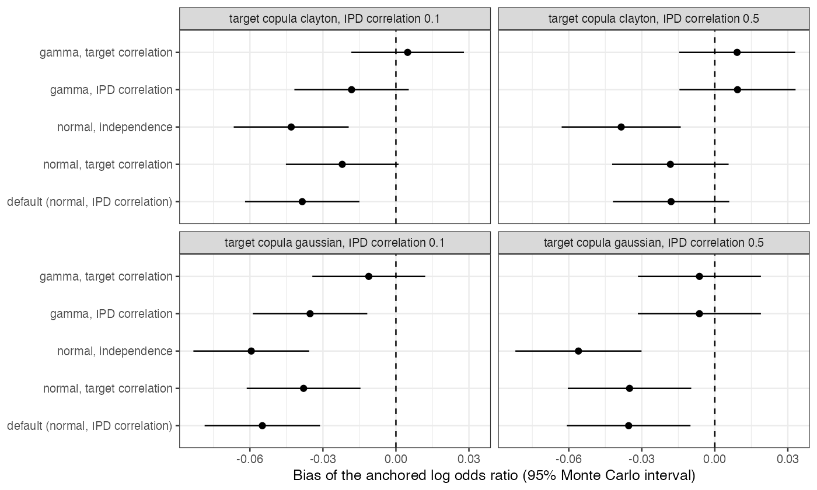
Figure 1: Bias of the anchored estimate under each reconstruction.
Table 1: Mean over 400 replicates of the within-dataset range.
target copula | IPD correlation | mean range across reconstructions | from the correlation choice | from the margin family
gaussian | 0.5 | 0.052 | 0.023 | 0.029
clayton | 0.5 | 0.050 | 0.023 | 0.028
gaussian | 0.1 | 0.049 | 0.022 | 0.020
clayton | 0.1 | 0.049 | 0.022 | 0.021

The registered primary called the sensitivity material, and it sat on the threshold in every cell (Table 1). The margin family and the correlation each accounted for about half of the range (Figure 1). Normal margins on skewed covariates biased the estimate by 0.02 to 0.06; independence was worst; using the individual data’s correlation when the target’s differed added bias. The copula’s tail dependence changed the range by at most 0.002, which agrees with CMP-15’s finding that the family’s effect on the logit scale is a few hundredths.

4. What this does not answer
Pairwise anchored comparison, two covariates, a correctly specified outcome model, point estimates only; no Bayesian G-computation, multiple-imputation marginalization or network use. Peer review has not been done.

References
1. Nathan Green, Chengyang Gao, Antonio Remiro-Azócar. outstandR: Model-based standardisation for indirect treatment comparison with limited subject-level data [Internet]. 2026. Available from: https://CRAN.R-project.org/package=outstandR

