One-at-a-time sensitivity analysis of two bias layers reports robustness that the joint analysis does not support
A numerical study answering catalog problem QBA-20
Ahmad Sofi-Mahmudi
2026-09-23

Abstract
Background. A disconnected component comparison with no cross-gap evidence rests on two unidentified assumptions: that the populations transport, and that shared components act the same on both sides of the gap. Sensitivity analyses vary one at a time. Catalog problem QBA-20 asks whether that bounds their joint effect.
Methods. A logistic model for the cross-gap contrast with an omitted modifier (population layer) and component main-effect and component-by-modifier drift (bridge layer). The bias of the reported target marginal log odds ratio (-0.20, favoring A) was computed exactly over elicited ranges at three scales, one parameter at a time and jointly.
Results. At the base scale each one-at-a-time curve stayed within ±0.157 and none reversed the decision; the joint box reached -0.413, and 7% of it reversed the decision. 24% of the box lay outside the one-at-a-time envelope. The component-by-modifier drift moved the estimate by at most 0.041 alone, because its effect is its product with the omitted modifier’s imbalance. Under positively dependent elicitation 13% of draws reversed the decision.
Conclusion. One-at-a-time curves do not bound two layers acting on one contrast, and the drift form current tooling excludes is the one they cannot see. The layers must be varied jointly and the region reported.

1. The problem
A bias analysis that varies each unidentified parameter with the others fixed at their null values measures a cross through the parameter space, not the space (1). For additive biases the joint range is the sum of the one-at-a-time ranges, so the cross never bounds it. Two features make the component case worse. The drift of a component’s interaction with a modifier biases the target contrast only through that modifier’s imbalance between populations, a product of the two layers that is zero along both axes of the cross. And with no cross-gap evidence, neither layer can be checked.

2. Design
Registered protocol: protocol.md. Individual model with measured and omitted; target , . The analysis assumes . Elicited half-ranges at scale 1: 0.5 (a population-layer bias of up to about 0.13), 0.2, 0.4; scales 0.5, 1 and 1.5. Exact quadrature; a grid over the box and 4000 draws from each of three elicited distributions (independent, or correlation between and each drift parameter).

3. Results
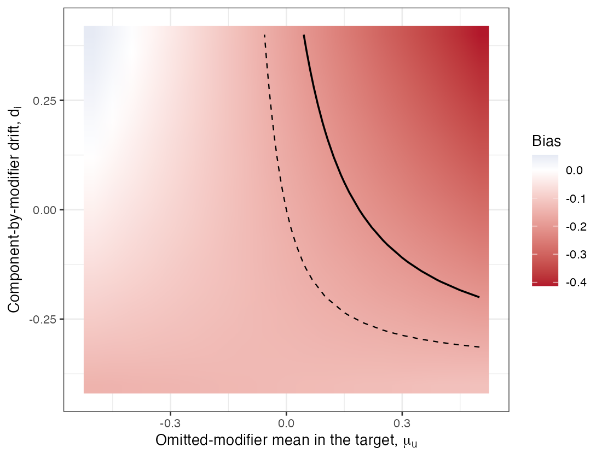
Figure 1: Bias of the reported log odds ratio at scale 1 with component main-effect drift at its upper limit (0.2). Dashed: the one-at-a-time envelope’s lower edge. Solid: the bias that reverses the decision; to its right the truth favors B.
Table 1: Reported log odds ratio -0.203; a bias below it reverses the decision. Masked: both layers at least 0.1 in absolute value with net bias below 0.05.
scale | one-at-a-time envelope | joint envelope | box reversing | box outside envelope | masked | outside, elicited ind / + / − | reversing, elicited ind / + / −
0.5 | -0.078 to 0.078 | -0.186 to 0.147 | 0% | 23% | 0% | 22% / 34% / 5% | 0% / 0% / 0%
1.0 | -0.156 to 0.157 | -0.413 to 0.341 | 7% | 24% | 4% | 21% / 32% / 8% | 5% / 13% / 0%
1.5 | -0.234 to 0.235 | -0.674 to 0.577 | 17% | 26% | 6% | 24% / 32% / 12% | 16% / 25% / 4%

The registered failure condition held at every scale: at least 23% of the box lay outside the one-at-a-time envelope (Table 1). At scale 1 the one-at-a-time analysis declared the decision robust while the joint box contained reversals, the spurious robustness the entry describes; at scale 0.5 both declared it robust, and at 1.5 neither did. The reversal region needs all three parameters to push the same way (Figure 1): a positive omitted-modifier imbalance, positive main-effect drift and positive interaction drift. Offsetting configurations also exist: in 4% of the box both layers were material and their net bias was under 0.05, so a correct-looking estimate could hide two large errors.
The elicited dependence mattered as much as the ranges. If the analyst believes the two layers move together, a quarter to a third of the elicited mass lies outside the one-at-a-time envelope; if opposite, far less. No data inform that dependence.

4. What this does not answer
A population-level calculation on one logistic model: no sampling, no component network fit and no time-to-event scale. The joint law of measured and omitted covariates was known, so the price of eliciting it (the design’s fairness requirement) is not measured. Component-by-component non-additivity and backbone interactions were not included and are drift forms this analysis does not cover. Peer review has not been done.

References
1. Sander Greenland. Multiple-bias modelling for analysis of observational data. Journal of the Royal Statistical Society Series A. 2005;168(2):267–306. doi:10.1111/j.1467-985X.2004.00349.x

