Matching a covariate measured by different instruments: a reliability correction is not enough
A simulation study answering catalog problem COV-09
Ahmad Sofi-Mahmudi
2026-09-23

Abstract
Background. MAIC balances a covariate by name. When the source trial and the target publication measured it with different instruments, the matched means agree on paper while the underlying populations do not. Catalog problem COV-09 asks how MAIC is biased and whether a reliability correction repairs it.
Methods. Latent effect modifier recorded in the source and reported by the target through linear instruments with offsets, slopes and measurement error. Five instrument pairs, source reliability 1, 0.8 or 0.6, modification 0, 0.3 or 0.6: 45 scenarios, 1000 replicates each. Naive MAIC, MAIC with a reliability correction, and an envelope of corrected intervals over declared instrument differences.
Results. Naive bias followed its closed form (slope 0.992). With a shared instrument the reliability correction removed the bias (at most 0.011). With differing instruments it left bias up to 0.176 and could increase it: at reliability 0.6 a target offset and the attenuation cancelled in the naive analysis (bias -0.018), and the correction undid the cancellation (0.172). The envelope over declared instrument differences covered 0.967 or more at 1.4 to 2.9 times the naive width.
Conclusion. A balance table cannot show instrument differences, and no source-side correction identifies them. Where instruments may differ, report a bounded analysis over declared differences.

1. The problem
The source records and the target reports the mean of . MAIC (1) tilts the source on to the reported mean. For a normal source the latent mean moves by times the shift in , so with effect modification the transported effect is biased by . With one shared instrument the bias is attenuation by the source reliability, and dividing by a known reliability repairs it. With different instruments the bias has either sign, and nothing in the source data identifies or .

2. Design
Registered protocol: protocol.md; ADEMP structure (2). Latent in the source (200 per arm) and in the target; . Instrument pairs : same ; same, shifted ; target offset ; target slope ; target offset and slope . The corrected analysis disattenuates the target point assuming one instrument and a known reliability. The bounded analysis takes the envelope of corrected intervals over target offsets in and slopes in relative to the source instrument, a range that contains every simulated pair.

3. Results
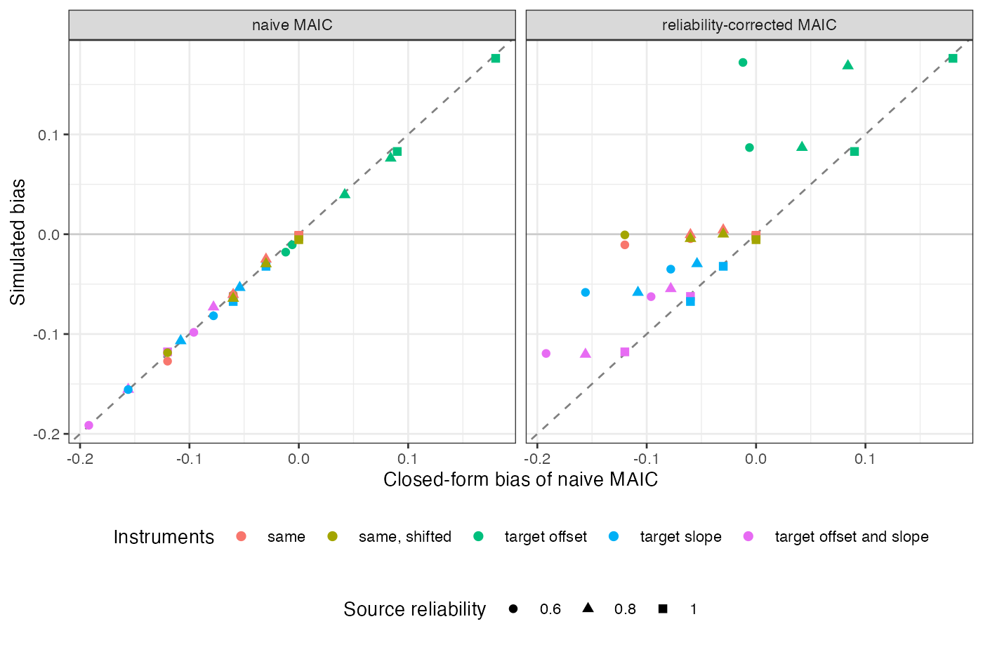
Figure 1: Simulated bias against the closed form, for naive and reliability-corrected MAIC, modification 0.3 and 0.6.
Naive bias matched the closed form in all 45 scenarios (Figure 1), and with no modification it was zero whatever the instruments. The reliability correction moved shared-instrument scenarios onto zero and left differing-instrument scenarios where the instrument difference put them. Coverage of the corrected interval fell to 0.847 for differing instruments.
The bounded analysis contains the truth whenever the declared range contains the true instrument difference, which it did here by construction; its cost was width. It does not protect against differences outside the declared range.

4. What this does not answer
Identity link and linear instruments; cut-point misclassification of binary covariates and correction from a bridging sample measured on both instruments were not run. The target’s reported mean was its population value, so target sampling error is absent. Peer review has not been done.

References
1. James E. Signorovitch, Eric Q. Wu, Andrew P. Yu, Charles M. Gerrits, Evan Kantor, Yanjun Bao, Shiraz R. Gupta, Parvez M. Mulani. Comparative effectiveness without head-to-head trials: A method for matching-adjusted indirect comparisons applied to psoriasis treatment with adalimumab or etanercept. PharmacoEconomics. 2010;28(10):935–45. doi:10.2165/11538370-000000000-00000
2. Tim P. Morris, Ian R. White, Michael J. Crowther. Using simulation studies to evaluate statistical methods. Statistics in Medicine. 2019;38(11):2074–102. doi:10.1002/sim.8086

