Different assessment schedules bias a cross-trial RMST difference by half the visit spacing times the event probability
A simulation study answering catalog problem OUT-14
Ahmad Sofi-Mahmudi
2026-09-23

Abstract
Background. Progression is detected at scheduled visits, so a recorded event time is the first visit after the event. When two trials in an unanchored comparison use different schedules, the recording delay differs between the arms. Catalog problem OUT-14 asks how much this biases a transported restricted mean survival time (RMST) difference.
Methods. Two single arms of 300, Weibull event times, visit spacing 0 (continuous), 1, 2 or 3 months in trial A and 0 or 3 months in trial B, two event rates and two true differences: 32 scenarios, 1000 replicates each. RMST at 24 months from Kaplan-Meier on recorded times, Kaplan-Meier after moving events back half a spacing, and an interval-censored Weibull model.
Results. Treating recorded times as exact biased the RMST difference by (simulated against predicted slope 1.014), up to 1.43 months where the schedules differed by 2 months or more. The true difference was 2.57 or 1.22 months. The midpoint shift and the interval-censored model reduced the bias to at most 0.081 and 0.071 months.
Conclusion. A 3-month difference in visit spacing produces a spurious RMST difference of the same size as a real treatment effect. Covariate balancing cannot remove it because it acts on the time axis. Move events to the interval midpoint or fit an interval-censored model.

1. The problem
An event in is recorded at , on average late. RMST up to (1) accumulates the delay for every event before , so treating recorded times as exact inflates it by about . DESIGN.md gave without the factor . Within one trial the delay is shared by both arms and nearly cancels. Across trials with different spacing it enters the contrast, and weighting on covariates does not act on it.

2. Design
Registered protocol: protocol.md; ADEMP structure (2). Weibull shape 1.2; A’s median 8 or 16 months, B’s median equal or 3 months longer; dropout uniform on 12 to 60 months; administrative censoring at 36 months; . Recorded times are used directly, which is what an ideal reconstruction of published curves returns. The interval-censored Weibull model treats each event as lying between the previous and the recorded visit; it is correctly specified here, which favors it.

3. Results
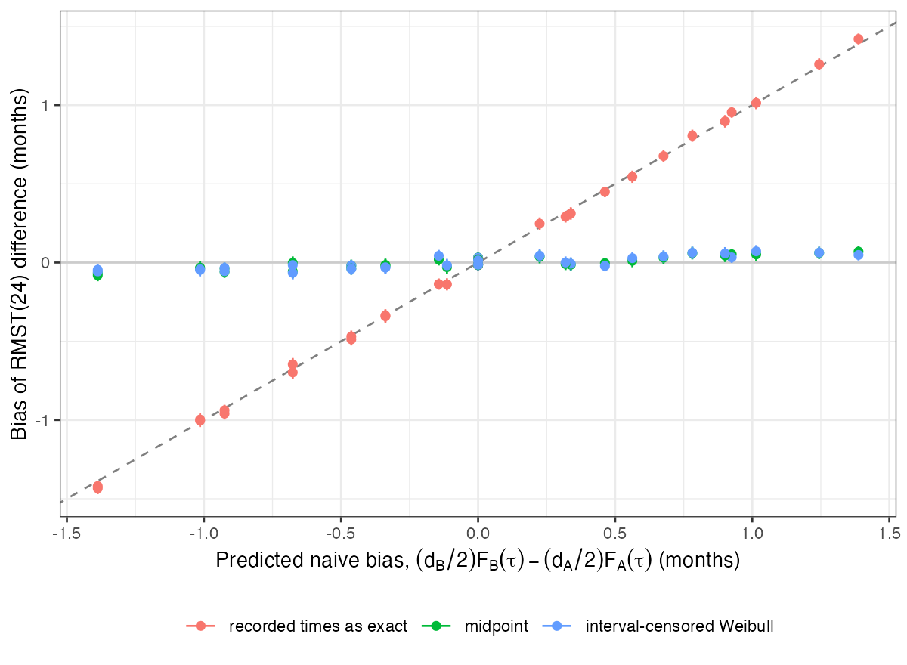
Figure 1: Bias of the RMST difference against the predicted naive bias, with 95% Monte Carlo intervals.
The naive bias followed the prediction across all scenarios (Figure 1), with either sign depending on which trial had the coarser schedule. With no true difference, a 3-month schedule in one trial alone produced an apparent difference of 1.42 months. With A’s median 16 months and a true difference of 1.22 months, a 3-month schedule in A alone removed 1.00 months of it. With equal schedules the bias was near zero where the arms had equal event probabilities; it was -0.137 and -0.138 where they did not (predicted -0.144 and -0.114), so the registered control, which assumed zero there, failed in 2 of 8 cells for a reason the mechanism predicts.
The midpoint shift left bias within 3 MCSE of zero in 27 of 32 scenarios and the interval-censored model in 28 of 32; the remaining bias was below 0.1 month.

4. What this does not answer
The binary event-by-time endpoint and comparisons with different maximum follow-up were not run. Reconstruction error from digitized curves was not simulated. Visits were exactly on schedule; real visit windows add jitter that the midpoint shift ignores. Peer review has not been done.

References
1. Patrick Royston, Mahesh K. B. Parmar. Restricted mean survival time: An alternative to the hazard ratio for the design and analysis of randomized trials with a time-to-event outcome. BMC Medical Research Methodology. 2013;13:152. doi:10.1186/1471-2288-13-152
2. Tim P. Morris, Ian R. White, Michael J. Crowther. Using simulation studies to evaluate statistical methods. Statistics in Medicine. 2019;38(11):2074–102. doi:10.1002/sim.8086

