Decision and estimation rankings of population-adjustment methods disagree only when the threshold’s side is known
A re-scoring study answering catalog problem DEC-01
Ahmad Sofi-Mahmudi
2026-09-23

Abstract
Background. Simulation studies rank population-adjustment methods by bias, RMSE and coverage, but a reimbursement decision depends on whether the estimate falls on the right side of a threshold. Catalog problem DEC-01 asks whether ranking methods by decision error changes the conclusions.
Methods. Re-scoring of 108,000 stored replicates from COV-03 (108 binary-outcome scenarios; unadjusted, three MAIC variants and G-computation). Thresholds were placed 0.1 or 0.3 above or below the true log odds ratio, with loss ratios of 1, 2 and 5 between wrong adoption and wrong rejection. Rankings by RMSE and by expected loss were compared within each scenario and threshold.
Results. Near the threshold in poor-overlap scenarios the mean rank correlation between RMSE and expected loss was 0.45, and the RMSE-best method was also loss-best in 38% of cases (registered verdict: confirmed). The disagreement was not Monte Carlo noise: each ranking reproduced across independent halves of the replicates (1.00 and 0.96). It came from the direction of bias: a biased method decided wrongly in 0.114 of replicates when its bias pointed away from the threshold and 0.635 when it pointed toward it. Averaged over the two sides of the threshold the rankings agreed (correlation 0.93, same best method in every poor-overlap scenario).
Conclusion. Decision error can rank methods differently from RMSE, but only for an analyst who knows which side of the threshold the truth lies on, and then the favored method is the one whose bias happens to point the right way. Without that knowledge RMSE is an adequate proxy for decision error here.

1. The problem
The wrong-decision probability depends on the estimator’s distribution relative to the threshold , not on its distance from the truth. Bias toward the threshold increases it and bias away decreases it, so a biased method can decide correctly more often than an unbiased one. ADEMP performance measures (1) contain no decision measure, and whether this matters for method rankings had not been measured.

2. Design
Registered protocol: protocol.md, committed before any decision scoring; COV-03’s estimation results were already known. , . With loss ratio , B is adopted when under ; gives . Poor overlap: target shift 0.6 SD with the source’s prognostic-index variance half the target’s. Two analyses were added after the registered one and are labeled exploratory: split-half reliability of each ranking, and loss averaged over the two sides of the threshold.

3. Results
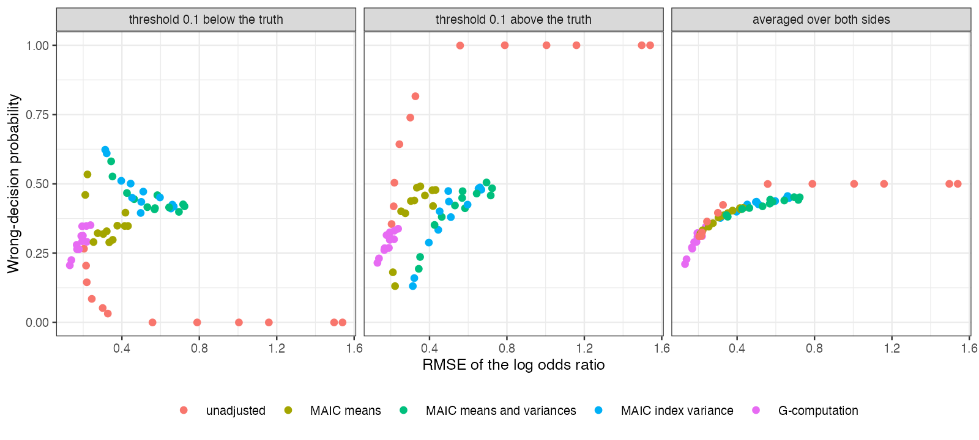
Figure 1: Wrong-decision probability against RMSE in the 12 poor-overlap scenarios, thresholds 0.1 from the truth.
One anchored scenario shows the mechanism. G-computation, unbiased with the smallest RMSE, decided wrongly in 0.280 and 0.261 of replicates with the threshold below and above the truth. The unadjusted analysis, biased upward by 0.099, decided wrongly in 0.145 when the threshold was below (bias pointing away) and 0.504 when it was above. Across the primary strata the loss-best method was the unadjusted analysis whenever the threshold was below the truth and G-computation or MAIC on the index variance when it was above (Figure 1).
Asymmetric losses did not change the pattern (mean correlations 0.28 to 0.66 across strata). Far from the threshold with identical populations every method decided correctly in at least 0.919 of replicates.

4. What this does not answer
The decision is on the relative effect alone, not a net-benefit model with costs and utilities. One source of replicates (COV-03), five methods and no ML-NMR. An analyst with genuine prior information on the side of the threshold could weigh methods by their likely bias direction; the study does not model such priors. Peer review has not been done.

References
1. Tim P. Morris, Ian R. White, Michael J. Crowther. Using simulation studies to evaluate statistical methods. Statistics in Medicine. 2019;38(11):2074–102. doi:10.1002/sim.8086

