Comparators reporting different covariates: neither the maximal nor the common adjustment set protects the ranking
A simulation study answering catalog problem COV-14
Ahmad Sofi-Mahmudi
2026-09-23

Abstract
Background. One individual-data trial is often compared, unanchored, with several aggregate comparators that report different covariates. Adjusting each contrast for all it reports (maximal sets) minimizes each contrast’s bias; adjusting every contrast for the covariates all comparators report (intersection) makes the omissions common. Catalog problem COV-14 asks whether the intersection gives the better ranking.
Methods. MAIC of one trial against four comparators with nine covariates. Three reporting patterns, three covariate strengths, similar or dispersed comparator populations, separated or nearly tied true effects: 36 scenarios and 8 controls, 1000 replicates each.
Results. In the registered primary scenarios the maximal sets gave both lower bias and fewer wrong top ranks (0.199 against 0.324; 0.073 against 0.416; 0.006 against 0.373, maximal against intersection), so the predicted inversion was not confirmed there. It held in all six Fawsitt-like scenarios with similar populations (for example 0.942 against 0.306). Over all 36 scenarios the intersection ranked better in 15 and the maximal sets in 19. The intersection’s per-contrast bias was a median 2.42 times the maximal. The difference between the two analyses did not flag a wrong top rank (AUROC 0.567). A bounded analysis that lets each unreported mean range over the other comparators’ reported means covered at least 0.929 with similar populations at 1.00 to 1.99 times the maximal width, and 0.678 with dispersed populations.
Conclusion. Which set ranks better depends on whether the omission bias pushes a lower-ranked comparator past a higher one, which is not visible in the data. Report the maximal contrasts with the bounded analysis when comparator populations are similar.

1. The problem
With independent normal covariates, MAIC (1) on set has bias , with the prognostic coefficient and A’s modification; DESIGN.md omitted , which matters in an unanchored comparison. A ranking depends on . Under the intersection this is , small when comparator populations are similar. Under maximal sets each is smaller but they differ, and the ranking breaks when a larger bias lands on a comparator with a smaller true effect.

2. Design
Registered protocol: protocol.md; ADEMP structure (2). Individual data on 300 patients of A, four comparators of 200, continuous outcome. Patterns: Fawsitt-like (covariate 1 missing for comparators 2 and 3, covariates 5 to 8 for comparator 4); random (three missing per comparator); and covariate 1, the strongest, missing for comparator 1, which has the largest true effect. True effects separated (0.6, 0.4, 0.2, 0) or tied (0.5, 0.45, 0.2, 0). The primary scenarios were the third pattern with similar populations and tied effects.

3. Results
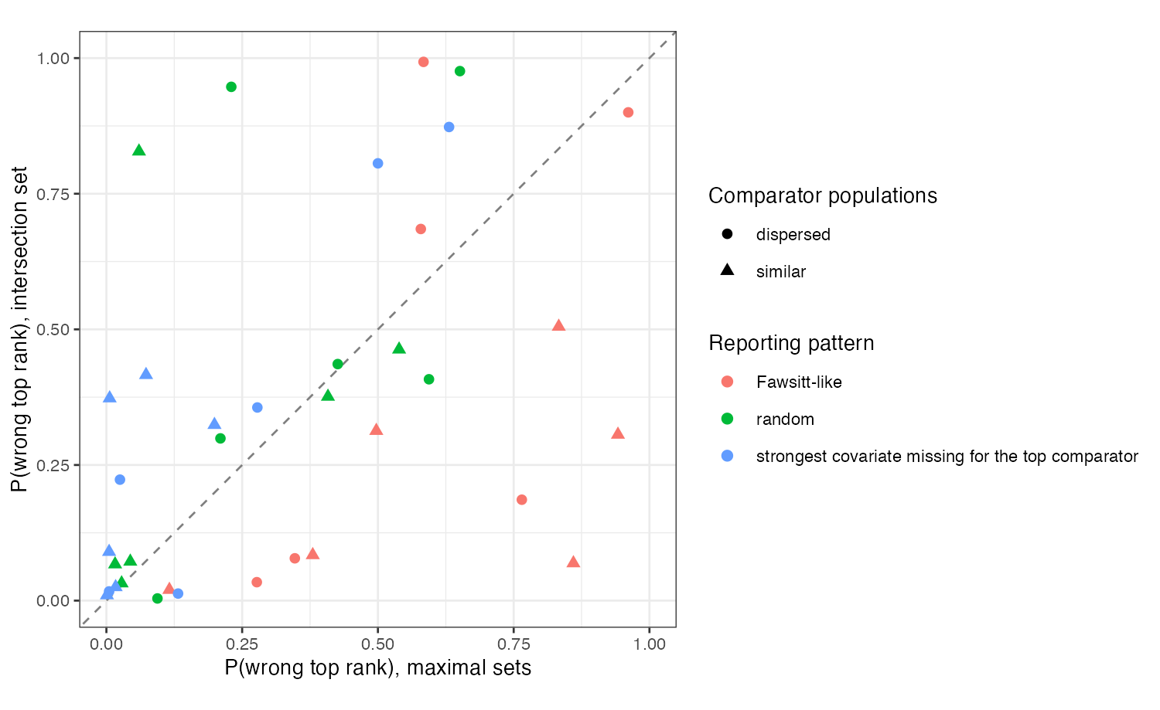
Figure 1: Probability of a wrong top rank under the intersection set against the maximal sets. Points above the diagonal favor the maximal sets.
The primary pattern was not adversarial for the top rank. Omitting covariate 1 raised comparator 1’s estimate (bias 0.292 at strength 0.5), widening its lead; the exact-bias table in results/probes.md showed this before the run. In the Fawsitt-like pattern the same omission raised comparators 2 and 3 past comparator 1, and the intersection, which gives every comparator a similar bias, preserved the order (Figure 1). With dispersed populations the intersection’s biases also diverged and neither rule dominated.
The bounded analysis in effect imputes an unreported mean from the other comparators, which works when they resemble each other. Maximal-set coverage fell to 0.086 in similar scenarios where the bounded interval kept 0.929 or more. Controls held: with complete reporting the methods coincided and were unbiased; with no covariate effects every contrast was unbiased; the simulated bias matched the exact bias within 3 MCSE in 142 of 144 contrasts, the two exceptions at 3.1 and 3.4 MCSE.

4. What this does not answer
Continuous outcome and independent covariates, so non-collapsibility and correlated omissions are absent; a single ML-NMR fit of the network and overlap as a separate factor were not run. The ranking results depend on where omissions fall relative to the true order, which the three patterns sample but do not exhaust. Peer review has not been done.

References
1. James E. Signorovitch, Eric Q. Wu, Andrew P. Yu, Charles M. Gerrits, Evan Kantor, Yanjun Bao, Shiraz R. Gupta, Parvez M. Mulani. Comparative effectiveness without head-to-head trials: A method for matching-adjusted indirect comparisons applied to psoriasis treatment with adalimumab or etanercept. PharmacoEconomics. 2010;28(10):935–45. doi:10.2165/11538370-000000000-00000
2. Tim P. Morris, Ian R. White, Michael J. Crowther. Using simulation studies to evaluate statistical methods. Statistics in Medicine. 2019;38(11):2074–102. doi:10.1002/sim.8086

