A violation twice the size that would change a decision raises the shared effect modifier check’s alarm rate from 1.3% to 4.5%
The published within-network check on shared effect modification scored for power, calibration and what a pass licenses, answering catalog problem IDN-05
Ahmad Sofi-Mahmudi
2026-07-28

1 What this measures
Population adjustment across a network of trials almost always assumes shared effect modification: that a covariate modifies the effect of every active treatment in a class in the same way. The assumption is what lets an analysis borrow an interaction estimated where there are individual data and apply it where there are only published summaries.
The check in general use for it is the following. Phillippo et al. (1) fit a multilevel network meta-regression with a single interaction shared across a treatment class, refit it with treatment-specific interactions one covariate at a time, and compare the posteriors and the model fit. multinma implements it (2). Their own assessment of its power is explicit: “it is likely that this approach to assessing the shared effect modifier assumption has low power, particularly when data are lacking.”
We are not aware of a study measuring what it can detect. That is a statement about the ML-NMR population-adjustment literature, where the check is a within-network comparison of shared against treatment-specific interactions, and it is not a claim about treatment-by-covariate interaction modeling in network meta-regression at large, where common, independent and exchangeable interaction structures have a longer history. It rests on a search of the population-adjustment methods literature and the multinma documentation rather than on a systematic review, and a reviewer was right to ask that the scope be stated rather than implied. Within that scope there is no threshold that separates a pass from a failure, no statement of how much interaction stability is enough, and no statement of what a pass licenses. This study measures all three, against a truth it constructs, under a design registered before any replicate was run.
What it measures is not one procedure. “Compare the posteriors and the model fit” is a description of an exploratory practice, not a decision rule, so this study evaluates five explicit rules of our own construction that the description admits. Those operating characteristics are ours; the practice they formalize is the published one, and the distinction matters for every number below.
The central measurement: when the two treatments’ effect modifiers differ by 0.30, which leaves the transported estimate wrong by twice the amount that would change a decision, the DIC rule fires in 0.045 of analyses, 95% interval [0.029, 0.070]. When the assumption holds exactly it fires in 0.013 [0.005, 0.029]. A violation that doubles the error that matters moves the alarm rate by about three percentage points.
The reason is precision, not thresholds: no network in this design came within a factor of three of the precision needed to place a 95% interval on the interaction contrast inside the region where the violation would not matter. Consequently the one reading that could affirm the assumption rather than merely fail to contradict it never fired, in 3,200 opportunities. That is a statement about what these networks can resolve, and Section 3.3 shows it is also partly a statement about the prior.
Following the check is still better than not, though not uniformly. Relaxing exactly what it fires on beat relaxing everything at every target examined, and beat imposing the restriction at every target except the one where nothing is transported. What the practice does not support is being read as a test the assumption has survived.

2 Design

2.1 The data-generating mechanism
Individual in study on treatment , binomial outcome, logit link:

Two covariates, correlated 0.25, prognostic coefficients 0.40. Reference PBO and two active treatments A and C in one class, which is what makes the shared-interaction restriction bind, with equal main effects 0.70. The drift is carried by and the parameter is the contrast:

is shared exactly, so every replicate supplies one power observation and one type I error observation from the same four fits.
One study contributes individual data and always compares PBO with A. The rest contribute the arm-level summaries a publication reports. So A is the treatment whose interaction is estimable within a study, and C appears only in aggregate studies, where its interaction is identified through between-study contrasts of covariate means and through the curvature of the aggregate likelihood (3). That asymmetry is the situation population adjustment exists for.
The registered design: 32 cells, 50 replicates each, four fits per replicate. Eight further cells at drift 0.15 were added by a dated amendment during the run and are reported separately in section 3.8.
Factor | Levels | What it varies
drift, | 0, 0.30, 0.60, 1.20 | how far the assumption is violated
network size | 6, 12 | how much evidence the network holds
covariate spread | 0.25, 0.60 | the ecological information about interactions
treatment-effect heterogeneity | 0, 0.15 | a second specification error the check was not built to see

2.2 The target, and why it is not a design factor
The check reads only the fitted network. Its output therefore cannot depend on the population an analyst later transports to. One set of fits is scored at every target displacement standard deviations along the drifting covariate, and that invariance is the mechanism under test rather than an assumption of convenience.
Because is prognostic, displacing the target would also slide the placebo risk along the logistic curve. The reference intercept is solved separately for each displacement to hold the marginal placebo risk at 0.30 exactly, so displacement moves the treatment contrast and nothing else.
True marginal risk difference for C versus A in the target, computed exactly by Gauss-Hermite quadrature of the true model. Nine of sixteen combinations exceed the 0.03 material threshold; displacement 0 never does.
drift | s = 0 | s = 0.5 | s = 1 | s = 1.5
0.0 | 0.0000 | 0.0000 | 0.0000 | 0.0000
0.3 | -0.0032 | -0.0310 | -0.0587 | -0.0858
0.6 | -0.0063 | -0.0617 | -0.1168 | -0.1704
1.2 | -0.0117 | -0.1210 | -0.2282 | -0.3302

2.3 The four fits
class_interactions in multinma 0.9.1.9002 (4) is a single global switch, so on its own it cannot express a procedure that relaxes one covariate at a time. The split is carried by the regression formula, using the .trt and .trtclass specials.
With two covariates these four fits are the complete model lattice, so a strategy that relaxes exactly what the check flagged can be scored rather than approximated.
Fit | Formula
common | ~ x1 + x2 + (x1 + x2):.trtclass
split_x1 | ~ x1 + x2 + (x1):.trt + (x2):.trtclass
split_x2 | ~ x1 + x2 + (x2):.trt + (x1):.trtclass
split_all | ~ x1 + x2 + (x1 + x2):.trt
This only works with class_interactions = "independent". Under the default "common", an x:.trt term in the formula is silently demoted to the class level: the split fit is the shared fit under another name, with the same parameter names and a DIC that differs only by Monte Carlo error. An analyst following the published recipe by editing the formula alone would see no evidence against sharing in any dataset, because no split model was ever fitted. Every split fit in this study asserts that treatment-specific coefficients exist before any statistic is computed from it.

2.4 Readings of the check
There is no agreed threshold, so every reading in use is reported. With two active treatments there is exactly one interaction contrast per covariate, , so no covariate is selected before the interval is read. That removes one route to miscalibration; it does not deliver nominal frequentist coverage, and it should not be reported as if it did. An earlier draft claimed it did, and this study’s own type I error contradicts the claim: under the global null the 95% interval rule fires on 0.075 of replicates where there is no treatment-effect heterogeneity and 0.110 where there is. Avoiding selection is necessary for coverage, not sufficient.
The rules below are thresholds we chose. The DIC differences of 2, 5 and 10 are conventional reading guides for model comparison in general, not validated cutoffs for detecting a violated shared effect modifier assumption, and (5) is cited for the criterion rather than for those cutoffs applied to this question.
- DIC rule: flag if for , the criterion of (5) read at cutoffs of our choosing; is the rule the verdict uses.
- Posterior rule: flag if the 95% credible interval for the contrast excludes zero.
- Margin rule: flag if with , the contrast that makes the C-versus-A marginal risk difference exactly material at displacement 1. The margin is set by consequence, not taste.
- Continuous scores: and the directional posterior probability, scored by AUROC (6).
- Prior-posterior contraction, so a fit that reported the prior can be told apart from one that reported the data.

3 Results
6,400 ML-NMR fits over the registered design (1600 replicates over 32 cells, four models each), 1,600 more in the amendment arm, and 960 in the prior-sensitivity arm. Every cell returned all 50 replicates: no replicate was lost to a sampler that failed to start.
The prior-sensitivity arm is a departure from registration and was not previously disclosed. The protocol registers 8 cells at 100 replicates each, which is 3,200 fits. It ran at 30 replicates per cell, 960 fits. A reviewer noticed that the published fit count could not be produced from the registered design and asked where it came from; counting the stored cells is how the shortfall was found. Nothing in the arm was re-selected after results were seen, but at 30 replicates a cell-level rate carries a Monte Carlo standard error near 0.09 rather than the 0.05 the registered size implied, so this arm’s comparisons are read as directional and not as measurements. The protocol now records the departure.

3.1 What the network resolves, and how firmly that can be stated
The standard error the network itself puts on the difference between the two treatments’ effect modifiers, with the prior removed, against the difference that would make the target estimate materially wrong.
studies | spread | heterogeneity | posterior SD, A | posterior SD, C | ratio | what the data alone resolve | multiples of
6 | 0.25 | 0.00 | 0.238 | 1.633 | 6.87 | 1.82 | 11.9
6 | 0.25 | 0.15 | 0.235 | 1.534 | 6.52 | 1.69 | 11.0
6 | 0.60 | 0.00 | 0.215 | 0.801 | 3.73 | 0.59 | 3.8
6 | 0.60 | 0.15 | 0.214 | 0.670 | 3.14 | 0.48 | 3.2
12 | 0.25 | 0.00 | 0.225 | 0.885 | 3.93 | 0.80 | 5.2
12 | 0.25 | 0.15 | 0.225 | 0.837 | 3.72 | 0.78 | 5.1
12 | 0.60 | 0.00 | 0.184 | 0.329 | 1.78 | 0.32 | 2.1
12 | 0.60 | 0.15 | 0.181 | 0.299 | 1.65 | 0.30 | 2.0
The difference between the two treatments’ interactions is the quantity the whole check is about. A network of the kind population adjustment is applied to resolves it to a standard error of 0.30 to 1.82 on the log-odds scale. The difference that makes the transported estimate materially wrong is . The evidence is therefore between 2.0 and 11.9 times too coarse to see what matters, before any question of thresholds or rules arises.
That last column is an approximation and its own sensitivity analysis says so. Subtracting prior precision from posterior precision recovers the likelihood exactly only if both are Gaussian, which a weakly identified interaction is not. Running the same networks under normal(0, 1) instead of normal(0, 2.5) gives a data-only standard error of about 0.99 where the wider prior gives about 1.73. Those should agree and do not. The quantity is therefore reported as an order-of-magnitude statement, not as a measurement, and no headline claim in this paper rests on it; an earlier draft put it in the title and a reviewer was right that it could not carry that weight.
What is measured rather than derived is the posterior standard deviation itself, 0.30 to 1.64 across strata, which is what an analyst reads off the output.
A correction to how contraction was reported. Contraction is . Until round-two review it was computed by dividing every arm by 2.5, the prior of the main design, including the prior-sensitivity arm that was fitted under normal(0, 1). A reviewer showed from the published numbers alone that the figures had to be measured against the wrong denominator, and gave the argument that settles it: for a fixed likelihood, tightening a prior cannot raise , yet the paper reported it rising. The reviewer was right, the error is in R/02-fit.R, and the direction of the reported effect was inverted. Against the prior each arm was actually fitted under, contraction on the drifting covariate falls from 0.33–0.42 under normal(0, 2.5) to 0.20–0.26 under normal(0, 1), which is the expected direction.
What survives, and was the point of the arm, is that the check’s behavior barely moves: the flag rate is 0.01–0.12 under the wider prior against 0.00–0.15 under the tighter one. The prior changes how informed the posterior looks relative to itself and leaves what the check does almost untouched. At 30 replicates per cell this arm is directional rather than precise.
The asymmetry the design was built around is large: the treatment with only aggregate data carries 1.65 to 6.87 times the posterior spread of the treatment with individual data. A ratio of two posterior standard deviations is not free of the prior, as an earlier draft called it; both posteriors are shrunk toward the same prior. What can be said is narrower and still worth saying: the ratio requires no subtraction of prior from posterior precision, so it does not inherit the instability that demoted the derived column above.
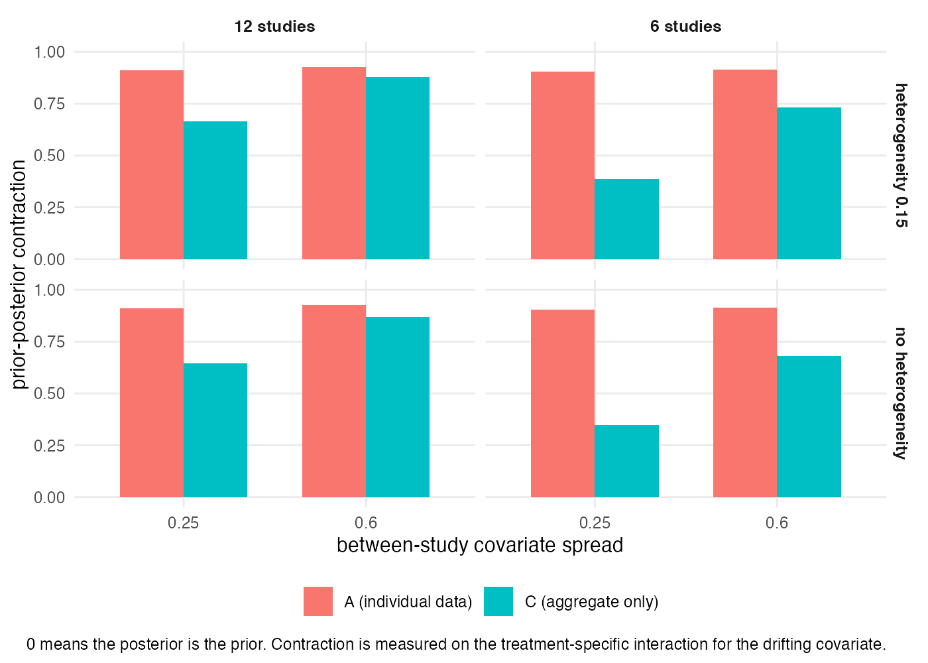
Figure 1: Prior-posterior contraction on the treatment-specific interaction for the drifting covariate. Zero means the posterior is the prior.
Registered mechanism claim M2 is partly confirmed. It asked for a contraction gap of at least 0.20, widening as the network shrinks. The gap runs from 0.047 to 0.558 and does widen monotonically as the network shrinks, but it clears 0.20 in 5 of the 8 strata rather than all of them, missing in the largest network at the widest covariate spread. The claim is reported as partly met rather than met, and the prior-free ratio is offered as the measure that should have been registered instead.

3.2 Power
Probability the check fires on the covariate that actually drifts.
drift | studies | spread | heterogeneity | DIC < -5 | 95% interval
0.3 | 6 | 0.25 | 0.00 | 0.02 | 0.08
0.3 | 6 | 0.25 | 0.15 | 0.06 | 0.10
0.3 | 6 | 0.60 | 0.00 | 0.04 | 0.12
0.3 | 6 | 0.60 | 0.15 | 0.06 | 0.12
0.3 | 12 | 0.25 | 0.00 | 0.00 | 0.02
0.3 | 12 | 0.25 | 0.15 | 0.04 | 0.12
0.3 | 12 | 0.60 | 0.00 | 0.06 | 0.16
0.3 | 12 | 0.60 | 0.15 | 0.08 | 0.18
0.6 | 6 | 0.25 | 0.00 | 0.00 | 0.04
0.6 | 6 | 0.25 | 0.15 | 0.08 | 0.10
0.6 | 6 | 0.60 | 0.00 | 0.12 | 0.24
0.6 | 6 | 0.60 | 0.15 | 0.16 | 0.32
0.6 | 12 | 0.25 | 0.00 | 0.06 | 0.12
0.6 | 12 | 0.25 | 0.15 | 0.18 | 0.28
0.6 | 12 | 0.60 | 0.00 | 0.28 | 0.40
0.6 | 12 | 0.60 | 0.15 | 0.30 | 0.38
1.2 | 6 | 0.25 | 0.00 | 0.06 | 0.12
1.2 | 6 | 0.25 | 0.15 | 0.18 | 0.22
1.2 | 6 | 0.60 | 0.00 | 0.46 | 0.62
1.2 | 6 | 0.60 | 0.15 | 0.44 | 0.58
1.2 | 12 | 0.25 | 0.00 | 0.38 | 0.52
1.2 | 12 | 0.25 | 0.15 | 0.42 | 0.46
1.2 | 12 | 0.60 | 0.00 | 0.82 | 0.88
1.2 | 12 | 0.60 | 0.15 | 0.86 | 0.92
Per cell these rates have a Monte Carlo standard error of about 0.065 at 50 replicates, so the largest of eight of them is not an upper bound on anything. Pooled across strata, where the standard error is near 0.01, the picture is this.
Detection on the drifting covariate, pooled across all eight design strata, 400 replicates per row. The contrast 0.15 is the amendment arm and is excluded from every registered claim; 0 is the global null.
rule | true contrast | arm | n | rate | 95% CI
95% interval | 0.00 | registered | 400 | 0.092 | [0.068, 0.125]
95% interval | 0.15 | amendment | 400 | 0.082 | [0.059, 0.114]
95% interval | 0.30 | registered | 400 | 0.112 | [0.085, 0.147]
95% interval | 0.60 | registered | 400 | 0.235 | [0.196, 0.279]
95% interval | 1.20 | registered | 400 | 0.540 | [0.491, 0.588]
DIC < -5 | 0.00 | registered | 400 | 0.013 | [0.005, 0.029]
DIC < -5 | 0.15 | amendment | 400 | 0.020 | [0.010, 0.039]
DIC < -5 | 0.30 | registered | 400 | 0.045 | [0.029, 0.070]
DIC < -5 | 0.60 | registered | 400 | 0.148 | [0.116, 0.186]
DIC < -5 | 1.20 | registered | 400 | 0.452 | [0.404, 0.501]
At a true contrast of 0.30 the transported estimate is wrong by 0.059 absolute risk at displacement 1, twice the material threshold. The DIC rule fires in 0.045 [0.029, 0.070] of analyses, against 0.013 [0.005, 0.029] when the assumption holds exactly. At 0.60 it reaches 0.147 and only at 1.20, eight times the contrast that would make the estimate materially wrong and a stress test rather than a plausible violation, does it reach 0.453.
At the amendment level of 0.15 the rate is 0.020 [0.010, 0.039], whose interval overlaps the null’s: at a violation sitting just under the threshold of mattering, the check does not reliably distinguish it from no violation at all.
The 95% interval rule is uniformly more sensitive and correspondingly less specific. Per-stratum rates are below, and are reported for description rather than for comparison.
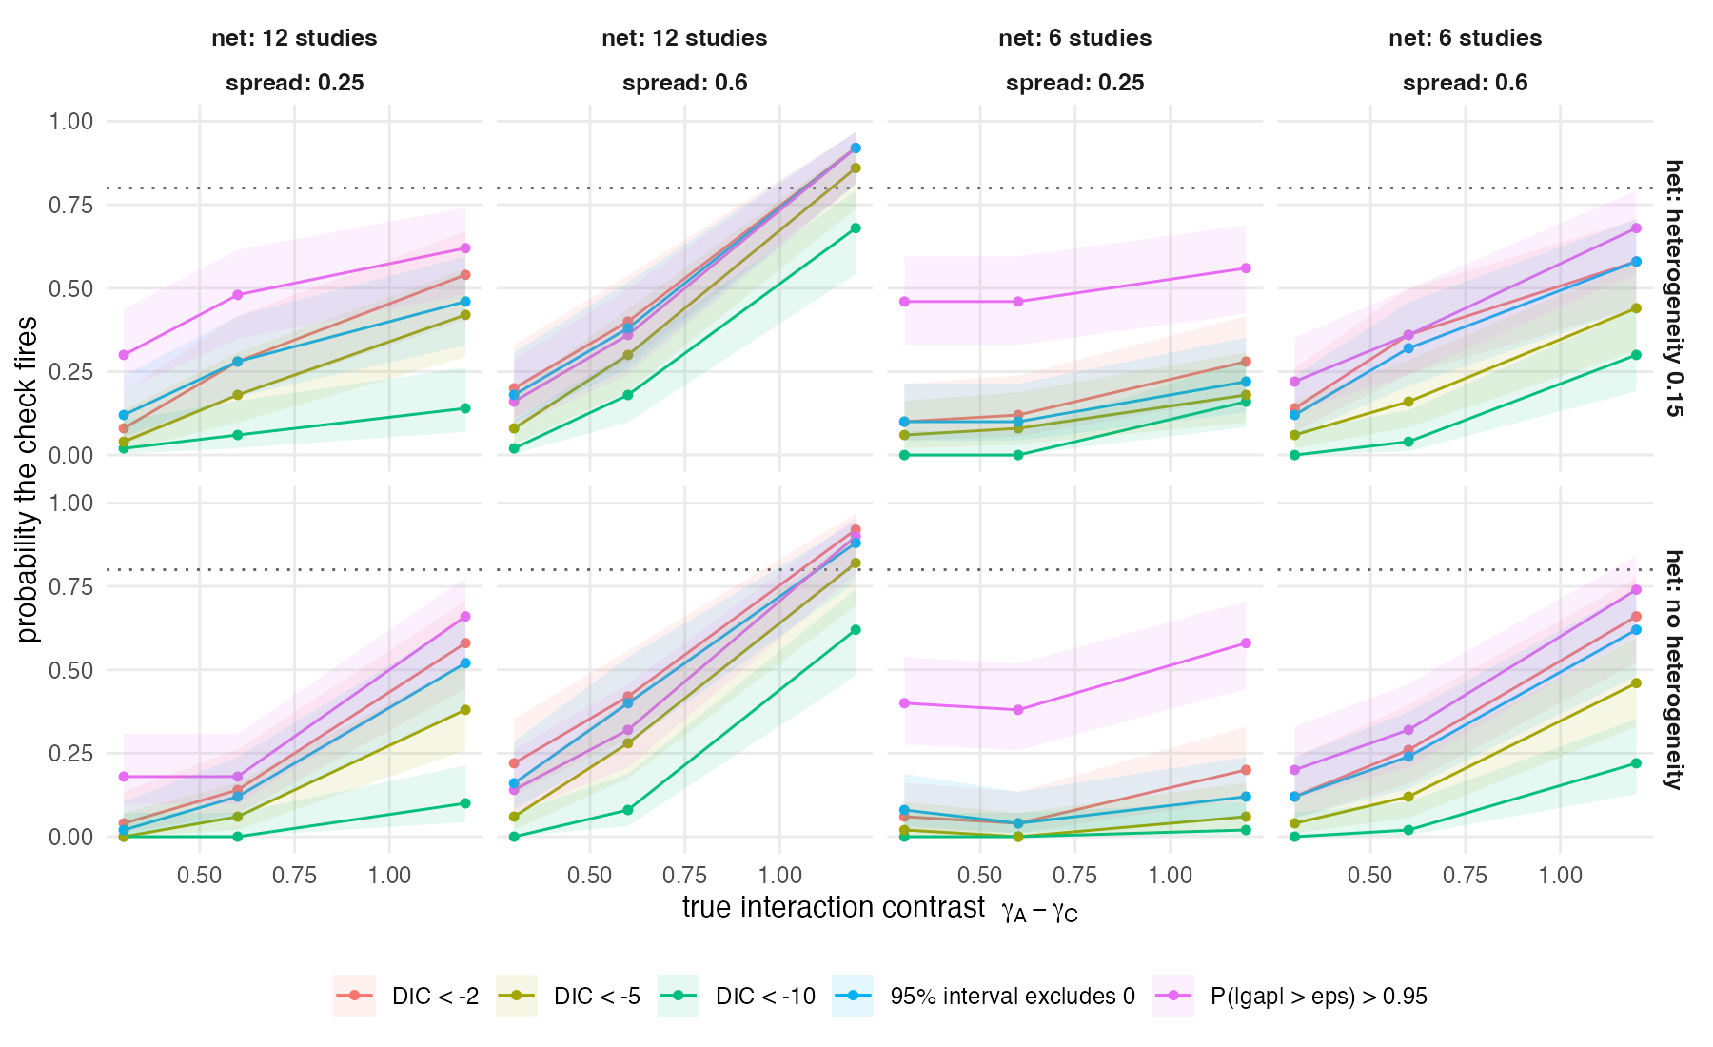
Figure 2: Probability the check fires on the covariate that actually drifts, by rule. The dotted line is 0.80. Every panel is a design stratum; the horizontal axis is the true difference between the two treatments’ effect modifiers.
Type I error under the global null, where every interaction is shared exactly. 400 replicates per rule.
rule | type I error | 95% CI
DIC < -10 | 0.0000 | [0.000, 0.010]
DIC < -2 | 0.0550 | [0.037, 0.082]
DIC < -5 | 0.0125 | [0.005, 0.029]
margin | 0.2350 | [0.196, 0.279]
95% interval | 0.0925 | [0.068, 0.125]
The 95% interval rule runs at about twice its nominal rate. The margin rule fires in nearly a quarter of replicates when the true difference is exactly zero, for the reason given in Section 3.3.
Every rate above depends on where the cut is put. The registered design also scores the two continuous statistics threshold-free, as classifiers by AUROC (6), which asks whether the check ranks analyses correctly whatever cut an analyst chooses. This analysis was prespecified, computed from the first run onward, and then omitted from the first two drafts. Three reviewers asked for it. Its absence was an undisclosed departure and this is the correction.
Ranking networks with a violation above networks without one, by DIC, each violation level against the global null. 0.5 is chance.
true contrast | AUROC | 95% CI | n
0.3 | 0.557 | [0.517, 0.596] | 800
0.6 | 0.681 | [0.644, 0.718] | 800
1.2 | 0.843 | [0.815, 0.870] | 800
Against the check’s own hypothesis, DIC separates a violation from none with an AUROC of 0.557 [0.517, 0.596] at twice the material violation, rising to 0.843 only at the eightfold stress test. The directional posterior probability is weaker throughout, reaching just 0.507 [0.467, 0.547] at the same violation, an interval that contains chance.
Ranking analyses by whether the transported estimate is materially wrong, by DIC. Every replicate of the 32 registered cells counts equally; this is not the deployment-weighted mixture the verdict uses.
target displacement | AUROC | 95% CI
0.0 | 0.538 | [0.509, 0.566]
0.5 | 0.601 | [0.572, 0.629]
1.0 | 0.666 | [0.636, 0.696]
1.5 | 0.669 | [0.637, 0.702]
Against the outcome that actually matters, a materially wrong transported estimate, the same statistic reaches 0.666 at displacement 1. No threshold recovers a ranking the statistic does not contain, so the weak detection rates above are a property of the statistic and not an artifact of the cuts chosen for it. This is the strongest form of the paper’s central claim, and it is the one that does not depend on any rule of ours.
Intervals are Hanley and McNeil’s (6). Ties are broken at run boundaries on the sorted score, which is the exact rather than the approximate treatment; the implementation is checked against the brute-force definition every time the analysis runs, and agrees to 2.6e-15.

3.3 The check cannot give an all-clear
A committee reading a check wants to know whether the assumption is safe, which is an equivalence statement: is the difference between the two treatments’ modifiers small enough to ignore? Computed from the same posteriors, fired in 0 of 3,200 covariate-checks across the registered design. Zero. Including every one of the 2,000 in which the two treatments’ modifiers were identical by construction.
Neither of these rules is prior-free, and the direction of the bias must be stated. Under independent normal(0, 2.5) priors on the two treatment-specific coefficients, their contrast has prior standard deviation 3.536. The prior alone therefore places 0.965 of the contrast beyond , which is above the 0.95 threshold at which the margin rule fires, and leaves only 0.035 inside the equivalence region. A reviewer identified this and it is correct: the margin rule fires under the prior before any data are seen, and the equivalence rule starts from almost nowhere.
So the right statement is not that the procedure cannot affirm the assumption. It is a statement about precision, and it is sharper. For the equivalence rule to fire, the posterior standard deviation of the contrast must fall below roughly . The tightest stratum in this design achieves 0.300, a factor of 3.8 short, and the loosest 1.64. No network in this design came within a factor of three of the precision required to affirm the assumption at the margin that matters.
Three things about that calculation, since round-two review questioned all three and the answers differ.
The condition is a normal approximation, and this paper elsewhere says weakly identified posteriors are not Gaussian, so it is offered as an interpretive gloss and not as a proof. It is not what produces the count of zero. That count is measured directly: is evaluated as the proportion of posterior draws satisfying the inequality, so it assumes no shape at all.
The contrast’s standard deviation likewise does account for the covariance between the two treatment-specific coefficients, because it is not assembled from two marginal standard deviations: the contrast is formed draw by draw from the joint posterior, , and its standard deviation is taken over those draws.
What cannot be defended is the claim an earlier draft made that the count would remain zero “under any prior that does not itself supply the answer”. A prior placed directly on the contrast, rather than independently on each coefficient, would change the arithmetic above, and this study did not run one. The count of zero is a result about these networks under these priors.
The complementary reading runs backwards for the same reason: fires in 0.48 of replicates at the thinnest cell under the global null and 0.08 at the richest, firing more often where there is less information. Both readings are governed by the width of the posterior rather than its location, and in this design that width is set as much by the prior as by the network.

3.4 What a pass licenses, and why the registered gate was unreachable
The registered gate, and the same quantity for a model that knows which specification is true, on the same replicates.
displacement | P(material error | passed) | the same for an oracle model | excess attributable to the check
0.0 | 0.427 | 0.446 | -0.019
0.5 | 0.559 | 0.573 | -0.014
1.0 | 0.675 | 0.639 | 0.036
1.5 | 0.723 | 0.662 | 0.061
The registered verdict fails. The upper 95% bound on at displacement 1.0, deployment-weighted, is 0.697 against a threshold of 0.1, on a point estimate of 0.675 with a standard error of 0.0134 over 1307 passing replicates from 32 cells. Scored against systematic error alone rather than realized error the estimate is 0.563. Both fail, by a factor of about seven.
Two notes on that bound, both from round-two review. First, an earlier draft reported 0.777 here, which is the Wilson bound on the unweighted risk of 0.758 printed beside the weighted point estimate; a reviewer observed that the published bound could not be reconstructed from the stated sample size and was right. The bound is now computed for the quantity the registered rule names. The verdict is unchanged, and would be unchanged under any interval this design could produce. Second, the systematic-error indicator is a deterministic function of a cell’s drift and the displacement, so it does not vary within a cell and its sampling variance is exactly zero; its bound equals its point estimate by construction rather than through unusual precision, and all remaining uncertainty sits in deployment weights that are declared rather than estimated.
It fails for a reason that is mostly not the check’s doing. An oracle that knows which specification is correct, fitted to the same replicates, is materially wrong 0.639 of the time. The check’s excess over that oracle is 0.036, and at displacements 0 and 0.5 the excess is negative. A perfect check would have failed this gate. The threshold was unreachable by any procedure, because at a material threshold of 0.03 absolute risk the estimation error of a six-study network alone exceeds it in 0.46 to 0.58 of replicates when the assumption is exactly true.
That is a finding about this program’s habit of writing verdict rules, not only about the check: a threshold on total error charges a diagnostic for noise it was never built to see. The oracle comparison is the fix, and it was added after a pre-run critique predicted the failure and computed the noise floor to within the interval the run later measured.

3.5 The mechanism: the check is blind to what determines the harm
The check’s output is identical at every displacement by construction; the harm is not.
displacement | P(material error | passed) | noise floor | excess over the floor | systematic only
0.0 | 0.427 | 0.427 | 0.000 | 0.000
0.5 | 0.559 | 0.427 | 0.132 | 0.563
1.0 | 0.675 | 0.427 | 0.248 | 0.563
1.5 | 0.723 | 0.427 | 0.296 | 0.563
The check reads the fitted network and nothing else, so its output cannot depend on the population an analyst transports to. The run confirms this as a bookkeeping identity: the pass rate is 0.816875 at every displacement, with a maximum absolute deviation of 0.
Over the same fits, the probability that a passed analysis is materially wrong rises from 0.427 to 0.723, an excess over the noise floor of 0.296, against a registered threshold of 0.20. Against systematic error the rise is from 0 to 0.563.
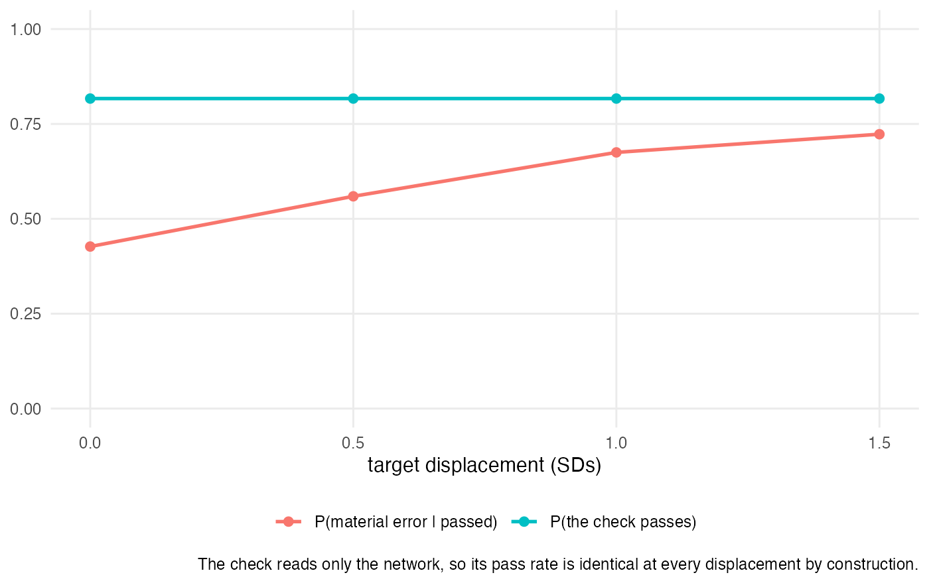
Figure 3: The check’s pass rate is flat by construction; what a pass is worth is not.
Registered mechanism claim M1 is confirmed, with one qualification a reviewer was right to press. The first half is an algebraic identity rather than an empirical finding: the same fits are reused at every displacement, so the pass rate must be identical, and the run verifies the bookkeeping rather than discovering anything. The second half is empirical. And the strong form of the conclusion is too strong: what a pass is worth depends on the target displacement and on the drift, and the check is blind to both. Displacement is the one this section isolates, because it can be varied while holding the fitted network exactly fixed.

3.6 The three readings are not three procedures
The published recipe says to compare posteriors and model fit, which reads as two independent opinions. They disagree in 0.107 of the 3200 covariate-checks, drawn from 1600 replicates. The registered threshold was 0.10 and the point estimate exceeds it, but the 95% interval is [0.096, 0.118], whose lower bound falls below 0.10, so M4 is reported as not clearly met. A first draft called it confirmed; a reviewer pointed out that a point estimate 0.007 above a threshold with a standard error of 0.006 does not clear it. A second reviewer then noted that the two checks inside a replicate share a fitted network, so a binomial interval on 3200 independent observations is anti-conservative; the interval above is clustered by replicate, which widens the standard error from 0.0055 to 0.0057. The verdict is the same either way.
The substantive point survives the arithmetic, and it is one-sided: the DIC rule fires without the interval rule in 0.0006 of checks, and the interval rule fires without DIC in 0.106. The DIC rule is very nearly a strict subset of the interval rule, not a second opinion on the same question.
Under the global null the two rules differ in type I error by 0.080 on the drifting covariate, the pooling the table above displays, and by 0.087 pooling both covariates. Both exceed the registered 0.05, so M3 is confirmed on either pooling. Earlier drafts quoted the second figure beside a table showing the first without saying which was which, and two reviewers reported the apparent contradiction in successive rounds.
When a violation is present the check also points at the wrong covariate. At drift 1.20 the interval rule fires on the covariate that is shared exactly in 0.388 of replicates. A fire is not a diagnosis.

3.7 Following the check still beats the alternatives
strategy | displacement | RMSE | P(material error) | decision reversal
check, then relax what fired | 0 | 0.0426 | 0.433 | 0.450
impose the restriction | 0 | 0.0422 | 0.438 | 0.453
relax everything | 0 | 0.0514 | 0.497 | 0.465
check, then relax what fired | 1 | 0.0928 | 0.687 | 0.385
impose the restriction | 1 | 0.0995 | 0.700 | 0.452
relax everything | 1 | 0.1218 | 0.801 | 0.357
Scoring the target estimand for all four fitted models, and defining check-then-relax as relaxing exactly the covariates that fired, the check earns its keep on some losses and not uniformly. It has the lowest material-error rate at every displacement. On squared error it is best at displacements 0.5, 1.0 and 1.5 but not at 0, where imposing the restriction is marginally better (0.0422 against 0.0426). An earlier draft claimed the lowest error “at every displacement”; a reviewer found the exception in this paper’s own table. It is reported here as the ordering it is: loss-dependent, and reversed at the one displacement where there is nothing to transport.
Paired differences at every displacement, on both losses, deployment-weighted to match the primary analysis. The three strategies are scored on the same replicate, so the comparison is paired and its interval is far tighter than a difference of two independent rates. Negative favours check-then-relax.
displacement | comparison | abs. error diff | 95% CI | sq. error diff | 95% CI
0.0 | check_then_relax minus always_common | -0.00005 | [-0.00069, 0.00059] | 3.08e-05 | [-0.000112, 0.000174]
0.0 | check_then_relax minus always_relaxed | -0.00517 | [-0.00676, -0.00358] | -8.26e-04 | [-0.001200, -0.000452]
0.5 | check_then_relax minus always_common | -0.00187 | [-0.00299, -0.00074] | -2.96e-04 | [-0.000522, -0.000071]
0.5 | check_then_relax minus always_relaxed | -0.01444 | [-0.01694, -0.01194] | -2.15e-03 | [-0.002660, -0.001647]
1.0 | check_then_relax minus always_common | -0.00505 | [-0.00686, -0.00323] | -1.29e-03 | [-0.001869, -0.000707]
1.0 | check_then_relax minus always_relaxed | -0.02882 | [-0.03279, -0.02486] | -6.21e-03 | [-0.007221, -0.005206]
1.5 | check_then_relax minus always_common | -0.00877 | [-0.01119, -0.00636] | -3.18e-03 | [-0.004194, -0.002168]
1.5 | check_then_relax minus always_relaxed | -0.04073 | [-0.04597, -0.03548] | -1.12e-02 | [-0.012920, -0.009422]
The ordering is not uniform, and saying exactly where it holds is the point.
Against relaxing everything, check-then-relax wins at every displacement, by 0.0288 [0.0249, 0.0328] in weighted mean absolute error at displacement 1.0, on both losses, with every interval excluding zero.
Against imposing the restriction it wins at displacements 0.5, 1.0 and 1.5 and is indistinguishable at 0. At displacement 1.0 the advantage is 0.0050 [0.0032, 0.0069]. At displacement 0 it is 0.00005 [-0.00059, 0.00069], an interval containing zero, and on squared error the point estimate there favours the restricted model. That is the expected result: at displacement 0 there is nothing to transport, so relaxing can only add variance.
An earlier draft claimed the lowest error “at every displacement”. A reviewer found the exception in this paper’s own RMSE column. Checking it exposed a second problem the reviewers did not see: the paired differences were computed unweighted while the RMSE table beside them was deployment-weighted, and the two disagreed in sign at displacement 0 for that reason alone. Both are now weighted, so the table and the paired test answer the same question.
Restricting to the 1479 replicates in which all four fits met their convergence criteria changes this hardly at all (0.0174 and 0.0116), which answers the obvious objection that retaining badly-behaved relaxed fits is what makes relaxation look poor. It is not.
Restricting instead to the sixteen cells with no treatment-effect heterogeneity, where the estimand is unambiguous, gives 0.0178 and 0.0069 at displacement 1.0. The ordering does not depend on the cells whose estimand a reviewer correctly questioned.
The margin is small, and the ranking of the alternatives is the interesting part: relaxing everything is worse than imposing the restriction on both RMSE and material error, because the relaxed model spends precision it does not have. It is better only on decision reversal (0.357 against 0.452), which is what one would expect of an unbiased but noisy estimator against a biased but precise one.
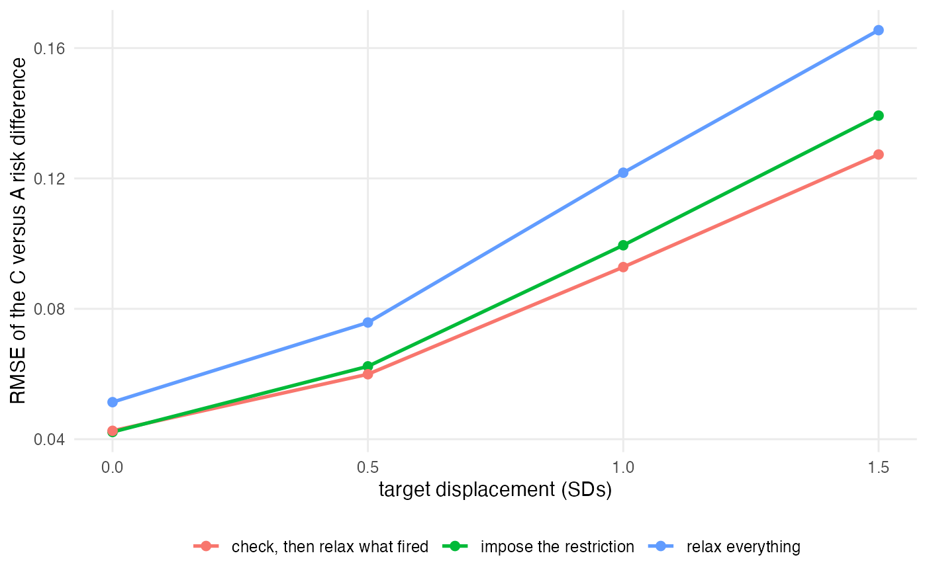
Figure 4: RMSE of the transported C-versus-A risk difference under the three strategies.
That the fully relaxed model is not simply available is visible in the sampler: it fails its convergence criteria in 0.068 of replicates overall and up to 0.24 in the worst cell, with reaching 1.89 and effective sample size falling to 3.4.
Those two figures are the worst reached by the fully relaxed model, and earlier drafts presented them as the worst in the study. They are not. Across all four models the worst is 5.13 and the worst effective sample size is 1.03, both in the singly-relaxed split_x2 fit. At least one fit misses its criteria in 0.076 of replicates. Quoting the better of the two understated the problem, and this correction was found while checking a reviewer’s arithmetic rather than reported by one. The shared-interaction model never once failed. Those replicates are retained and reported; excluding them would have removed exactly the cases where relaxation is hardest.

3.8 Nothing in the panel beats scrutinizing everything
The panel is compared on net benefit (7). The action is to distrust the adjusted estimate and commission individual patient data; the event the action is meant to catch is a material error, defined throughout this paper as a realized C-versus-A marginal risk difference wrong by more than 0.03 on the absolute scale. It is not a decision reversal: no external decision threshold is imposed anywhere in this study, so the event is defined by the size of the error and not by which side of a boundary it lands on. For a rule that fires on a fraction of analyses, net benefit at threshold is

with both probabilities taken over the deployment mixture at displacement 1.0, so is the probability of material error at which commissioning the data is worth its cost. Distrusting every analysis is for prevalence , and distrusting none is zero by construction. Every rule in the panel is a strict inequality on a continuous statistic (, and so on), so the firing indicator is exact and no tie-breaking rule is needed; the one place ties are handled explicitly is the weighted AUROC of Section 3.1, where they are broken at run boundaries on the sorted score.
The prevalence entering the curve is the same one the verdict reports: material error is present in 0.675 of passing analyses at displacement 1.0. Sweeping from 0.05 to 0.60, distrusting every analysis has higher net benefit than every rule in the panel at every threshold examined. At a threshold of 0.20 the values are 0.625 for distrusting everything against 0.098 for the DIC rule and 0.195 for the interval rule.
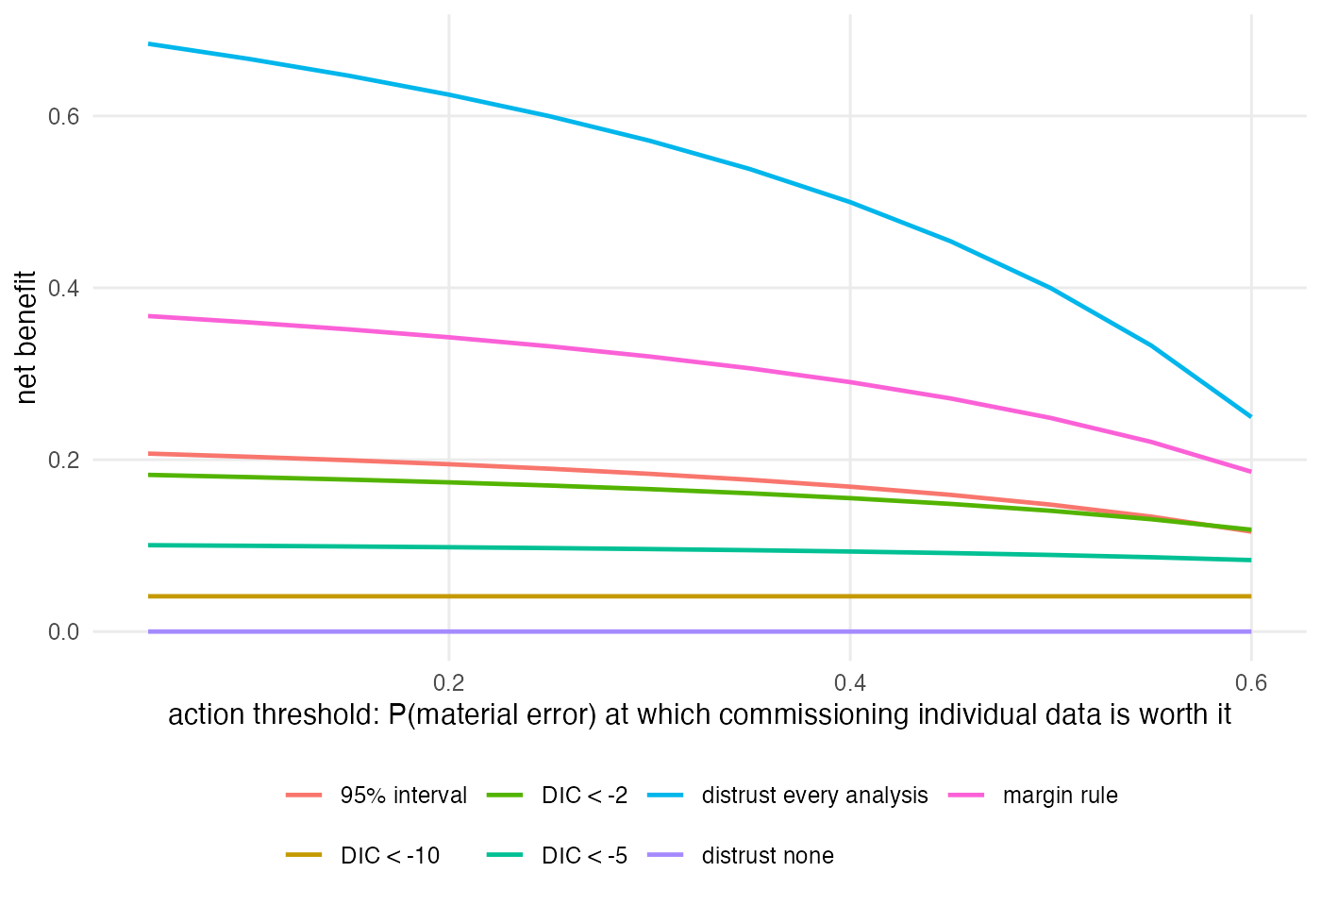
Figure 5: Decision curve. The action is to distrust the adjusted estimate and commission individual data.
This result and the previous one point in opposite directions, and the reconciliation is the point. Section Section 3.7 says following the check beats the alternatives; this section says distrusting everything beats following the check. Both are true because they score different things. The strategy comparison scores estimation error, where the check has something to contribute and contributes a little. The decision curve scores whether to trust an analysis at all, and the event it must predict is realized material error, most of which is ordinary sampling noise: at zero drift, with the assumption exactly true, the shared-interaction fit is already materially wrong in about half of six-study replicates. No covariate check can predict that, because it is not a covariate phenomenon. A reviewer put it exactly right in round one: with a prevalence this high, treat-all dominates any rule built on the check almost regardless of what the check does, so this curve restates the noise-floor finding rather than measuring the check.
Read together: on the error of the estimate the check earns a small keep, and on the question of whether a committee should trust a six-study population-adjusted analysis at all, the answer does not depend on the check. That second statement is about network size, not about this procedure.
The action’s consequences are not modeled. Commissioning individual patient data is treated as an act with a cost expressible as a probability threshold and a benefit of avoiding a material error; its delay, its chance of being refused, and its chance of not resolving the question are all set aside. So “nothing in the panel beats scrutinizing everything” is a property of this coding of the action and this deployment mixture, and is not a general recommendation to commission data.

3.9 The verdict does not transport across the one axis that matters
A one-term mapping from the check statistic to the probability of material error, fitted with one level of one factor held out and evaluated on that level.
held-out factor | level | observed | predicted | absolute error
drift | 0.00 | 0.422 | 0.891 | 0.469
drift | 0.30 | 0.767 | 0.749 | 0.018
drift | 0.60 | 0.983 | 0.737 | 0.246
drift | 1.20 | 1.000 | 0.828 | 0.172
n_studies | 6.00 | 0.812 | 0.755 | 0.058
n_studies | 12.00 | 0.774 | 0.827 | 0.053
spread | 0.25 | 0.784 | 0.760 | 0.024
spread | 0.60 | 0.802 | 0.828 | 0.025
tau_re | 0.00 | 0.794 | 0.780 | 0.014
tau_re | 0.15 | 0.792 | 0.806 | 0.013
A mapping from to the probability of material error transports across network size, covariate spread and treatment-effect heterogeneity, with absolute errors of 0.013 to 0.058. It does not transport across drift, where the error reaches 0.469. The statistic’s meaning depends on how badly the assumption is violated, which is the one thing the analyst is using it to find out.
The protocol also prespecified a target-aware mapping, and its results belong here. Two earlier drafts drew the wrong conclusion from it, in two different ways, and the third reading is the one the numbers support.
Adding the displacement as a second predictor changes the held-out absolute error from 0.086 to 0.086 on average, which is no change at all. The first draft explained this by saying displacement cannot help because it does not enter the check statistic. That is a logical error: a predictor can improve a prediction without changing another predictor. The second draft said that all four displacements appear in training within every fold, so displacement carries no information the mapping did not have. A reviewer answered that correctly: being estimable is not the same as being redundant, and since the check statistic is identical across the four target rows while the risk of material error changes strongly across them, displacement must carry information the statistic does not.
The reviewer is right, and the explanation is a property of the registered metric. Absolute error between mean predicted probability and mean observed rate is calibration in the large, and a logistic model fitted by maximum likelihood is calibrated in the large on its training set by construction. A predictor whose distribution is identical in training and test therefore cannot move it. The metric is nearly blind to what was being asked.
Discrimination is not, and it answers the question:
Held-out discrimination for material error, from the check statistic alone and from the check statistic plus the target displacement.
held-out factor | level | AUROC, statistic only | AUROC, plus displacement
drift | 0.00 | 0.516 | 0.502
drift | 0.30 | 0.495 | 0.753
drift | 0.60 | 0.483 | 0.825
drift | 1.20 | 0.498 | 0.801
n_studies | 6.00 | 0.558 | 0.686
n_studies | 12.00 | 0.630 | 0.747
spread | 0.25 | 0.593 | 0.719
spread | 0.60 | 0.598 | 0.710
tau_re | 0.00 | 0.593 | 0.716
tau_re | 0.15 | 0.596 | 0.715
Across the ten folds the check statistic alone discriminates material error at 0.48 to 0.63, which is close to chance. Adding the displacement raises it to 0.50 to 0.83 over the same folds, and to 0.69 to 0.75 over the six that hold out a design factor rather than a drift level. The single fold where displacement does not help is the one holding out drift 0, where the test set contains no violation at all and material error is pure estimation noise that nothing can predict.
Knowing the target is worth far more than knowing the check statistic, and the check cannot tell an analyst the target. That is a sharper version of this section’s claim, not a weaker one, and the paper reached it only because a reviewer refused two wrong explanations of a null result.
What remains true, and is what the registered metric does measure, is that the mapping transports across network size, spread and heterogeneity and fails across drift.

3.10 The decision boundary
The amendment arm: drift 0.15, exactly one epsilon, the violation at which the transported estimate becomes materially wrong at displacement 1.
studies | spread | heterogeneity | DIC < -5 | 95% interval | margin | affirms sharing
6 | 0.25 | 0.00 | 0.02 | 0.00 | 0.54 | 0
6 | 0.25 | 0.15 | 0.04 | 0.08 | 0.42 | 0
6 | 0.60 | 0.00 | 0.00 | 0.04 | 0.12 | 0
6 | 0.60 | 0.15 | 0.02 | 0.10 | 0.22 | 0
12 | 0.25 | 0.00 | 0.02 | 0.14 | 0.28 | 0
12 | 0.25 | 0.15 | 0.02 | 0.18 | 0.36 | 0
12 | 0.60 | 0.00 | 0.00 | 0.04 | 0.02 | 0
12 | 0.60 | 0.15 | 0.04 | 0.08 | 0.08 | 0
The registered grid ran 0, 1.96, 3.92 and 7.84 multiples of , so it measured the floor and the ceiling and nothing in between. A second pre-run critique caught this while the run was in progress, and eight cells at exactly one were added by dated amendment.
Correction, made under review. These cells sit just below the boundary, not on it. At drift 0.15 the transported C-versus-A risk difference is wrong by 0.0294 at displacement 1, against a material threshold of 0.03, so by this study’s own definition the violation is not material; the contrast that lands exactly on the threshold is 0.1531. A first draft of this section described drift 0.15 as the exact boundary and as the violation that “precisely changes a decision”, and that was false. What these cells show is the check’s behaviour at a violation just short of mattering. The shared-interaction fit duly delivers that error, with a bias of 0.0207 to 0.0311 and a material-error rate of 0.48 to 0.64.
Pooled over the eight strata the DIC rule fires in 0.020 [0.010, 0.039] of those analyses and the interval rule in 0.083, against 0.013 and 0.092 under the global null. The intervals overlap. The registered grid could not have produced this comparison, and it is the one a reader needs: just below the size of violation that would change a decision, the check does not distinguish the violation from its absence.

3.11 Checks on the machinery
multinma reconstructs the joint covariate distribution of the aggregate studies from a copula whose correlation matrix is estimated from the one individual-level study. That estimate is off by a mean of 0.035 on a true correlation of 0.25, so it is not a material source of error here.
Every DIC difference here is computed from a likelihood that is a numerical integral over 64 points. Refitting the same simulated networks at 256 points moved that difference by a median of 0.33 and at most 2.08, and changed the DIC-5 verdict in 8.3% of replicates and the interval verdict in 4.2%. So a part of what the check reports is quadrature, not evidence. This rate is of the same order as the signal it sits beside: the DIC rule’s detection rate rises by about three percentage points between no violation and one twice the size that matters, and the numerical grid alone moves the verdict in 8.3% of replicates. A first draft called this small; it is not. The check was run on 24 simulated networks drawn from two cells, the largest network at the widest covariate spread with and without drift, which is the configuration where quadrature is most stressed; 256 points is not demonstrated to be a converged reference, so this is a lower bound on the instability rather than a measurement of it.

3.12 An independent reviewer’s registered predictions
The second pre-run critique registered a table of predicted results so they could be scored. Its prediction for the headline was 0.72 to 0.75 on the realized scale against a measured 0.758 unweighted, and 0.011 for the DIC rule’s type I error against a measured 0.0125. Both hold. It predicted M3 would be refuted, on the assumption that the 95% interval rule sits at its nominal 0.05; the rule actually runs at 0.092, so M3 is confirmed instead. Its per-cell power predictions are accurate at the low end and optimistic at the high end.

4 Discussion
The shared effect modifier assumption is what allows an interaction estimated where there are individual data to be applied where there are only summaries. On networks of this size and composition, the published check on it does not have the resolution to test it. That is not a defect of the procedure so much as a property of the evidence: the posterior standard deviation of the difference between two treatments’ effect modifiers runs 0.30 to 1.64, which is 2.0 to 10.7 times the difference that would change a decision. That statement is drawn from the measured posterior standard deviations, not from the derived data-only quantity that an earlier draft used here and that Section 3.1 demotes to an order of magnitude.
The threshold-free version is the one that depends on nothing we chose: at a violation twice the size that matters, ranks a violated network above an intact one with an AUROC of 0.557 [0.517, 0.596].
Three consequences follow, and none of them is a threshold problem.
Silence is not reassurance. The check never once affirmed that the assumption holds, in 3,200 opportunities, including every replicate where it held exactly. A procedure that can only fail to object should not be reported in a way that reads as confirmation, and the sentence “we assessed the shared effect modifier assumption and found no evidence against it” carries almost no information about whether the assumption holds.
A pass is worth what the target makes it worth. The check’s output is invariant to the population being transported to, exactly and by construction, while the damage from an undetected violation is proportional to how far that population sits from the network. The same pass licenses very different things in the two cases, and nothing in the check distinguishes them.
Use it anyway, but not as a gate. Following the check and relaxing exactly what it fires on beats relaxing everything at every displacement on both losses, and beats imposing the restriction at every displacement except zero, where the two are indistinguishable and there is nothing to transport. It is worth running. What it is not worth is treating as a test that the assumption has survived. This is a comparison of three strategies, and the strategy an analyst would most want, partial pooling of the interactions, is not among them.
The practical recommendation is to report the width alongside the verdict. The posterior standard deviation of the interaction contrast, compared against the contrast that would move the decision, says in one number whether the check had any chance of firing. In the thinnest networks here that ratio is about 11 to one, and a reader who saw it would know to discount the pass entirely.

5 What this does not settle
What is being measured is our formalization, not a uniquely defined published rule. “Compare the posteriors and the model fit” describes an exploratory practice. The DIC cuts at 2, 5 and 10, the interval rule, the margin rule and the equivalence rule are five decision rules we constructed that the description admits, and the equivalence rule in particular was never part of the original proposal. Failure of a rule we invented is not evidence that the authors of the practice claimed something it does not deliver. What the study establishes is that no rule in this family, on these networks, separates violations that matter from their absence.
A departure from the registered eligibility rule. The protocol said a replicate would be excluded if any of its four fits had above 1.05, bulk ESS below 100, or divergences. The first cell of the run showed that this rule excludes selectively: all six exclusions were diagnostic failures and five involved a split model, while the shared model never failed once, so the rule removes exactly the replicates where relaxation is hardest. The rule was amended before the reported run to record the diagnostics rather than exclude on them, which is a departure from what was registered and is disclosed as one. The consequences are reported: convergence failure rates by cell and model, and every primary comparison repeated on the subset where all four fits converged.
The estimand under treatment-effect heterogeneity. Where the truth is defined at , which is a superpopulation quantity, while the fixed-effect fits estimate a precision-weighted function of the realized studies; and on the risk scale, integrating the inverse link over the random-effect distribution is not the same as setting the random effect to zero. Part of the error attributed to the check in those cells is that mismatch. The oracle comparison does not remove it, because the oracle is also a fixed-effect model there, so it is an interaction-specification oracle and not a fully correct one. Results restricted to the sixteen cells are reported for the primary gate (Section 3.4) and the strategy comparison (Section 3.7); an earlier draft said they were separated “throughout” when they were separated only in the per-cell tables, which a reviewer caught. Neither conclusion changes. What is not repaired is the estimand itself: this study does not define a single target under heterogeneity and estimate that, and doing so would require refitting with a random-effects model.
The design is a best case in several specific ways that favour the check, and the failures attributable to those idealizations are conservative. The true marginal reference risk is supplied, covariate moments in the target are known exactly, the ecological identification route is unbiased, conditional constancy holds, and the violation is a single linear drift in one covariate. No general lower-bound claim is made, because three features of the design cut the other way and could make the check look worse here than in practice: fitting fixed-effect models to data generated with is a second specification error that inflates firing, 64-point quadrature adds verdict noise that belongs to the implementation rather than to the evidence, and a single individual-level study is an assumption about the network, not necessarily a pessimistic one. An earlier draft asserted a lower bound without these qualifications; a reviewer was right that the general claim is not licensed.
The true marginal reference risk in the target is supplied to the estimator, so no baseline-risk estimation error enters. Covariates are normal with known target moments, and the ecological route by which the aggregate-only treatment’s interaction is identified is unbiased by construction: study covariate means are drawn independently of study baselines and of the random treatment effects. Real networks will often violate that, and the check’s failures there will arrive through a door this study nailed shut. Conditional constancy holds. Only one covariate drifts, and it drifts linearly.
There are two active treatments in one class and two covariates. A real network has more of both, so multiplicity across covariates and the selection involved in reading the widest of several pairwise differences are not measured here; an earlier version of this design had three treatments and was found, before running, to be reading a selected contrast whose 95% interval is not a 95% interval.
The fits are fixed-effect while half the cells generate random treatment effects of standard deviation 0.15. That is deliberate, and it is the realistic case, but it means that in those cells the check is being read under a second misspecification.
Only one individual-level study. What a second would buy is not measured: that factor was dropped from the design to pay for treatment-effect heterogeneity, which a pre-run critique identified as the more consequential omission.
class_interactions = "exchangeable" is documented in multinma 0.9.1.9002 (4) and raises “not yet supported”, so the hierarchical middle ground between a shared interaction and fully independent ones could not be fitted at all. That relaxation is the one this catalog’s entry for IDN-05 proposed as the way forward, and the entry’s claim that it ships in the package is wrong for this version and is corrected alongside this study.
This is the sharpest limit on the recommendation in Section 3.7. The three strategies compared are impose, relax everything, and relax what fired. A fourth, shrinking the treatment-specific interactions towards each other rather than choosing between identical and independent, is exactly what the problem entry proposes and is the one most likely to beat all three, because the failure documented throughout this paper is a precision failure and partial pooling is the standard answer to a precision failure. Package non-implementation is a reason for its absence, not a justification: we could have written the model. We did not, and until someone does, “check, then relax what fired” is the best of three options rather than a recommendation about what to do.
The material threshold of 0.03 absolute risk, the deployment weights, and the choice of normal(0, 2.5) rather than the package default for the regression prior are all declared judgments. The prior-sensitivity arm shows the headline is insensitive to the last of them.
Fifty replicates per cell gives a per-cell standard error of about 0.065, which is why every result above is reported by stratum or pooled and why no difference below about 0.13 within a single cell is claimed.

References
1. David M. Phillippo, Sofia Dias, A. E. Ades, Mark Belger, Alan Brnabic, Daniel Saure, Alexander Schacht, Yulan Yang, Nicky J. Welton. Validating the assumptions of population adjustment: Application of multilevel network meta-regression to a network of treatments for plaque psoriasis. Medical Decision Making. 2023;43(1):53–67. doi:10.1177/0272989X221117162
2. David M. Phillippo. Multinma: Bayesian network meta-analysis of individual and aggregate data. 2025. doi:10.5281/zenodo.3904454
3. David M. Phillippo, Sofia Dias, A. E. Ades, Mark Belger, Alan Brnabic, Alexander Schacht, Daniel Saure, Zbigniew Kadziola, Nicky J. Welton. Multilevel network meta-regression for population-adjusted treatment comparisons. Journal of the Royal Statistical Society Series A. 2020;183(3):1189–210. doi:10.1111/rssa.12579
4. David M. Phillippo. Multinma: Bayesian network meta-analysis of individual and aggregate data [Internet]. 2026. Available from: https://github.com/dmphillippo/multinma/tree/8489bd83f388f3cb48062947cd9ab083218947dd
5. David J. Spiegelhalter, Nicola G. Best, Bradley P. Carlin, Angelika van der Linde. Bayesian measures of model complexity and fit. Journal of the Royal Statistical Society: Series B. 2002;64(4):583–639. doi:10.1111/1467-9868.00353
6. James A. Hanley, Barbara J. McNeil. The meaning and use of the area under a receiver operating characteristic (ROC) curve. Radiology. 1982;143(1):29–36. doi:10.1148/radiology.143.1.7063747
7. Andrew J. Vickers, Elena B. Elkin. Decision curve analysis: A novel method for evaluating prediction models. Medical Decision Making. 2006;26(6):565–74. doi:10.1177/0272989X06295361

