An omitted component interaction biases never-administered regimens and leaks into regimens that do not contain it
A numerical study answering catalog problem CMP-03
Ahmad Sofi-Mahmudi
2026-09-23

Abstract
Background. Additive component network meta-analysis (1) makes any combination of observed components estimable, including regimens no trial administered, and prints them like randomized ones. Catalog problem CMP-03 asks whether the interactions additivity omits are small enough for that to be harmless.
Methods. An exact calculation on an eight-trial network of four components with three co-administered and three never co-administered pairs; synergy of 0.1 to 0.3 on one pair, on two, or spread over all six; additive and prespecified-interaction models; bias and coverage of every regimen.
Results. At synergy 0.2, 15 of 32 never-administered regimen results had 95% coverage below 0.90, down to 0.111. Synergy on a never co-administered pair (C+D) passed entirely into the regimens containing it (coverage 0.628) and was invisible elsewhere. Synergy on a co-administered pair (A+B) was absorbed into the component estimates and leaked into regimens without it: B+C, administered, and B+D, never administered, were each biased by -0.125. Modeling interactions for the co-administered pairs removed the leakage and could not touch C+D. The share of a regimen’s pairs never co-administered did not predict which de novo estimates failed (AUROC 0.369).
Conclusion. An estimable never-administered regimen is a model extrapolation. Its estimate should be flagged as such, interactions for co-administered pairs should be modeled where the network allows, and a bound over plausible synergy for the pairs never co-administered should accompany it.

1. The problem
Under additivity a regimen’s effect is the sum of its components’ effects, and the sum is estimable whenever each component appears somewhere. No trial needs to have given the combination. If two components interact, the additive estimate of any regimen containing both misses the interaction; if the interacting pair was co-administered somewhere, the least-squares fit spreads the misfit over the component effects, so regimens that do not contain the pair are biased too.

2. Design
Registered protocol: protocol.md. Components A, B, C, D (effects against placebo); trials P-A, P-B, P-C, P-D, A vs A+B, B vs B+C, C vs A+C and P vs A+B, each contrast with variance 0.01. Synergy (same sign as the effects) of 0.1, 0.2 or 0.3 on A+B, on C+D, on both, or half that on all six pairs. The additive model and the model with interaction terms for A+B, B+C and A+C were fitted by generalized least squares; bias, SD and coverage are exact.

3. Results
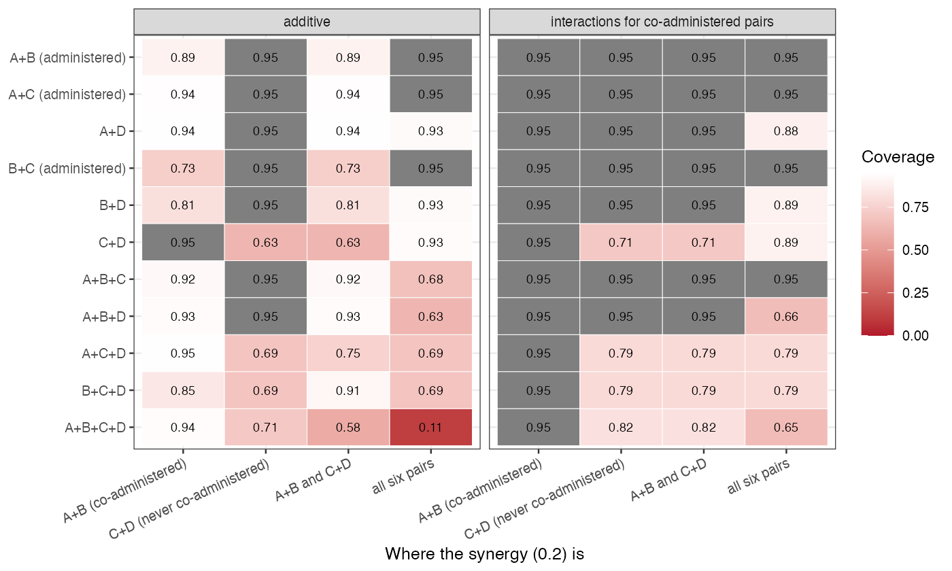
Figure 1: Coverage of each regimen’s 95% interval at synergy 0.2.
The registered primary was confirmed (Figure 1). The additive model reported every regimen as estimable, and three patterns followed from where the synergy sat. On a never co-administered pair the whole interaction went into the regimens containing the pair: C+D, A+C+D, B+C+D and A+B+C+D were biased by 0.2 with coverage 0.628 to 0.707, while every other regimen was exact. The data carry no information about this interaction, so no model fitted to them can detect or correct it. On a co-administered pair the fit absorbed the interaction into the component effects: A+B itself was underestimated in magnitude (bias 0.050), and regimens sharing a component but not the pair were biased by -0.125 (B+C, administered, coverage 0.733) and -0.125 (B+D, never administered, coverage 0.813). Modeling the three co-administered pairs’ interactions made every estimate unbiased in that scenario, at the price of wider intervals. Spread over all pairs, the four-component regimen covered 0.111.
The provenance share , the fraction of a regimen’s pairs never co-administered, was not a useful flag: it assigns B+D and C+D the same value, but only one of them contains the synergy, and it gives A+B+C, assembled from co-administered pairs but never administered as a triple, a value of zero while leakage biased it.

4. What this does not answer
A single connected network with a continuous outcome and a fixed-effect model; no disconnection or subnetwork drift, no covariate adjustment layer, no heredity-constrained or data-driven selection, and no formal bound over omitted synergy. Peer review has not been done.

References
1. Gerta Rücker, Maria Petropoulou, Guido Schwarzer. Network meta-analysis of multicomponent interventions. Biometrical Journal. 2020;62(3):808–21. doi:10.1002/bimj.201800167

